VIRTUAL DATA SCIENCE WITH PYTHON APPRENTICESHIP
Week 5 Capstone Project Report
From data audit to strategic recommendations: an end-to-end analysis of the Breast Cancer Wisconsin (Diagnostic) dataset
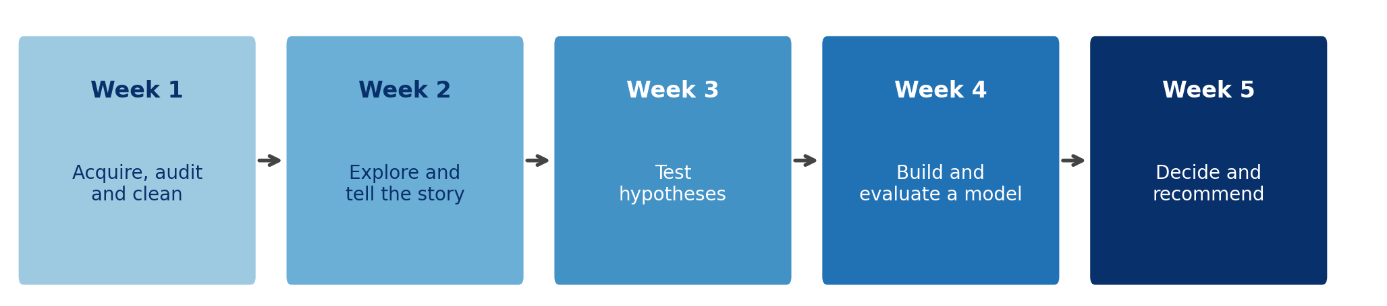
Prepared by
Sameera P
Date
October 31, 2026
Project code and figures
https://github.com/SameeraPeer/Virtual-Data-Science-with-Python/tree/main/week5_project

Contents
1. Executive Summary
2. Introduction
3. Project Synthesis: What Weeks 1 to 4 Taught Us
4. Data and Methodology
5. Results and Analysis
6. Discussion
7. Strategic Recommendations
8. Business Impact and Research Outcomes
9. Limitations and Future Improvements
10. Conclusion
Appendix A. Reproducing This Project
Appendix B. Plain-Language Glossary

1. Executive Summary
This report brings together everything from the five-week apprenticeship: acquiring and auditing data (Week 1), telling a story with charts (Week 2), testing claims statistically (Week 3), building and judging a machine learning model (Week 4), and now turning the results into decisions (Week 5). To show the full chain on a single problem, I re-ran the whole workflow end to end on the Breast Cancer Wisconsin (Diagnostic) dataset: 569 tumour samples, each described by 30 measurements of cell nuclei, labelled benign or malignant.
The question for stakeholders: can routine measurements support a screening decision-support tool, and how should such a tool be set up so that its mistakes match what matters to the organisation?
Bottom line
A simple, transparent model (logistic regression) separates malignant from benign samples very well: ROC AUC 0.996 on held-out data (95% bootstrap interval 0.986 to 1).
Accuracy alone hides the real issue. At the default 0.50 cut-off the model missed 3 of 42 malignant samples in the test set. Lowering the cut-off to 0.20, chosen using training data only, cut the misses to 1 at the price of 3 extra false alarms.
The best cut-off is a business decision, not a statistical one. If a missed malignancy is five or more times as costly as a false alarm, the lower cut-off roughly halves the expected cost (14.04 to 7.89 per 100 patients at a 5:1 ratio).

Key findings
- Data quality was high. No missing values, duplicates or impossible values. 608 extreme cells (3.56% of all values) were kept because they reflect real tumours, and they are far more common in malignant samples (53.8% of malignant rows contain one versus 16% of benign rows).
- Size and shape separate the groups. 9 of 10 average measurements differ significantly between groups after Bonferroni correction. The largest effect is mean concave points (Cohen's d = 2.55). Mean fractal dimension shows no difference at all (d = -0.03, p = 0.767).
- Measurements overlap heavily. 21 pairs of the 30 features correlate above 0.90, so the model has far fewer independent signals than columns.
- Simple beats complex here. Logistic regression (cross-validated AUC 0.996) matched or beat a random forest (0.990) and clearly beat a decision tree (0.902).
- A small set of measurements keeps most of the performance. Five measurements reach a cross-validated AUC of 0.985, against 0.996 for all 30.

Recommendations in brief
- Deploy only as decision support for a human reader, starting with a silent pilot.
- Ask the organisation to state the cost of a missed case relative to a false alarm, and set the cut-off from that.
- Keep logistic regression as the main model, with a random forest as a monitored challenger.
- Send borderline cases to a second reader: in testing, 9 cases (7.9%) fell in the review band and contained 3 of the 4 default-cut-off errors.
- Treat a reduced five-measurement model as a possible fast pre-screen, not a replacement.
- Require external validation, calibration checks and ongoing monitoring before any real-world use.

Important caution. This is a learning project on a public benchmark dataset. It is not a medical device and its results must not be used for clinical decisions.

2. Introduction

2.1 Purpose and audience
The Week 5 brief asks for an exhaustive, end-to-end report that integrates the earlier weeks and ends in strategic recommendations. The intended readers are mixed: a technical reviewer who wants to see sound method and code, and a non-technical decision-maker who wants to know what to do. Each section therefore opens with plain-language takeaways and keeps the technical detail underneath.

2.2 Why one dataset for the capstone
Weeks 1 to 4 each used a different dataset (Titanic, Breast Cancer Wisconsin, Wine, and Digits) so that every week exercised the skill from a fresh angle. For the capstone, the more useful demonstration is the whole chain applied to one problem. I chose the Breast Cancer Wisconsin (Diagnostic) data from Week 2 because it has a natural decision at the end: a false negative and a false positive clearly have different costs. It also ships with scikit-learn, so every number in this report can be reproduced offline.

2.3 Objectives
- Synthesise the methods and lessons from Weeks 1 to 4.
- Run a complete, leak-free analysis: audit, explore, test, model.
- Go beyond accuracy: connect model errors to costs and recommend an operating policy.
- State the business impact, the limitations and the next steps honestly.

2.4 How the report is organised
Section 3 summarises the four earlier weeks. Section 4 describes the data and methods with code excerpts. Section 5 presents the analysis in the same order as the weeks. Sections 6 to 9 interpret the results, give recommendations and impacts, and discuss limits. Appendices explain how to reproduce the work and define technical terms.

3. Project Synthesis: What Weeks 1 to 4 Taught Us
The table below collects the main finding of each earlier week and the lesson that carries forward into this capstone.
Week | Dataset and task | Key methods | Headline result and lesson
1 | Titanic passenger data.  Acquisition, cleaning and EDA | Missing-value handling, duplicate and type checks, histograms, box plots, correlation views | Real data is messy: Age (177), Cabin (687) and Embarked (2) had missing values out of 891 rows. Lesson: every cleaning choice needs a written reason.
2 | Breast Cancer Wisconsin.  Visual storytelling | Seven annotated charts: distributions, correlation, two-feature separation, risk by cell size, all-feature overview | Malignant samples sit higher on size and shape measurements, and many measurements repeat each other. Lesson: a chart should answer one question for one audience.
3 | Wine (three cultivars).  Hypothesis testing | Welch t-test, Welch ANOVA with post-hoc, chi-square, Pearson correlation, confidence intervals | Alcohol in cultivar A was about 1.47 units higher than in B (95% CI 1.29 to 1.64), and flavanoids differed across all three cultivars. Lesson: report effect sizes and intervals, not just p-values, and check assumptions.
4 | Handwritten Digits.  Machine learning | Logistic regression, random forest, decision tree, majority-class baseline, cross-validation, confusion matrices, ROC | Logistic regression reached 97.2% accuracy (10 errors in 360 images) against a 10.0% baseline; random forest 96.9%; decision tree 82.5%. Lesson: always compare with a baseline and keep test data untouched.
5 | Breast Cancer Wisconsin.  End-to-end and strategy | All of the above, plus a cost-based cut-off, a human-review band and feature reduction | This report. Lesson: a model is only useful when its errors are matched to the cost of being wrong.

As a reproducibility check, the Week 3 Wine result was recomputed during this project: the alcohol difference between cultivars A and B came out at 1.47 units with a 95% interval of 1.29 to 1.64, matching the Week 3 report. The Week 1 figures for Titanic are carried over from that week's report; the Week 4 figures are carried over from the Week 4 report.

3.1 Cross-cutting lessons
- Audit before analysing. Even a clean dataset deserves written evidence that it is clean (Week 1).
- Pictures find structure that tables hide. Redundant measurements were obvious in a heatmap (Week 2).
- Significance is not importance. With strong effects, p-values are tiny; effect sizes and intervals carry the information (Week 3).
- Evaluation must be honest. Use baselines, cross-validation and a test set that is touched once (Week 4).
- Decisions need costs. The same model can be good or poor depending on what its mistakes cost (Week 5).

4. Data and Methodology

4.1 Data source and description
The Breast Cancer Wisconsin (Diagnostic) dataset is a public benchmark distributed with scikit-learn. Each of the 569 rows is a digitised image of a fine-needle aspirate of a breast mass. Ten properties of the cell nuclei (radius, texture, perimeter, area, smoothness, compactness, concavity, concave points, symmetry, fractal dimension) are summarised three ways (mean, standard error and worst value), giving 30 numeric features. The label is the diagnosis. The dataset has 357 benign (62.7%) and 212 malignant (37.3%) samples. I re-coded the label so that 1 means malignant, which makes "recall" mean "share of malignant cases found".

4.2 Data audit and cleaning (Week 1 skills)
Cleaning is a set of decisions, each with a reason. The checks and the decision taken for each are listed below.
Check | Result | Decision and reason
Missing values | 0 | Nothing to impute. Imputing would only add invented data.
Duplicate rows | 0 | Nothing to drop. Duplicates would inflate test scores if copies landed in both train and test.
Data types | All numeric | No conversion needed. The label is stored as an integer and was re-coded.
Impossible values | 0 negative values | 78 zeros exist in concavity measures. Zero is valid for a perfectly smooth outline, so they were kept.
Outliers (1.5 x IQR rule) | 608 cells (3.56%) in 171 rows | Kept. They are not errors: 53.8% of malignant rows contain one versus 16% of benign rows, so removing them would delete the signal.
Scale differences | Medians span about 215,406x | Features are standardised inside a pipeline, fitted on training data only, so no test information leaks.
Skewness | 22 of 30 features skew above 1 | Not transformed. The group comparisons were confirmed with the rank-based Mann-Whitney test, and the model is fitted on standardised data.
Redundancy | 21 feature pairs with |r| > 0.90 | Kept, but this motivates regularised models and the feature-reduction experiment in Section 5.5.

bunch = load_breast_cancer(as_frame=True)
df = bunch.frame.copy()
df["malignant"] = 1 - df["target"] # 1 = malignant (sklearn: 0)
df = df.drop(columns="target")

df.isna().sum().sum() # missing values -> 0
df.duplicated().sum() # duplicate rows -> 0

q1, q3 = X.quantile(0.25), X.quantile(0.75)
iqr = q3 - q1
out_mask = (X < q1 - 1.5*iqr) | (X > q3 + 1.5*iqr) # flag, keep
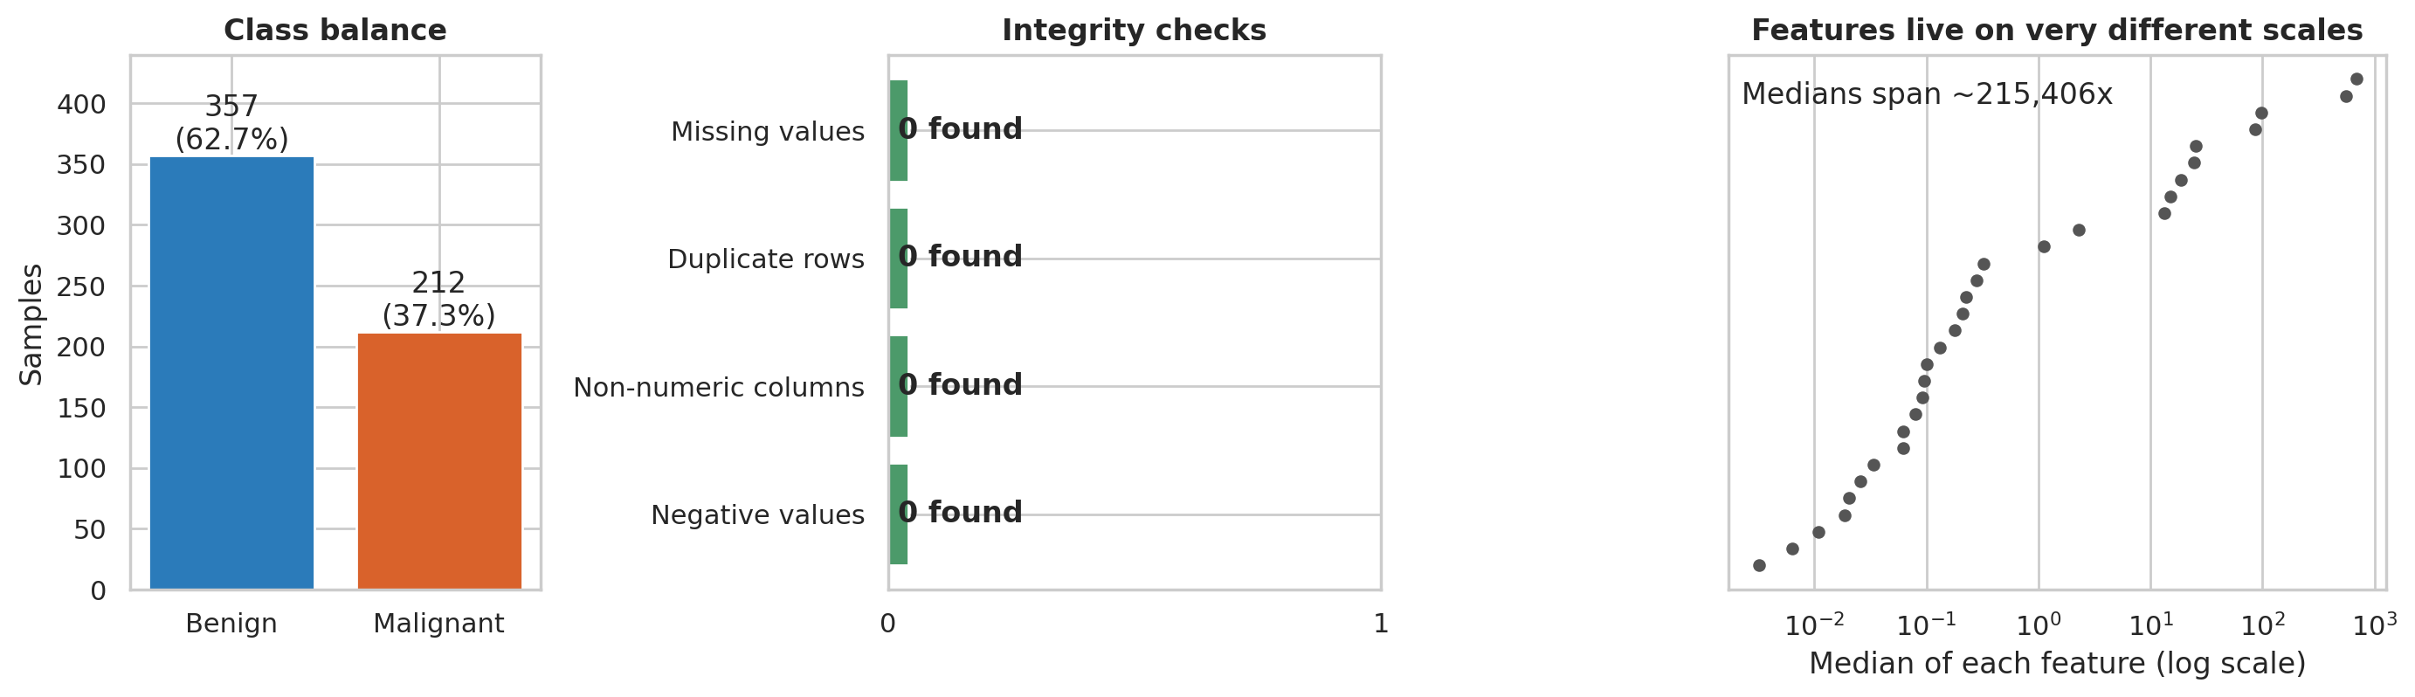
Figure 1. Data audit summary
What it shows. The class balance (about 63% benign, 37% malignant), the four integrity checks (all clean), and the very different scales of the 30 features.
Why it matters. A moderate class imbalance means accuracy can look good while malignant cases are missed, so recall is tracked throughout. The scale spread is the reason features are standardised.

4.3 Statistical methodology (Week 3 skills)
For each of the ten mean measurements, malignant and benign groups were compared with a Welch t-test (which does not assume equal variances) and confirmed with a Mann-Whitney U test (which does not assume normality). Effect size is Cohen's d with an approximate 95% confidence interval. Because ten tests were run, the significance threshold was tightened by Bonferroni correction to 0.05 / 10 = 0.005.
t, p = stats.ttest_ind(a, b, equal_var=False) # Welch t-test
u, pu = stats.mannwhitneyu(a, b, alternative="two-sided")
va, vb = a.var(ddof=1), b.var(ddof=1)
sp = np.sqrt(((n1-1)*va + (n2-1)*vb) / (n1+n2-2))
d = (a.mean() - b.mean()) / sp # Cohen's d
se = np.sqrt((n1+n2)/(n1*n2) + d**2/(2*(n1+n2)))
ci = (d - 1.96*se, d + 1.96*se)
significant = p < 0.05 / 10 # Bonferroni

4.4 Modelling methodology (Week 4 skills)
- Split. 80/20 stratified split with a fixed seed: 455 training and 114 test samples (42 malignant in the test set). The test set was used once for final reporting.
- Candidates. A majority-class baseline, logistic regression, a random forest and a depth-4 decision tree.
- Main model, fixed in advance. Logistic regression, because it is simple, fast, transparent and well suited to roughly linear, correlated measurements. Its regularisation strength was tuned on training data only (best C = 1).
- Validation. Repeated stratified 5-fold cross-validation (3 repeats) on the training set to compare models by ROC AUC and recall.
- Uncertainty. 2,000 bootstrap resamples of the test set give intervals for the main model's test metrics.
X_tr, X_te, y_tr, y_te = train_test_split(X, y, test_size=0.2,
stratify=y, random_state=42)
model = Pipeline([('sc', StandardScaler()),
('m', LogisticRegression(max_iter=5000))])
grid = {'m__C': [0.01, 0.03, 0.1, 0.3, 1, 3, 10, 30]}
inner = StratifiedKFold(5, shuffle=True, random_state=42)
gs = GridSearchCV(model, grid, scoring='roc_auc', cv=inner)
gs.fit(X_tr, y_tr) # tuning sees training data only
cv = RepeatedStratifiedKFold(n_splits=5, n_repeats=3, random_state=42)
cross_val_score(gs.best_estimator_, X_tr, y_tr, cv=cv, scoring='roc_auc')

4.5 Decision analysis (Week 5 contribution)
Most models output a probability, and a cut-off turns it into a decision. The default 0.50 treats both kinds of error as equally bad, which is rarely true. The cut-off was therefore chosen in three steps, all using training data only. First, out-of-fold probabilities were produced with cross-validation. Second, the highest cut-off that kept out-of-fold sensitivity at or above 0.98 was selected, which gave 0.20. Third, that fixed cut-off was applied once to the test set. A cost analysis then repeated the choice under four assumed cost ratios, where a missed malignant case costs 1, 5, 10 or 20 times a false alarm. These ratios are illustrative assumptions, not measured costs.
oof = cross_val_predict(main, X_tr, y_tr, cv=inner,
method='predict_proba')[:, 1] # out-of-fold, training only
ok = thresholds[sensitivity_oof >= 0.98]
t_safe = ok.max() # highest cut-off meeting the goal

# ratio = cost of a missed case relative to a false alarm
cost = (false_negatives * ratio + false_positives) / n

To test whether a simpler model is possible, feature selection was placed inside the cross-validation pipeline, so that the choice of features is re-made on each training fold and never sees validation data:
pipe = Pipeline([('sel', SelectKBest(f_classif, k=k)),
('sc', StandardScaler()),
('m', LogisticRegression(max_iter=5000, C=best_C))])

4.6 Reproducibility
All randomness uses seed 42, all library versions are listed in requirements.txt, and a single script regenerates every figure and number in this report. Appendix A gives the steps.

5. Results and Analysis

5.1 Exploratory analysis (Week 2 skills)
Takeaway for non-technical readers: malignant samples are, on average, larger and more irregular, and many of the measurements are near-copies of one another.
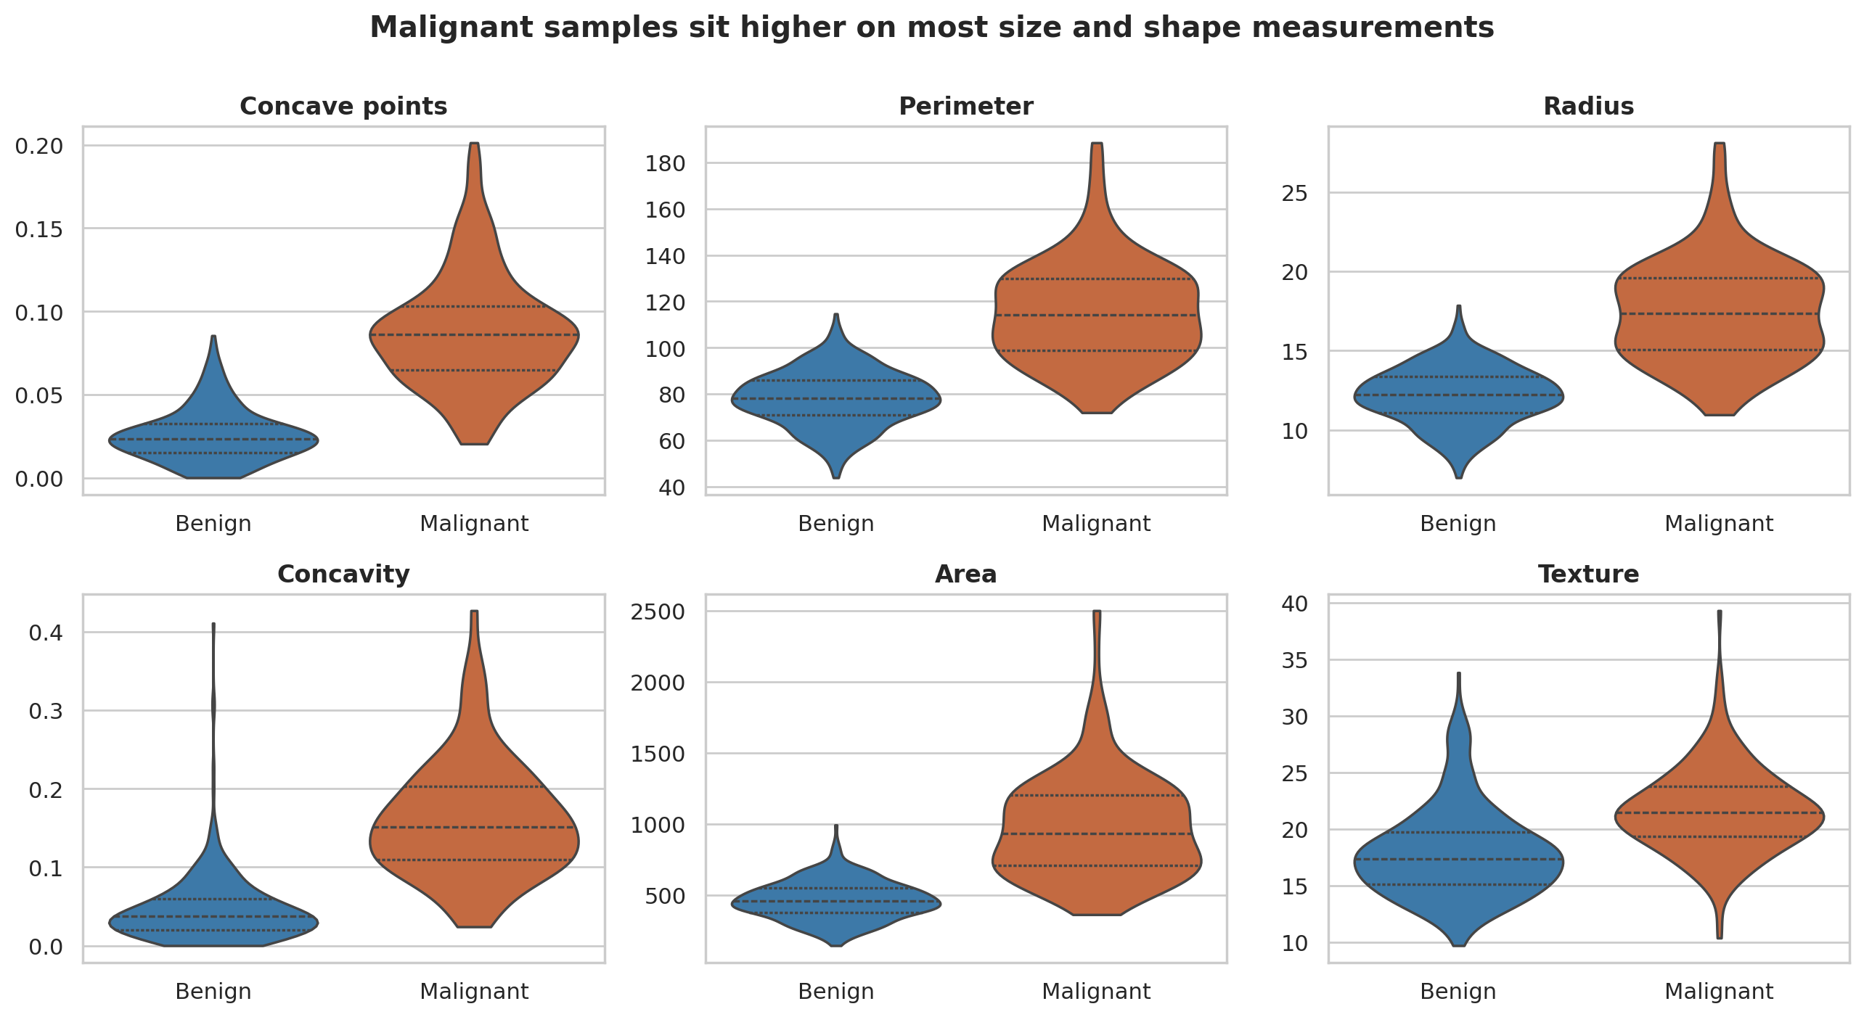
Figure 2. Distribution of six key measurements by diagnosis
What it shows. Violin plots for six measurements. The dashed lines mark quartiles. Malignant samples sit clearly higher on concave points, perimeter, radius, concavity and area, with a smaller shift for texture.
Why it matters. These are the first visual evidence that the groups differ. The separation is strongest where the violins barely overlap (concave points), which foreshadows the large effect sizes in Section 5.2.
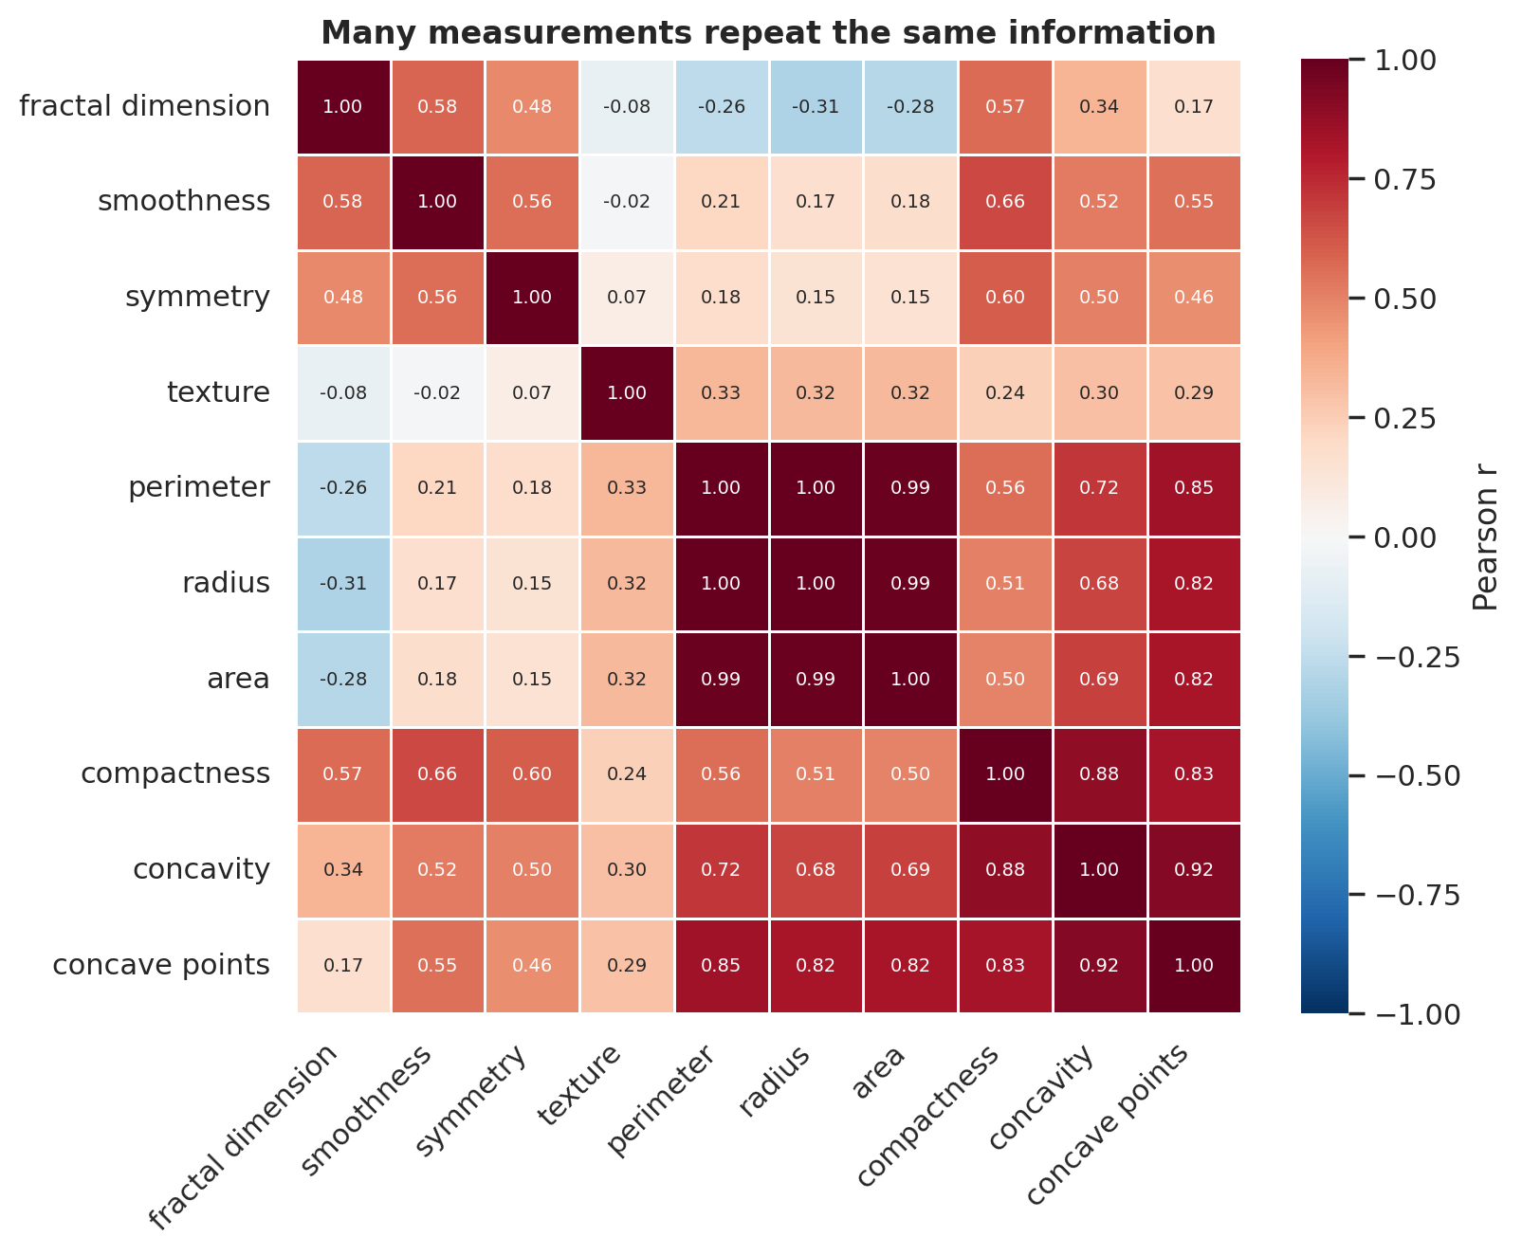
Figure 3. Correlation among the ten mean measurements
What it shows. Radius, perimeter and area are almost identical (r = 0.998 between radius and perimeter, 0.987 between radius and area). Concavity, concave points and compactness form a second tight group. Texture and fractal dimension are largely separate from the size group.
Why it matters. Redundancy means the model has fewer independent signals than columns, makes individual coefficients unstable, and explains why a handful of measurements can do most of the work (Section 5.5).

5.2 Hypothesis tests (Week 3 skills)
Hypothesis. Null: the mean of each measurement is the same in malignant and benign samples. Alternative: the means differ. Significance level after Bonferroni correction: 0.005.
Measurement | Mean (malignant) | Mean (benign) | Cohen's d [95% CI] | Welch p | Significant?
concave points | 0.088 | 0.026 | 2.55 [2.32, 2.77] | < 1e-10 | Yes
perimeter | 115.365 | 78.075 | 2.29 [2.07, 2.51] | < 1e-10 | Yes
radius | 17.463 | 12.147 | 2.21 [1.99, 2.42] | < 1e-10 | Yes
area | 978.376 | 462.790 | 2.08 [1.87, 2.28] | < 1e-10 | Yes
concavity | 0.161 | 0.046 | 2.00 [1.80, 2.21] | < 1e-10 | Yes
compactness | 0.145 | 0.080 | 1.53 [1.34, 1.73] | < 1e-10 | Yes
texture | 21.605 | 17.915 | 0.94 [0.76, 1.12] | < 1e-10 | Yes
smoothness | 0.103 | 0.092 | 0.79 [0.62, 0.97] | < 1e-10 | Yes
symmetry | 0.193 | 0.174 | 0.72 [0.55, 0.90] | < 1e-10 | Yes
fractal dimension | 0.063 | 0.063 | -0.03 [-0.20, 0.14] | 0.767 | No

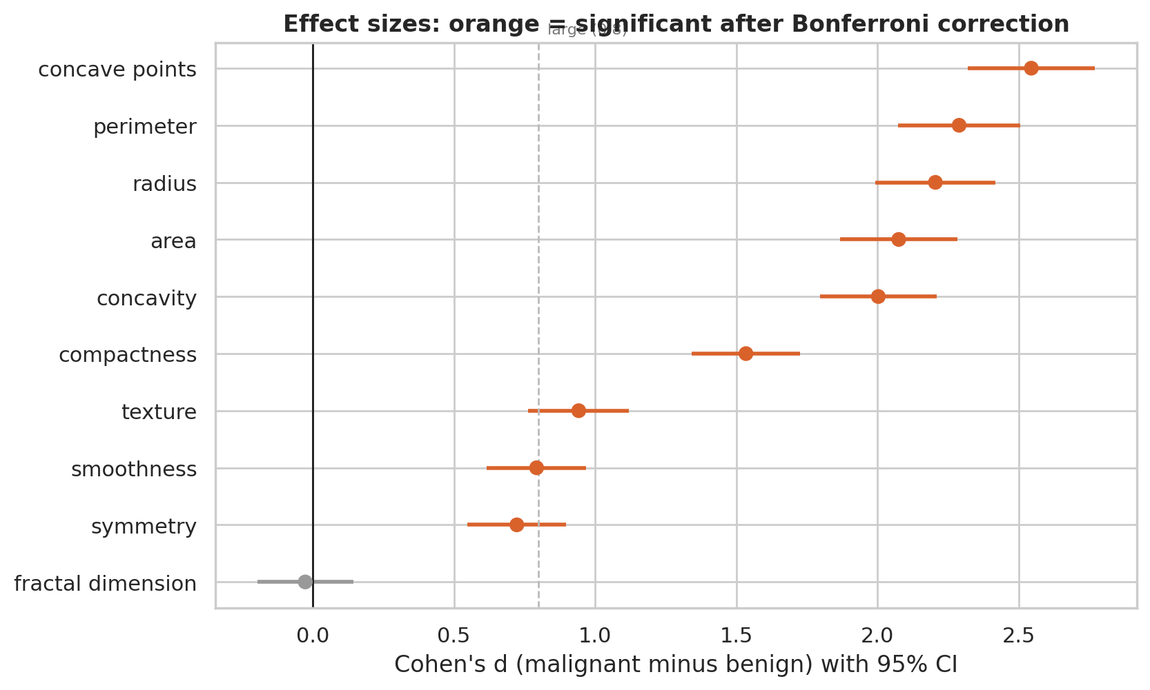
Figure 4. Effect sizes with 95% confidence intervals
What it shows. 9 of 10 measurements differ significantly. Concave points, perimeter, radius, area and concavity have very large effects (d above 2). Fractal dimension has an effect of essentially zero.
Why it matters. Cohen's d above 0.8 is conventionally "large", and most values here are far beyond that. The Mann-Whitney test agreed with the Welch test on every measurement. The tight intervals show the estimates are precise, but they assume each row is an independent sample.

5.3 Model development and evaluation (Week 4 skills)
Model | CV AUC | CV recall | Test accuracy | Test AUC | Test recall | Missed | False alarms
Majority-class baseline | 0.500 | 0.000 | 0.632 | 0.500 | 0.000 | 42 | 0
Logistic regression | 0.996 | 0.957 | 0.965 | 0.996 | 0.929 | 3 | 1
Random forest | 0.990 | 0.925 | 0.974 | 0.994 | 0.929 | 3 | 0
Decision tree | 0.902 | 0.867 | 0.912 | 0.877 | 0.809 | 8 | 2

CV = repeated cross-validation on training data. Test figures use the default 0.50 cut-off on 114 held-out samples (42 malignant). "Missed" is the number of malignant samples predicted benign.
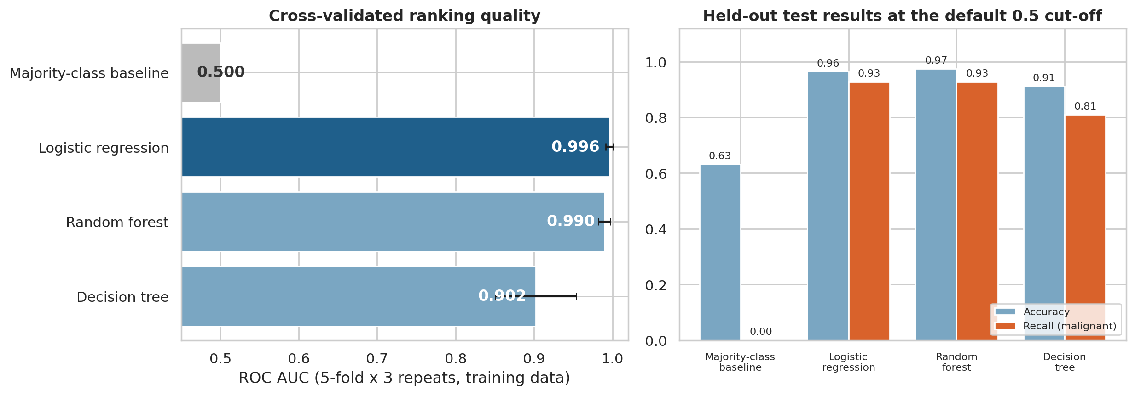
Figure 5. Model comparison
What it shows. Left: cross-validated AUC with spread across folds. Right: test accuracy and recall at the default cut-off.
Why it matters. The baseline reaches 63% accuracy by always predicting "benign" but finds no cancers, which shows why recall must be reported next to accuracy. Logistic regression has the highest cross-validated AUC and the most stable results. The decision tree is clearly weaker and far less stable.
For the main model, bootstrap 95% intervals on the test set are wide because only 42 malignant samples were available: AUC 0.986 to 1, recall 0.841 to 1, accuracy 0.93 to 0.991. Logistic regression and the random forest cannot be separated statistically on a test set this small, which supports choosing the simpler, more transparent model.
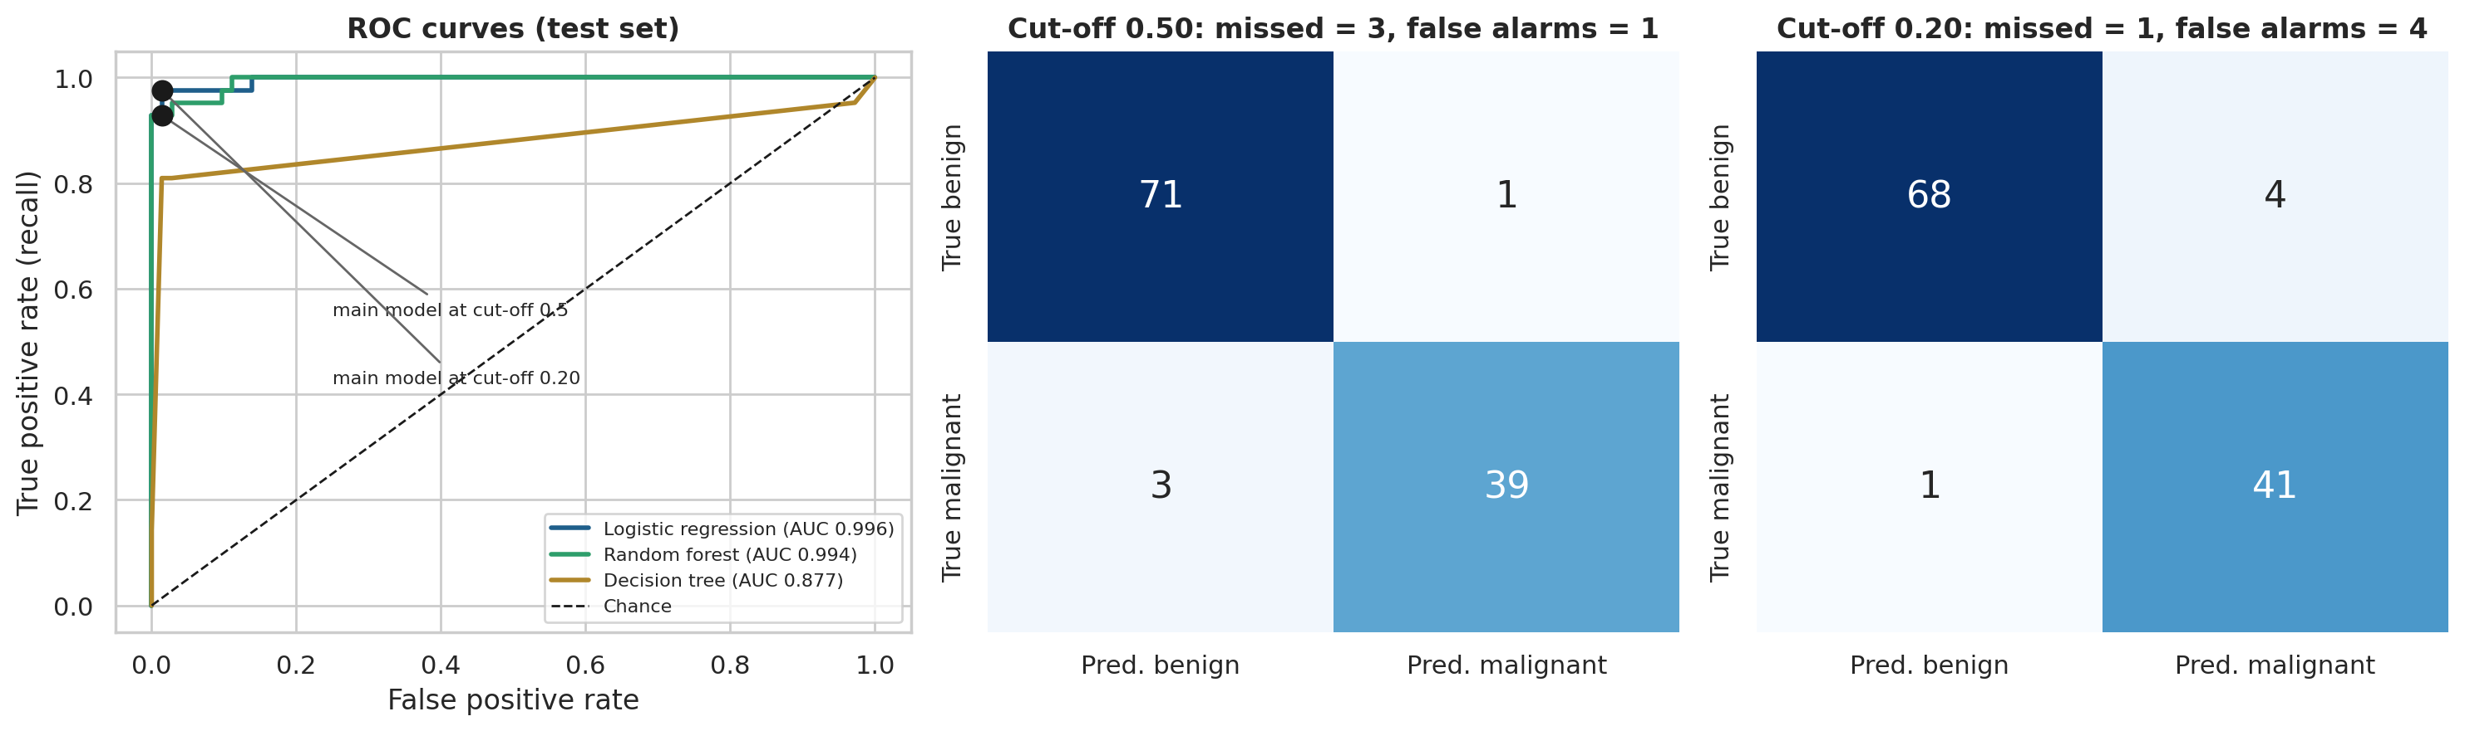
Figure 6. ROC curves and confusion matrices at two cut-offs
What it shows. Left: ROC curves for the three real models, with the main model's two operating points marked. Middle and right: confusion matrices for the main model at cut-off 0.50 (3 missed, 1 false alarm) and 0.20 (1 missed, 4 false alarms).
Why it matters. The ROC curve shows that one model can operate at many different trade-offs. Moving along the curve is the lever that Section 5.4 uses to match the model to the cost of errors.

5.4 Strategic analysis: choosing the operating point
Figure 7 (left) shows how the cut-off trades sensitivity against specificity on out-of-fold training data. The chosen cut-off of 0.20 achieves out-of-fold sensitivity of 0.982 and specificity of 0.951. The right panel converts the trade-off into cost under different assumptions.
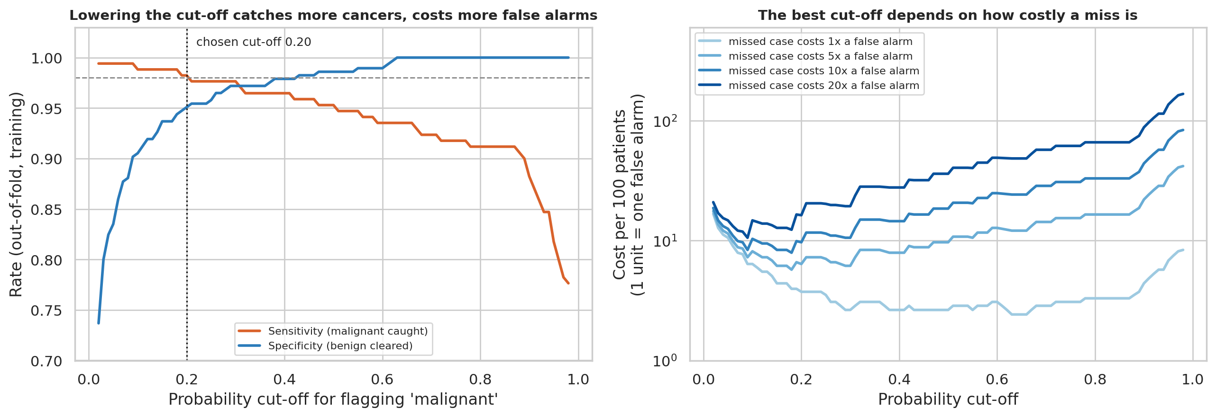
Figure 7. Cut-off trade-off and expected cost
What it shows. Left: sensitivity and specificity as the cut-off moves, with the 98% sensitivity goal dashed. Right: cost per 100 patients for four cost ratios (log scale).
Why it matters. Every cost curve has a different lowest point. If misses and false alarms cost the same, the best cut-off is near the default. As misses become more costly, the best cut-off moves lower. This is the evidence for recommendation 2.
Metric (test set) | Default cut-off 0.50 | Safety cut-off 0.20
Sensitivity (malignant found) | 92.9% | 97.6%
Specificity (benign cleared) | 98.6% | 94.4%
Positive predictive value | 97.5% | 91.1%
Negative predictive value | 96.0% | 98.6%
Accuracy | 96.5% | 95.6%
Malignant cases missed | 3 | 1
False alarms | 1 | 4

Overall accuracy is slightly lower at the safety cut-off (96.5% to 95.6%), which is exactly why accuracy is the wrong yardstick here. The expected-cost comparison tells a different story:
Cost of a miss vs a false alarm | Cut-off chosen on training data | Cost per 100 at default | Cost per 100 at chosen | Change
1 : 1 | 0.63 | 3.51 | 3.51 | None
5 : 1 | 0.18 | 14.04 | 7.89 | -44%
10 : 1 | 0.18 | 27.19 | 12.28 | -55%
20 : 1 | 0.09 | 53.51 | 23.68 | -56%

Costs are in units of one false alarm. The cut-off was chosen on training data and costs are measured on the test set. With only 42 malignant test samples, the gap between 3 and 1 missed cases is small in absolute terms, so these percentages show the direction of the effect rather than a precise size. The training-data analysis points the same way: cross-validated recall at the default cut-off was 95.7%, against 98.2% out-of-fold at the safety cut-off.

5.5 Can a simpler model do the job?
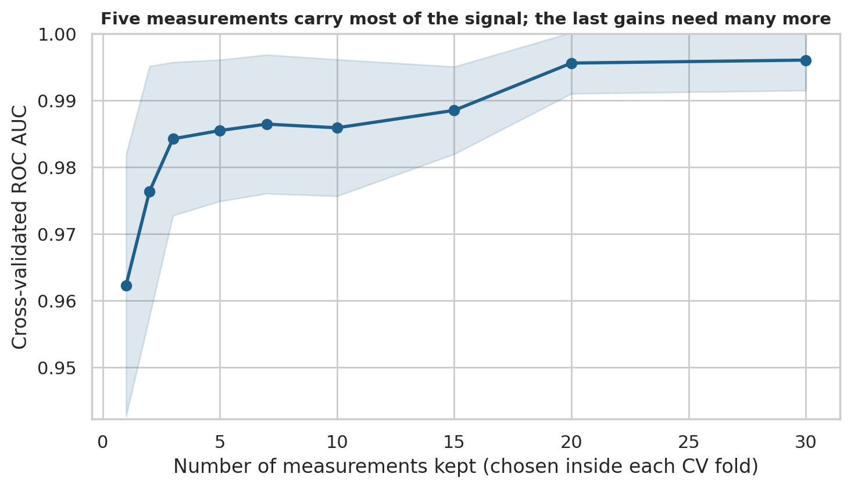
Figure 8. Cross-validated AUC against number of measurements kept
What it shows. With one measurement, AUC is 0.962. It rises quickly to 0.984 with three and 0.985 with five, then creeps to 0.996 at twenty and 0.996 at thirty. The shaded band is one standard deviation across folds.
Why it matters. Most of the signal sits in a few strongly informative measurements, but the final small gain needs many more. A short model would be cheaper to collect and easier to explain, yet it gives up about 0.01 AUC. Whether that trade is acceptable is a stakeholder decision.

5.6 Error analysis
At the default cut-off the main model made 4 test errors. Their positions in the test set and predicted malignancy probabilities are:
Test row | Truth | Predicted probability of malignancy | Type | At cut-off 0.20
4 | benign | 0.509 | False alarm | Still wrong
16 | malignant | 0.061 | Missed case | Still wrong
87 | malignant | 0.315 | Missed case | Corrected
112 | malignant | 0.492 | Missed case | Corrected

- Two of the three missed cases (probabilities 0.315 and 0.492) were close calls that the lower cut-off corrects. The third (0.061) is a confident error: no sensible cut-off catches it, so a human second opinion is the only safeguard.
- The lower cut-off introduces 3 new false alarms, all with probabilities between 0.20 and 0.24.
- A review band between the safety cut-off and 0.80 contained 9 test cases (7.9%) and 3 of the 4 default errors, so a second reader would see a small share of cases and catch most of the model's mistakes.
- The largest standardised coefficients (worst texture 1.434, radius error 1.233, worst symmetry 1.061, mean concave points 0.953) should not be over-interpreted. With many near-duplicate measurements, the model can spread credit among them in arbitrary ways.

6. Discussion
The weeks fit together. The audit in Week 1 style confirmed the data could be trusted. The visual story showed why separation is easy: malignant samples are larger and more irregular. The tests turned that impression into effect sizes with intervals, and showed one measurement (fractal dimension) that tells us nothing. The model then used the signal, and the decision analysis connected its errors to consequences.
Why the model works so well, and why that is not the whole story. Nine of ten tests showed medium-to-very-large effects, so near-perfect ranking is expected. This is a tidy benchmark whose features were computed from carefully prepared images. Results this strong would almost certainly be lower on messier real-world data, and the report should be read as evidence that the process is sound rather than that this exact model would perform as well in practice.
The most useful result is not the AUC. The AUC barely changes between sensible models. What changes the outcome is the cut-off, because it controls which errors occur. Teams often spend weeks on model choice and minutes on the cut-off; this project suggests the proportions should be reversed.
Simplicity pays. The tuned logistic regression was at least as good as a random forest and is much easier to audit. The decision tree was the weakest and least stable, consistent with the Week 4 finding on the Digits data.
Caution on multiple measurements. Because many features are near-copies, a model can look sophisticated while relying on a few underlying signals. That is helpful for simplification but a warning against reading individual coefficients as causes.

7. Strategic Recommendations
Each recommendation is tied to evidence in this report and to a concrete action. The intended stakeholders are the clinical or laboratory leadership who would own the decision, and the analytics team who would run the tool.
# | Recommendation | Evidence | Action
1 | Use the model as decision support for a human reader, not as an automatic decision-maker. | AUC 0.996, but 3 missed cases at the default cut-off, including one confident error. Test intervals are wide (recall 0.841 to 1). | Run a silent pilot alongside current practice and compare outcomes before the tool influences any decision.
2 | Set the cut-off from the cost of errors, not from accuracy. | If a miss is 5 times a false alarm, the safety cut-off cuts expected cost by about 44%. At 1:1 it makes no difference. | Have clinical and finance leads agree the cost ratio in writing, then fix the cut-off from training data using the method in Section 4.5 and review it annually.
3 | Keep logistic regression as the main model and a random forest as a challenger. | CV AUC 0.996 against 0.990; the two cannot be separated on 114 test samples, and the simpler one is easier to explain and audit. | Document the model, track both in production and switch only if the challenger wins consistently on new data.
4 | Route borderline cases to a second reader. | 9 of 114 test cases (7.9%) were in the review band and contained 3 of 4 errors. | Define the band (here 0.20 to 0.80) as policy, and track the workload and the rate of errors it catches.
5 | Consider a five-measurement model as a fast pre-screen only. | AUC 0.985 with five measurements against 0.996 with all 30. | Test it in the pilot as a cheap first step. Do not replace the full model unless the lost accuracy is acceptable.
6 | Require validation and monitoring before any real use. | Single benchmark dataset, 569 samples, 37% malignant, features pre-computed from images. | Validate on external data from the intended setting, check probability calibration, and monitor for drift in measurements and case mix.

7.1 How these recommendations support decisions
- Governance. Recommendations 1, 2 and 6 define who decides, what is measured and when the tool may be trusted.
- Cost control. Recommendations 2 and 4 spend human attention only where the model is unsure.
- Risk reduction. Recommendations 1, 3 and 6 limit the damage of a wrong or drifting model.
- Efficiency. Recommendation 5 lowers the data-collection burden if the pilot supports it.

8. Business Impact and Research Outcomes

8.1 Illustrative impact
To make the trade-off concrete, the table scales the test-set rates to 1,000 samples with the same case mix as this dataset (about 373 malignant and 627 benign). The case mix of 37% malignant is far higher than in routine screening, so the absolute counts would be different in a real setting; the direction of the trade-off is what carries over.
Per 1,000 samples | Default cut-off 0.50 | Safety cut-off 0.20 | Difference
Malignant cases missed | 27 | 9 | -18
False alarms needing follow-up | 9 | 35 | +26
Cases flagged in total | 355 | 399 | +44

In plain terms: in this setting, lowering the cut-off trades roughly 26 additional false alarms for about 18 fewer missed cancers per 1,000 samples, or about 1.4 extra follow-ups for each extra case found. Whether that exchange is worthwhile depends on follow-up cost and patient burden, which is why recommendation 2 asks stakeholders to state the ratio. These figures come from a test set with only 42 malignant samples and should be treated as indicative.

8.2 Research outcomes
- Nuclear size and shape features (concave points, perimeter, radius, area, concavity) carry the strongest diagnostic signal, with very large and precisely estimated effect sizes.
- Fractal dimension carries essentially no group difference, which makes it a candidate for removal.
- High redundancy among features supports regularised linear models and compact feature sets.
- Choosing the cut-off by cost can matter more than choosing between competent algorithms.
- A leak-free workflow, with scaling, tuning, feature selection and cut-off choice all kept inside training data, gives results that can be trusted to mean what they say.

9. Limitations and Future Improvements

9.1 Limitations
- Small test set. 114 test samples with 42 malignant ones give wide intervals. A difference of two missed cases is suggestive, not conclusive.
- Single benchmark dataset. Features were derived from prepared images, and results here are almost certainly better than on raw, multi-site clinical data.
- Case mix. 37% malignant is much higher than in screening populations, which affects predictive values and the absolute counts in Section 8.
- Assumed costs. The 1, 5, 10 and 20 cost ratios are illustrations. No real cost data was available.
- Single split. The test set came from one random split. Repeating the whole procedure with nested cross-validation would give steadier estimates.
- Statistical assumptions. The tests assume independent samples. The dataset does not say whether any patient contributed more than one sample.
- Multiple testing and analyst choices. Bonferroni correction handles the ten tests, but the choice to test the ten mean measurements was mine and made after seeing the data description.
- Synthesis scope. Weeks 1 to 4 used different datasets, so the synthesis combines methods and lessons, not data. Week 1 and Week 4 figures in Section 3 are carried over from those weeks' reports.
- Not clinical. Nothing here has been assessed for regulatory or clinical use.

9.2 Future improvements
- Validate on an external dataset from a different site and check how performance and the best cut-off shift.
- Check and, if needed, correct probability calibration so that a stated 30% risk really means about 30%.
- Use repeated nested cross-validation to compare models and tune the cut-off with more stable estimates.
- Replace the assumed cost ratios with real figures from clinical and operational staff, and optimise the cut-off against them.
- Try gradient boosting and regularised variants such as elastic net, and use permutation importance or SHAP to explain predictions.
- Add subgroup analysis (for example by age or site, if available) to check that errors are not concentrated in any group.
- Build a simple monitoring dashboard for drift, review-band volume and agreement between model and reader.

10. Conclusion
This capstone shows the full data science chain on one problem: audit the data, explore it visually, test the claims, build and honestly evaluate a model, and turn the result into a policy. The technical result is that a simple logistic regression ranks malignant and benign samples with near-perfect accuracy on this benchmark. The strategic result is that the decision rule matters more than the algorithm: choosing the cut-off from the cost of errors, backing it with a human review band, and insisting on external validation turns a good score into a defensible tool.
The main lesson I take from the five weeks is that each step makes the next one trustworthy. Clean data makes the charts honest, honest charts make the hypotheses sensible, sound tests make the features credible, careful evaluation makes the model believable, and clear costs make the recommendation usable.

Appendix A. Reproducing This Project
Repository folder:
https://github.com/SameeraPeer/Virtual-Data-Science-with-Python/tree/main/week5_project
week5_project/
week5_capstone.py # full analysis: audit, tests, models, decision analysis
requirements.txt # numpy, pandas, scipy, scikit-learn, matplotlib, seaborn
figures/ # fig0 to fig8 (PNG)
reports/
results.json # every number quoted in this report
hypothesis_tests.csv # full test table
eda_summary.txt # readable summary of results
Week5_Capstone_Report.docx

pip install -r requirements.txt
python week5_capstone.py

The script needs no internet connection because the dataset is bundled with scikit-learn. Running it recreates all figures and result files.

Appendix B. Plain-Language Glossary
Term | Meaning
Benign / malignant | Not cancerous / cancerous.
Sensitivity (recall) | Of all truly malignant samples, the share the model correctly flags.
Specificity | Of all truly benign samples, the share the model correctly clears.
Positive predictive value | Of all samples the model flags, the share that are truly malignant.
Negative predictive value | Of all samples the model clears, the share that are truly benign.
ROC AUC | A score from 0.5 (no better than guessing) to 1.0 (perfect) for how well a model ranks malignant samples above benign ones.
Cut-off (threshold) | The probability above which the model says 'malignant'.
Cross-validation | Repeatedly training on part of the data and checking on the rest, to estimate performance without touching the test set.
Data leakage | Letting information from the test data influence training, which makes results look better than they are.
Cohen's d | A measure of how far apart two group averages are, in units of spread. Around 0.8 is conventionally 'large'.
Bonferroni correction | Making the significance threshold stricter when many tests are run, to avoid false discoveries.
Bootstrap interval | A range for a result obtained by repeatedly resampling the data, showing how much it could vary.

