Customer 360 for the Call Center

Table of Contents

Intro 1

Executive Summary 1

Proof 2

1. Connect - Model Business Entities and Relationships 3

2. Integrate - Load As-Is 9

3. Explore Immediately 10

4. Integrate - Mapping 12

5. Explore 14

6. Integrate – Mastering 18

7. More on Knowledge Graphs 24

8. Export 27

9. Query Console – SQL Views 27

Conclusion 27

APPENDIX 28

# Intro

You’ve likely seen the corporate overview, and know that MarkLogic is Data Integration. Simplified. But the goal of this walkthrough is to show you what this looks like in action with real data.

This walkthrough uses synthetic data created based on our experiences in the field. It’s simple enough to help convey the concepts. We know it’s always more meaningful to people when they see this in action with their own data, and now with this cookbook data hub example, you have a getting started kit for integrating your own data. After going through the walkthrough our goal is to leave you empowered to quickly edit the model and steps accordingly to use this data hub with your own data.

Our walkthrough is presented in the terms of a common use case, presented with fictional companies.and data.

# Executive Summary

A company has a data silo problem that is resulting in a tremendous amount of customer dissatisfaction and significant cost to the business.

Over the years, a retailer has grown through acquisition and provides multiple products associated with multiple brands.  Customers can place orders online or in store.  Orders are sourced from multiple warehouses and shipped via multiple freight carriers.

Customers call the company customer care center and frequently ask: “Where's my Stuff?”

The majority of the time a Customer wants to know when they can expect their shipment to arrive or has a question on a product return and refund.

The Call Center rep needs to match the customer that’s calling in with the correct product. But the customer may exist in multiple systems with orders captured in different systems that have been shipped via different carriers. Because the data is silo’d, the call center rep may have to look up into as many as 12 different screens to correctly identify and match the customer on the phone with the system that matches the detail needed to begin to answer their simple questions.

Calls can take up and over to 15 minutes to answer, which leads to customer frustration and dissatisfaction and puts customer retention at great risk. The current call center experience also comes at great cost to the company to support all the call center reps and their time on the phone. A rep for one company MarkLogic works with once told us if they could shave just 4 seconds off of every call that comes in the company could save up to $400,000 annually. (True story.)

The MarkLogic Data Hub solution: Provide the call center rep a single pane of glass they can look at for a "Customer 360" view and see everything associated with a customer and their orders. With this the company can:

* Provide quicker customer care by quickly matching customers to their orders and those orders with associated freight carriers
* Get the call durations down to 3 minutes or less
  + Increasing customer satisfaction and retention rates
  + Greatly reducing call center costs
    - Saving the company literally millions of dollars
* Bonus: Provide recommendations to the customer
  + Based on
    - A customer’s relationships to other products
    - A customer’s relationship to similar customers based on demographics

# Proof

You’ve likely seen Load, Curate, Deliver on slides before in MarkLogic overviews and MarkLogic World presentations. A goal of this walkthrough is to show you what this looks like in action.

We’re going to integrate data from two different brands and display that data for our call center rep in a unified view.

For this walkthrough, we’re going to take you through the MarkLogic Data Hub process which allows you to:

1. Load your data as-is
2. Curate the data into a unified view
   1. We will model the key business entities and relationships we want to be able to query across
   2. We will map our data sources to our model
   3. We will harmonize the data into a consistent and unified view
   4. We will master Customer entities to disambiguate and merge similar customers
3. Deliver the results of the unified view to the call center rep
   1. As well as to different consumers through different lenses on a single, integrated set of information in the data hub

As it turns out, Load and Curate can and often do occur in parallel. This is the flexibility MarkLogic provides. And when getting started, we start the process by defining the business problem we want to address first before actually loading any data.

# 1. Connect - Model Business Entities and Relationships

You have the data. It’s in silos. We know it’s all over the place in your organization. At MarkLogic we deal with this all the time. The real questions we need to start with are:

* How does your business want to capture insight into your data?
* What key business concepts, expressed as entities and relationships, do you want to be able to connect in the data hub that will answer the questions and solve the problems your business is currently facing?

We make our beginning by modeling a solution to our problem using our Connect application.

* Action: Login

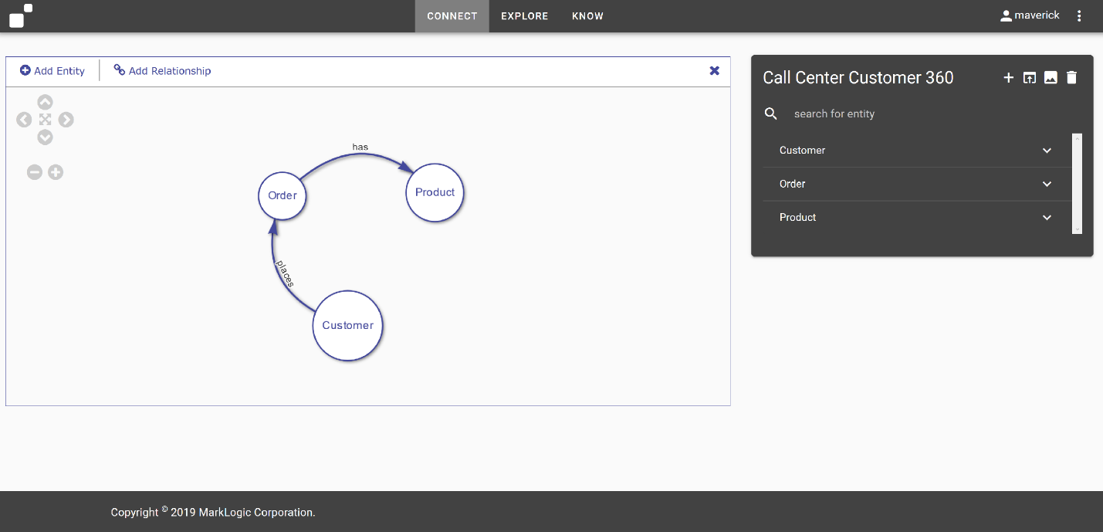

MarkLogic allows us to create a data model, decoupled from the underlying sources, and that’s what we’re going to do here. The conceptual model we create will be persisted in the database and drive our requirements for data integration and delivery.

It’s an incremental approach to data integration. So we start with the minimal set of entities and attributes we want to connect to create our model. We can always come back and add more to the model and more data to our integration. That’s the beauty of it.

By default, we pre-load a few models for use based on familiar use cases we’ve seen over the years. The first available model is loaded for display. We’re going to come back to this. But for now, let’s start with a blank canvas so we can see what creating a model looks like.

* Action: Click the ‘+’ sign in the upper right hand corner

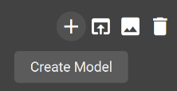

* Action: Enter ‘Customer 360’ as the Model Name

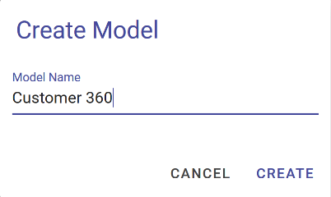

* Action: Click CREATE

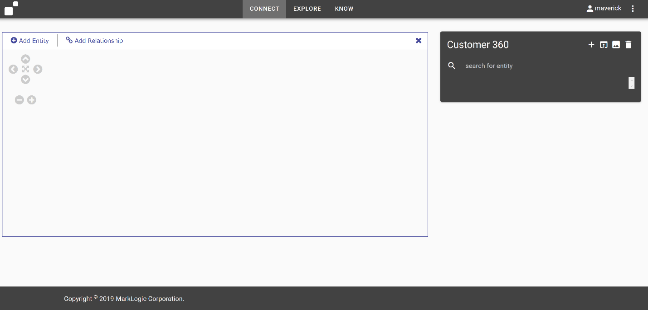

This is our canvas. Everyone understands a whiteboard or a back of the napkin diagram. In this application we simply add circles for entities and drag lines between entities for relationships to define our model for the data. In this way, we create our model. This helps us to understand our business while capturing our requirements for how we wish to express and work with our data in a unified view. In the upper right we see the name of the model we’re working on: ‘Customer 360’.

Now, we’ve been told for this Customer 360 solution we have Customers and those customers place Orders and those orders contain Products. So let’s go ahead and create those entities and relationships.

* Action: Click ‘Add Entity’ in the upper left of the graph canvas
* Action: Click somewhere on the graph canvas

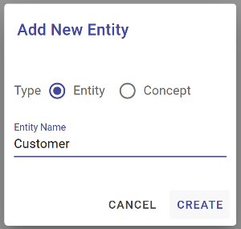

We simply add the name of our new entity when prompted.

* Action: Enter Entity Name: Customer
* Action: Click ‘Create’ to create the Customer entity

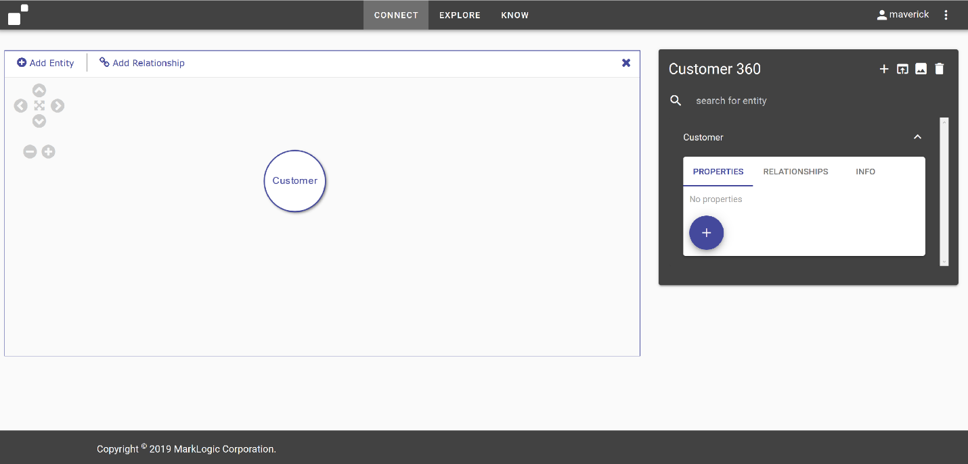

We now see our Customer entity has been added to the canvas. On the right we also see our entity listed along with the ability to define the properties we care about capturing in our unified view for this particular entity. We’ll come back to that later.

Let’s add our Order entity similar to how we did our Customer.

* Action: Repeat steps above taken for ‘Customer’ entity to add ‘Order’ entity.

Next, you’ve informed us that Customers ‘place’ Orders, so let’s just add that relationship.

* Action: Click ‘Add Relationship’
* Action: Mouse down on ‘Customer’ entity
* Action: Drag Relationship from ‘Customer’ entity to ‘Order’ entity
* Action: Release mouse button on ‘Order’ entity

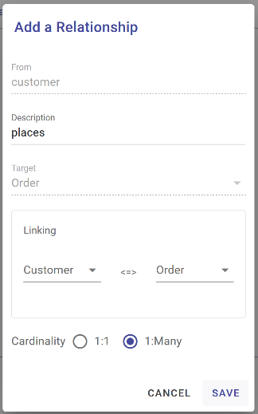

* Action: Enter ‘places’ in the Description field to name the relationship
* Action: Select 1:Many
* Action: Click ‘Save’ to save the relationship

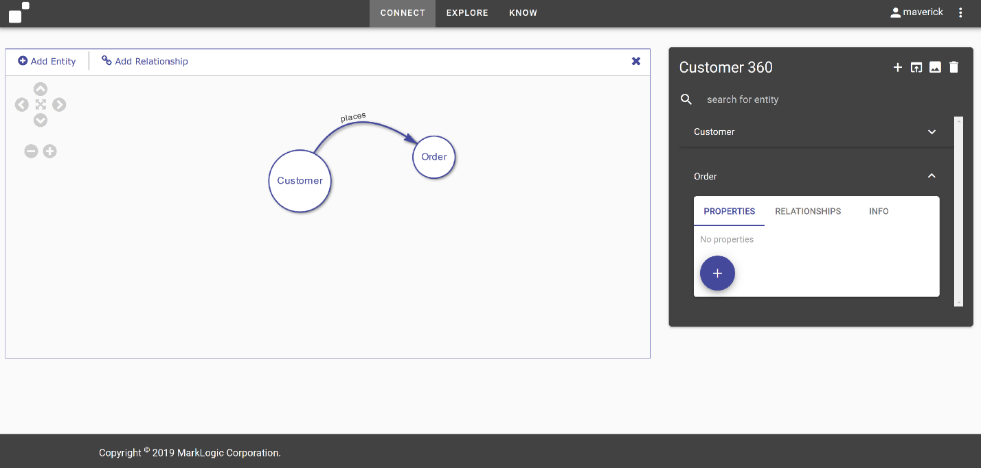

Creating our model can be as simple as drawing circles and lines. We simply label them with nouns and verbs.

* *Optional Actions:* 
  + *Add ‘Product’ entity*
  + *Add ‘contains’ relationship between ‘Order’ and ‘Product’*

For our Customer, we can also define the properties we want to be able to query in the unified view of our data.

In MarkLogic, we model what we need, as we need it. This Concept Connector allows us to quickly capture the key attributes we need to answer the immediate business problem. We can always come back and append and enrich our model later.

* Action: Click the’+’ button on the Properties tab for the Customer entity.

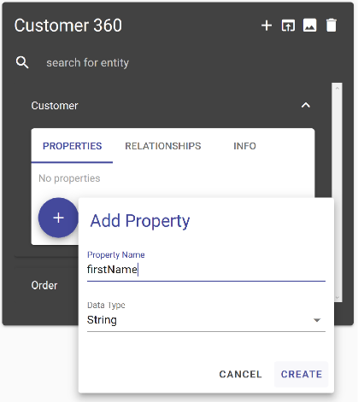

* Action: Enter ‘firstName’ for the property Name
* Action: Click ‘CREATE’

We see firstName added to the Properties definitions for our Customer entity.

We can of course add other things like lastName, and id, and maybe there’s some key attribute like loyaltyCardHolder that’s a Boolean. We can select the data type while defining the properties as either Boolean, String, Integer, Decimal, or Date.

* Action: Enter ‘preferred’ for a property name.
* Action: Display drop down of available types

As we’re doing this, our model is being saved to the MarkLogic Data Hub using its Entity Services. MarkLogic provides a model driven approach to data integration. But these models aren’t like relational models set in concrete. They inform the shape the shape and characteristics of our data like security, while allowing the data that doesn’t fit the model to still exist as-is in the system and remain available for search and query and future curation.

But I’m not going to make you sit through creating everything here. We’ve already started a model for us. So we’ll just open that up and continue from there.

* Action: Click the ‘load model’ icon in the upper right hand corner

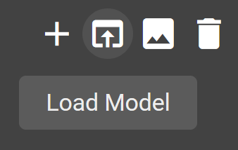

* Action: Select ‘Call Center Customer 360’ from the ‘Pick a Model’ dropdown menu.

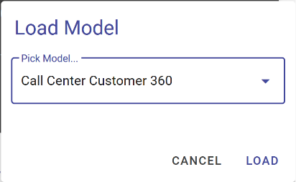

* Action: Click ‘LOAD’

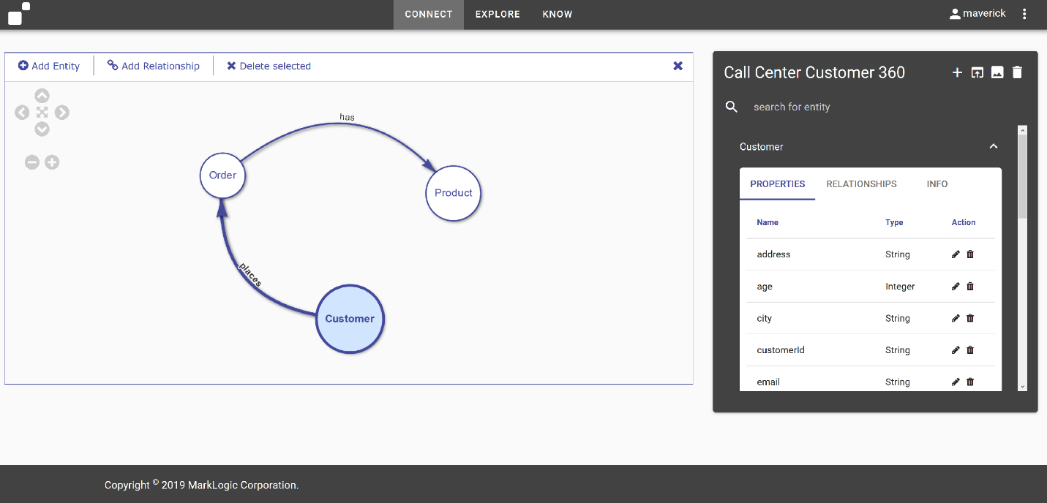

When you look at the business problem on the canvas, it appears to be really simple. We’ve got Customers, they place Orders, and those orders contain Products. With a handful of attributes from each, we can provide a Call Center Rep a single pane of glass to better serve our customers and meet our business objective of getting call center times down.

The real challenge is the fact that we have multiple silos of data for the customers, the orders, and the products. But MarkLogic allows us to simply map our sources to the model to create our unified view of data and we’ll look at that next.

And that’s it, we now have our model for how we wish to express our data to meet our Call Center Customer 360 business requirement. You can click around the entities and relationships to inspect their properties.

* Action: Click different entities. Show and call out some of the properties.

When we loaded our saved model, it was actually persisted in the data hub as MarkLogic Entity Services. Again, Entity Services provides the backbone for how we drive data integration in MarkLogic.

And we can always come back and update a model with new attributes and relationships and even more entities. What’s really interesting is since our model is decoupled from the actual sources and we can pour data into it incrementally, we can actually be aspirational in our modeling.

*OPTIONAL: We’ve seen this type of whiteboard modeling be very useful for bridging the gap between business and IT. Let’s say Business wants to add a Carrier entity to the model with a relationship to the Products (Carrier ships Products). A stakeholder in the room may correctly point out: “We don’t have that data”. And you may not, yet, but you’ve captured something important to the business. A business stakeholder may inform us that they have a plan to acquire the data because if they better understood which products were shipped via which carriers they’d be better equipped at negotiation time to leverage their insights to get the company better shipping rates in the coming year. With this simple discussion and addition to the model, IT now has some insight into what types of data Business wants import in the future and why and now can prepare for it and look for opportunities to supply it and populate it in the data hub in the future. There’s no harm in capturing additional requirements in the model now.*

*OPTIONAL: After we create our model, we can export an image of the model to share with our colleagues as well.*

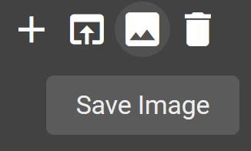

The next step is to map sources to our model. And for that we’ll go to our mapping and mastering component in the Integrate tab.

# 2. Integrate - Load As-Is

In the MarkLogic Data Hub we create flows for ingesting and curating data. A flow can contain multiple steps and these steps can be for ingest, mapping, mastering, and custom operations on our data.

What you see here listed on the left are 3 flows that we’ve created for 2 different brands we’re integrating as part of our Customer 360 Call Center solution.

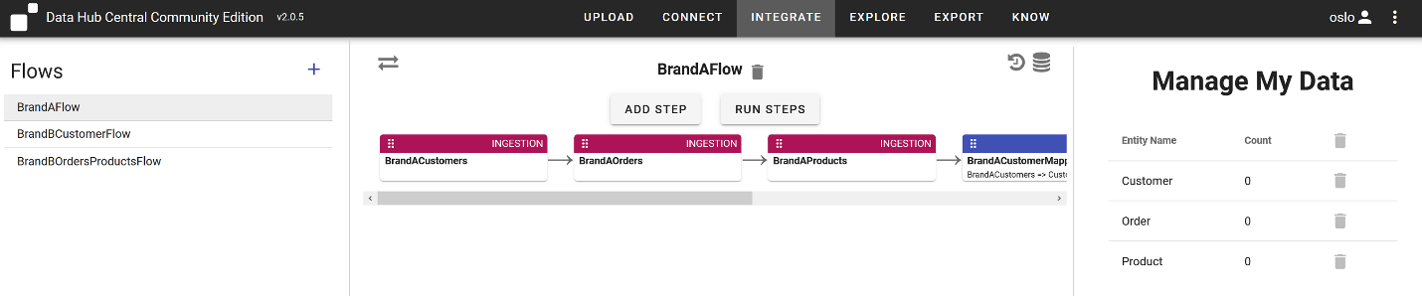

Let’s take a closer look at our BrandAFlow.

For our Brand A Customers, we’ve defined a single flow with 3 ingestion steps and 3 mapping steps.

*Note: Data Hub Community Edition does not allow you to create Ingestion steps. You can create them using QuickStart though and DHCCE can then use them. This is what we’ve done here.*

*Note: DHCCE provides an Upload tab, which allows you to load your data through drag and drop. Your flows can then start with a mapping step and don’t require an ingest step.*

The ingestion steps are where we load as-is. So let’s take a closer look at these.

There are three here, one for each source of Customer, Product, and Order data.

Let’s open the BrandACustomers step by clicking on it and take a look. Here we see the location of our data to be loaded. Remember to update this accordingly if your data is in a different location.

Feel free to inspect the data and you’ll see for Customers the majority of these are .csv files.

We load the raw data by running the ingestion steps and we have our data in our hub.

* Action: With BrandAFlow selected, Click Run Steps
* Action: Select the checkboxes for the ingest steps
* Action: Click Run to run the ingest steps for BrandACustomers

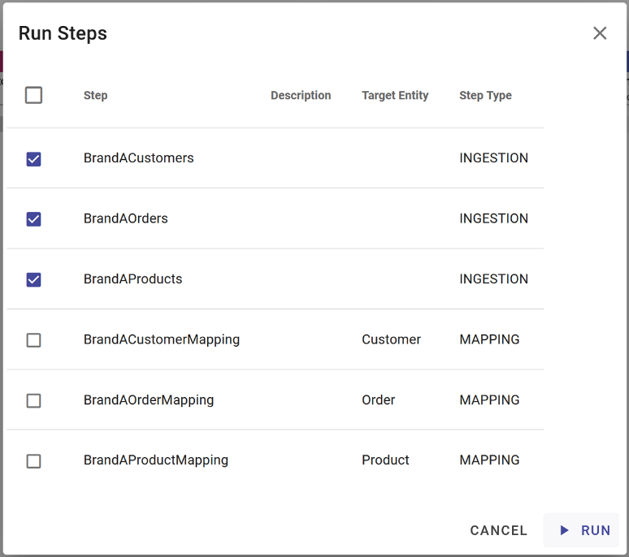

# 3. Explore Immediately

The next step is to map the raw data sources we loaded to our model. For that, we create mapping steps. But we don’t have to do any mapping to start getting insights into our data!

When we load data into MarkLogic, all text and structure was indexed for us. We can immediately start to explore this data from the Explore tab.

The Explore tab defaults to the Final database. In a data hub, data is first loaded to a staging database for curation. After harmonization, data will be available in the final database.

* Action: In the upper right select “Staging” from the Database dropdown menu

On the left we see the collection names for the sets of data we’ve ingested for our flow along with counts for how many records of each have been loaded. The default collection names come from the names of our ingestion steps.

On the right we see a list of the records, identified by their identifier in MarkLogic, along with a snippet of text and some metadata for each.

Now we can start to do some discovery and look at what we have in the hub so far that has to do with engineering.

* Action: Search on ‘sashenka’

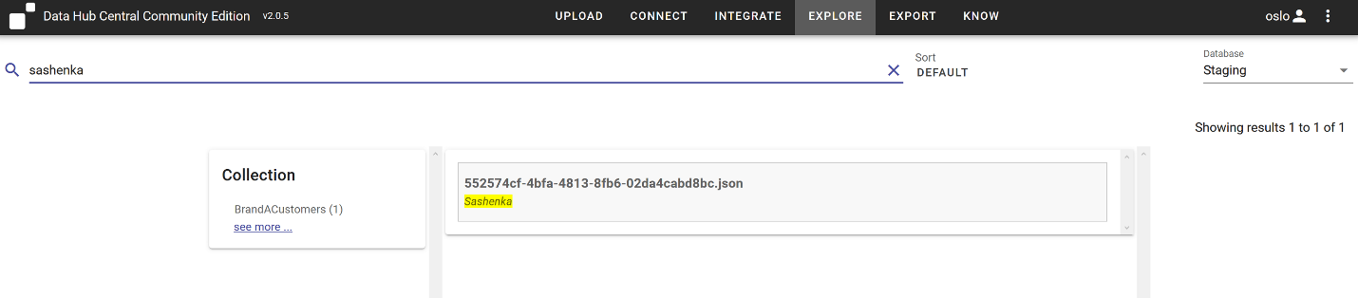

This can be very useful for validation, and getting answers immediately before we’ve mapped anything to the entities we’ve defined. Here we see a single Customer record.

If we click on the record identifier, we can even explore the shape of the data, which can be useful for informing how we map and model data.

* Action: Click on the record displaying text snippet “Sashenka”

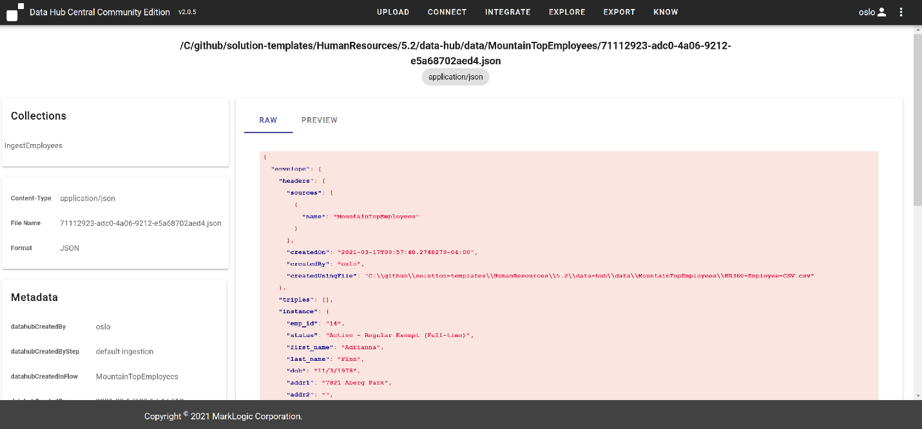

On the right, we see a raw document preview for one of the Customer records we’ve selected. This is how MarkLogic stores the document internally. To the left of the document we see all metadata associated with this record. At the top, the gobbledygook string ending in .json is the name of the record in MarkLogic.

So with MarkLogic’s powerful indexing, we can start to search and query our data as is, but we know we’ll want a common vocabulary across these unstructured , disparate sources to enable structured queries and search so let’s go clean this raw data up by mapping it to our Connect model.

# 4. Integrate - Mapping

When we create a mapping step, we get to choose our source data and the entity we want to map it to.

When we loaded our data, it was actually loaded into collections named after the ingestion step. So we just define our Source as the IngestEmployees collection and choose Employee as our target entity.

You can add mapping steps by clicking Add Steps and selecting the mapping option. For us though, let’s examine what we’ve already created.

* Action: Select the BrandAFlow flow
* Action: Select the BrandACustomerMapping step
* Action: Click the cog icon to edit the step configuration. This displays the following

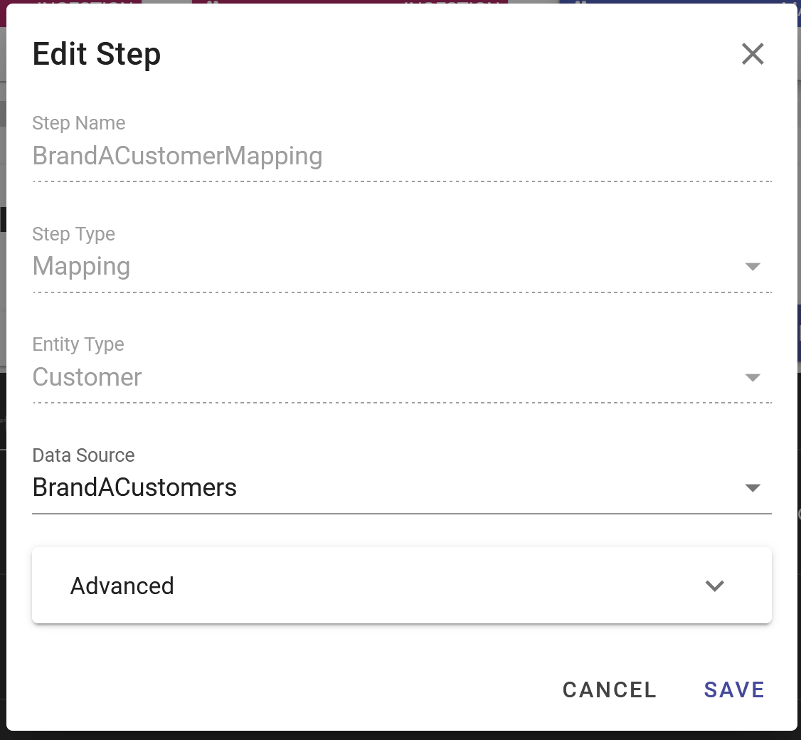

* Action: Click Cancel

In DHCCE we just map our source properties from the raw records to our target properties we’ve defined on our Connect model to create our mapping.

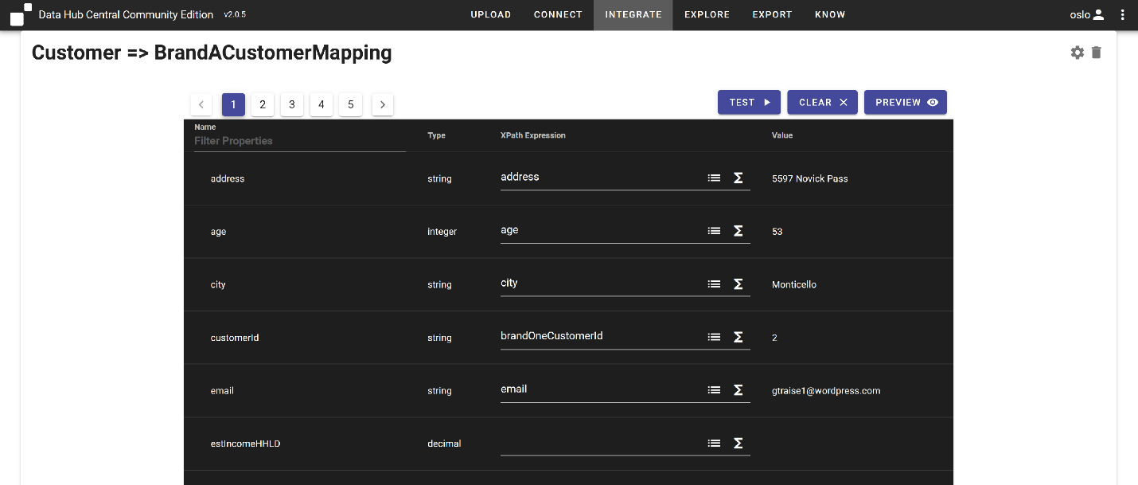

On the left we see the target properties for our Connect model as defined on our Customer entity. On the right we see fields where we’ve created our mappings. When we select the dropdown on the left of the f(x) for the target entity, we see the attributes available for mapping from our source data. When we select one, we’ll be provided a preview of that data for a randomly selected record. It’s easy for MarkLogic to provide this as all text and structure of records was indexed during ingest.

Mapping is where overcome the headache of firstName being fName in one system, givenNameOne in another, etc. We see here that we’ve mapped emp_id to employeeId.

The f(x) allows us to leverage the Data Hub’s built in functions to help cleanse and rationalize our data.

You notice that not all values are mapped. That’s ok. The target properties can get populated from a different source later. We’re mapping what we have available now to answer the business problem in front of us.

And after our mapping is we created, we just run the mapping step to harmonize our data. We created 5 mappings, one for each of our entity types and data sources.

* Action: Run the mapping steps for BrandAFlow

As data is mapped from source to model and harmonized, entity instances are created in the final database. We can see their counts in the “Manage My Data” pane on the right.

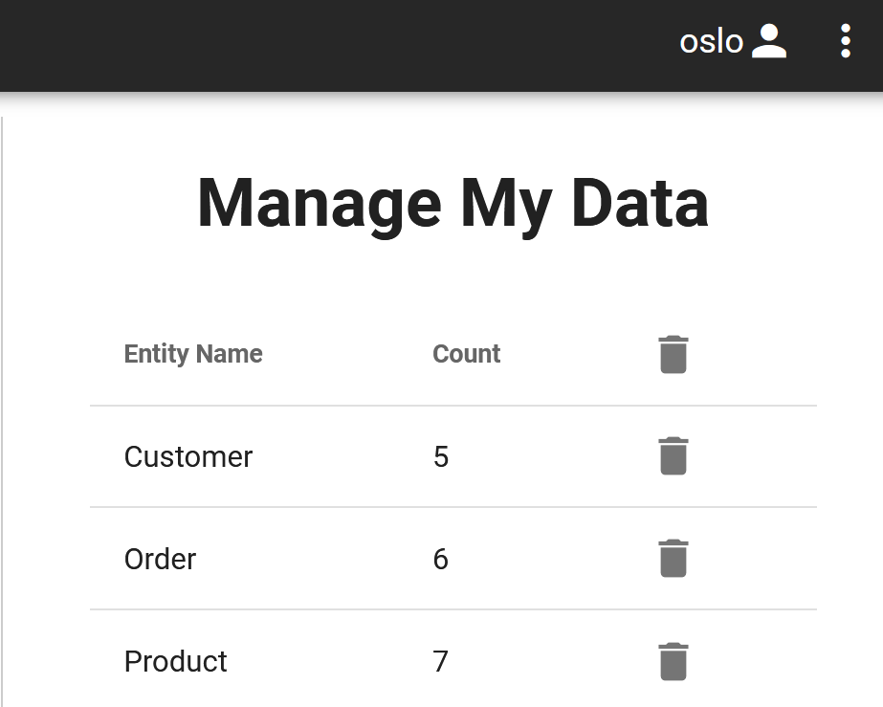

And that’s it. We can now take a look at our data in a unified view. For that, we’ll take a look at Explore again.

# 5. Explore

Now that we’ve harmonized our data, we can examine it in a unified view. Just that simple.

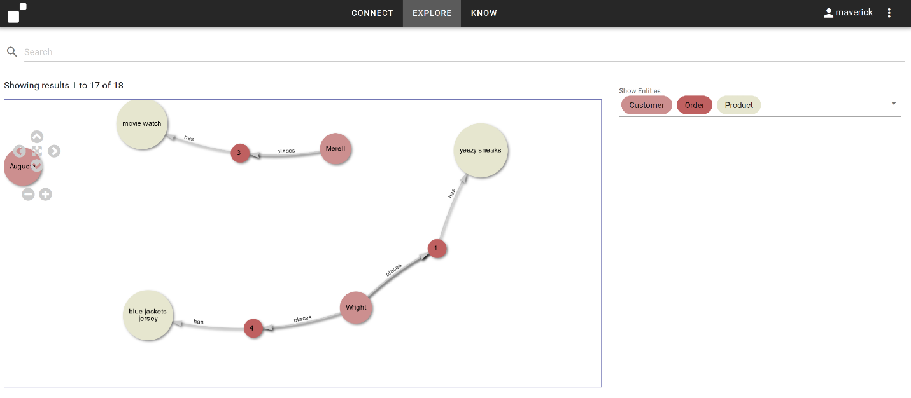

Recall, we had 3 sources of data we harmonized. And now we look at our populated model, and we can see that our data looks very much like our model. The conceptual and physical representations of data in MarkLogic are closely aligned, which makes it a lot simple for people to understand and interact with their data.

And we haven’t really done in any integration yet. We’ll revisit this after we load our Brand B customers. But this is to show you we already have a way to interact and get value of this data while we continue to enrich and append to it.

If we click on any entity, we can see the data that was populated from the source.

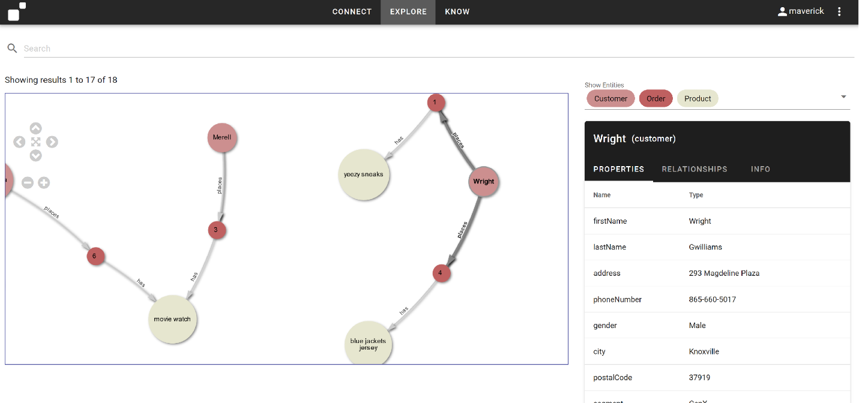

*OPTIONAL: The labels on the nodes are currently showing firstName for Customer, name for Product, and shipDate for Orders. You can actually configure the labels for these nodes in the Connect info tab.*

Let’s think about our Call Center scenario. We get a call from Gael Traise. Since MarkLogic indexes all text and structure on index, we can simple search on the last name to find our customer.

* Action: search on ‘traise’ You may have to scroll down in viewer to display entity
* Action: Click on Gael entity to display properties

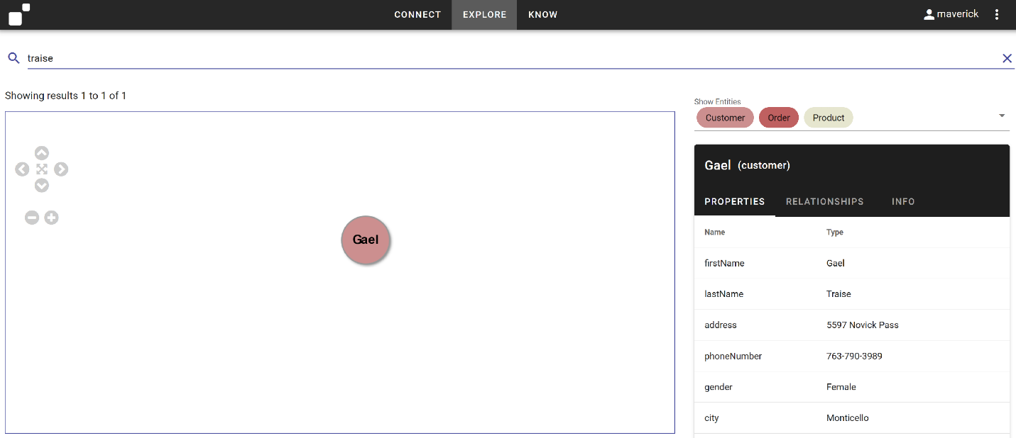

We can click on the Relationships tab to see what relationships Gael has to other entities.

* Action: Click on RELATIONSHIPS tab to display relationships

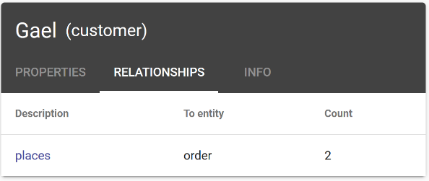

We see we currently have 2 orders associated with Gael. We can just click the ‘places’ description to expand these relationships in the graph.

* Action: Click ‘places’ relationship to expand in graph view

We can similarly inspect the associated Order relationships tab to expand those relationships as well.

* Action: Expand relationships for Gael’s Orders
  + *OPTIONAL: Expand relationships by right-clicking on Order entities in graph view*

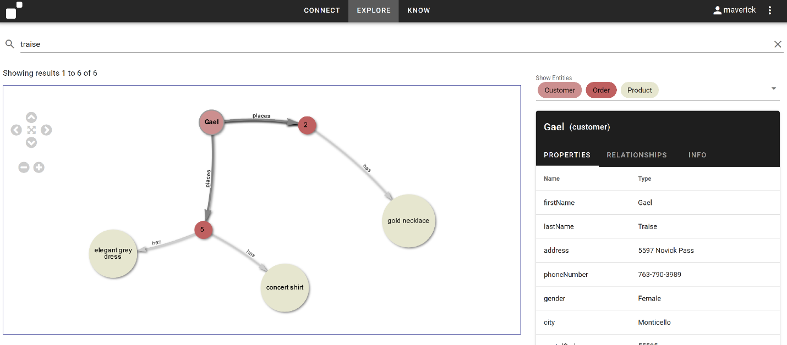

* Action: Select Gael entity
* Click on ‘Properties’ tab

Gael is calling about the Gold Necklace she ordered.

* Action: Click ‘Order’ entity associated with ‘Gold Necklace’

We can tell her with confidence it appears it shipped on March 6th, so please wait a couple of more days for delivery.

This will get more interesting when we have data from more brands in here. But we’re already getting use out of this data.

* Action: Clear the Search to reset the default display of data
* Action: Select the Customer facet on the left to focus on Customer entities
* Action: Expand the relationships for Customers ‘Sashenka’ and ‘Merrell’.

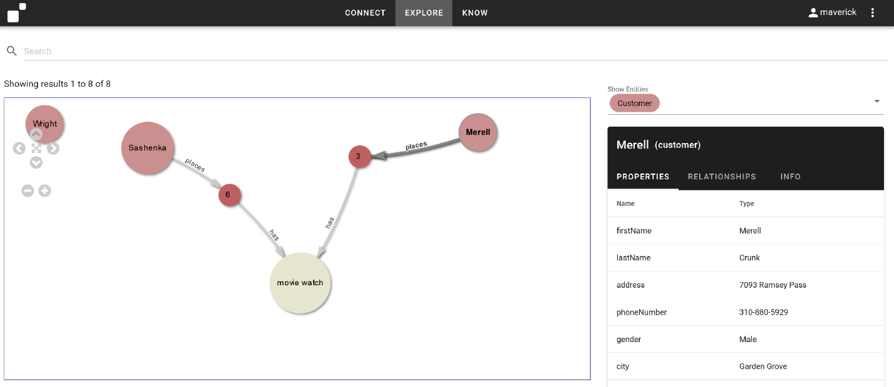

We can easily see that Customer entities Sashenka and Merrell both have a relationship to the movie watch Product.

#### Knowledge Graphs created by Default

These are two customers that may not know each other at all in real life. But they share a relationship based on their purchases. Relationships are a first class citizen in MarkLogic and a graph of integrated entities and relationships is created by default when we integrate data in the data hub. Illuminating these relationships enhances our understanding of our Customers and their demographics, providing the opportunity for us to meet the requirements for graph use cases such as recommendation engines, product recommendation systems, asset management, social network graphs, knowledge graphs, and fraud detection and analysis solutions. With a greater understanding of Sashenka and Merrell’s connections to other Customers, Orders, and Products we can start to create future opportunities in our Customer Call Center 360 solution for recommendations and upselling during the minutes that were previously wasted hunting through silos just to match a single customer with the right order.

*Note: A deeper demonstration of graph capabilities is available at #7,* ***More on Knowledge Graphs****, below.*

#### Governed by Default

We saw that when we loaded data into MarkLogic we ingested information with security applied automatically on ingest.

Another requirement for governance is understanding, where did this data come from?

By default, the MarkLogic tracks where information comes from to provide provenance and lineage on data out of the box.

* Action: Select ‘Merrel’ customer.
* Action: Click ‘INFO’ tab

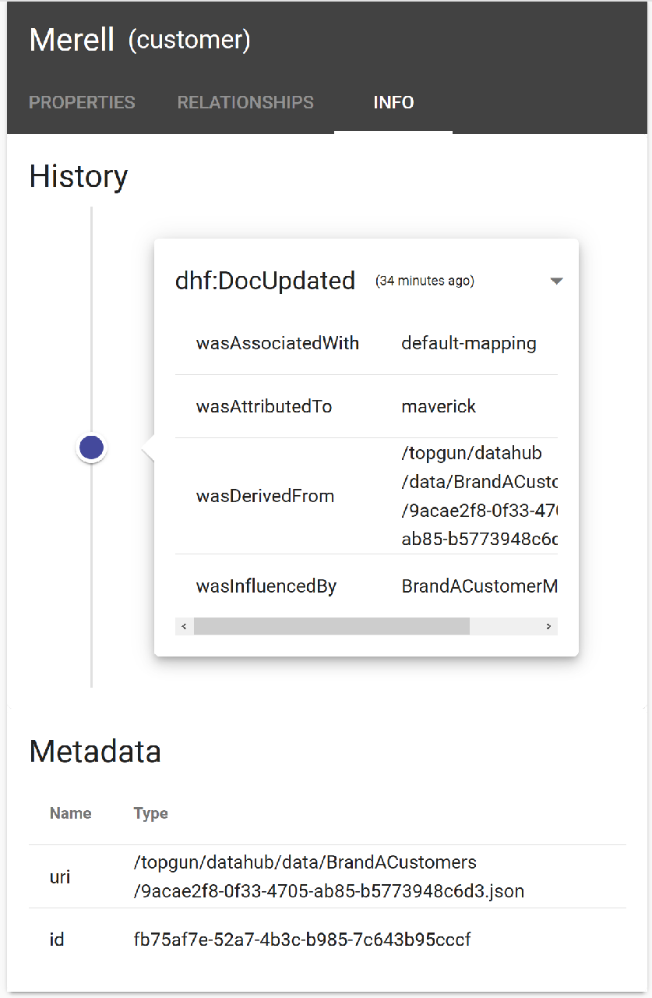

We see an event history of the entity with the latest action applied to the entity at the top of the list. We can click on any event to expand its detail and see just where the source data from the entity came from and came to be.

* Action: Click event dropdown to expand its detail

By default information is saved about where this entity came from, what was the last flow step applied, and who was the user that applied it.

But this isn’t the end of the story. We have more data to load. We want to incrementally and iteratively enrich and append the data in the hub. So let’s continue by integrating the data for our second brand in the call center.

# 6. Integrate – Mastering

We see that there are 3 flows defined in our data hub

BrandAFlow brought in data from Brand A and we just explored the data in Explore. Now we’re going to bring in the data for Brand B. However, some of the customers that exist in A also exist in B. We’re going to want to merge similar Customers for entity disambiguation and to eliminate duplicates. For that we’re going to look at Smart Mastering in the Data Hub. Let’s take a look at the BrandBCustomer flow.

The first two steps of the flow look similar to our customer data for BrandAFlow. We have an ingest step and a mapping step for our Brand B data. We’ll just run those

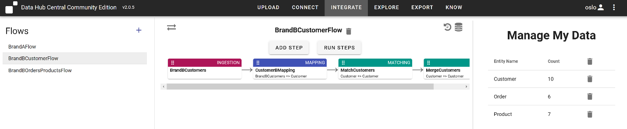

* Action: Explore the BrandBCustomers step ingest configuration.
* Action: Explore the BrandBCustomers step mapping configuration.
  + We see we’re getting some similar, and some different attributes for this data. And some column names are different. But we’re mapping them to the entity model we created at the start. Here we use the memory-lookup() function as well.
* Action: Run the ingestion and mapping steps for BrandBCustomer flow.

Before we run the mastering steps, let’s look at our Customer “sashenka” and her properties in the Explore tab.

* Action: Search on ‘sashenka, expand relationships, and select the Customer entity with no relationships.

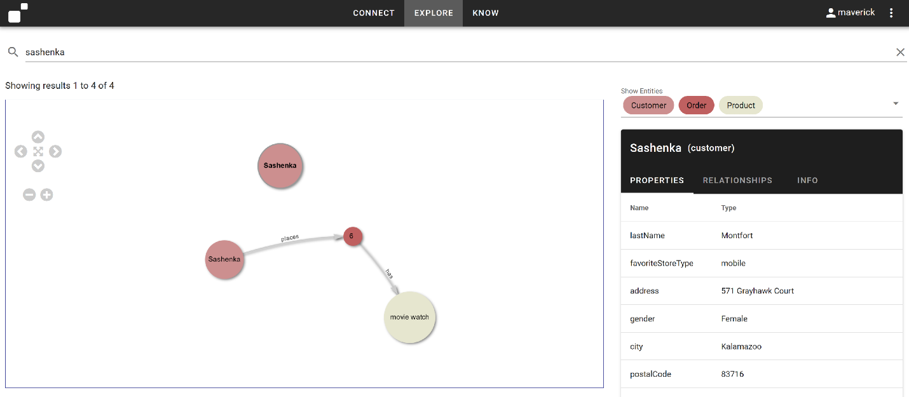

We see there are two of her in there now. Previously there was just one. This is where smart mastering helps us.

The business is expecting duplicate Customers and has informed us that if the first name, last name, and phone number of a Customer is the same across Brands, we know they’re the same Customer. We can use MarkLogic’s Smart Mastering steps in the BrandBCustomers flow to master our Customers from both BrandA and BrandB. Mastering in the data hub requires two steps: a Match step for finding matching records and a Merge step, for defining additional rules for how to cleans and rationalize data when similar entities are merged.

* Action: Select MatchCustomersStep Step

This step will master Customers using this Match configuration:

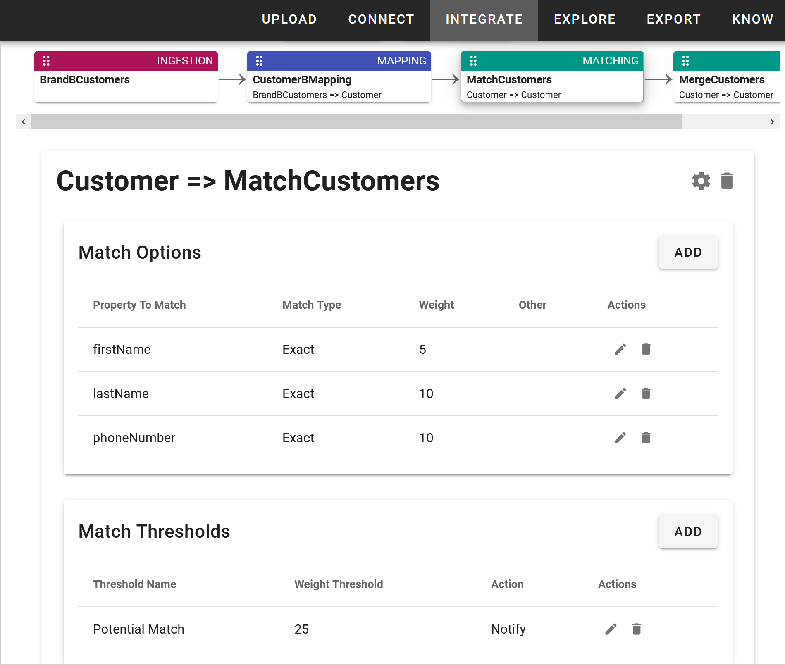

In the matching options, we define the criteria for a match. Here we’re just using exact values, but MarkLogic Smart Mastering provides all sorts of capabilities for us to disambiguate entities using built-in algorithms or even letting you define your own custom rules.

We defined the attributes to inspect, and associate a weight with each. We then set a threshold weight and an action. If the sum of the values for matches reaches the threshold, the action will be taken upon similar entities. Here we’ve defined a notify action. If we choose the merge action, then similar entities will automatically be merged for us. But often we require Human in the Loop (HITL) curation. So with notify, we’ll be able to use DHCCE’s Mastering workspace to review similar records and then decide if we want to merge them or not.

The capabilities for entity disambiguation come out of the box with MarkLogic Smart Mastering. But what do we do if we have a match? Let’s look at the Merge step configuration.

* Action: Select MergeCustomers step

With the merge options we can configure how two or more records in the data would be merged together. A new record is created with the combined contents of the original records, according to the merging rules you create. The original records stay in the database and are tagged as archived. We’re just using the default merge options here. So we’ll see what this looks in the data after mastering.

Let’s run our mastering steps

* Action: Run the BrandBCusstomers flow Match and Merge steps
* Action: Go to the Explore pane and take a look at Sashenka to see she is still in 2 separate entities

After running, in the upper right we receive a notification we have 2 possible matches to review.

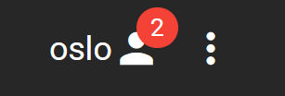

* Action: Click the 3 dots and select “Notifications’ from the dropdown menu

Here is our notification inbox. We see 2 matches.

* Action: Click the Potential Match labeled Sashenka to review her matches.

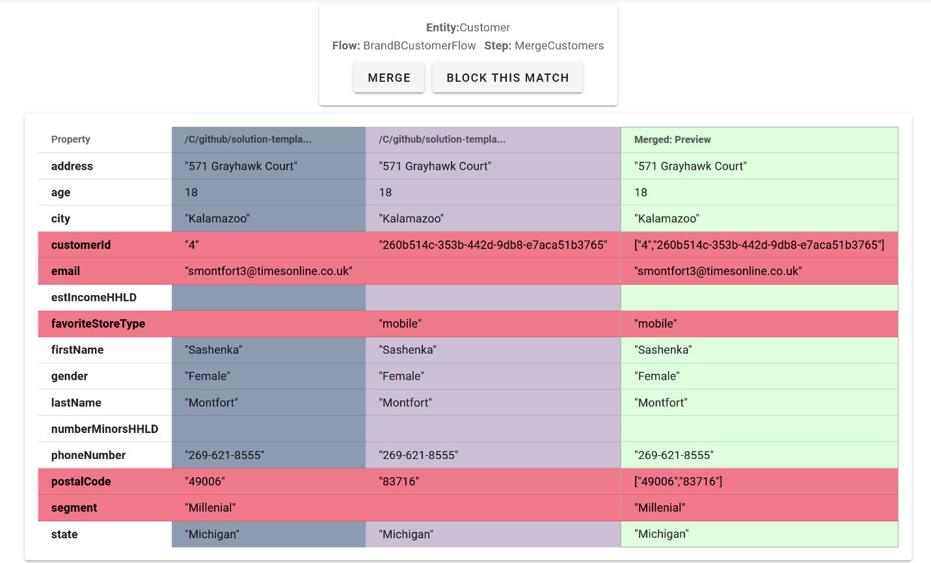

Starting from the left, we see the records that matched for Sashenka given our mastering rules. On the far right, we see a merged preview of what her entity record will look like if we merge the similar entities.

* Action: Click the merge button

If we select “Block” then merging will be blocked for subsequent of any mastering flows where these records match the match criteria.

Also, while Sashenka only has 2 matching records in this case, it’s not uncommon to have several records for a single potential match.

* Action: Goto Explore and Refresh search page for Sashenka

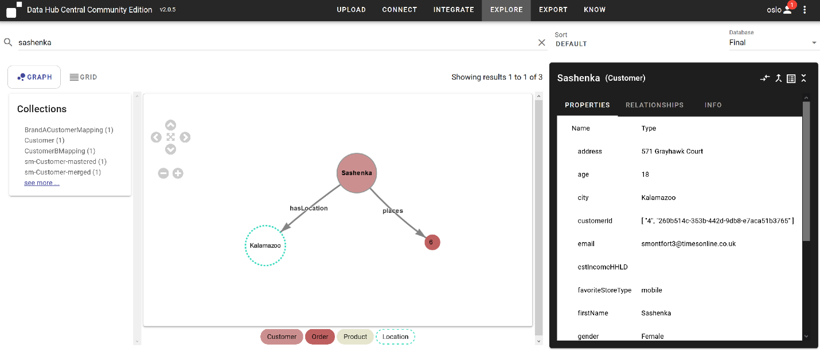

We see we now have a single Sashenka Customer entity, that’s been merged from 2 disparate Customer records coming from 2 different systems. Her entity information now contains lists of information for some property values (like customer id). This is the default merge behavior of Smart Mastering. The merge options can be used to set rules as to what’s ultimately stored here. But the arrays of information can now be used as keys to join with Orders and Produsts as well. We also see we have the ability to ‘unmerge’ entities. We’ll revisit this in a moment.

Let’s finish loading our second brand. We’ll add Brand B Orders and Products using the 3rd, CoastalEmployees flow.

This flow just has 2 ingest steps and 2 mapping steps to map the order source data to our Order entity and the product source data to the Product entity.

* Action: run the BrandBOrdersProductsFlow in Integrate.

Let’s look at Sashenka one last time.

* Action: search on ‘sashenka
* Action: Expand all relationships

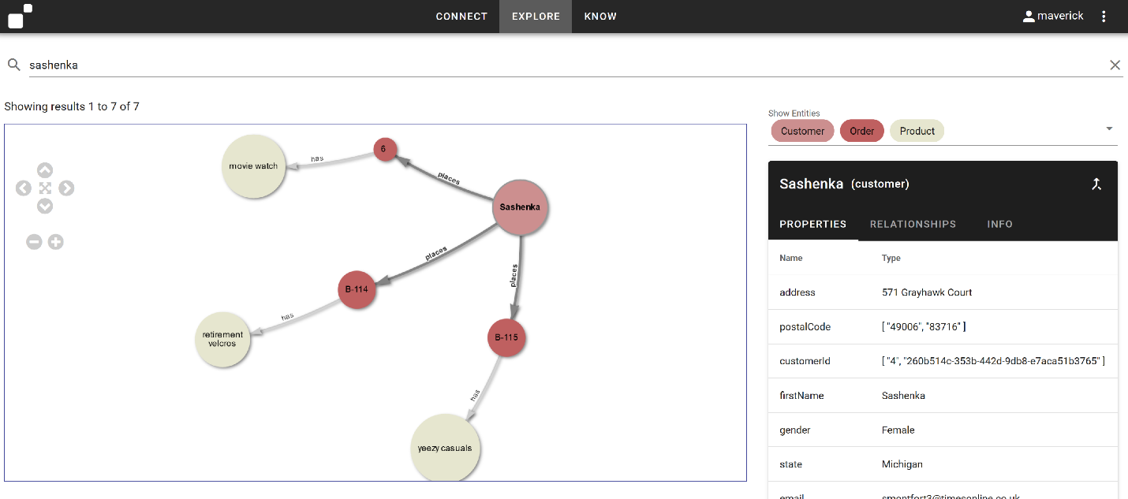

We see the single Sashenka entity now references orders from both Brand A and Brand B. The Call Center rep can easily identify order types by the order id label on the order entities and select the appropriate order to confirm its status for the customer. We’ve provided a solution for the business problem while demonstrating how we iteratively and incrementally integrate data in the MarkLogic Data Hub.

Finally. Let’s say upon further inspection, the business decides that these Sashenka’s are actually separate entities. Well, we can just unmerge them.

* Action: Click Unmerge for ‘Sashenka’ entity

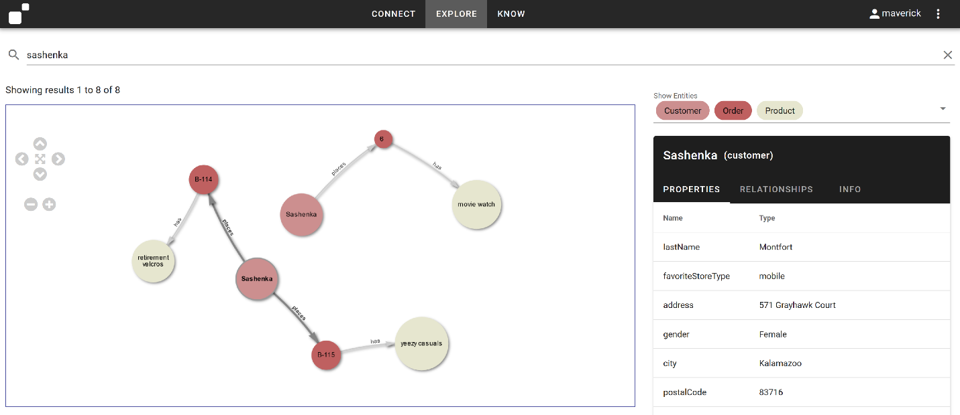

And as we can see. The relevant relationships are maintained and the data remains usable, and now more accurate that the business has validated the properties of this entity. So it’s very easy to merge, unmerge, and connect data in the data hub.

And the MarkLogic Data Hub can integrate data like this ALL DAY LONG. Now we just add our other 4 brands and as we continue to add brands, our call center rep has a richer and more usable lens on the data they require to best serve their customers and the business.

# 7. More on Knowledge Graphs

#### **OPTIONAL:** Expressing Concepts in our Model to Analyze New Relationships, Enrich our Graph, and Connect with Linked Open Data in the Data Hub

With MarkLogic, it’s simple to add new relationships between entities to explore and analyze new connections between entities as well as to enable them to connect to a larger graph of data stored in MarkLogic. With our Connect whiteboard model, we can illustrate what this looks like in action.

In Connect, we can create a special type of Entity, we refer to here as a Concept that will project the values for our property as nodes in the graph.

Let’s add a Concept, Category, which will create Category nodes for our graph based on values for the category property we defined in our Product entity.

* Action: Click ‘Connect’ tab
* Action: Click ‘Add Entity’
* Action: Click the ‘Concept’ radio button
* Action: Enter the name ‘Category’ for our new Concept

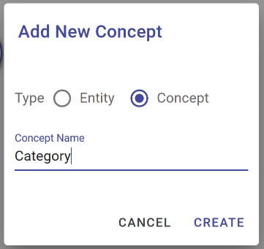

* Action: Click ‘CREATE’

We see special type of Entity added to our canvas. Solid line circles are Entities. Dashed circles are Concepts.

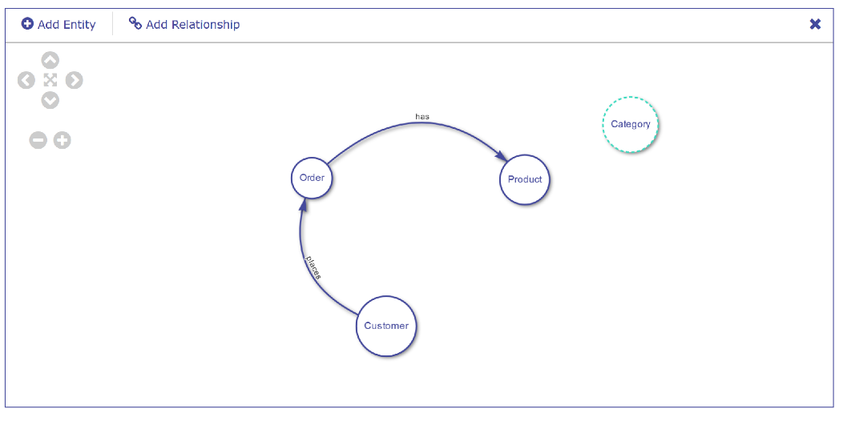

* Action: Click ‘Add Relationship’
* Drag the relationship from Product to Category

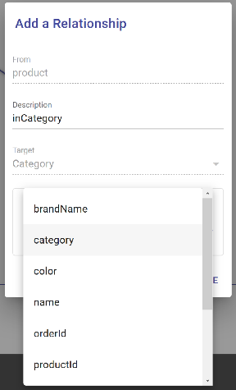

* Action: Enter ‘inCategory’ for Description of the relationship name.
* Action: Select the category property from the list of Product properties available for the Target in the relationship
* Click ‘SAVE’

We now see our Category concept related to Product define on the canvas.

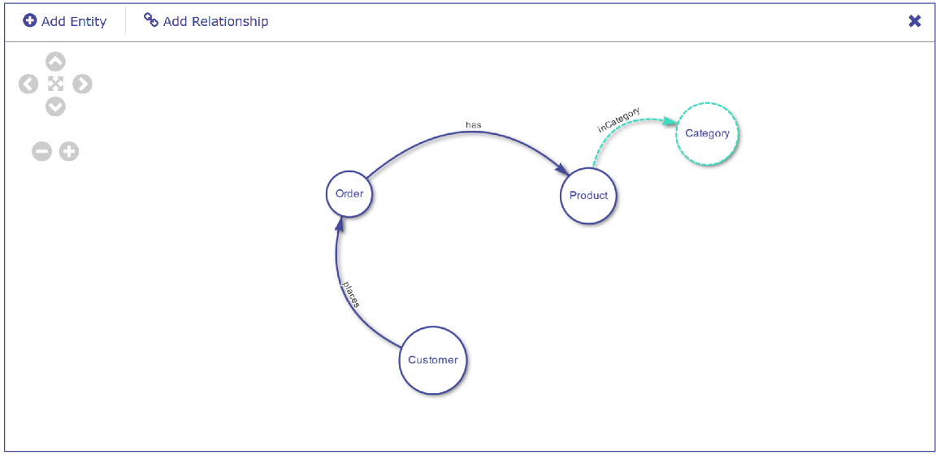

Let’s now go look at the Explore tab.

* Action: Click the ‘EXPLORE’ tab

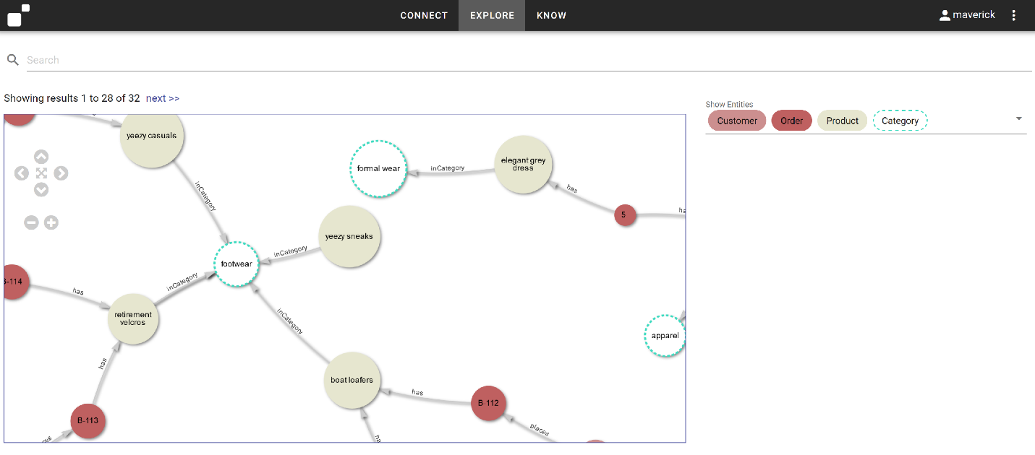

We now see our entities connected by the concepts we’ve expressed through our model. The values for the Product.category property are projected as Concepts and allows us to visualize the relationships between entities based on these values.

In addition to connecting the existing data, we can leverage these concepts to connect our integrated data with other ontologies and linked open data we’ve loaded into the hub to allow us a richer view and level of accessibility to our data.

*Note: Connections can only be made from Entity to Concept to express a properties value.* ***Connections can NOT be made from Concept to Concept.*** *That’s the work of an ontology editor. The feature here is to make it so Entity values can be given the ability to plug the harmonized model into a graph*

8. Export

We know that many of our consumers will still want to interact with the data we’ve integrated in the way they’re familiar with. NoSQL in MarkLogic means Not Only SQL. But MarkLogic can definitely do SQL

From the Export tab, we can export .csv files of our harmonized entities and then open these in our BI Tool of choice.

MarkLogic also has connectors for Tableau and PowerBi that can also be used with the following default views created in section 10 below.

# 9. Query Console – SQL Views

When we created our Connect Model, we actually created a tabular view of each entity based on the entities, properties, and relationships defined. This happens by default in MarkLogic for the entities we’ve defined. The data hub allows us to create Employee SQL views using a declarative template as well.

What you’re looking at here is Query Console (Available by default at localhost:8001 ). This is MarkLogic’s query and development environment. Here I select the database for our harmonized data, and just issue a query to show me what we have in the Employee view.

This is the same data we were looking at in the graph view, just in table form. One of the things MarkLogic is REALLY good at is providing different types of lenses on a single set of data so people and applications can consume it in the formats they’re familiar with.

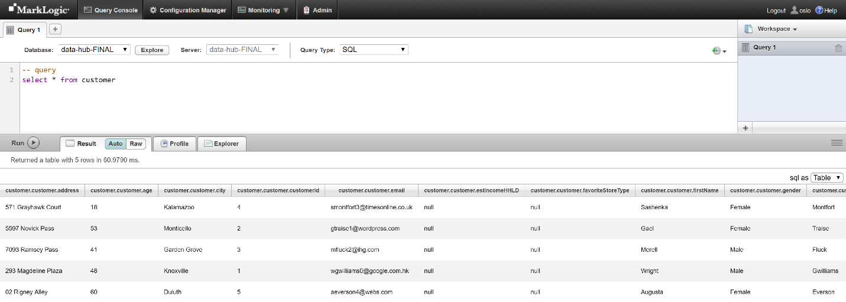

You can also select * from sys_tables; for viewing all the views currently available.

# Conclusion

And that’s what integrating data in MarkLogic looks like in action. When we say Load, Curate, Access, you’ve seen that we don’t necessarily start by loading data first.

1. We start by defining the business problem we want to solve and model our solution as the key business entities and relationships we want to be able to interrogate to provide our answers. We created this model using **Connect**.
2. In the MarkLogic Data Hub we define flows for ingesting data, mapping our sources to our model, and mastering our entities for disambiguation. We can also define custom steps. We used **Integrate** for this.
3. We explored our data and saw it looked exactly like our model using **Explore**. We could search and expand relationships as well as view the provenance and lineage associated with each entity.
4. Throughout this process we saw how we can iteratively and incrementally append and enrich our data in the hub, as well as unmerge mastered entities.
5. And finally, we saw the **MarkLogic Data Hub** provides the ability to easily create multiple lenses on the same set of data so that users can access their data via custom web applications, SQL, or a BI tool such as Power BI or Tableau.

MarkLogic allows you to integrate what you need as you need it and has data in use in ¼ to 1/5 the time of integrating data and delivering results using traditional tools and applications.

We’ve shown you today using this sample data. But we’d like you to experience this with yours. We hope this guide helps accelerate your success!

# APPENDIX

*For Information on how to use Connect and Explore not covered in this walkthrough, please refer to the guides for the individual components on the wiki and on github*