**Write a flow ILP for the Steiner tree problem for the graph (see attached)  
with yellow terminals 1, 3, 5.**

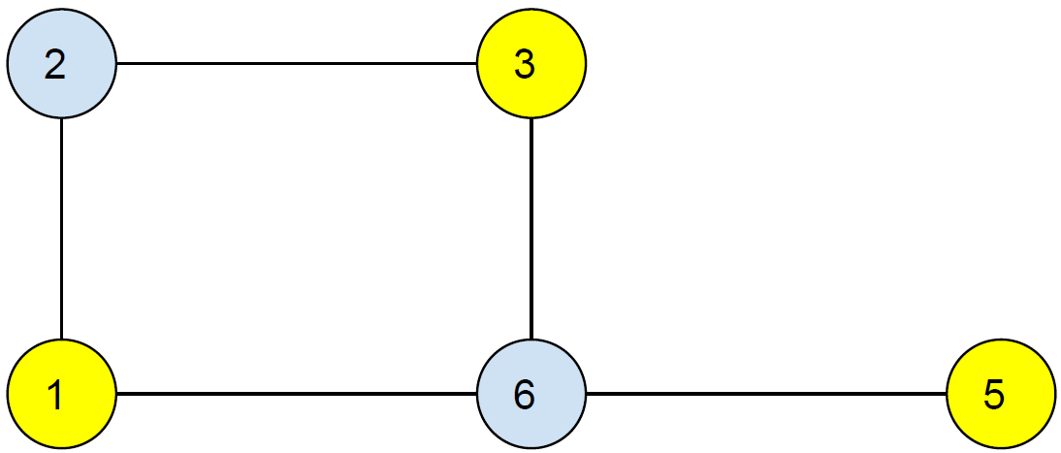

**Solution**:

S = {1, 3, 5}

Xe : whether edge e is chosen or not chosen.

Minimize: ∑e€E ceXe,

∑e€(A, A’) Xe >= 1, for all S separating some (ap, bp) pair.

  Xe >= 0.

Flow: fpq13 >= 0 ∀ (p, q) € E, ∀ R € V

∑ fpr13 = ∑ frq13

**Source**:

1: ∑ fp113 (incoming) = ∑ f1q13 – 1(outgoing)

**Destination**:

3: ∑ fp313 (incoming) = ∑ f3q13 + 1(outgoing)

Therefore,

For vertex1:

X1,2 + X1,6 >= 1 (Separating vertex 1)

X2,3 + X3,6 >= 1 (separating vertex 3)

x56 >= 1 (Separating vertex 5)

Edge between vertices 1,2:

X1,2 >= f1,21,3

X1,2 >= f2,11,3

X1,2 >= f1,21,5

X1,2 >= f2,11,5

Edge between vertices 2,3:

X2,3 >= f2,31,3

X2,3 >= f3,21,3

X2,3 >= f2,31,5

X2,3 >= f3,21,5

Edge between vertices1,6:

X1,6 >= f1,61,3

X1,6 >= f6,11,3

X1,6 >= f1,61,5

X1,6 >= f6,11,5

Edge between vertices 3,6

X3,6 >= f3,61,3

X3,6 >= f6,31,3

X3,6 >= f3,61,5

X3,6 >= f6,31,5

For the edge between 6, 5

X5,6 >= f6,51,5

X5,6 >= f5,61,5