**Data Warehousing & Business Intelligence**

Assignment 2

2022

Submitted By:

Subasinghe S.S.

IT20273712

**Table of Contents**

1. Data Warehouse Introduction

2. Cube Implementation

2.1 Step 1: Creating Data Source

2.2 Step 2: Creating Data Source View

2.3 Step 3: Creating the Cube

2.4 Step 4: Creating Hierarchies

2.5 Step 5: Creating KPIs

2.6 Step 6: Deploying the Cube

3. Demonstration of OLAP Operations

3.1 Connection to the SSAS Cube

3.2 Excel Report for OLAP Operations Demonstrations

3.2.1 Drill down and rollup demonstration

3.2.2 Slice Demonstration

3.2.3 Dice Demonstration

3.2.4 Pivot

4. SQL Server Reporting Service (SSRS) Reports

4.1 Basic steps of Report builder

4.1.1 Step 1: Creating Data source

4.1.2 Step 2: Creating a dataset

4.1.3 Step 3: Creating a Matrix or a Table

4.1.4 Step 4: Report Demonstration

# Data Warehouse Introduction

The data source used here is the ‘**Health Violations’ (HV)** which is the database which was created as the data warehouse earlier. The data warehouse mainly focuses on the violations that happened in restaurants within the range of 2018 to 2020. The original dataset is named as ‘LA RESTAURANTS AND MARKET HEALTH DATA’ which is hosted by the city of Los Angeles

In this Data Warehouse Owner has many facilities and owner is considered as a place where lot of facilities (Target, Subway etc.) are located. These facilities are rated by taking records on Violations and given a score and fine for the relevant facility.

This data source is used for analysis for reporting services and to implement dashboards.

Snowflake schema was used to design the Data warehouse design. There is one fact table as transactions and four dimensions including the Date dimension. Dimensional model of the Data warehouse can be found below

Figure 1 Snowflake Schema

This shows the Dimension tables and the Fact table of the HV_DW data warehouse which is already created.

# Cube Implementation

A multidimensional data cube is a structure that holds data for analysis. Dimensions and measurements are the primary components of a cube. This is mostly made up of two facts:

• Dimensions: Define the cube's structure for slicing and dicing.

• Measures: Provide the end user with aggregated numerical values.

SQL Server Data Tools were used for this procedure.

**Procedure for cube Implementation**

## Step 1: Creating Data Source

The Data source was created by connecting to the ‘**Health Violations’ (HV)** database through SQL server management studio. a new data source was added with a new connection and Service account was used to connect to the SQL Server management studio.

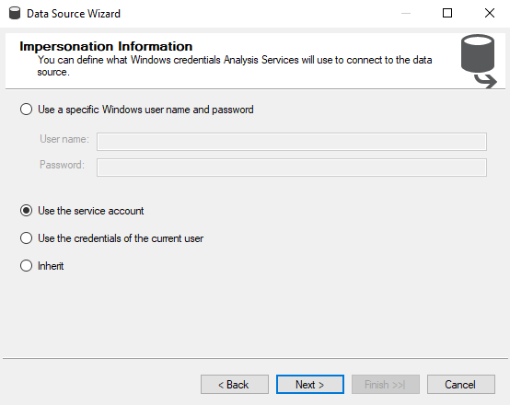

After Configuring the Data Source, the preview will be like this:

## Step 2: Creating Data Source View

Because the analysis service only has access to the relations that are available in this data source view, this step comprises getting the relations and views of our dataset. As a result, the data source view is generated utilizing the data source that was defined in step 1.

After selecting the Data source, we can choose the tables needed in the Data source view

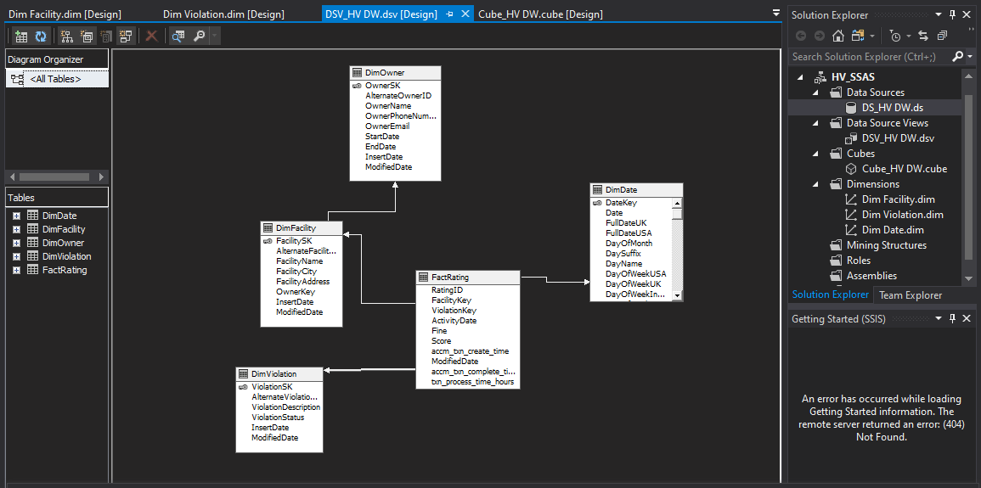Data Source view

## Step 3: Creating the Cube

This step includes creation of the cube using the data source view. When creating the method existing tables option was used , and all the tables were selected as measure groups, FactRating relation can be taken as the fact table as it contains all our measures required for the analysis process.

**Implemented Cube:**

## Step 4: Creating Hierarchies

In SSAS, hierarchies are useful tools for reducing attribute complexity and guiding users down a drill-down path.

In here, two hierarchies are mentioned,

* .Facility Address and Facility City
* Date

## Step 5: Creating KPIs

KPIs are introduced to the database cube in SSAS to analyze business performance as represented in the cube data. A KPI is a collection of computations that is associated with a measure group.

Here, the KPI s created for the Score and the Fine.

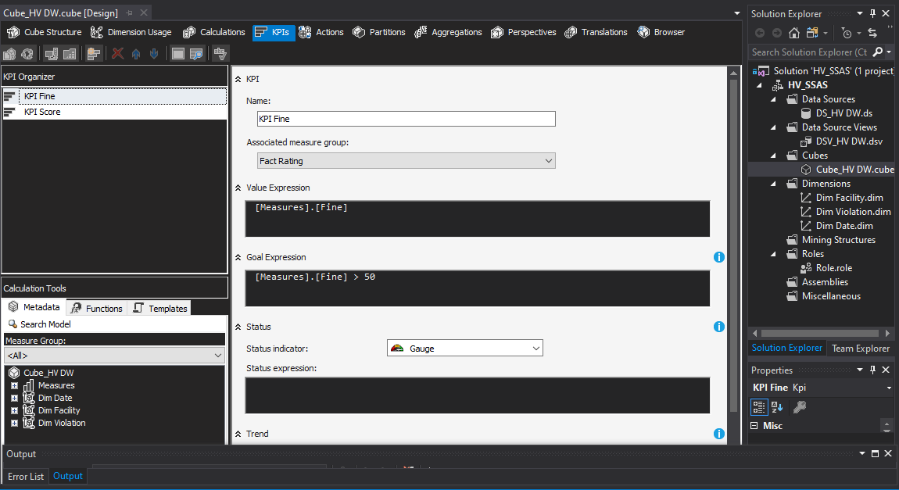

## Step 6: Deploying the Cube

# Demonstration of OLAP Operations

Both business users and IT teams benefit from a successful OLAP system. This is an important aspect of Business Intelligence, as it provides powerful data mining and trend analysis capabilities. OLAP allows users to quickly evaluate large amounts of data from several perspectives.

Instead of using MDX query, the data tab in the ribbon is used to access data from my SSAS Cube in this scenario.

## Graphical user interface, text, application, email Description automatically generatedConnection to the SSAS Cube

## Excel Report for OLAP Operations Demonstrations

* **Report 1 and 2 – Drill down and roll up Demo**
* **Report 3– Slice Demo**
* **Report 4– Dice Demo**
* **Report 5 – Pivot Demo**

### Drill down and rollup demonstration

• The Role Up operation aggregates a multidimensional data cube either by climbing up the hierarchy or by reducing the dimensions.

• The Drill Down procedure is performed by either descending a dimension's concept hierarchy or adding a new dimension. This allows for the deployment of very detailed data from a data cube.

* **Report 1 - Total Score and Fine for the Facilities Owned by Owners**

**ROLL UP**

Here the Facility Name has been rolled up according to the owner’s name

**DRILL DOWN**

* **Report 2 - Total Score and Total Fine belongs to the Owner by Year**

**ROLL UP**

Here the Owner Name has been rolled up according to the Year

**DRILL** **DOWN**

### Slice Demonstration

* + • A Slice is a two-dimensional representation of an OLAP data cube that arranges data in a grid like a spreadsheet. A Slice function, like a report or a query, returns data in response to a request for what to view.
* **Report 3 - Total Score and Total Fine belong to the Owner by Year**

This displays the Total Score and the Total Fine of the owners by Year.

### Dice Demonstration

• The operation of dice is identical to that of a slice. In dice, you choose two or more dimensions to create a sub-cube. Dicing, on the other hand, is a zoom feature that selects a subset of all dimensions for certain values of the dimension.

* **Chart, bar chart

  Description automatically generatedReport 4 – Total Score and Total Fine by Year and by Owner Name**

This displays the Total score and the Total Fine according to the Year and Owner Name.

### Pivot

* **Report 5 - Total Fine and Total Score by Year and Owner Name**

# SQL Server Reporting Service (SSRS) Reports

SQL Server Reporting Service (SSRS) is a reporting tool that allows users to create structured reports using tables, pictures, graphs, and charts. These reports are stored on a server and can be run at any time by specifying parameters.

To generate following reports, report builder application was used.

## Basic steps of Report builder

### Step 1: Creating Data source

This step will link to the data warehouse that was previously constructed in assignment 1.

### Step 2: Creating a dataset

In this stage, we'll import a necessary dataset into our report builder utilizing a query that will be manually assigned according to the needs.

This is the query used when creating the data set

### Step 3: Creating a Matrix or a Table

Using the imported dataset, we will create a matrix or a table according to our requirements

### Step 4: Report Demonstration

* + **Report 1 – Matrix**
  + **Report 2 – Report with Multi-parameter**
  + **Report 3 – Drill down**
  + **Report 4 – Drill through**
* **Report 1 – Matrix –Owner-wise Rating Detail Report by Year**

In SSRS, a matrix is like a table, but it is set up to display data grouped by columns and rows, with aggregate data at the intersection.

Design View:

**2 – Multi-Parameters – Total Rating Value (Score) by Owner**

In SSRS using Multiparameter-values allows us to pass either one or more than the input value to the report. Also, it offers a “Select All” option that helps to select all parameter values.

Selecting the Owner name

Selecting the Score According to the Owner name

Design View

* Here we have created two parameters and three data sets as following.
  + Graphical user interface, text, application

    Description automatically generatedDS_HV_DW_2: This data set contains the rating data which will be displayed in the report through the matrix.
  + Query:

select dp.ViolationDescription, dp.ViolationStatus, dpc.FacilityName, dpc.FacilityAddress,

dc.OwnerName, dc.AlternateOwnerID, dd.Month, dd.MonthName, dd.Year, fs.Fine, fs.Score

from FactRating fs

inner join DimViolation dp on fs.ViolationKey= dp.ViolationSK

inner join DimFacility dpc on fs.FacilityKey= dpc.FacilitySK

inner join DimOwner dc

on dpc.OwnerKey = dc.OwnerSK

inner join DimDate dd

on fs.ActivityDate = dd.DateKey

where dc.OwnerName in (@owner_name) and fs.Score in (@score)

* + Owner_list: This data set contains the required owner names which is needed to be shown for selection as the 1st parameter.

* + Query:

Select OwnerName, OwnerSK, AlternateOwnerID from DimOwner

* + Graphical user interface, application

    Description automatically generatedScore_list: This contains the scores belongs to the selected owner. When the owner names are selected, they will be passed as a parameter and the relevant data will be retrieved from the database.
  + Query: select distinct (Score) from FactRating
* **Report 3 – Drill down – Facility and Owner-wise Rating Detail Report by Year**

Drilling down in SSRS refers to allowing users to view or conceal column data using plus and minus symbols on a textbox (In short, providing interactivity to the user).

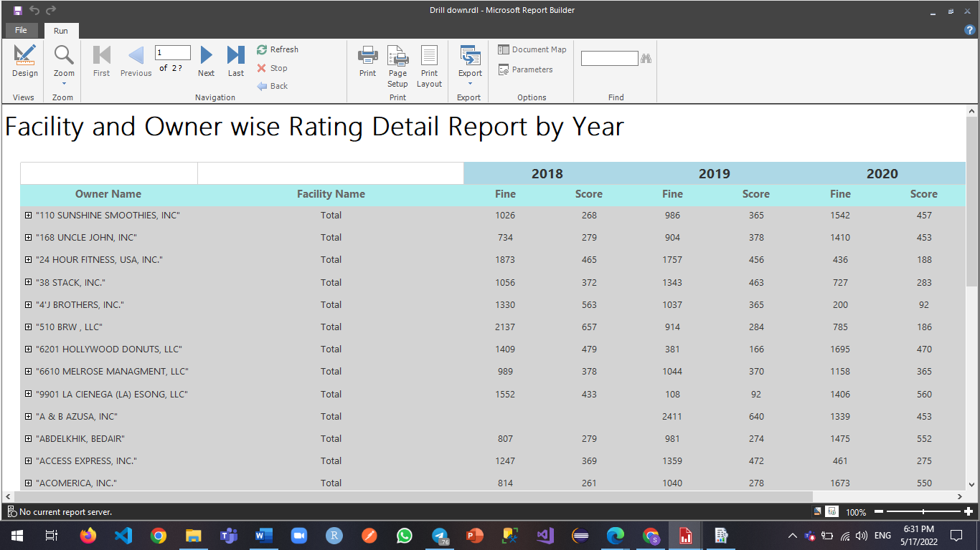

When you click on the plus mark in front of the Owner Name, it will display the details of Facility Names owned by that Owner.

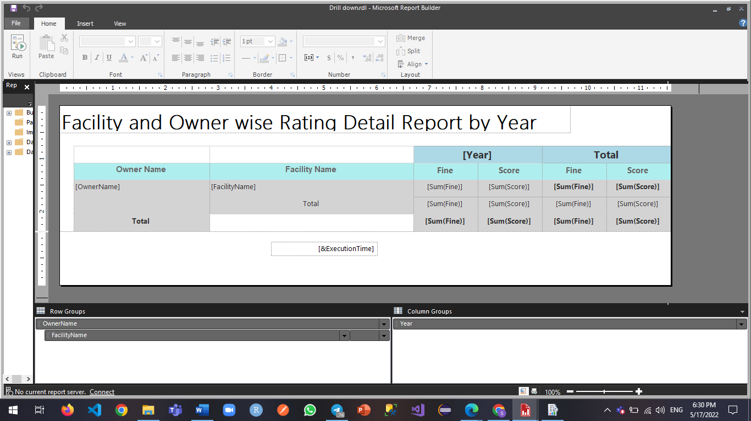Design View

* **Report 4 – Drill through – Owner Rating Analysis**

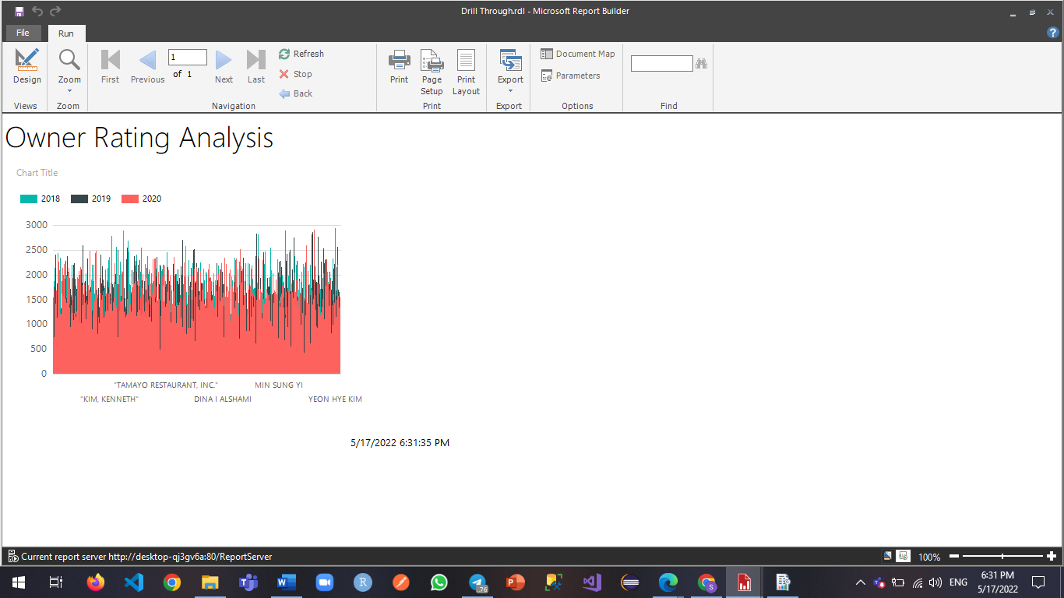

This report displays owner ratings. To get the rating of a specific owner we have to click on the required owner name cell.

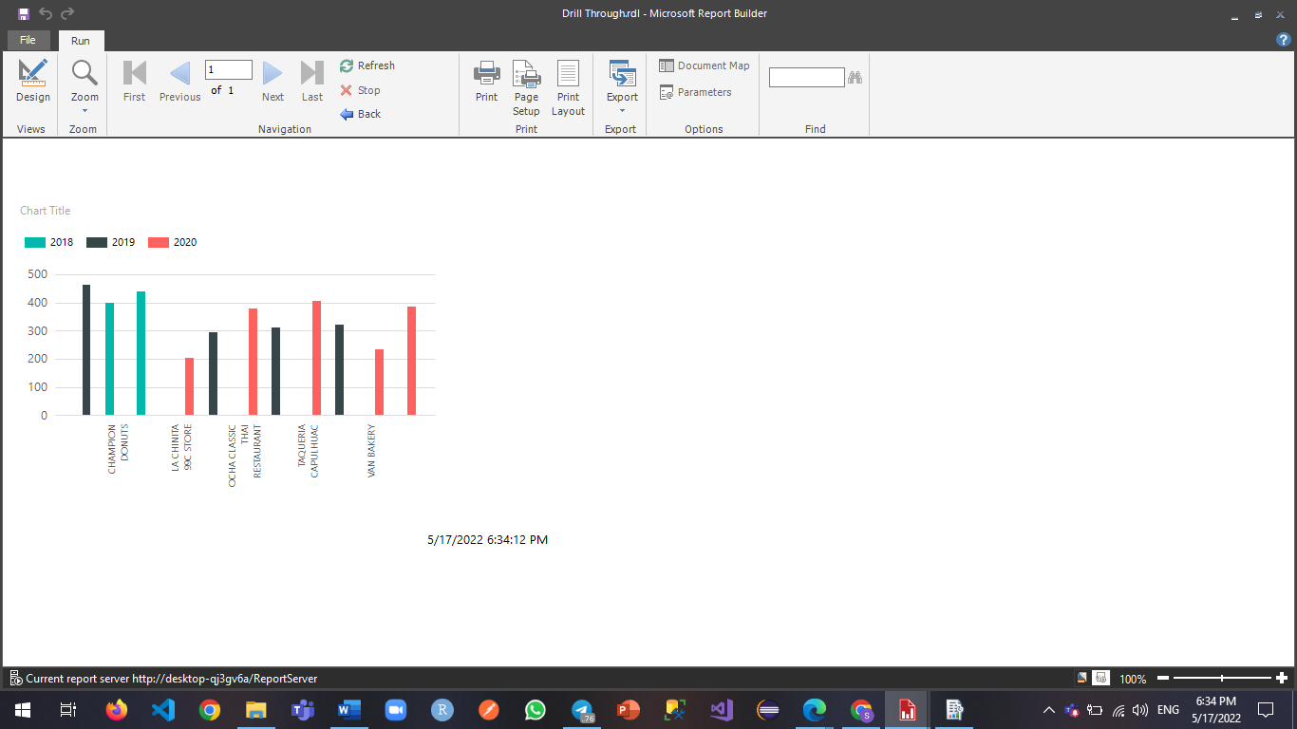

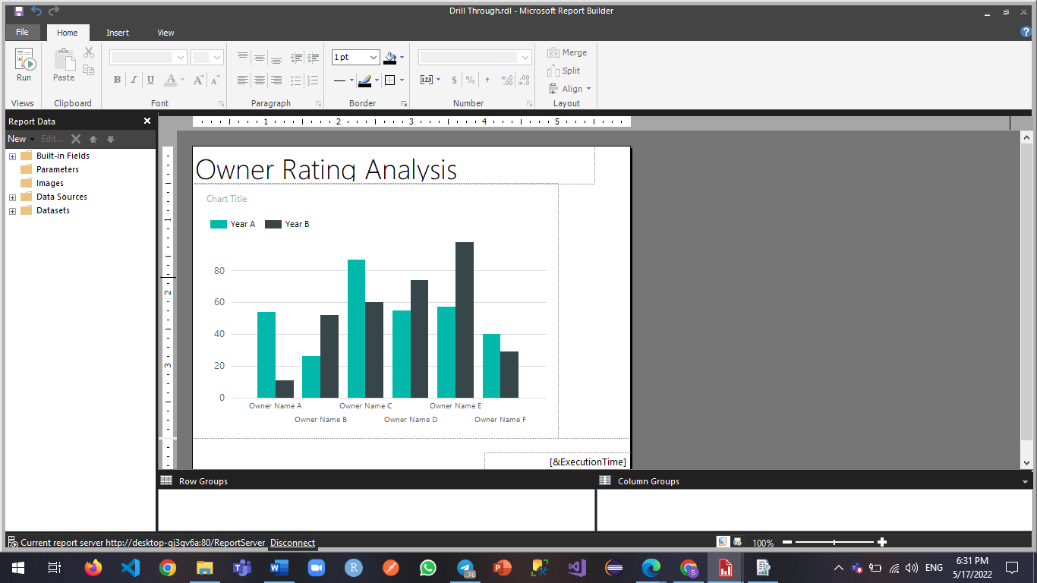

* After clicking on the owner name of the main report the sub report (Drill Through 2) with the bar graph will be displayed.
* Button click action has to be set for the main report (Drill Through) on required text box.
* Then a parameter named as owner_name is passed to the sub report which will use the parameter to get the required data according to the passed group name.

