**SQL – Day 1**

**Video playlist :** [**https://www.youtube.com/watch?v=9LC8z7WdwGE&list=PL7D4X4pSOcCGoKVKDNjeKLRDK4TNRxc1x&index=2&ab_channel=showtech**](https://www.youtube.com/watch?v=9LC8z7WdwGE&list=PL7D4X4pSOcCGoKVKDNjeKLRDK4TNRxc1x&index=2&ab_channel=showtech)

1. **What is the SQL ?**

* SQL (Structured Query Language) is a standardized language used to store, manipulate, and retrieve data in relational databases. It allows users to interact with the database by performing various operations such as querying, updating, and managing the data.

1. **What re the operations in SQL ?**
2. SELECT – Retrieve data from one or more tables
3. INSERT – Add new records into a table
4. UPDATE – Modify existing records in a table
5. DELETE – Remove records from a table
6. CREATE – Create new tables, databases, indexes, or other objects
7. DROP – Delete tables, databases, or other objects
8. ALTER – Modify the structure of an existing table
9. TRUNCATE – Remove all records from a table, but keep its structure
10. JOIN – Combine rows from two or more tables based on a related column
11. WHERE – Filter records based on specific conditions
12. GROUP BY – Group rows that have the same values in specified columns
13. ORDER BY – Sort the result set in ascending or descending order
14. HAVING – Filter groups after grouping with GROUP BY

**For Example :**

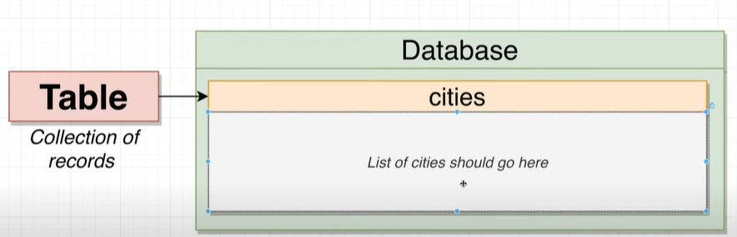

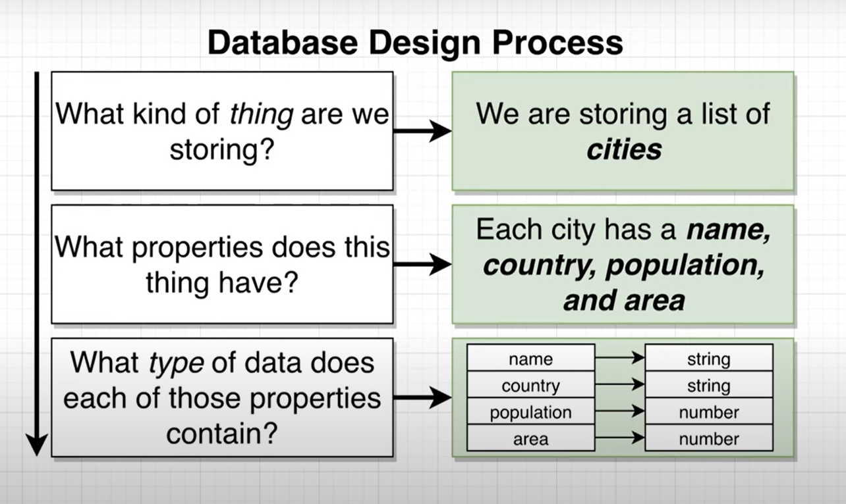

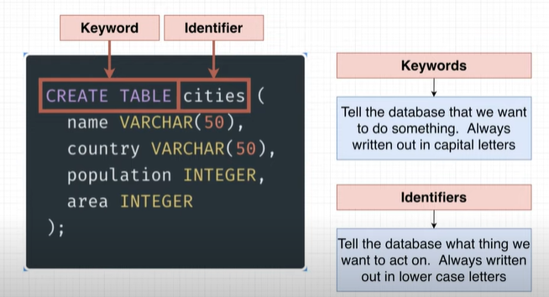**Using SQL editor in Browser for practice :** [**https://pg-sql.com/**](https://pg-sql.com/) **video No. - 3**

**CREATE TABLE cities (**

**name VARCHAR(50),**

**country VARCHAR(50),**

**population INTEGER,**

**area INTEGER );**

**);**