**Zigbee Interoperable Hubs**

**Product Link:**

<https://www.alibaba.com/product-detail/Milfra-zigbee-iot-gateway-Intelligent-Bridge_1600690403970.html?spm=a2700.galleryofferlist.normal_offer.d_image.242a13a0KGOd6s>

**Supplier's Link:**

<https://hidin.en.alibaba.com/company_profile.html?spm=a2700.details.0.0.76656646NezZgZ>

**Price:**

99 to 5 pieces

$17.50

999 to 100 pieces

$14.50

1999 to 1000 pieces

$13.50

>= 2000 pieces

$13.00

**Category:** Zigbee Gateway and Hubs

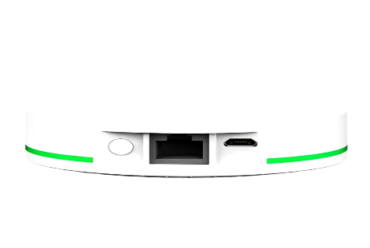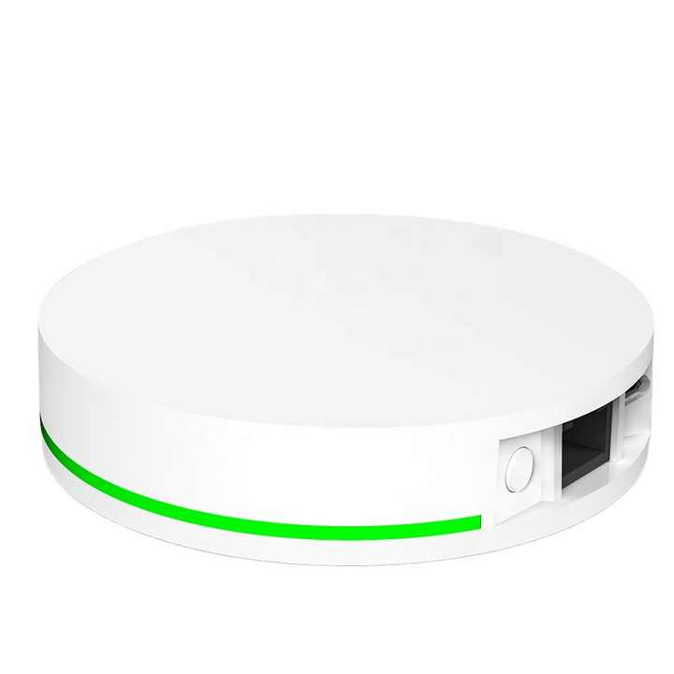

**Product name:** zigbee Intelligent Bridge Wireless with - Smart Home Hub -GAOTek

**Product ID:** GAOTek-ZGH-559

**Meta Description:** Zigbee IoT hub enables seamless smart home control, supporting, devices with voice control. It features Zigbee 3.0 wireless transceiver technology

**Technical Specifications:**

|  |  |
| --- | --- |
| Zigbee standard | IEEE802.15.4 |
| Rated Voltage | AC 100 to 250V |
| Supports APP | Smart Life |
| Working temperature | (-10℃ to 55℃)14 F to 131 F |
| Color | White |
| Product Size | 3.54 in x 0.92 in (90 mm x 23.5 mm) |
| Working humidity | <90% |

**Product Link:**

<https://www.alibaba.com/product-detail/Zigbee-Lorawan-Sms-Gsm-Iot-Lora_1600864977703.html?spm=a2700.galleryofferlist.normal_offer.d_image.242a13a0KGOd6s>

**Supplier's Link:**

<https://honeycomm.en.alibaba.com/company_profile.html?spm=a2700.details.0.0.32da6b91RXUlbr>

**Price:**

19 to 2 pieces

$60.49

999 to 20 pieces

$59.28

9999 to 1000 pieces

$48.39

>= 10000 pieces

$20.56

**Category:** Zigbee Gateway and Hubs

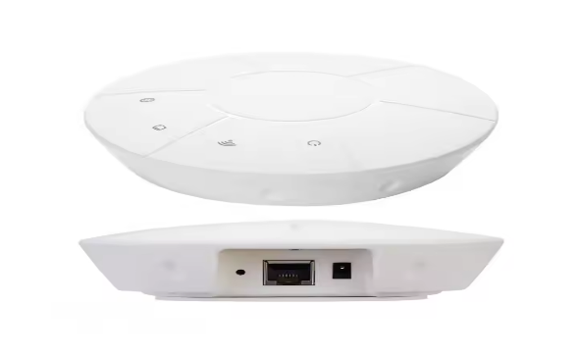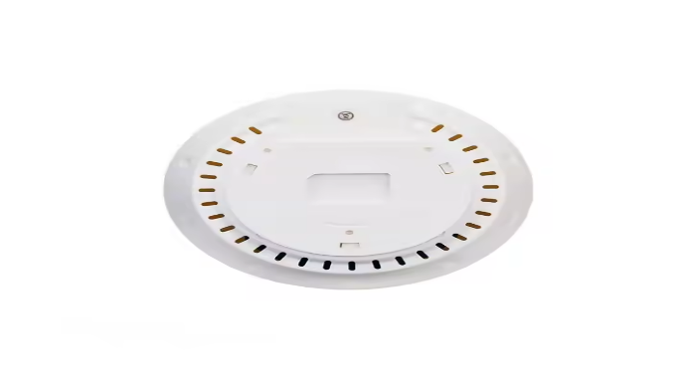

**Product name:** Zigbee Laptop Smart Hub with -12V DC Power & WiFi 32 Port -GAOTek

**Product ID:** GAOTek-ZGH-560

**Meta Description:** Zigbee IoT hub integrates SMS, GSM and Lora communication protocols, featuring Modbus RTU to TCP, Wi-Fi, and 4G support for industrial IoT applications

**Technical Specifications:**

|  |  |
| --- | --- |
| Chipset | nRF52832+MT7628 |
| Bluetooth Version | 4.2 & 5.0 |
| Bluetooth Chipset | nRF52832 |
| Wi-Fi | MT7628NN |
| Wireless Protocol | 2.4Ghz |
| Power supply | 12VDC POE |
| Network | RJ45 or Wi-Fi or 4G |
| Communication protocol | TCP or UDP pr IP or MQTT or HTTP |
| Function | Collect Data, send to server |
| Working temperature | (-10 C to 50 C) 14 F to 122 F |
| Firmware Upgrade | OTA, LAN, FILE |

**Product Link:**

<https://www.alibaba.com/product-detail/Wholesale-Multi-mode-Matter-Zigbee-Smart_10000016696906.html?spm=a2700.galleryofferlist.normal_offer.d_image.242a13a0KGOd6s>

**Supplier's Link:**

<https://emylo.en.alibaba.com/company_profile.html?spm=a2700.details.0.0.a8b772e9IDENiP>

**Price:**

99 to 5 pieces

$28.69

999 to 100 pieces

$27.55

>= 1000 pieces

$25.98

**Category:** Zigbee Gateway and Hubs

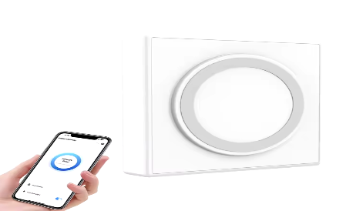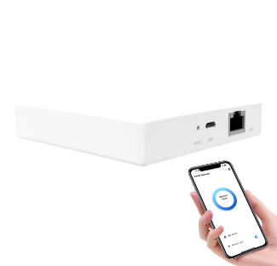

**Product name:** Multi mode Smart Home Automation with - White Smart Zigbee Hub-GAOTek

**Product ID:** GAOTek-ZGH-561

**Meta Description:** Multi mode Zigbee Smart Home hub enables automation with seamless integration of Zigbee 3.0 and Matter devices, providing remote control for lighting.

**Technical Specifications:**

|  |  |
| --- | --- |
| Function | Smart Home Automation |
| Size | 3.74 in x 3.74 in x 2.04 in (9.50 cm x 9.50 cm x 5.20 cm |
| Color | White |
| Weight | 4.93 oz (140 g) |
| Certification | CE FCC RoHS |
| Material | PC |

**Product Link:**

<https://www.alibaba.com/product-detail/Homekit-compatible-Zigbee-3-0-Wired_1601068880379.html?spm=a2700.galleryofferlist.normal_offer.d_image.242a13a0KGOd6s>

**Supplier's Link:**

<https://wilmorecn.en.alibaba.com/company_profile.html?spm=a2700.details.0.0.5a3e2143WvQCN5>

**Price:**

Minimum order quantity: 1 piece

$12.50

**Category:** Zigbee Gateway and Hubs

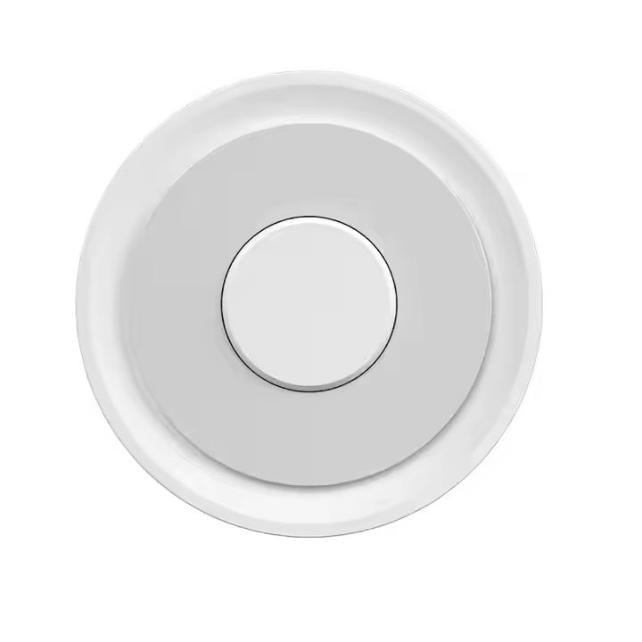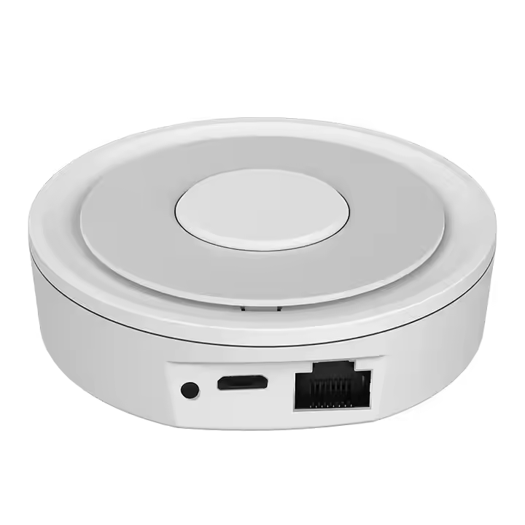

**Product name:** HomeKit compatible Zigbee 3.0 Hub with - Remote Control Bridge-GAOTek

**Product ID:** GAOTek-ZGH-562

**Meta Description:** HomeKit compatible Zigbee 3.0 Wired Hub allows remote control through the app, providing seamless smart home automation for various applications

**Technical Specifications:**

|  |  |
| --- | --- |
| Product Type | Center control |
| Use | Universal |
| Private Mold | Yes |
| Protocol | Zigbee |
| Color | White |
| Power supply | 5V 1A |
| Material | ABS & PC |
| Standby current | <180mA |
| Storage Temperature | (-10℃ to 55℃) 14 F to 131 F |
| Size | 3.07 in x 3.07 in x 0.98 in (78 mm x 78 mm x 25 mm) |

**Product Link:**

<https://www.alibaba.com/product-detail/Smart-Wireless-Home-Gateway-Controller-WiFi_1600902789634.html?spm=a2700.galleryofferlist.normal_offer.d_image.242a13a0KGOd6s>

**Supplier's Link:**

<https://duomeishiye.en.alibaba.com/company_profile.html?spm=a2700.details.0.0.2cc15aeaNRQdHb>

**Price:**

99 to 1 piece

$19.99

299 to 100 pieces

$18.99

>= 300 pieces

$17.69

**Category:** Zigbee Gateway and Hubs

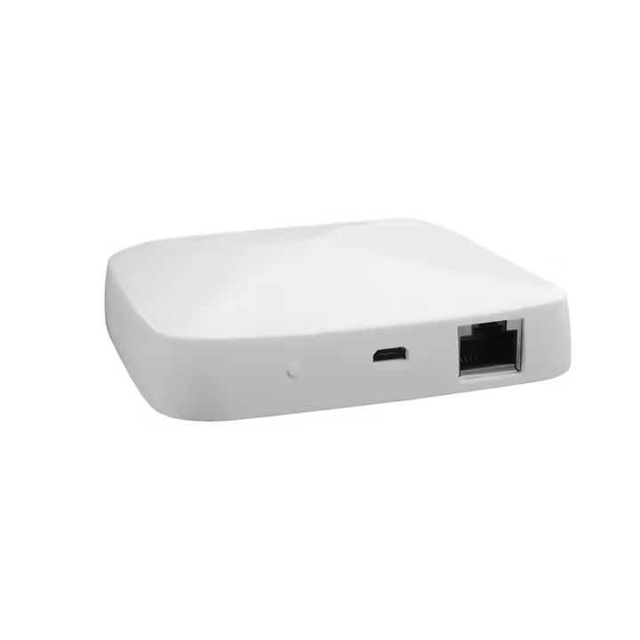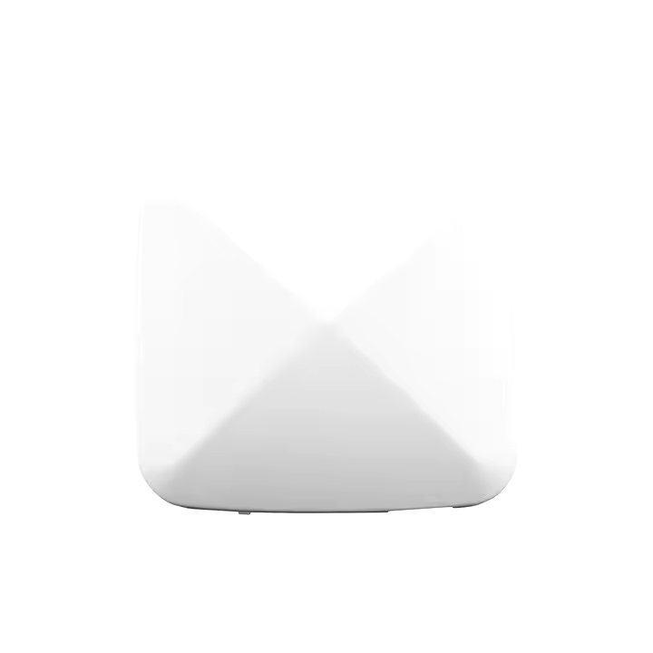

**Product name:** Wireless Home Controller Hub with- 5V Compatible Power Supply -GAOTek

**Product ID:** GAOTek-ZGH-563

**Meta Description:** Smart Wireless Home hub Controller features Zigbee and Bluetooth integration, compatible with Home for smart home automation 2.0 to 2.9-inch screen.

**Technical Specifications:**

|  |  |
| --- | --- |
| Chipset | LPWA IoT module |
| Screen Resolution | 1920 x 1080 |
| Operation System | home |
| Screen | 2.0 to 2.9 inch |
| Power input | 5V 1A |
| Supplier Type | Zigbee Module, ZigBee Hub 3.0 |
| Working humidity | 10% RH to 90% RH (non-condensation) |
| Wireless Technology | 2.4G WIFI & Zigbee & BLE5.0& Mesh |
| Chipset | Zigbee 3.0 |
| Operating temperature | (-20℃ to 45℃) -4 F to 113 F |
| Product size | 3.38 in x 3.38 in x 0.66 in  (86 mm x 86 mm x 17 mm) |

**Product Link:**

<https://www.alibaba.com/product-detail/TYSH-Iot-Products-Tuya-Smart-Wireless_1600363627328.html?spm=a2700.galleryofferlist.normal_offer.d_image.242a13a0L5XaJm>

**Supplier's Link:**

<https://tuyasmarthome.en.alibaba.com/company_profile.html?spm=a2700.details.0.0.3f401b9dKWTfHm>

**Price:**

499 to 2 pieces

$18.00

1999 to 500 pieces

$17.00

>= 2000 pieces

$15.00

**Category:** Zigbee Gateway and Hubs

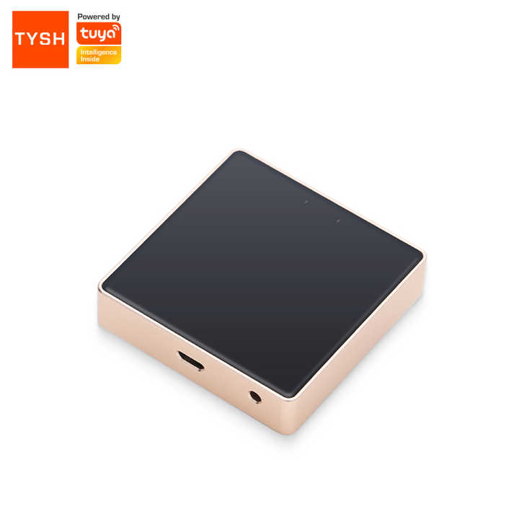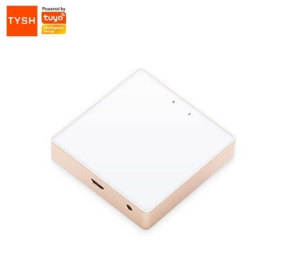

**Product name:** Wireless Zigbee Use for Smart Home System - Zigbee Hub Module-GAOTek

**Product ID:** GAOTek-ZGH-564

**Meta Description:** Smart Wireless Zigbee hub supports Wi-Fi and Zigbee 802.15.4, ideal for smart home systems with app control via Smart. Compact and reliable, No Camera.

**Technical Specifications:**

|  |  |
| --- | --- |
| Feature | Wi-fi |
| Camera | No Camera |
| Screen Resolution | 1920 x 1080 |
| Operation System | home |
| Use | Universal |
| Screen | < 2 inch |
| Private Mold | Yes |
| Power input | 5V1A |
| Wireless | WIFI802.11 bgn Zigbee802.15.4 |
| Color | White & BLACK |
| Working humidity | 10% RH to 90% RH (non-condensation) |
| Product size | 2.40 in x 2.40 in x 0.59 in (61 mm x 61 mm x 15 mm) |
| Product weight | 2.53 oz (72 g) |
| Operating temperature | (-20°C to 45°C) -4 F to 113 F |

**Product Link:**

<https://www.alibaba.com/product-detail/Tuya-10-Smart-Home-Control-Hub_1600910456887.html?spm=a2700.galleryofferlist.normal_offer.d_image.242a13a0L5XaJm>

**Supplier's Link:**

<https://smatek.en.alibaba.com/company_profile.html?spm=a2700.details.0.0.47e012123wQOKv>

**Price:**

99 to 5 pieces

$199.00

299 to 100 pieces

$179.00

499 to 300 pieces

$173.00

>= 500 pieces

$169.00

**Category:** Zigbee Gateway and Hubs

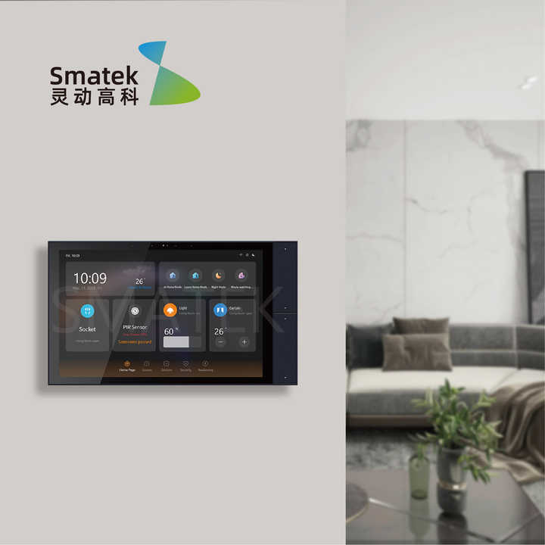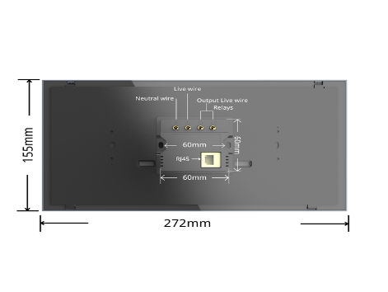

**Product name:** Smart Control Hub with - Video Doorbell Switch & 1 USB port -GAOTek

**Product ID:** GAOTek-ZGH-565

**Meta Description:** Smart Home Control Hub integrates a built in Zigbee hub for seamless control of smart home devices, supporting video doorbells and door locks

**Technical Specifications:**

|  |  |
| --- | --- |
| Max. Current | 10A |
| Max. Voltage | 100 to 240V AC |
| Customized support | Software reengineering |
| Number of Switches | 4 |
| USB Type-C ports | 1 Ports |
| WIFI | Yes |
| Material | PC |
| Function | Whole Home Automation |
| Power Supply | 100 to 240V AC, 0.3A, 50 to 60Hz |
| Wireless Protocols | Wi-Fi, BLE, Zigbee |
| Working Temperature | (0℃ to +40℃) 32 F to 104 F |
| Working Humidity | 5% RH to 90% RH (Non condensing) |
| Product dimensions | 10.70 in x 6.10 in x 1.49 in (272 mm x 155 mm x 38 mm) |

**Product Link:**

<https://www.alibaba.com/product-detail/Tuya-zigbee-wired-gateway-Smart-life_62420251323.html?spm=a2700.galleryofferlist.normal_offer.d_image.242a13a0L5XaJm>

**Supplier's Link:**

<https://keepersmart.en.alibaba.com/company_profile.html?spm=a2700.details.0.0.14b23468D5gpYa>

**Price:**

99 to 2 pieces

$22.00

499 to 100 pieces

$20.00

999 to 500 pieces

$18.80

>= 1000 pieces

$17.60

**Category:** Zigbee Gateway and Hubs

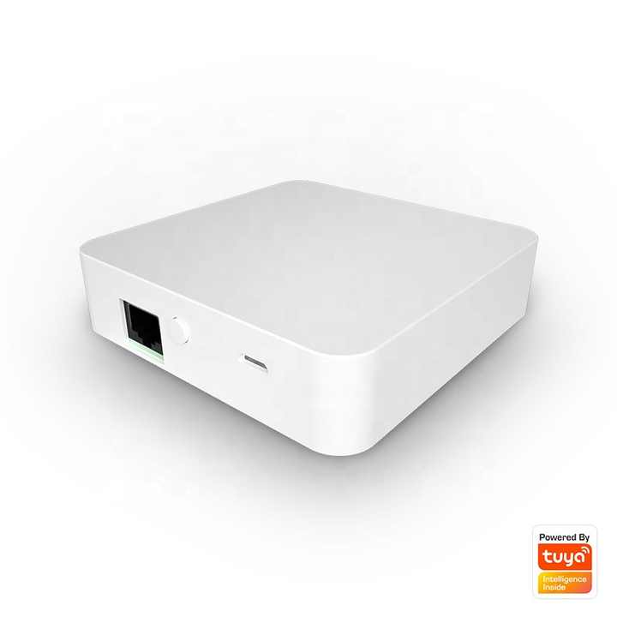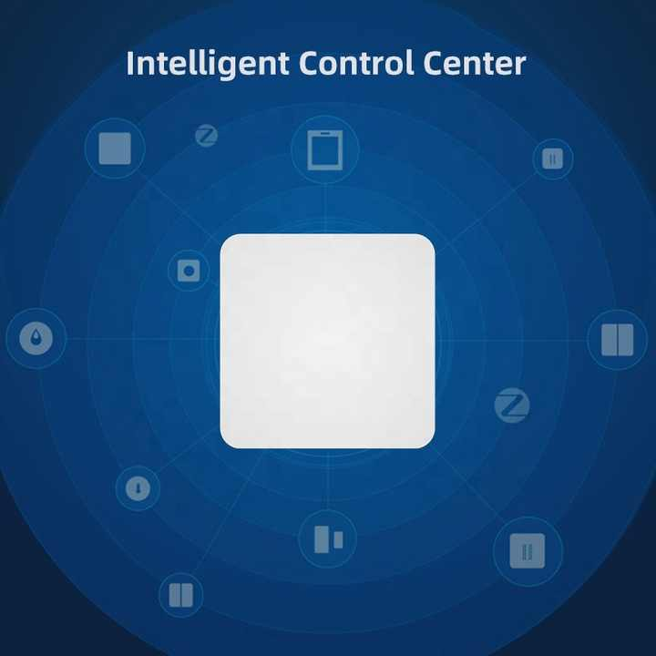

**Product name:** ZigBee Wired Smart Life with - 5V Power Supply & Micro USB-GAOTek

**Product ID:** GAOTek-ZGH-566

**Meta Description:** Zigbee Wired hub supports IFTTT integration, enabling smart home control through a compact, energy-efficient design with app-based remote management

**Technical Specifications:**

|  |  |
| --- | --- |
| Use | Universal |
| Power Source | USB |
| Private Mold | NO |
| Communication method | Zigbee |
| Status indicator | 4 LED (Green) |
| Operation buttons | 2 Button (Reset) |
| Power supply | Micro USB DC 5 V |
| Working current | <1A |
| Working Voltage | 1.8V to 3.3V |
| Hardware interface | 1 Micro USB, 1 LAN Interface |
| Working temperature | (-10 C to 55 C) 14 F to 131 F |
| size | 3.62 in x 3.62 in x 1 in (92 mm x 92 mm x 25.5 mm) |

**Product Link:**

<https://www.alibaba.com/product-detail/Tuya-Zigbee-3-0-Roller-Blind_1601179261389.html?spm=a2700.galleryofferlist.normal_offer.d_image.242a13a0L5XaJm>

**Supplier's Link:**

<https://santongyuan.en.alibaba.com/company_profile.html?spm=a2700.details.0.0.6a5624adsfXbkb>

**Price:**

19 to 2 pieces

$21.00

99 to 20 pieces

$20.50

>= 100 pieces

$20.00

**Category:** Zigbee Gateway and Hubs

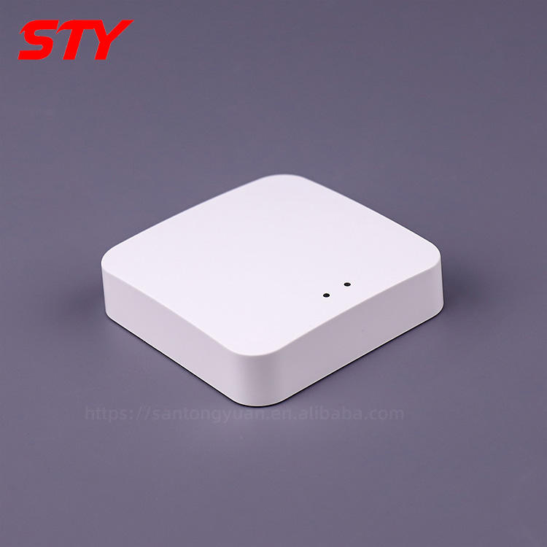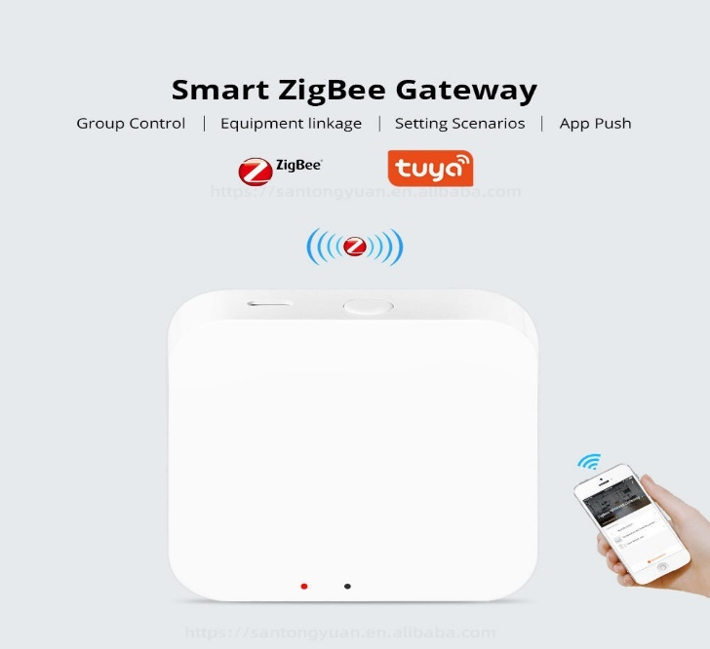

**Product name:** Zigbee Smart Motor Hub with -240V Power Supply & 10000 Capacity-GAOTek

**Product ID:** GAOTek-ZGH-567

**Meta Description:** Roller Blind Motor is compatible with Smart Life and Home Assistant. It offers wireless control via a hub for seamless automation of smart curtains

**Technical Specifications:**

|  |  |
| --- | --- |
| Usage | Smart Curtain Motor |
| Batteries Required | NO |
| Plastic Type | PVC |
| Curtain Poles, Tracks & Accessories Type | Curtain Accessories |
| Type | Curtain Poles, Tracks & Accessories |
| Material | Plastic |
| Metal Type | aluminum alloy |
| Capacity | 5000 to 10000 |
| Power Supply | AC 100 to 240 V |
| Smart Type | Electronic, Bluetooth, Voice control |
| Control Mode | Smart Phone Application |
| Working Temperature | (-10 C to 55 C) 14 F to 131 F |

**Product Link:**

<https://www.alibaba.com/product-detail/2024-Hot-Selling-Wi-Fi-Zigbee_1601167134598.html?spm=a2700.galleryofferlist.normal_offer.d_image.242a13a0L5XaJm>

**Supplier's Link:**

<https://szsafety.en.alibaba.com/company_profile.html?spm=a2700.details.0.0.1e615c17RZJPjM>

**Price:**

999 to 100 pieces

$16.00

4999 to 1000 pieces

$15.00

>= 5000 pieces

$14.00

**Category:** Zigbee Gateway and Hubs

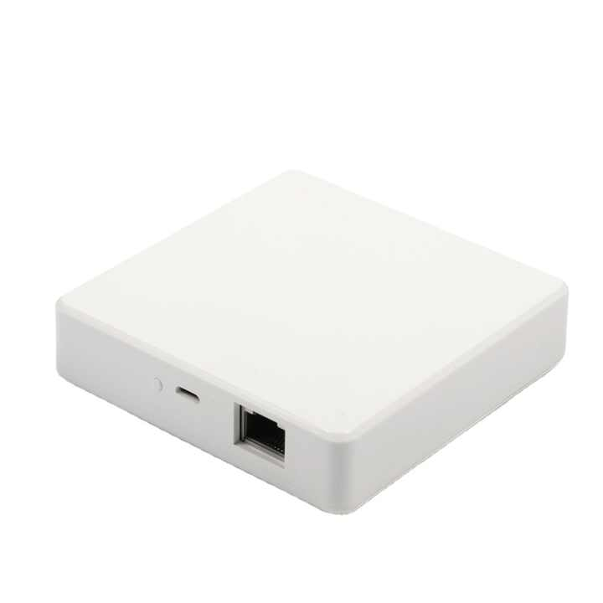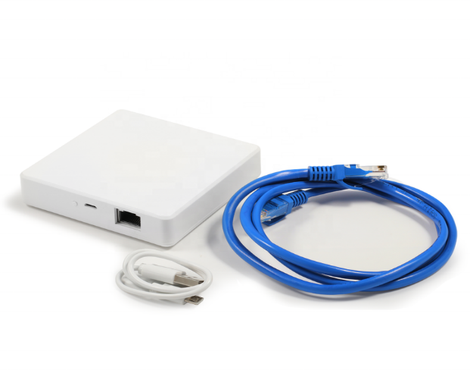

**Product name:** Smart Zigbee Gateway Hub with - 220V Power Supply & 0.25A Input-GAOTek

**Product ID:** GAOTek-ZGH-568

**Meta Description:** Wi-Fi and Zigbee 2 in 1 multi-Mode Hub integrate Zigbee, compatible with Alexa, Google Assistant, and IFTTT. Ideal for smart home automation.

**Technical Specifications:**

|  |  |
| --- | --- |
| Feature | Voice control |
| Operation System | Android |
| Camera | No Camera |
| Use | Universal |
| Power Source | Battery, USB, Electric |
| Smart Voice Control | Home |
| Compatibility | Android & IOS |
| Communication mode | ZigBee |
| Input | 220V & 50Hz 0.25A |
| Working temperature | -10 C to 55 C (14 F to 131 F) |
| Working humidity | 10% RH to 90% RH |