

A
PROJECT DEVELOPMENT AND IMPLEMENTATION
Report On
“NIRMAAN 2.0: CONSTRUCTION PROGRESS MONITORING AND VISUALIZATION USING SALESFORCE”

In partial fulfilment for the award of degree in “Bachelor of Technology”
Computer Science and Engineering (AI-ML)

Submitted To: Submitted By:
Ms. Neha Ranga Samir Srinath
(Assistant Professor) Sid- 2347454

AESTR (Computer Science and Engineering)
Suresh Gyan Vihar University, Jaipur 302017
2026-2027

Student Declaration

I hereby declare that my 7th semester project report entitled “NIRMAAN 2.0: CONSTRUCTION PROGRESS MONITORING AND VISUALIZATION USING SALESFORCE” is my own work, carried out under the supervision of Ms. Neha Ranga.

This report presents the work undertaken as part of my academic requirements for the 7th semester. The information and work presented in this report are true to the best of my knowledge.

Submitted to:

Ms. Neha Ranga

(Assistant professor)

Acknowledgement

I would like to express my heartfelt gratitude to our respected faculty of Salesforce and Project Development Laboratory, AESTR, Suresh Gyan Vihar University, for their valuable guidance, continuous support, and encouragement throughout the completion of my 7th semester project titled “NIRMAAN 2.0: Construction Progress Monitoring and Visualization Using Salesforce.”
I am also thankful to Suresh Gyan Vihar University for providing the necessary resources, facilities, and technical environment that made this project possible.
My sincere thanks go to my classmates and friends for their constructive suggestions, cooperation, and constant motivation during the development and testing of this project.
Finally, I extend my deepest gratitude to my family for their patience, understanding, and moral support throughout the duration of this work.

Student Name:
Samir Srinath

Abstract
NIRMAAN 2.0 is a construction-tracking and engineering-visualization project for organizing project, construction-package, pile, raft, pedestal, and related progress information. The original use case relates to NTPC Nabinagar Stage II (3 × 800 MW) and used Node.js, HTML/CSS/JavaScript, Tailwind CSS, MySQL, and Leaflet.js. The Salesforce-oriented version models construction entities as custom objects and uses Lightning Web Components (LWC), Apex, Lightning pages, reports, dashboards, and Salesforce security features.
A central requirement is visualization in a shared engineering X/Y coordinate system. Piles and pedestals use coordinate pairs; each raft is represented by an ordered set of polygon vertices stored as JSON. The raft coordinate editor supports dynamic entry and a polygon preview. A planned package-level workspace combines piles, rafts, and pedestals in a 2D view with filters and summary information. The final state of the combined viewer, app navigation, tests, and deployment must be verified against the target org before this draft is submitted as a completion report.
Keywords: Construction Management, Salesforce, LWC, Apex, SVG, Coordinate Geometry, Civil Construction

Table of Contents
- 1. Introduction
- 2. Problem Statement and Objectives
- 3. Existing and Proposed Systems
- 4. Requirements and Scope
- 5. System Architecture and Technology Stack
- 6. Data Model
- 7. Coordinate Geometry and Visualization
- 8. Implementation Status
- 9. Testing and Validation
- 10. Security, Limitations and Future Work
- 11. Conclusion
- References
- Appendices

1. Introduction

Construction projects involve a large amount of technical and operational information, including construction packages, foundation elements, engineering coordinates, inspection records, daily progress updates, and project status reports. Managing this information efficiently is essential for maintaining accuracy, improving coordination, and monitoring the overall progress of construction activities. As projects grow in size and complexity, the volume of data generated during different stages of construction also increases. Without a structured system for organizing and accessing these records, it can become difficult to maintain data consistency, identify specific construction elements, understand their spatial relationships, and prepare reliable progress reports.
Traditional approaches to construction data management may involve multiple spreadsheets, separate databases, manually maintained documents, or disconnected software tools. Although these methods can store useful information, managing records across different sources can create challenges. Information may become duplicated, updates may not be reflected consistently, and users may need to search through multiple files to obtain a complete picture of a particular construction package or foundation element. In addition, understanding the physical arrangement of piles, rafts, and pedestals can be difficult when engineering coordinates are available only in tabular form.
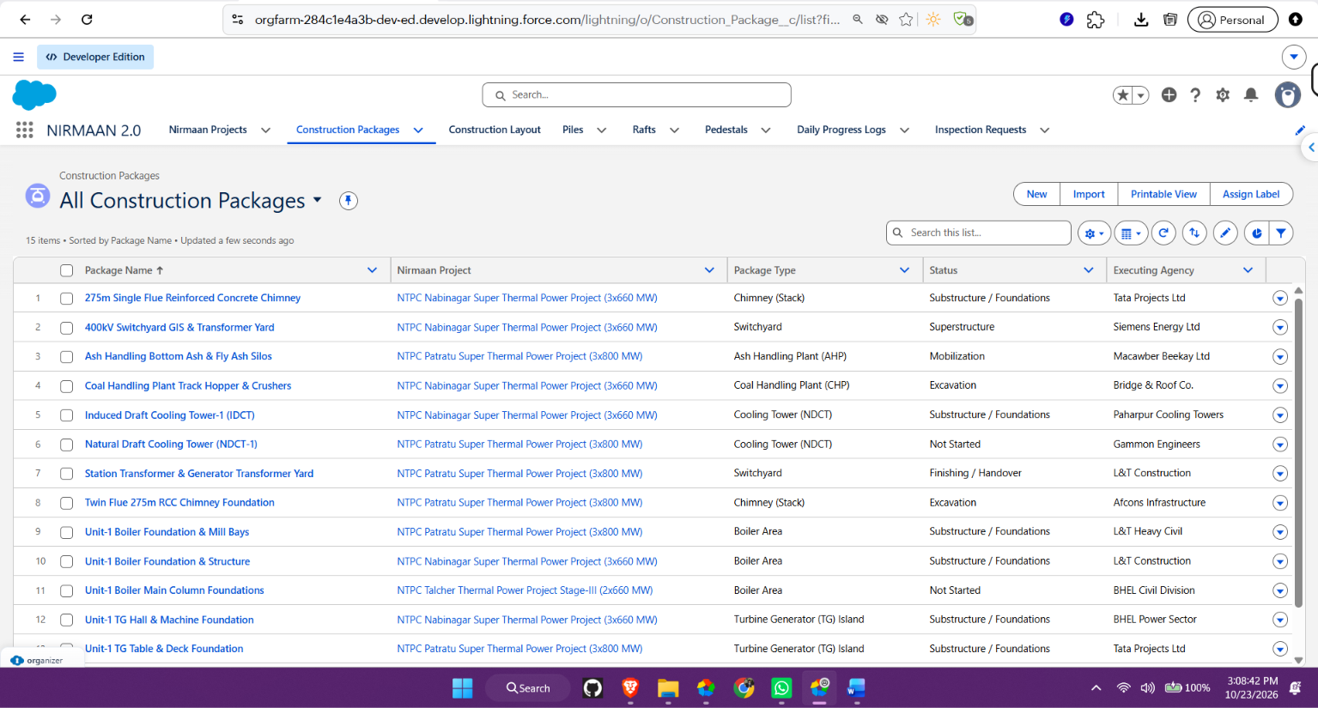
NIRMAAN 2.0: Construction Progress Monitoring and Visualization Using Salesforce is designed to address these challenges by providing a structured approach to construction data management and visualization. The project adapts a construction-tracking use case to the Salesforce platform, where custom objects can represent important construction entities and Lightning components can provide an interface for accessing, managing, and presenting relevant information. The objective is to organize construction records in a centralized application environment and make the information easier to search, filter, review, and understand.
The project focuses particularly on the management of foundation-related construction data, including piles, rafts, and pedestals. These elements have engineering information associated with them, such as identification details, construction package relationships, and coordinate values. By storing this information in a structured format, the application can provide a consistent basis for retrieving individual records and presenting their positions in a combined engineering plan view. This visualization helps users understand the relative locations of different foundation elements within a construction area.
The Salesforce-oriented implementation uses custom objects to organize the project data according to its purpose and relationships. Construction packages act as the primary grouping mechanism for organizing relevant construction elements, avoiding the need for a separate Area object in the current data model. Other records can be associated with the relevant project or construction package, helping maintain logical relationships between the different categories of information. Lightning components can then use these records to provide a more accessible and interactive user experience.
Another important aspect of NIRMAAN 2.0 is the presentation of spatial information. Engineering coordinates are useful for defining the locations of foundation elements, but numerical values alone do not always provide an intuitive understanding of their arrangement. A visual representation can make it easier to identify the relative positions of piles and pedestals and to examine raft boundaries. The proposed combined visualization brings these elements together in a single plan view, allowing users to understand their spatial relationships more clearly. Since rafts may have different numbers of corners, the system also requires a flexible method for representing their polygon geometry.
In addition to data organization and visualization, the project considers common application features such as dashboards, summary information, search, filtering, pagination, and reporting. These features are intended to help users navigate large collections of records and focus on information relevant to a particular construction package or foundation element. Summary cards and dashboards can provide a high-level view of available information, while detailed record views support the examination of individual items. Search and filtering can reduce the effort required to locate specific records, and pagination can improve the usability of screens that display many entries.
The project therefore combines construction-domain data modeling with Salesforce application development and coordinate-based visualization. It provides an academic implementation framework for demonstrating how a cloud-based application platform can be adapted to a specialized engineering use case. The emphasis is on creating a logical data structure, providing accessible interfaces, and establishing a foundation for presenting construction information in a clear and organized manner.

1.1 Project Context
The original use case for NIRMAAN was associated with NTPC Nabinagar Stage II civil construction, where construction-related information included foundation elements such as piles, pedestals, and rafts. The use case was described as containing more than 13,000 records. This figure represents the scale of the source use case and provides context for the need for structured data management. It should not be interpreted as a verified count of records currently loaded into the Salesforce development organization.
At this scale, efficient information retrieval and clear data organization become important considerations. Users may need to locate a specific pile, inspect the details of a pedestal, review a raft's coordinate geometry, or examine the elements associated with a particular construction package. If records are not organized according to consistent relationships, such tasks may require additional manual effort and increase the possibility of confusion.
The original use case also highlighted the importance of combining conventional record management with spatial visualization. Construction records are not simply independent rows of data; they represent physical elements positioned within an engineering layout. Their locations and relationships are meaningful for understanding the arrangement of foundation work. Consequently, the system needs to support both the storage of engineering attributes and their visual presentation.
The Salesforce-oriented version adapts this domain to Salesforce custom objects and Lightning components. Rather than treating the original technology implementation as unchanged, the Salesforce version represents an adaptation of the same general construction-monitoring requirements to a different application platform. Its data model is organized around construction projects, construction packages, foundation elements, and related progress or inspection information.
This distinction is important when describing the project's current status. The original record count and use-case background explain the problem the project is intended to address, whereas the records, components, and functionality actually available in the development organization must be verified separately. This report therefore treats the original scale as contextual information and describes proposed or planned capabilities as such unless their implementation has been confirmed.
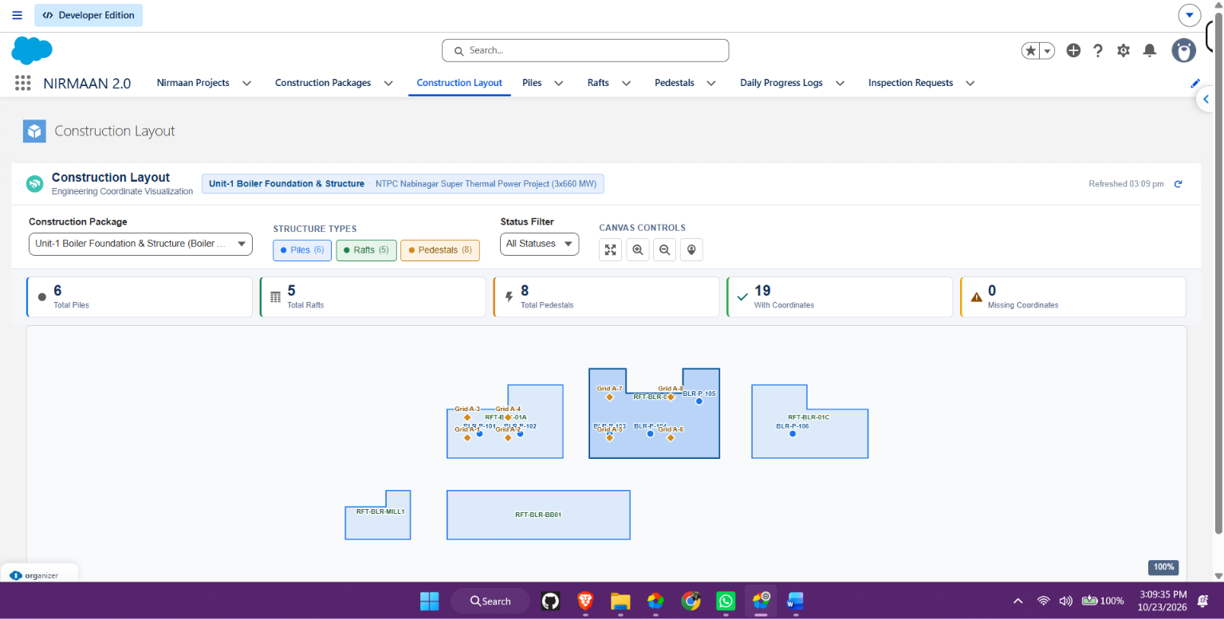
1.2 Purpose
The primary purpose of NIRMAAN 2.0 is to provide a structured and accessible way to organize construction-related records and establish a reliable basis for monitoring and visualizing foundation information. The project aims to reduce the difficulty of working with scattered records by bringing relevant data into a consistent application model. Through the Salesforce platform, construction information can be organized into related records that are easier to retrieve, maintain, and present.
A central part of this purpose is to connect the descriptive information of foundation elements with their engineering coordinates. Each pile or pedestal can be represented using its relevant coordinate values, while a raft can be represented through a set of vertices defining its boundary. These coordinate values provide the input required for displaying the elements in a plan view. The combined visualization is intended to present the different foundation element types in one view, helping users understand their relative positions within the selected construction package.
The project also aims to make construction information easier to access through a user-friendly interface. Search and filtering features can help users narrow down the displayed records, while pagination can make larger record lists easier to navigate. Summary cards and dashboards can present selected information at a glance, and reporting capabilities can support the preparation and review of construction-related information. Together, these features are intended to make the application more useful than a simple collection of disconnected data tables.
Another purpose is to demonstrate how Salesforce custom objects and Lightning components can be used to implement a domain-specific application. The project applies structured data modeling to construction entities and uses the platform's application capabilities to provide interfaces for accessing and presenting those entities. This makes NIRMAAN 2.0 both a construction-data management concept and an academic demonstration of Salesforce-based application development.
Ultimately, the purpose of the project is to establish a centralized, organized, and extensible foundation for construction progress monitoring and spatial visualization. The system is intended to help users understand the records associated with construction activities, retrieve relevant information with less effort, and interpret the arrangement of foundation elements through a combined engineering plan view. Its effectiveness depends on the accuracy of the stored data, the correctness of the coordinate information, and the successful implementation and validation of the relevant application features.

2. Problem Statement and Objectives

2.1 Problem Statement
Construction data must be linked across projects, packages, and foundation elements. A record-only interface does not show the spatial arrangement of piles, rafts, and pedestals. Missing coordinates or malformed geometry can compromise a combined plan view. The system therefore needs structured records and a controlled method for capturing, validating, and visualizing engineering coordinates.

2.2 Objectives
- Represent construction projects and packages in a consistent Salesforce data model.
- Maintain pile, raft, and pedestal records associated with Construction Package.
- Capture numeric X/Y coordinates for piles and pedestals.
- Capture raft geometry as ordered coordinate pairs stored as JSON.
- Provide an LWC coordinate editor with validation and polygon preview.
- Create a package-level workspace with filters, summary cards, and a combined 2D view.
- Apply Salesforce permissions and sharing controls.
- Support reporting and future construction-progress analytics.

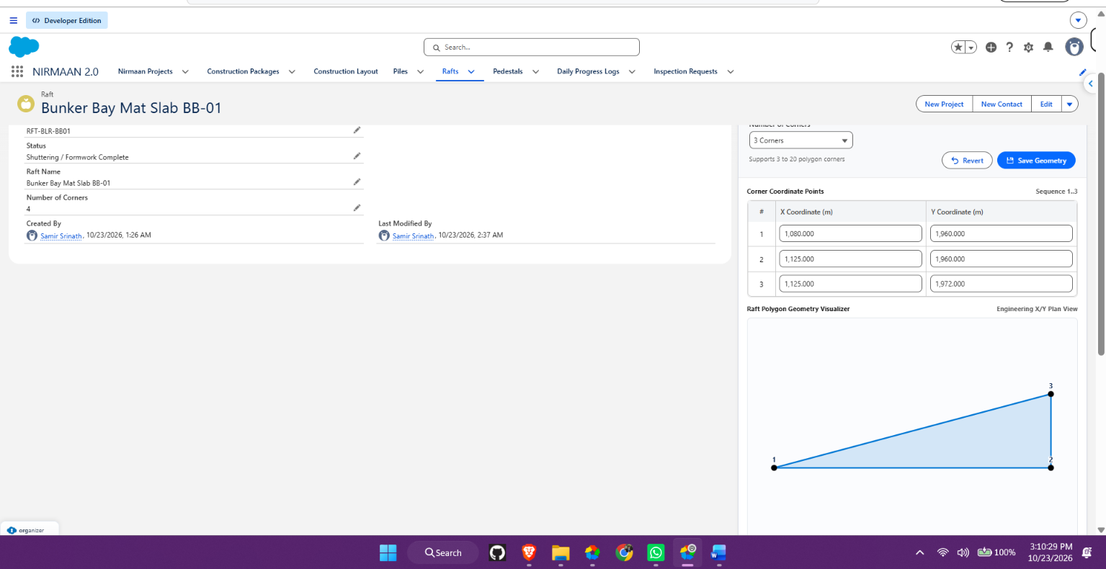

3. Existing and Proposed Systems

3.1 Original Use Case
The original use case used Node.js, HTML, CSS, JavaScript, Tailwind CSS, MySQL, and Leaflet.js. Capabilities included construction record management, dashboards, reporting, search, filtering, pagination, and spatial presentation.

3.2 Salesforce-Oriented System
The Salesforce version uses custom objects and relationships for construction entities. Apex supports server-side operations, while LWC provides interactive interfaces. Salesforce reports and dashboards can support aggregate monitoring. Permission sets, sharing, validation, and field-level security are intended to control access.
Area | Original use case | Salesforce implementation
User interface | HTML/CSS/JavaScript, Tailwind | Lightning Experience and LWC
Server logic | Node.js | Apex
Data storage | MySQL | Salesforce custom objects and fields
Geometry | Leaflet.js/map-oriented view | SVG engineering plan view
Analytics | Dashboards and reports | Salesforce Reports and Dashboards
Access control | Application-level controls | Sharing, permission sets, object/field permissions

4. Requirements and Scope

4.1 Functional Requirements
- Manage construction projects and packages.
- Associate piles, rafts, and pedestals with the appropriate construction package.
- Store X/Y coordinates for piles and pedestals.
- Store ordered raft vertices as JSON.
- Select raft corner count and validate coordinate pairs.
- Preview valid raft polygon geometry.
- Provide a Construction Layout workspace with package and structure filters.
- Show summary counts and identify missing or invalid coordinate data.
- Allow users to select structures and inspect their Salesforce records.

4.2 Non-Functional Requirements
- Responsive layout for desktop and narrower screens.
- Consistent engineering coordinate origin, units, and orientation.
- Secure data access using Salesforce permissions and sharing.
- Graceful handling of missing coordinates, invalid JSON, and query errors.
- Maintainable separation between UI and server-side logic.
- Performance appropriate to the record volume of each package.

4.3 Scope Boundaries
Construction_Package__c serves as the package/area-level grouping in the current model. A separate Area__c object is not required. The combined viewer uses engineering coordinates, not GPS latitude and longitude.

5. System Architecture and Technology Stack
Layer | Technology | Responsibility
Application | Salesforce Lightning Experience | Navigation and workspace
Interactive UI | Lightning Web Components | Coordinate editor, filters, SVG view
Business logic | Apex | Secure retrieval, validation, persistence
Data layer | Salesforce custom objects | Projects, packages, piles, rafts, pedestals, progress/inspection records
Visualization | SVG | Polygons and coordinate markers
Analytics | Salesforce Reports and Dashboards | Summaries and progress monitoring
Development | VS Code and Salesforce CLI | Metadata development, validation, deployment workflow

5.1 High-Level Data Flow
- User opens the NIRMAAN_2 Lightning application.
- User selects the Construction Layout navigation item.
- Workspace loads construction packages available to the user.
- Selected package scopes retrieval of related piles, rafts, and pedestals.
- Valid coordinates are mapped into the SVG viewport.
- Filters and selection actions update the visualization and summary information.

6. Data Model
The exact field API names and field types should be checked against the final org metadata before submission.
Object | Purpose | Relevant data/relationships
Nirmaan_Project__c | Construction project | Project-level details
Construction_Package__c | Package grouping and area-level selection | Related construction elements
Pile__c | Pile/foundation record | Package relationship, pile identifier, X/Y
Raft__c | Raft foundation and geometry | Package relationship, raft number, corner count, coordinate JSON
Pedestal__c | Pedestal record | Package relationship, grid reference, X/Y, optional raft relationship
Daily_Progress_Log__c | Daily progress | Progress-related data as implemented
Inspection_Request__c | Inspection tracking | Inspection-related data as implemented

6.1 Coordinate Representation
Piles and pedestals are represented by two numeric values: X (horizontal engineering coordinate) and Y (vertical engineering coordinate). Raft geometry uses a variable number of ordered coordinate pairs. The corner count should be at least three and must match the number of valid points.
Illustrative JSON format only:
[
{"sequence": 1, "x": 100.0, "y": 100.0},
{"sequence": 2, "x": 200.0, "y": 100.0},
{"sequence": 3, "x": 240.0, "y": 160.0},
{"sequence": 4, "x": 160.0, "y": 220.0},
{"sequence": 5, "x": 80.0, "y": 160.0}
]
These are example values, not verified construction measurements. Vertex order is essential because the viewer connects points sequentially and closes the polygon.

7. Coordinate Geometry and Visualization

7.1 Rendering
The combined viewer is intended to use an SVG canvas. Rafts are rendered as closed polygons, piles as circular markers, and pedestals as distinct markers. Each visual element should retain its Salesforce record ID so that selection can show details or navigate to the record.
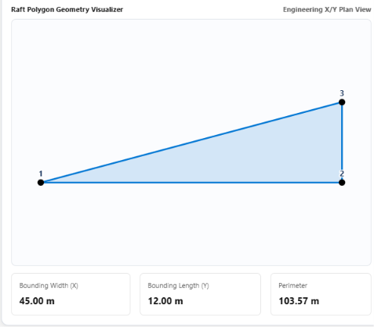

7.2 Scaling and Orientation
The viewer should calculate minimum and maximum X/Y values for valid visible structures and map them into the SVG viewport using a uniform scale to preserve proportions. SVG screen Y increases downward, so the mapping should invert Y for a conventional engineering plan view. Padding should be included around the geometry.

7.3 Filters and Information Panels
- Construction Package: primary filter for all records.
- Structure Type: independently show or hide piles, rafts, and pedestals.
- Construction Status: use actual status fields and picklist values where available.
- Summary cards: counts by structure type and coordinate quality.
- Selected structure: identifier, type, coordinates, and Salesforce record link.

7.4 Data Quality
Records with null or invalid coordinates should be counted and excluded from geometric rendering. Malformed raft JSON, fewer than three points, non-finite values, and mismatches between corner count and point count should not prevent other valid structures from rendering.

8. Implementation Status

8.1 Salesforce Metadata
The project notes identify the Lightning app as NIRMAAN_2 and permission sets named Nirmaan_Project_Admin, Nirmaan_Site_Engineer, and Nirmaan_Field_Supervisor. The final report should verify which metadata is deployed and active in the target org.

8.2 Raft Coordinate Editor
The raft editor provides a dynamic interface for entering coordinate pairs based on corner count. The intended workflow validates points, serializes them into the raft geometry JSON field, and displays a polygon preview. Server-side validation should remain authoritative.

8.3 Construction Layout Navigation
The planned next stage is a dedicated Construction Layout workspace accessible from the NIRMAAN_2 navigation. It will host the combined viewer, filters, summary cards, legend, and selected-record details. The navigation item and page activation must be verified in Salesforce Setup.

9. Testing and Validation
Execute the following test cases and record actual results. Do not mark a test as passed until it has been run in the target Salesforce environment.
ID | Test case | Expected result
T01 | Select a Construction Package | Only authorized related records appear
T02 | Plot pile with numeric X/Y | Marker appears at expected relative position
T03 | Plot pedestal with numeric X/Y | Distinct marker appears
T04 | Render three-corner raft | Closed triangle is drawn
T05 | Render five-corner raft | Ordered vertices connect and polygon closes
T06 | Malformed raft JSON | Raft excluded/reported; viewer remains usable
T07 | Missing pile/pedestal coordinate | Record counted as missing and not plotted
T08 | Change structure filters | Only selected types remain visible
T09 | Select a structure | Correct details are shown
T10 | Permission-restricted user | Unauthorized data is not exposed
T11 | Empty package | Clear empty state is shown
T12 | Zoom and fit-to-view | Geometry remains legible and within canvas

9.1 Validation Checklist
- Validate LWC HTML, JavaScript, CSS, and metadata.
- Run Apex unit tests for retrieval and geometry validation.
- Verify CRUD, field-level security, and sharing.
- Test filters with records from multiple packages.
- Confirm the viewer uses Salesforce data rather than hardcoded examples.
- Verify Lightning page and navigation item in the target app.
- Record the org/environment, date, command, and actual result.

10. Security, Limitations and Future Work

10.1 Security
Apex methods should use appropriate sharing and enforce object and field permissions. The UI is not a security boundary. Validate query parameters and restrict retrieval to records the user may access. Field-level security for the raft JSON field needs a deliberate design so users cannot edit raw JSON directly while the approved coordinate editor can save validated geometry.

10.2 Limitations and Assumptions
- Current sample records were described as random test data and should not be used for engineering decisions.
- Coordinates are only comparable when they share an engineering origin, units, and orientation.
- The combined viewer, navigation activation, tests, and deployment status were not verified during report preparation.
- The source use case's record volume does not establish the current Salesforce org's record count or performance.
- No engineering accuracy or safety claim should be made until coordinate sources and outputs are validated.

10.3 Future Enhancements
- Progress-state colors for piles, rafts, and pedestals.
- Inspection and quality-status overlays.
- Record detail panels and direct navigation to Salesforce records.
- Progress dashboards and date-based comparisons.
- Coordinate import with validation and error reporting.
- Performance improvements for large packages.
- Plan-view export to PDF or image if required.

11. Conclusion

NIRMAAN 2.0: Construction Progress Monitoring and Visualization Using Salesforce is a construction-tracking project designed to organize construction-related information and provide a structured approach to managing foundation elements. The project applies Salesforce capabilities to a construction-domain use case in which information about construction packages, piles, rafts, and pedestals needs to be stored, accessed, and presented systematically. By organizing these entities within a logical data model, the application establishes a foundation for improving the accessibility, consistency, and usability of construction records.
One of the key aspects of NIRMAAN 2.0 is its focus on combining conventional record management with engineering coordinate-based visualization. Construction elements are associated with spatial information that describes their positions within a construction layout. Although coordinates can be stored and displayed as numerical values, interpreting the arrangement of multiple foundation elements can be difficult when the information is viewed only in tabular form. The proposed visualization approach addresses this challenge by providing a plan view in which different types of construction elements can be represented together. This helps users develop a clearer understanding of their relative positions and spatial relationships within a selected construction package.
The project's data model provides a structured way to represent construction packages and their associated foundation elements. Construction packages act as the primary grouping mechanism for organizing relevant records, while piles, rafts, and pedestals represent different types of construction structures. This organization supports a more consistent relationship between the construction information and the engineering layout. It also provides a basis for extending the application in the future to include additional construction attributes, progress information, inspection details, and reporting requirements.
Another important component of the project is the handling of raft geometry. Unlike piles and pedestals, which can be represented using individual X/Y coordinate pairs, rafts may have different numbers of corners depending on their shapes. A fixed set of coordinate fields would therefore be insufficient for representing every possible raft boundary. To address this requirement, the raft editor is designed to support variable-corner polygon geometry by collecting ordered X/Y coordinate pairs and storing them in JSON format. This approach provides flexibility in representing raft boundaries while maintaining a structured format for the coordinate data. The order of the vertices is important because it determines how the polygon boundary is constructed for visualization.
The planned Construction Layout workspace extends this coordinate-based approach by bringing piles, rafts, and pedestals together in a combined engineering plan view. Instead of requiring users to examine separate records or individual structure types independently, the workspace is intended to present their spatial arrangement within a common visualization. Filters can help users focus on relevant construction packages or structure types, while summary information can provide a quick overview of the selected records. Record-level details can further support the examination of individual construction elements and their associated attributes. Together, these capabilities are intended to make the application more interactive and useful for understanding construction layouts.
The use of Salesforce also provides a platform for organizing the application's data and user interfaces. Custom objects can represent the construction entities, while Lightning components can provide the interfaces required for record management and visualization. The overall design demonstrates how a cloud-based application platform can be adapted to a specialized engineering use case. It also provides a foundation for further development, including improved dashboards, progress summaries, inspection tracking, reporting, and more advanced visualization features.
However, the successful completion of the project must be assessed not only through its design but also through implementation and testing. Before this report is submitted as a final project document, the combined Construction Layout viewer should be tested with representative records to confirm that coordinate values are displayed correctly and that piles, pedestals, and raft polygons appear in their expected positions. The raft editor should be checked for correct handling of different corner counts, coordinate validation, JSON serialization, and polygon rendering. Application navigation should also be verified to ensure that the relevant workspace is accessible through the intended Salesforce Lightning application.
In addition, Apex tests, where applicable, should be executed and their actual results recorded. Security behavior should be reviewed to confirm that users can access and modify records according to the configured permissions and sharing rules. Deployment validation should be performed to identify configuration errors, missing dependencies, or other issues that may prevent the application from working correctly in the target environment. Actual screenshots, test outcomes, and relevant implementation evidence should be included in the final report so that the documented features accurately reflect the state of the project.
In conclusion, NIRMAAN 2.0 establishes a structured approach to construction data organization and coordinate-based visualization using Salesforce. Its main contribution is the combination of construction-package organization, foundation-element records, flexible raft geometry, and the planned integration of multiple structure types into a single engineering layout. The project demonstrates the potential of combining application development with spatial data representation to make construction information easier to access and interpret. With successful implementation, testing, and validation of the planned features, NIRMAAN 2.0 can serve as a foundation for a more comprehensive construction-monitoring solution that supports organized records, clearer spatial understanding, and future improvements in construction progress management.

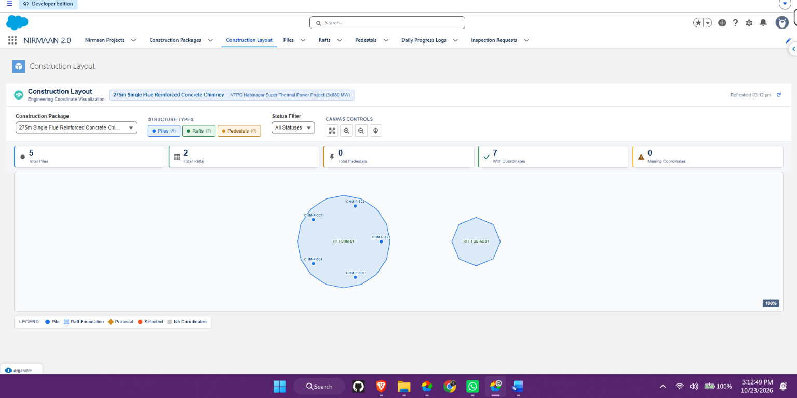

References
- Salesforce Developers, Lightning Web Components Developer Guide: https://developer.salesforce.com/docs/platform/lwc/guide
- Salesforce Developers, Apex Developer Guide: https://developer.salesforce.com/docs/atlas.en-us.apexcode.meta/apexcode/
- Salesforce Help, Lightning App Builder and Lightning Pages documentation: https://help.salesforce.com/
- Project source context: NIRMAAN 2.0 construction-tracking schema and implementation notes supplied during project development.

