Lab_6 – IT20650520

# **Markov_Decision_Process**

## 3. Complete the incomplete parts in each notebook (these parts are mentioned by ‘#type your code here’).

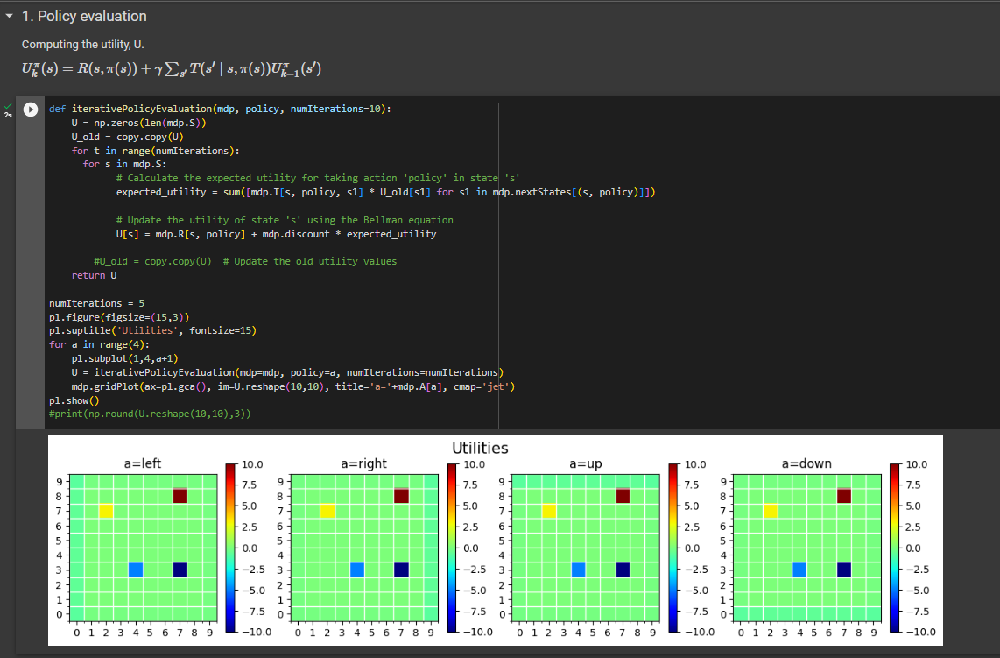

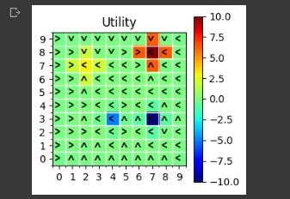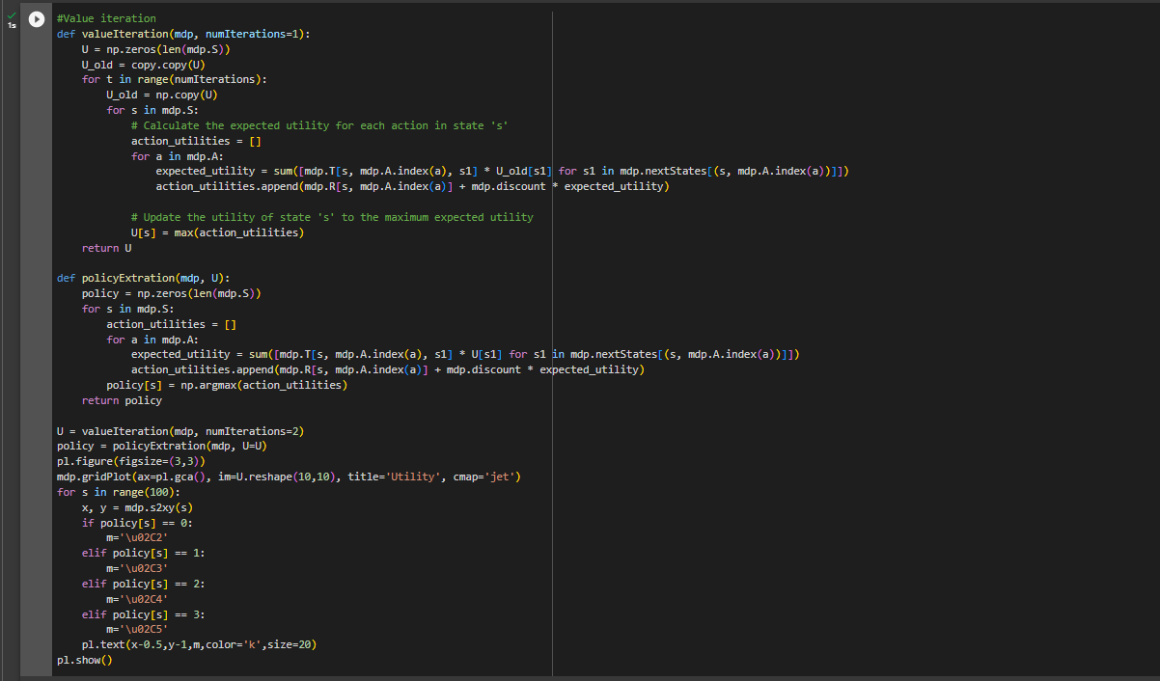

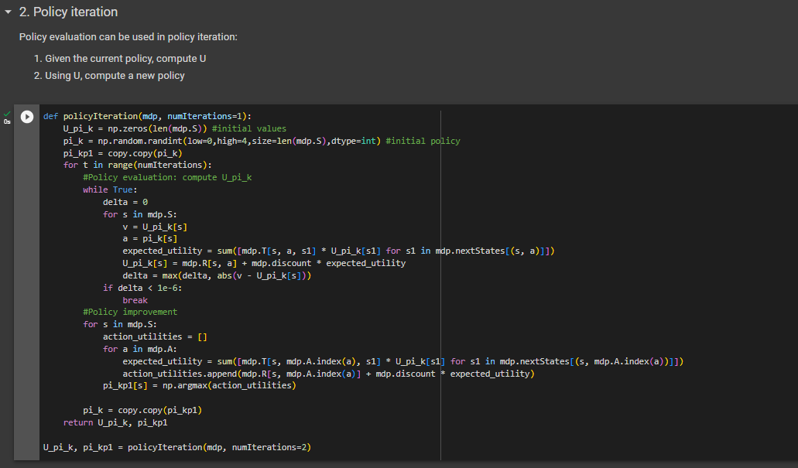

# **Gridworld**

