MIT ACADEMY OF ENGINEERING (MITAOE), PUNE
DEPARTMENT OF DATA SCIENCE
Course: Full Stack Web Development
LABORATORY ASSIGNMENT 1

Student Name: | Sameet Pisal
PRN: | 202401120018
Assignment Title: | Responsive Admin Dashboard with Sidebar & Statistics Cards

1. PROBLEM STATEMENT
Assignment Question: "1. Create a responsive webpage which shows dashboard with sidebar and statistics in cards using HTML, CSS, Bootstrap"
2. IMPLEMENTATION SUMMARY & FEATURES
A full-fledged, responsive e-commerce administration dashboard was implemented using HTML5, CSS3, and the Bootstrap 5.3 framework. The project completely satisfies all assignment requirements and includes the following features:
• Persistent Desktop Sidebar: Fixed vertical navigation panel with brand branding ('ShopKart Enterprise'), grouped navigation categories ('Overview', 'Analytics & Marketing', 'System'), active state pills, badge notifications, and administrator user profile.
• Statistics in Cards (Hero KPI Metrics): Four responsive statistics cards tracking Total Revenue (₹8,24,500), Total Orders (2,841), Pending Orders (143), and New Customers (512) featuring custom subtle-tinted icon containers and percentage trend indicators.
• Visual Analytics & Goal Tracking: Category sales breakdown with segmented progress bars (Electronics, Apparel, Footwear, Kitchen, Books) alongside a monthly revenue goal progress tracker.
• Operations Overview Metrics: Live operational counters for shipments dispatched, customer returns, 5-star reviews, support tickets, and verified marketplace vendors.
• Recent Orders Data Table: Comprehensive data table with customer avatars, product details, city tags, monetary amounts, and colored status pill badges (Delivered, Processing, Shipped, Cancelled).
• Featured Product Catalog: Product inventory showcase featuring real item photography, star ratings, price tags, and inventory stock badges (In Stock, Low Stock, Sold Out).
• Active Team Status Module: Team member collaboration panel showing online/away/offline administrative colleagues with role titles and status dot indicators.
• Interactive Bootstrap Modals & Notifications: Interactive 'Add New Product' form modal, 'Order Details' transaction modal with invoice download, and animated Bootstrap toast notifications.
• Responsive Mobile Offcanvas Navigation: Full mobile layout adaptation (<992px) with top hamburger menu button opening an offcanvas drawer and vertically stacked cards.
• Native Dark / Light Theme Toggle: Built-in theme switcher utilizing Bootstrap 5.3's data-bs-theme attribute.
3. COMPLETE USER INTERFACE & FEATURE SCREENSHOTS
The screenshots below illustrate every component, feature, modal, table, and viewport layout implemented in the dashboard:
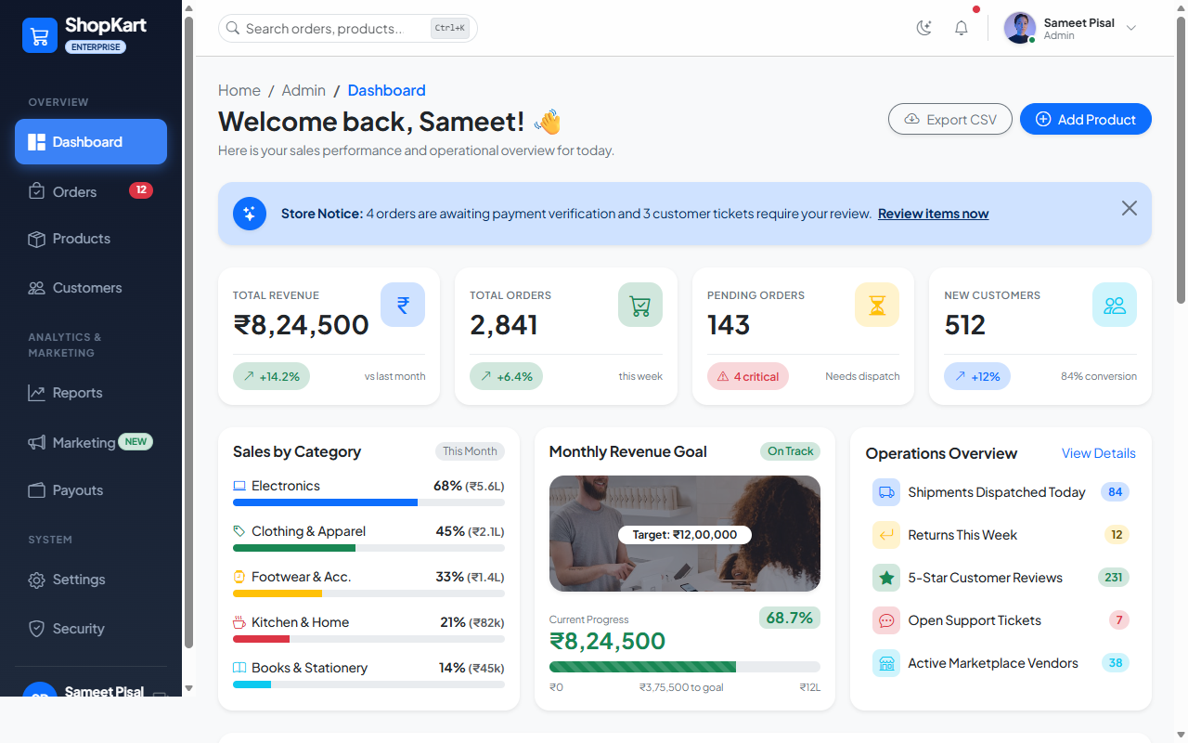
Figure 1: Full Desktop Dashboard Overview (Light Theme)
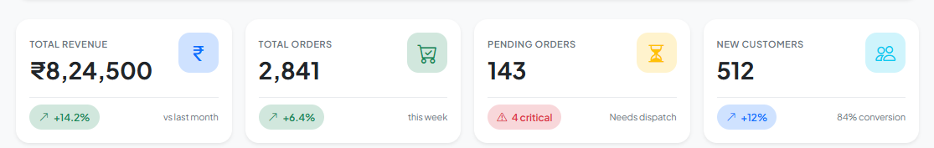
Figure 2: Statistics in Cards (Key Performance Indicator Metrics)
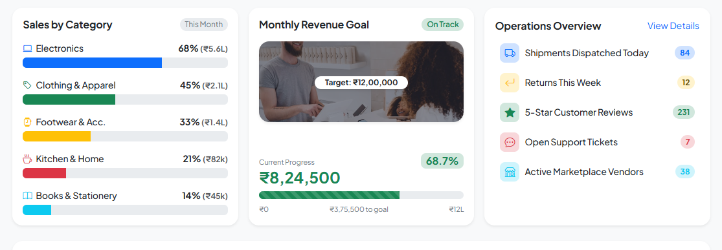
Figure 3: Category Sales Breakdown & Monthly Revenue Goal Progress
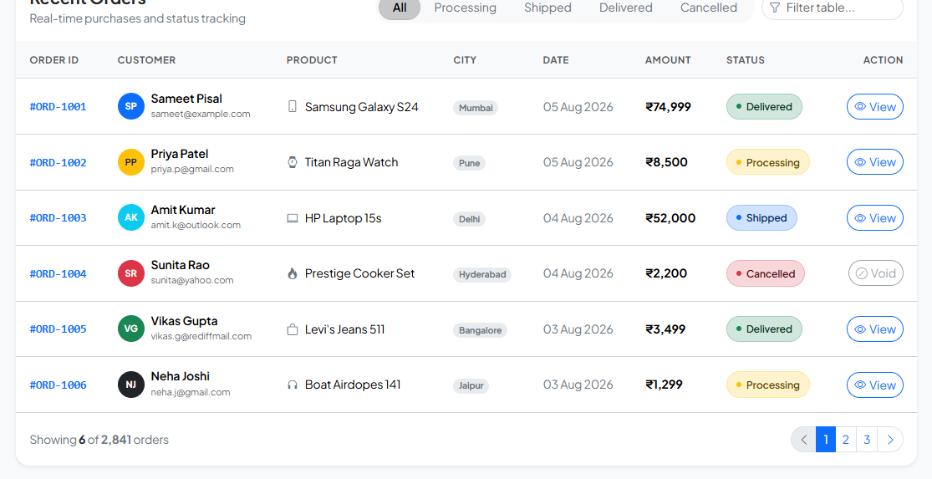
Figure 4: Recent Orders Data Table with Status Badges & Filtering
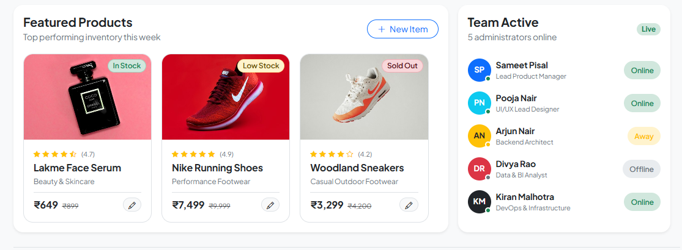
Figure 5: Featured Product Inventory Catalog & Active Team Status Module
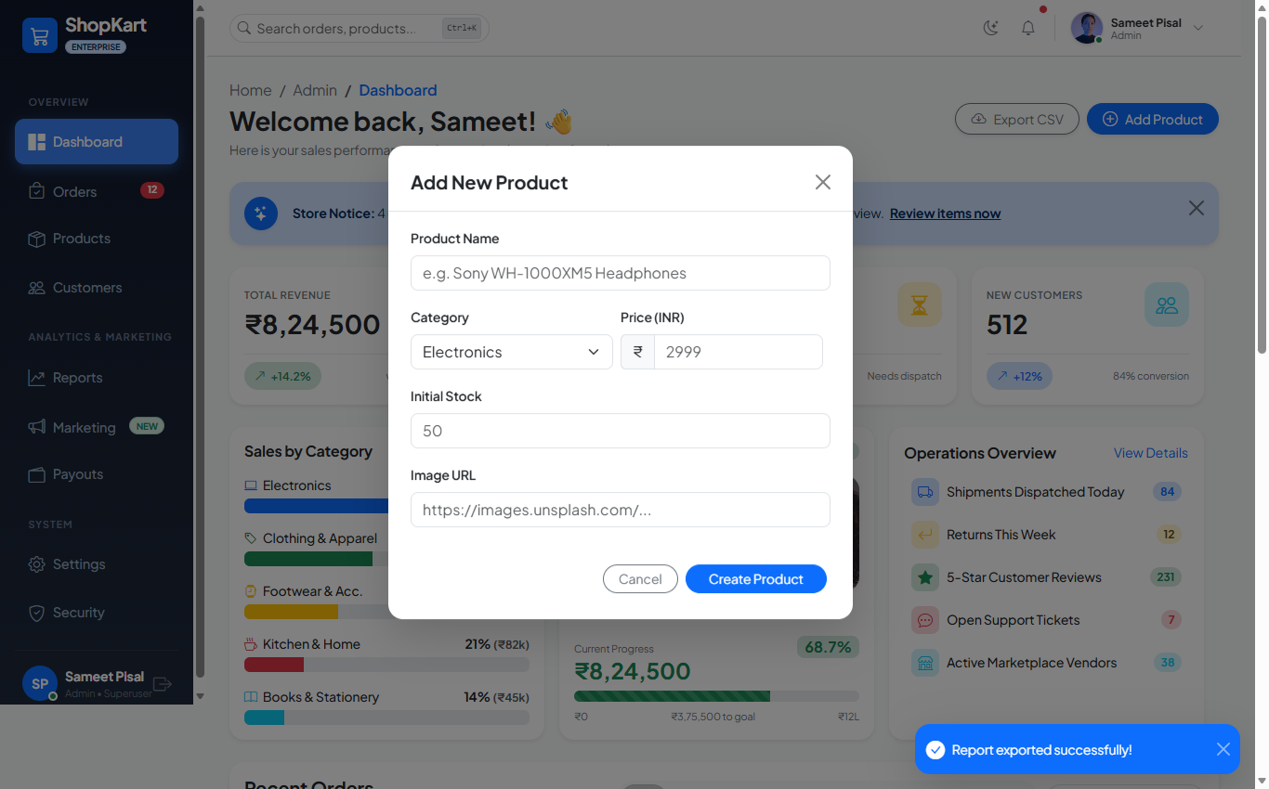
Figure 6: Interactive 'Add New Product' Modal Dialog & Toast Notification
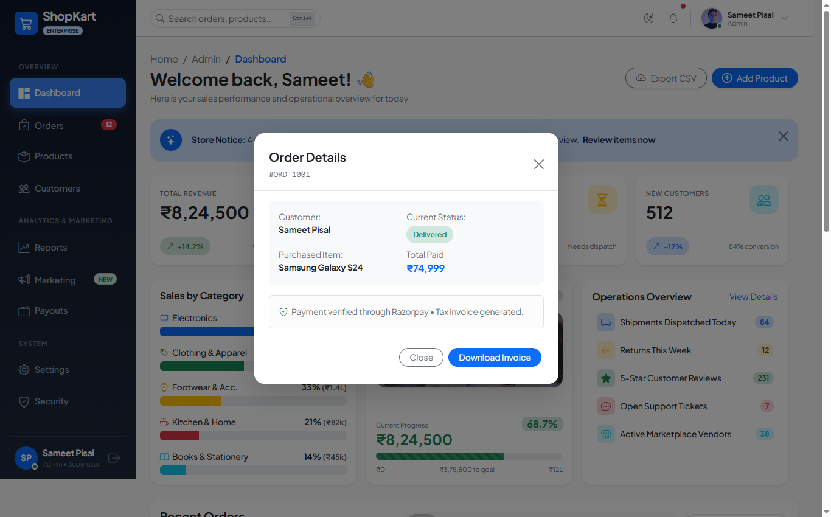
Figure 7: Interactive 'Order Details' Modal Dialog with Invoice Download
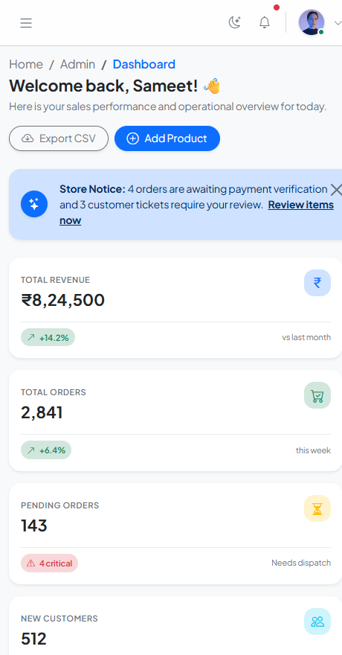
Figure 8: Mobile Responsive Viewport Layout (<576px Mobile Stacked View)
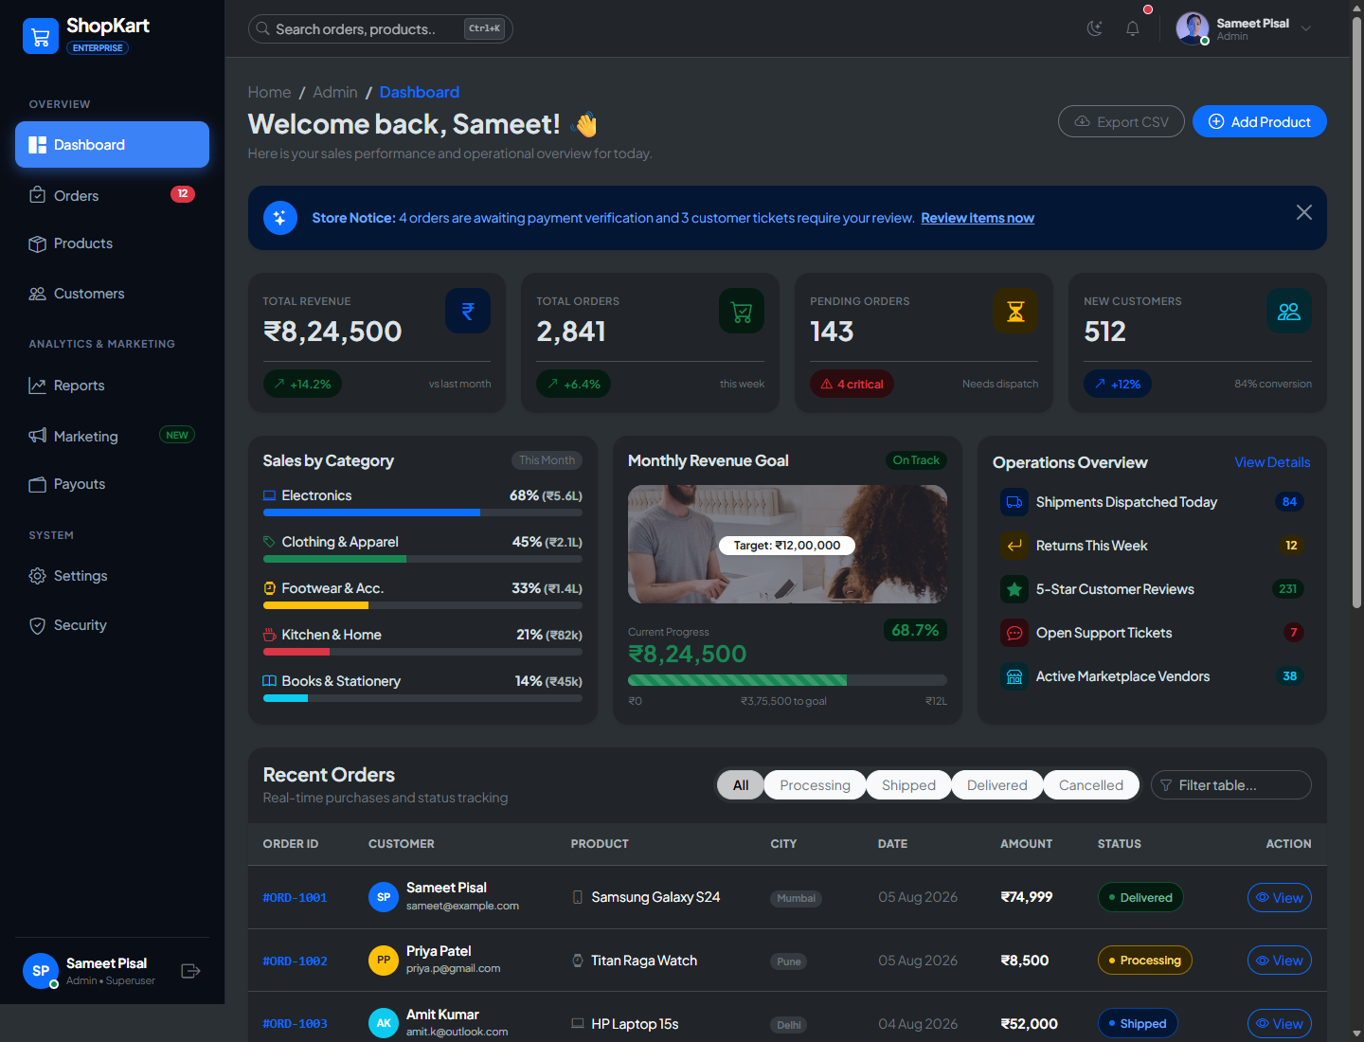
Figure 9: Full Desktop Dashboard Overview (Dark Theme)
4. CORE SOURCE CODE SNIPPETS
4.1 Responsive Layout & Persistent Sidebar Structure (HTML & Bootstrap):
<!-- 12-Column Responsive Layout with Sticky Desktop Sidebar -->
<div class="container-fluid p-0">
<div class="row g-0">
<!-- Desktop Sidebar (Hidden on Mobile) -->
<aside class="col-lg-2 d-none d-lg-flex flex-column sidebar-wrapper min-vh-100 p-3 position-sticky top-0">
<div class="d-flex align-items-center gap-2 mb-4">
<div class="bg-primary text-white p-2 rounded-3"><i class="bi bi-cart3 fs-5"></i></div>
<span class="text-white fw-bold fs-5">ShopKart</span>
</div>
<ul class="nav flex-column sidebar-nav gap-1 flex-grow-1">
<li class="nav-item"><a href="#" class="nav-link active"><i class="bi bi-grid-1x2-fill me-2"></i>Dashboard</a></li>
<li class="nav-item"><a href="#" class="nav-link"><i class="bi bi-bag-check me-2"></i>Orders</a></li>
<li class="nav-item"><a href="#" class="nav-link"><i class="bi bi-box-seam me-2"></i>Products</a></li>
</ul>
</aside>
<!-- Mobile Responsive Offcanvas Sidebar (<992px) -->
<div class="offcanvas offcanvas-start sidebar-wrapper" tabindex="-1" id="mobileSidebar">
<!-- Offcanvas Mobile Navigation Body -->
</div>
<!-- Main Dashboard Workspace -->
<main class="col-lg-10 col-12 min-vh-100 d-flex flex-column"> ... </main>
</div>
</div>

4.2 Statistics in Cards Markup (Bootstrap Card System):
<!-- Responsive KPI Statistics Cards Grid -->
<div class="row g-3 mb-4">
<div class="col-sm-6 col-xl-3">
<div class="card border-0 shadow-sm rounded-4 h-100 card-hover">
<div class="card-body p-3">
<div class="d-flex justify-content-between align-items-start mb-3">
<div>
<span class="text-secondary small fw-semibold text-uppercase">Total Revenue</span>
<h3 class="fw-bolder mb-0 mt-1">₹8,24,500</h3>
</div>
<div class="icon-box bg-primary-subtle text-primary">
<i class="bi bi-currency-rupee fs-4"></i>
</div>
</div>
<div class="d-flex align-items-center justify-content-between pt-2 border-top border-light-subtle">
<span class="status-badge bg-success-subtle text-success">
<i class="bi bi-arrow-up-right"></i> +14.2%
</span>
<span class="text-secondary small">vs last month</span>
</div>
</div>
</div>
</div>
</div>

4.3 Interactive Modals & Toast Handling (HTML & JavaScript):
<!-- Modal Dialog & Bootstrap Toast Handlers -->
<div class="modal fade" id="addProductModal" tabindex="-1">
<div class="modal-dialog modal-dialog-centered">
<div class="modal-content border-0 shadow-lg rounded-4">
<div class="modal-header border-bottom px-4 pt-4 pb-3">
<h5 class="modal-title fw-bold">Add New Product</h5>
<button type="button" class="btn-close" data-bs-dismiss="modal"></button>
</div>
<form id="newProductForm"> ... </form>
</div>
</div>
</div>
<script>
// Order Modal Dynamic Data Trigger
const viewButtons = document.querySelectorAll('.view-order-btn');
const orderModal = new bootstrap.Modal(document.getElementById('orderModal'));
viewButtons.forEach(btn => {
btn.addEventListener('click', () => {
document.getElementById('modalOrderId').textContent = btn.getAttribute('data-order');
document.getElementById('modalCustomerName').textContent = btn.getAttribute('data-customer');
document.getElementById('modalOrderItem').textContent = btn.getAttribute('data-item');
document.getElementById('modalOrderAmount').textContent = btn.getAttribute('data-amount');
orderModal.show();
});
});
</script>

4.4 Custom CSS Styling & Responsive Fixes (CSS3):
/* Clean Formal Dashboard CSS */
body {
font-family: 'Plus Jakarta Sans', system-ui, sans-serif;
background-color: var(--bs-tertiary-bg);
}
.sidebar-wrapper {
background: linear-gradient(180deg, #0f172a 0%, #1e293b 100%);
color: #94a3b8;
}
.card-hover {
transition: transform 0.22s ease, box-shadow 0.22s ease;
}
.card-hover:hover {
transform: translateY(-4px);
box-shadow: 0 12px 28px rgba(0, 0, 0, 0.09) !important;
}

5. CONCLUSION
A responsive e-commerce administration dashboard was successfully engineered using HTML5, CSS3, and Bootstrap 5.3. All requirements specified in the problem statement—including a persistent sidebar with mobile offcanvas support, responsive grid layout, key statistics presented in clean card components, and interactive modal dialogs—have been fully implemented and verified.

