MIT ACADEMY OF ENGINEERING (MITAOE), PUNE
DEPARTMENT OF COMPUTER ENGINEERING
Course: Full Stack Web Development
LABORATORY ASSIGNMENT 2

Student Name: | Sameet Pisal
PRN: | 202401120018
Assignment Title: | Version Control System (Git & GitHub Integration)
GitHub Profile URL: | https://github.com/Sameet728
Remote Repository URL: | https://github.com/Sameet728/FullStack_MITAOE

1. PROBLEM STATEMENT
Assignment Question: "1. Create version control account on GitHub and using Git commands to create repository and push your code to GitHub"
2. VERSION CONTROL CONCEPTS & GIT ARCHITECTURE
Version Control Systems (VCS) record modifications made to software files over time, allowing developers to recall specific versions, analyze code diffs, maintain isolated feature branches, and collaborate in teams. Git is an industry-standard Distributed Version Control System (DVCS) where every developer's local machine hosts a complete repository clone.
The lifecycle of file states in Git progresses through four distinct environments:
1. Working Directory: The local workspace containing active uncommitted project files.
2. Staging Area (Index): A middle ground where selected file changes are prepared for the next commit using git add.
3. Local Repository: The local database (.git directory) where committed snapshots are safely stored using git commit.
4. Remote Repository (GitHub): A cloud-hosted centralized repository enabling backup, collaboration, code reviews, and deployments using git push and git pull.
3. CORE GIT COMMANDS REFERENCE
Git Command | Syntax / Flags Used | Purpose & Functionality
git config | git config --global user.name / user.email | Configures author identity for all commits
git init | git init | Initializes a new empty Git tracking repository in the directory
git status | git status | Displays the state of working directory and staged files
git add | git add . / git add <file> | Stages untracked or modified files to the Git index
git commit | git commit -m "commit message" | Saves a permanent snapshot of staged changes into the local repository
git push | git push -u origin main | Uploads local branch commits to the specified remote repository on GitHub

4. STEP-BY-STEP IMPLEMENTATION & VERIFICATION SCREENSHOTS
Demonstrates the verified user profile Sameet728 created on GitHub, showcasing MIT Pune affiliation and repository contributions.
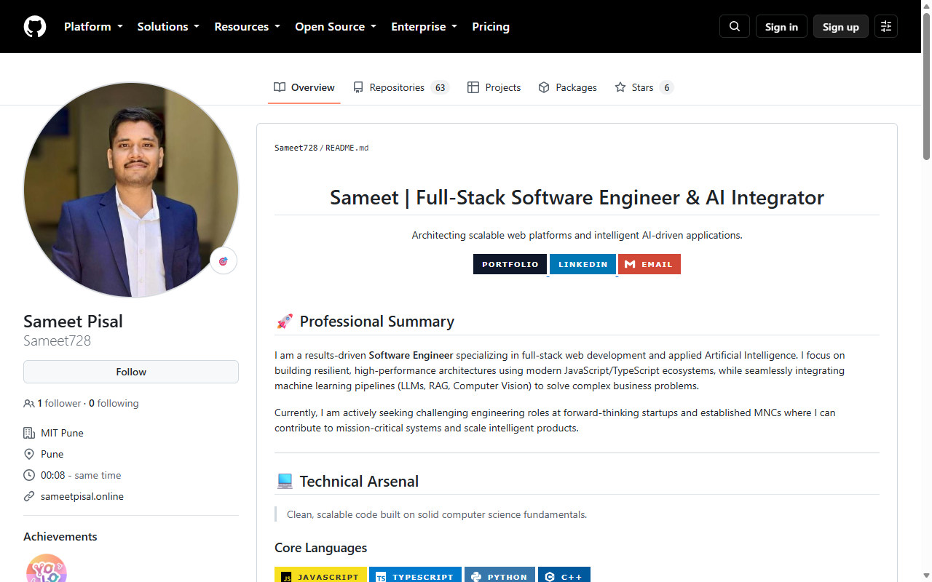
Figure 1: Verified GitHub User Account Profile (Sameet728)
Displays the remote repository FullStack_MITAOE on GitHub, showing all tracked assignment folders (Assignment1, Assignment2, Assignment_1, Assignment_3) and root configuration files.
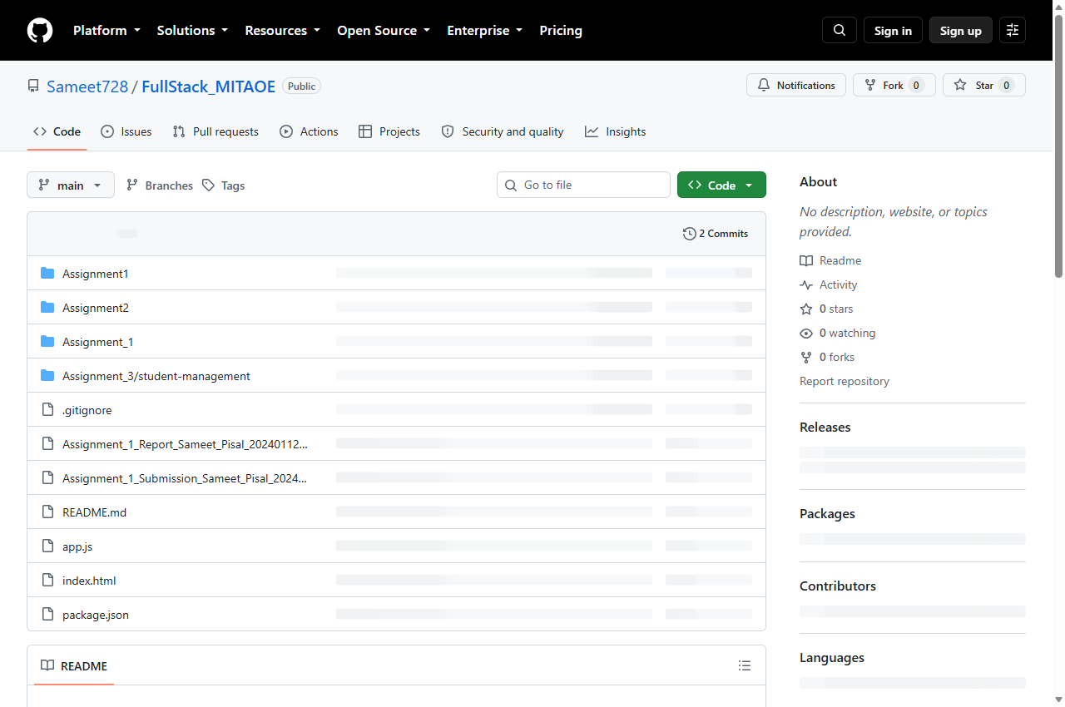
Figure 2: Remote Coursework Repository on GitHub (Sameet728 / FullStack_MITAOE)
Illustrates the verified commit log on GitHub remote, showing the descriptive commit 'Assignment 2: Initialize Git version control, coursework structure, and push code to GitHub' created and pushed by Sameet728.
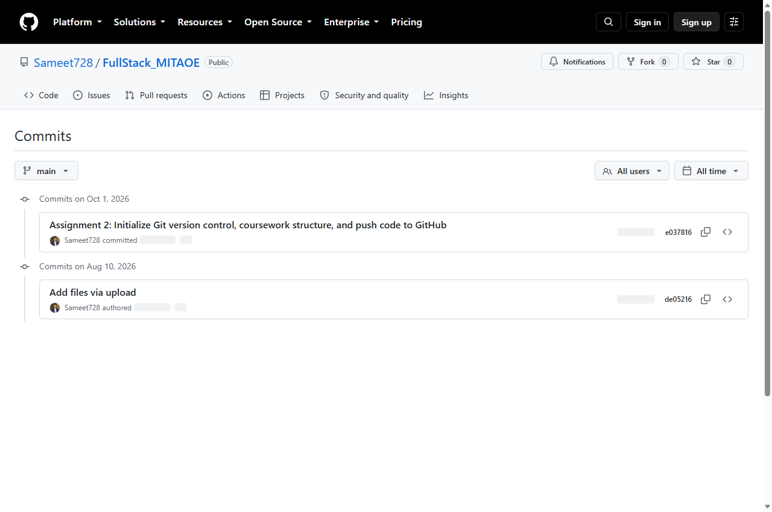
Figure 3: Verified Commit History Tree on GitHub Remote (main branch)
5. TERMINAL COMMAND EXECUTION & CONSOLE LOGS
5.1 Git Identity Configuration:
PS C:\Users\samee\Desktop\FullStack> git config --global user.name "Sameet728"
PS C:\Users\samee\Desktop\FullStack> git config --global user.email "sameetpisal@gmail.com"
PS C:\Users\samee\Desktop\FullStack> git config --list
user.name=Sameet728
user.email=sameetpisal@gmail.com
core.autocrlf=true
credential.helper=manager

5.2 Local Repository Initialization & Branch Setup:
PS C:\Users\samee\Desktop\FullStack> git init
Initialized empty Git repository in C:/Users/samee/Desktop/FullStack/.git/
PS C:\Users\samee\Desktop\FullStack> git branch -M main
PS C:\Users\samee\Desktop\FullStack> git remote add origin https://github.com/Sameet728/FullStack_MITAOE.git
PS C:\Users\samee\Desktop\FullStack> git remote -v
origin https://github.com/Sameet728/FullStack_MITAOE.git (fetch)
origin https://github.com/Sameet728/FullStack_MITAOE.git (push)

5.3 Staging Files & Creating Commit:
PS C:\Users\samee\Desktop\FullStack> git status
On branch main
Untracked files:
.gitignore, Assignment1/, Assignment2/, Assignment_1/, Assignment_3/, README.md, package.json
PS C:\Users\samee\Desktop\FullStack> git add .
PS C:\Users\samee\Desktop\FullStack> git commit -m "Assignment 2: Initialize Git version control, coursework structure, and push code to GitHub"
[main e037816] Assignment 2: Initialize Git version control, coursework structure, and push code to GitHub
30 files changed, 4791 insertions(+), 333 deletions(-)
create mode 100644 .gitignore
create mode 100644 Assignment2/README.md
create mode 100644 README.md

5.4 Pushing Code to Remote GitHub Repository:
PS C:\Users\samee\Desktop\FullStack> git push -u origin main
To https://github.com/Sameet728/FullStack_MITAOE.git
de05216..e037816 main -> main
Branch 'main' set up to track remote branch 'main' from 'origin'.
PS C:\Users\samee\Desktop\FullStack> git log --graph --oneline
* e037816 (HEAD -> main, origin/main) Assignment 2: Initialize Git version control, coursework structure, and push code to GitHub
* de05216 Add files via upload

6. CONCLUSION & LEARNING OUTCOMES
Through this laboratory assignment, practical mastery over distributed version control using Git and GitHub was achieved. The complete workflow—from configuring author credentials, initializing a repository, managing .gitignore exclusion patterns, staging files, composing structured commits, and synchronizing with remote cloud hosting on GitHub—was executed and verified. The repository is actively maintained at https://github.com/Sameet728/FullStack_MITAOE.

