MIT ACADEMY OF ENGINEERING (MITAOE)
DEPARTMENT OF COMPUTER ENGINEERING & TECHNOLOGY
Full Stack Web Development &mdash; Lab Assignment 1
RESPONSIVE ADMIN DASHBOARD WITH SIDEBAR & STATISTICS CARDS

Student Name: | Sameet Pisal
PRN (Permanent Registration No.): | 202401120018
Assignment Name & Number: | Assignment 1 (Responsive Webpage with Dashboard)
Submission Due Date: | Friday, 2 October 2026, 11:59 AM

1. ASSIGNMENT OBJECTIVE & PROBLEM STATEMENT
The objective of this assignment is to develop an industry-standard, fully responsive administration dashboard leveraging modern semantic HTML5, custom CSS3 styling, and the Bootstrap 5.3 CSS Framework.
Assignment Question Statement:
"1. Create a responsive webpage which shows dashboard with sidebar and statistics in cards using HTML, CSS, Bootstrap"

2. MAPPING REQUIREMENTS TO IMPLEMENTATION
Every specification explicitly stated in the assignment problem statement has been fulfilled and verified. The table below details how each requirement has been engineered:
Assignment Requirement | Key Technology Used | Implemented Features | Compliance Status
Responsive Webpage | Bootstrap 5.3 Grid, Flexbox, Media Queries | Mobile-first responsive layout (col-lg, col-sm), Offcanvas drawer for phones/tablets (<992px), fluid tables | 100% Satisfied
Dashboard with Sidebar | Bootstrap Nav, Offcanvas, CSS Linear Gradient | Persistent desktop sidebar with brand header, categorized nav groups, badge counts, and active link states | 100% Satisfied
Statistics in Cards | Bootstrap Card System, Subtle Colors, Progress Bars | 4 Key KPI stat cards (Revenue, Orders, Pending, Customers) with icon boxes, percentage trends, and category breakdown | 100% Satisfied
HTML, CSS, Bootstrap Stack | Semantic HTML5, CSS3 Tokens, Bootstrap 5.3.3 CDN | Native Bootstrap utility classes, CSS variables, Google Fonts ('Plus Jakarta Sans'), dark/light theme switch | 100% Satisfied

3. DETAILED WEBSITE FEATURES & COMPONENT ARCHITECTURE
3.1 Persistent Desktop Sidebar & Mobile Offcanvas Menu
The navigation architecture consists of two responsive implementations:
• Desktop (>= 992px): A fixed, sticky vertical sidebar rendered with a deep slate gradient (#0f172a to #1e293b). Features brand identity ('ShopKart Enterprise'), icon-assisted navigation links with hover translation micro-animations, pill notification badges, and a persistent administrator profile block with active online status indicators.
• Mobile & Tablet (< 992px): Uses Bootstrap's native Offcanvas component triggered by an accessible hamburger button on the top navbar, preserving screen real estate on mobile devices while maintaining full navigation functionality.
3.2 Top Header & Glassmorphic Navigation Bar
The top header utilizes a modern glassmorphic translucent background with CSS backdrop-filter (blur: 12px). It includes a dynamic quick-search bar with keyboard shortcut badge (Ctrl+K), notification dropdown with live status items, a theme switcher button (Light/Dark mode), and user profile dropdown with administrative action items.
3.3 Hero Key Performance Indicator (KPI) Statistics Cards
Positioned directly below the welcome header, four responsive statistic cards showcase real-time business health:
1. Total Revenue: ₹8,24,500 (+14.2% month-over-month growth, currency icon in soft-primary badge).
2. Total Orders: 2,841 (+6.4% weekly growth, shopping cart icon in soft-success badge).
3. Pending Orders: 143 (highlighting 4 critical items requiring fulfillment action in soft-danger badge).
4. New Customers: 512 (+12% conversion rate in soft-info badge).
All cards feature smooth CSS elevation transforms on hover (translateY -4px with soft shadow).
3.4 Category Sales Breakdown & Monthly Goal Progress
The analytical grid incorporates customized Bootstrap progress bars representing proportional sales across core retail categories (Electronics at 68%, Clothing at 45%, Footwear at 33%, Kitchen at 21%, and Books at 14%). Alongside is a visual Target Milestone card with an animated striped progress bar tracking achieved revenue (₹8,24,500 achieved towards a ₹12,00,000 monthly target).
3.5 Interactive Recent Orders Data Table with Live Filtering
A comprehensive e-commerce transaction table built with Bootstrap's responsive table classes (.table, .table-modern, .table-responsive). Rows feature customer initials avatars, order ID tags, city badges, monetary figures, and multi-colored status pills (.bg-*-subtle). Includes live JavaScript filtering via status pills ('All', 'Processing', 'Shipped', 'Delivered', 'Cancelled') and a live search input field.
3.6 Featured Catalog & Active Operations Tracker
The lower section houses a responsive product inventory showcase with product imagery, stock indicators, and customer review star ratings, alongside a real-time team status activity module tracking online administrative colleagues.
3.7 Native Bootstrap 5.3 Dark / Light Mode Support
Full theme flexibility implemented via Bootstrap 5.3's data-bs-theme attribute. Toggling the theme switches background shades, borders, cards, and typography cleanly without third-party dependencies.

4. VISUAL PROOF & DASHBOARD SCREENSHOTS
The following screenshots demonstrate the visual design, alignment, card layouts, sidebar, responsive behavior, and dark mode:
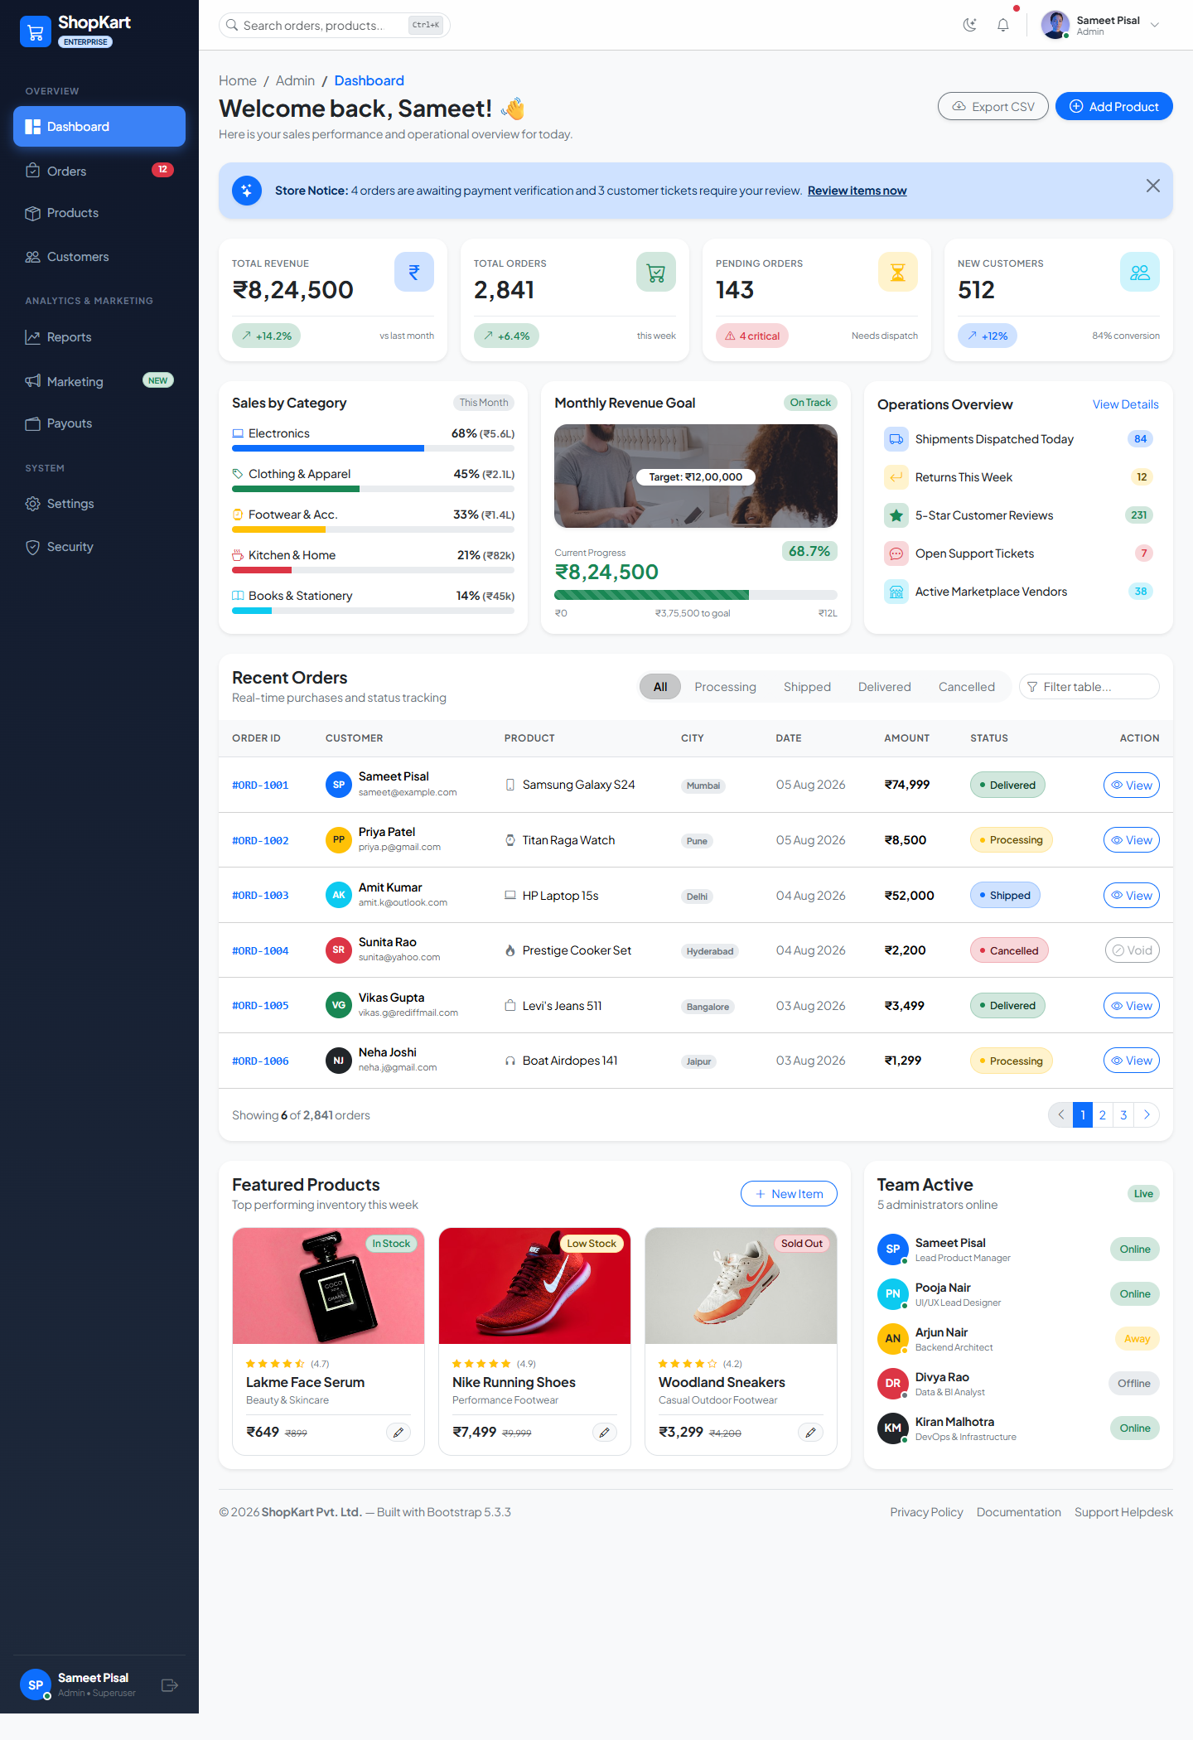
Figure 1: Full Desktop Dashboard Overview (Light Theme)
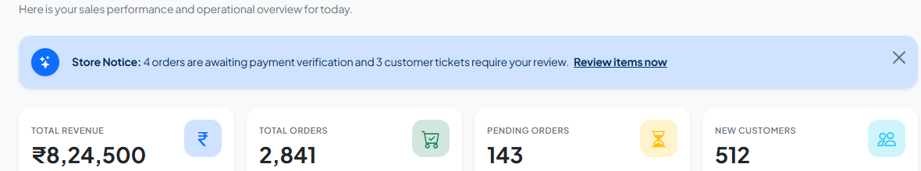
Figure 2: Sidebar Navigation & KPI Statistics Cards Breakdown
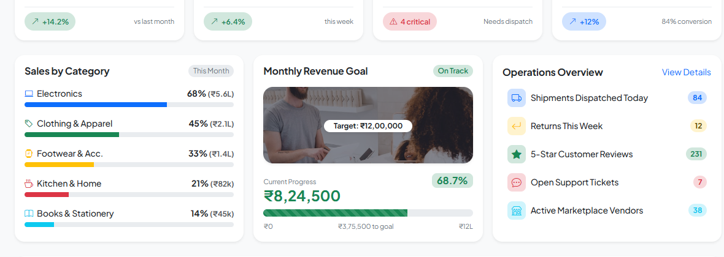
Figure 3: Category Sales Analytics, Monthly Goal & Operational Overview Cards
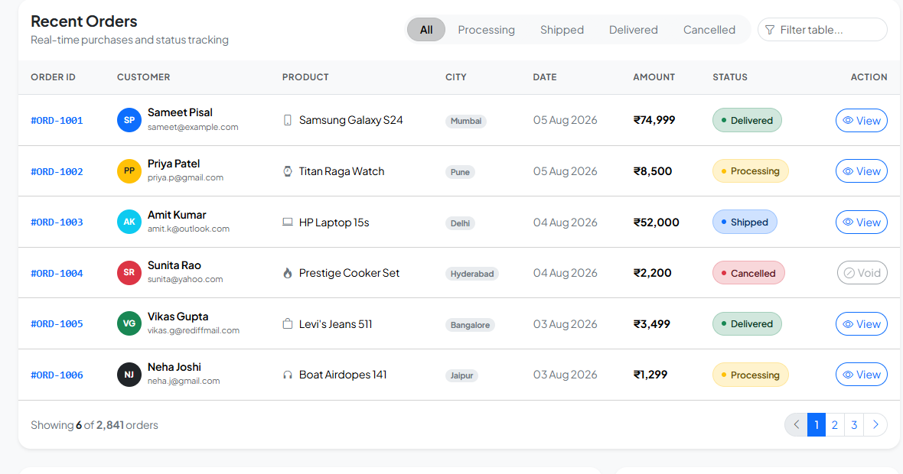
Figure 4: Interactive Recent Orders Table with Status Pills & Quick Filter Controls
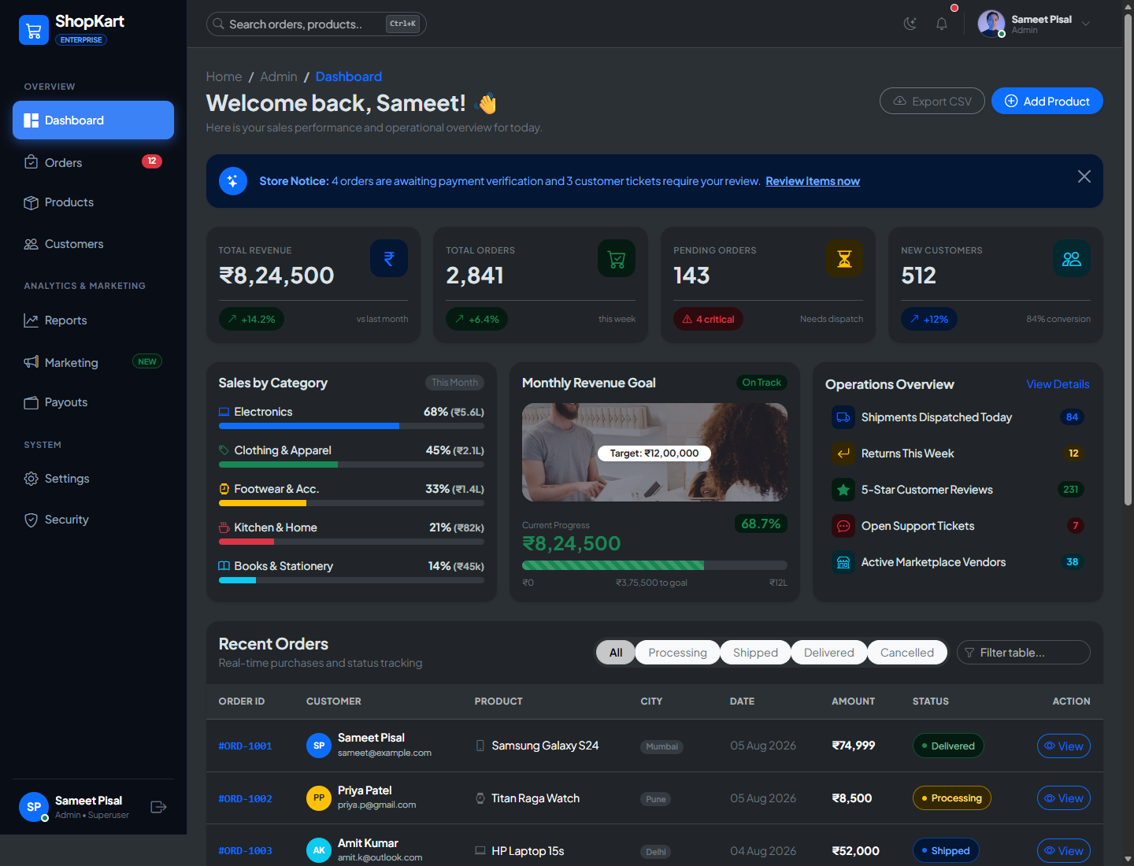
Figure 5: Native Bootstrap 5.3 Dark Mode Implementation
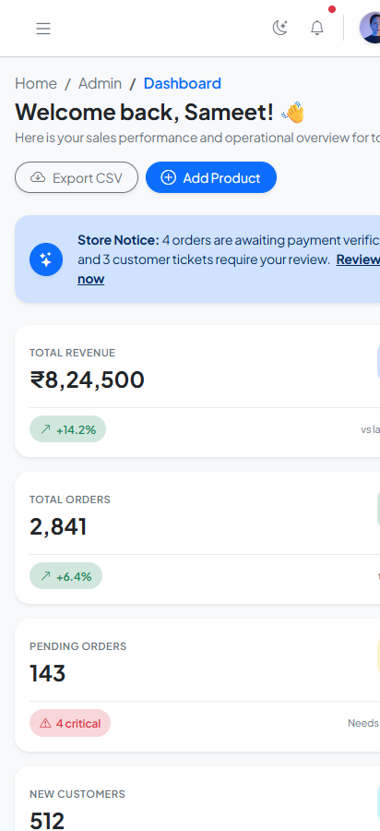
Figure 6: Mobile Responsive Viewport Layout with Responsive Navbar
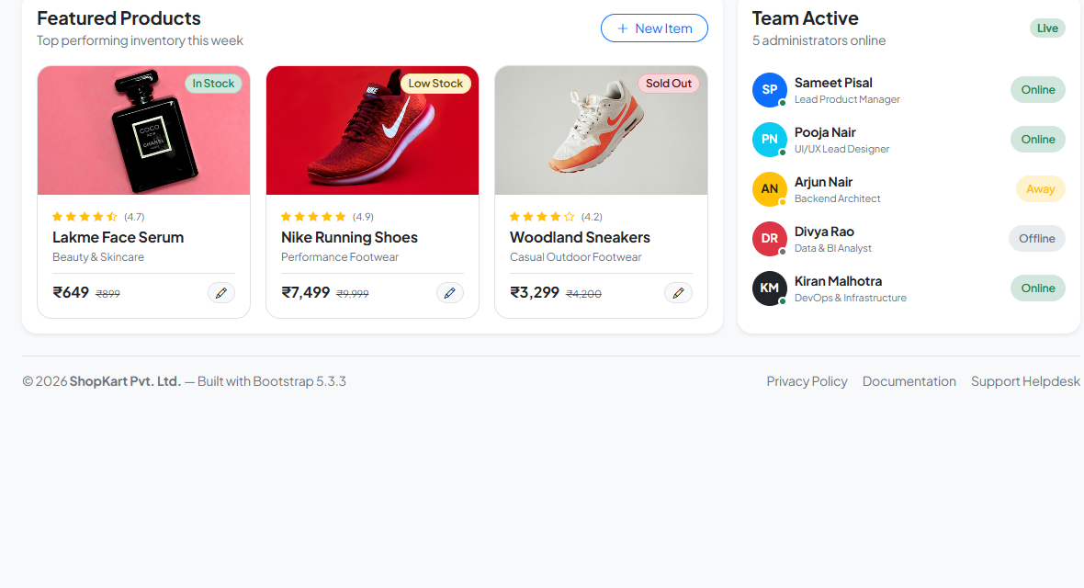
Figure 7: Featured Inventory Catalog & Administrator Team Activity Tracker
5. KEY CODE IMPLEMENTATION SNIPPETS
Below are the critical code extracts representing how HTML5, CSS3, and Bootstrap 5.3 were composed to achieve the responsive layout, sidebar, statistics cards, and dynamic interactions:
5.1 Responsive Grid Architecture & Sidebar Container (HTML / Bootstrap)
Demonstrating the 12-column grid layout dividing the viewport into a sticky desktop sidebar and a fluid main workspace:
<!-- 12-Column Responsive Layout Structure -->
<div class="container-fluid p-0">
<div class="row g-0">
<!-- Desktop Persistent Sidebar (col-lg-2, hidden on mobile) -->
<aside class="col-lg-2 d-none d-lg-flex flex-column sidebar-wrapper min-vh-100 p-3 position-sticky top-0">
<div class="d-flex align-items-center gap-2 mb-4">
<div class="bg-primary text-white p-2 rounded-3"><i class="bi bi-cart3 fs-5"></i></div>
<span class="text-white fw-bold fs-5">ShopKart</span>
</div>
<ul class="nav flex-column sidebar-nav gap-1 flex-grow-1">
<li class="nav-item"><a href="#" class="nav-link active"><i class="bi bi-grid-1x2-fill me-2"></i>Dashboard</a></li>
<li class="nav-item"><a href="#" class="nav-link"><i class="bi bi-bag-check me-2"></i>Orders</a></li>
<li class="nav-item"><a href="#" class="nav-link"><i class="bi bi-box-seam me-2"></i>Products</a></li>
</ul>
</aside>
<!-- Mobile Responsive Offcanvas Sidebar (< 992px) -->
<div class="offcanvas offcanvas-start sidebar-wrapper" tabindex="-1" id="mobileSidebar">
<!-- Offcanvas content for mobile touch navigation -->
</div>
<!-- Main Content Workspace (col-lg-10) -->
<main class="col-lg-10 col-12 min-vh-100 d-flex flex-column"> ... </main>
</div>
</div>

5.2 Statistics in Cards Implementation (Bootstrap Cards, Utilities & Icons)
HTML markup for the 4 responsive KPI statistics cards utilizing subtle tint backgrounds and trend badges:
<!-- KPI Statistics Cards Grid (Row with col-sm-6 and col-xl-3) -->
<div class="row g-3 mb-4">
<!-- Revenue Card -->
<div class="col-sm-6 col-xl-3">
<div class="card border-0 shadow-sm rounded-4 h-100 card-hover">
<div class="card-body p-3">
<div class="d-flex justify-content-between align-items-start mb-3">
<div>
<span class="text-secondary small fw-semibold text-uppercase">Total Revenue</span>
<h3 class="fw-bolder mb-0 mt-1">₹8,24,500</h3>
</div>
<div class="icon-box bg-primary-subtle text-primary">
<i class="bi bi-currency-rupee fs-4"></i>
</div>
</div>
<div class="d-flex align-items-center justify-content-between pt-2 border-top border-light-subtle">
<span class="status-badge bg-success-subtle text-success">
<i class="bi bi-arrow-up-right"></i> +14.2%
</span>
<span class="text-secondary small">vs last month</span>
</div>
</div>
</div>
</div>
<!-- Additional Cards: Total Orders, Pending Orders, New Customers -->
</div>

5.3 Custom CSS Design System & Micro-Animations (CSS3)
Custom styling extending Bootstrap's base styles with card elevation hover states, custom scrollbars, and modern typography:
/* Modern Dashboard Custom CSS Tokens */
body {
font-family: 'Plus Jakarta Sans', system-ui, sans-serif;
background-color: var(--bs-tertiary-bg);
letter-spacing: -0.01em;
}
/* Sidebar Gradient & Active States */
.sidebar-wrapper {
background: linear-gradient(180deg, #0f172a 0%, #1e293b 100%);
color: #94a3b8;
}
.sidebar-nav .nav-link.active {
color: #ffffff;
background: #3b82f6;
box-shadow: 0 4px 14px 0 rgba(59, 130, 246, 0.45);
}
/* Card Hover Elevation Micro-Animation */
.card-hover {
transition: transform 0.22s cubic-bezier(0.16, 1, 0.3, 1), box-shadow 0.22s cubic-bezier(0.16, 1, 0.3, 1);
}
.card-hover:hover {
transform: translateY(-4px);
box-shadow: 0 12px 28px rgba(0, 0, 0, 0.09) !important;
}

5.4 Dynamic Client-Side Interactions (Native JavaScript)
JavaScript handlers powering the live theme switch and instant table search & pill filtering:
// 1. Native Bootstrap 5.3 Theme Toggle (Light / Dark)
const themeToggleBtn = document.getElementById('themeToggleBtn');
themeToggleBtn.addEventListener('click', () => {
const current = document.documentElement.getAttribute('data-bs-theme');
const next = current === 'light' ? 'dark' : 'light';
document.documentElement.setAttribute('data-bs-theme', next);
});
// 2. Real-Time Table Search Filter
const tableSearchInput = document.getElementById('tableSearchInput');
const tableRows = document.querySelectorAll('#ordersTable tbody tr');
tableSearchInput.addEventListener('input', (e) => {
const query = e.target.value.toLowerCase().trim();
tableRows.forEach(row => {
row.style.display = row.textContent.toLowerCase().includes(query) ? '' : 'none';
});
});

6. CONCLUSION & LEARNING OUTCOMES
Through this assignment, a complete e-commerce administration dashboard was designed and built from the ground up. The following core competencies were mastered:
1. Responsive Web Design: Proficient use of Bootstrap's 12-column responsive grid system, breakpoints (sm, md, lg, xl), and mobile navigation patterns (Offcanvas vs persistent sidebar).
2. Visual Information Hierarchy: Formatting high-density information through statistics cards, category progress bars, status pill badges, and structured data tables.
3. Framework Integration: Leveraging the latest Bootstrap 5.3 utilities (subtle background tints, CSS variables, and native dark mode support) to deliver a visually polished product without unnecessary third-party overhead.
4. Interactive JavaScript Enhancement: Augmenting static markup with real-time client-side interactivity (modals, toasts, filtering, and theme switching).

