MIT ACADEMY OF ENGINEERING (MITAOE), PUNE
DEPARTMENT OF COMPUTER ENGINEERING
Course: Full Stack Web Development
LABORATORY ASSIGNMENT 1

Student Name: | Sameet Pisal
PRN: | 202401120018
Assignment Title: | Responsive Admin Dashboard with Sidebar & Statistics Cards

1. PROBLEM STATEMENT
Assignment Question: "1. Create a responsive webpage which shows dashboard with sidebar and statistics in cards using HTML, CSS, Bootstrap"
2. IMPLEMENTATION SUMMARY
The project implements a modern, fully responsive administrative web dashboard using HTML5, CSS3, and the Bootstrap 5.3 framework. Key components developed to satisfy the assignment objectives include:
• Responsive Sidebar Navigation: A fixed vertical navigation sidebar on desktop (>=992px) with branding, grouped links, notification badges, and administrator profile. On smaller screens (<992px), it transitions into an offcanvas mobile drawer accessible via a hamburger menu button.
• Statistics in Cards (KPI Metrics): Four primary key performance indicator (KPI) cards displaying Total Revenue (₹8,24,500), Total Orders (2,841), Pending Orders (143), and New Customers (512) with custom subtle-tinted icon containers and percentage change indicators.
• Analytical & Progress Overview: Custom category sales progress indicators and a monthly revenue milestone goal tracker.
• Interactive Recent Orders Table: A responsive data table with status pill badges, live search filtering, and client-side status filter controls.
• Responsive Design & Theme Support: Built strictly using Bootstrap 5.3 utilities, responsive grid columns (col-lg, col-sm, col-12), and native dark/light theme switching.
3. DASHBOARD OUTPUT & SCREENSHOTS
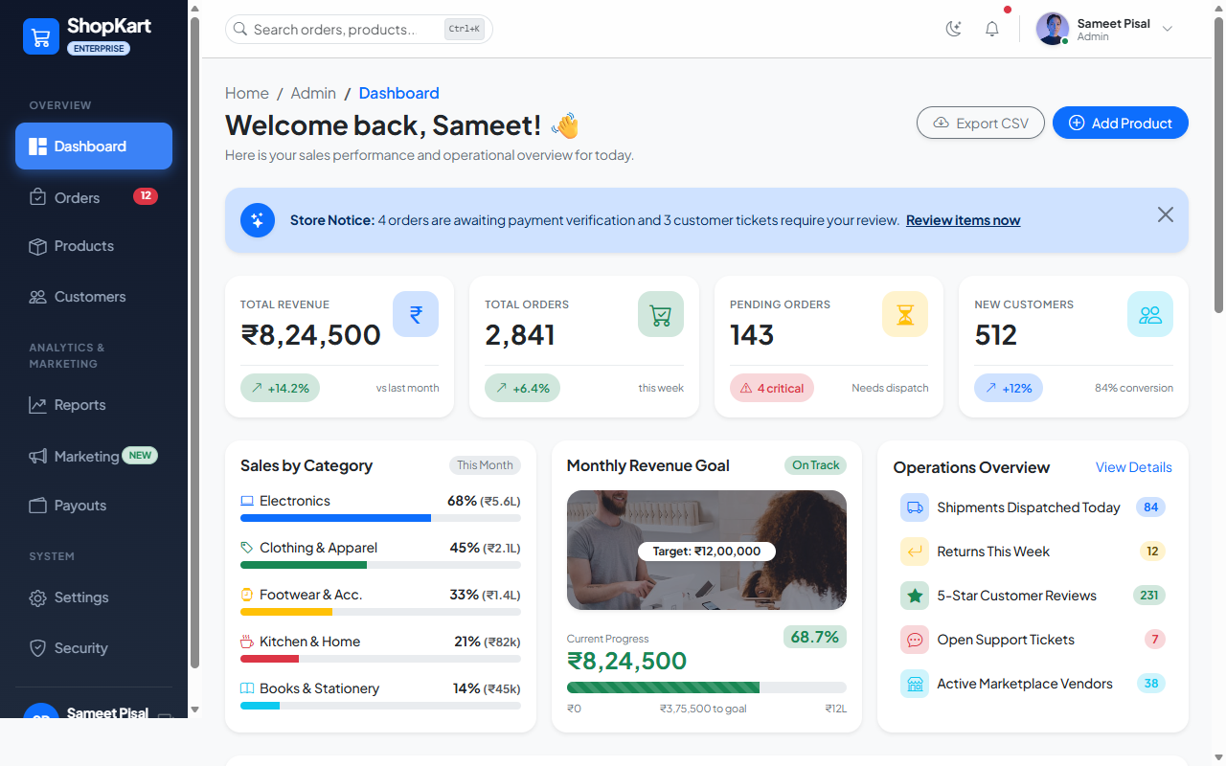
Figure 1: Full Desktop Dashboard Overview (Light Theme)
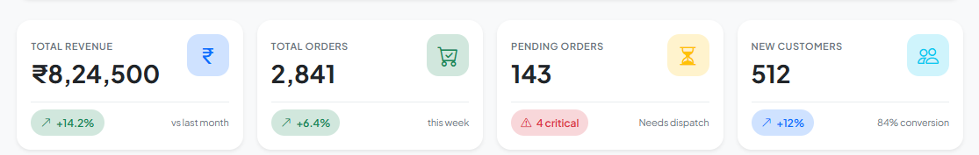
Figure 2: Statistics in Cards (Key Performance Indicators)
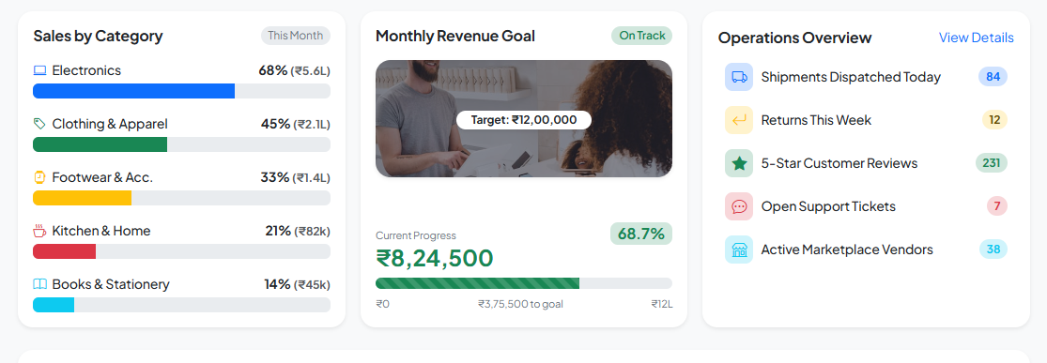
Figure 3: Category Sales Analytics & Operational Overview
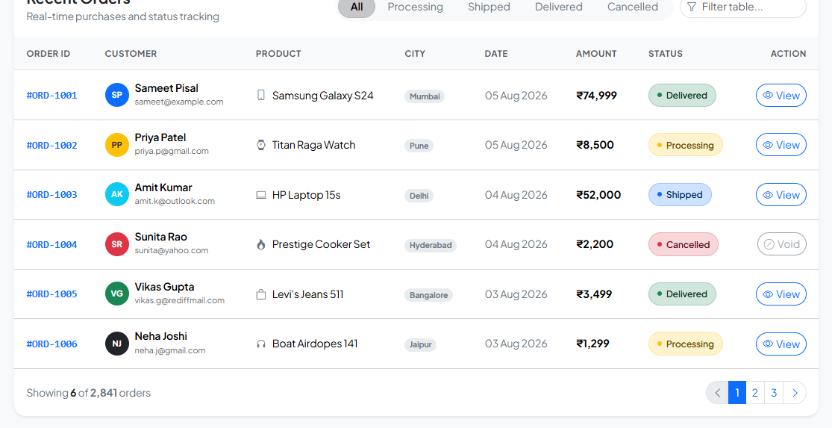
Figure 4: Recent Orders Data Table with Status Badges
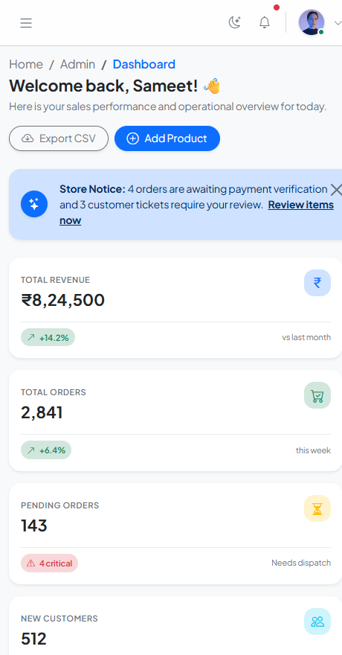
Figure 5: Mobile Responsive Layout Viewport (<576px Stacked View)
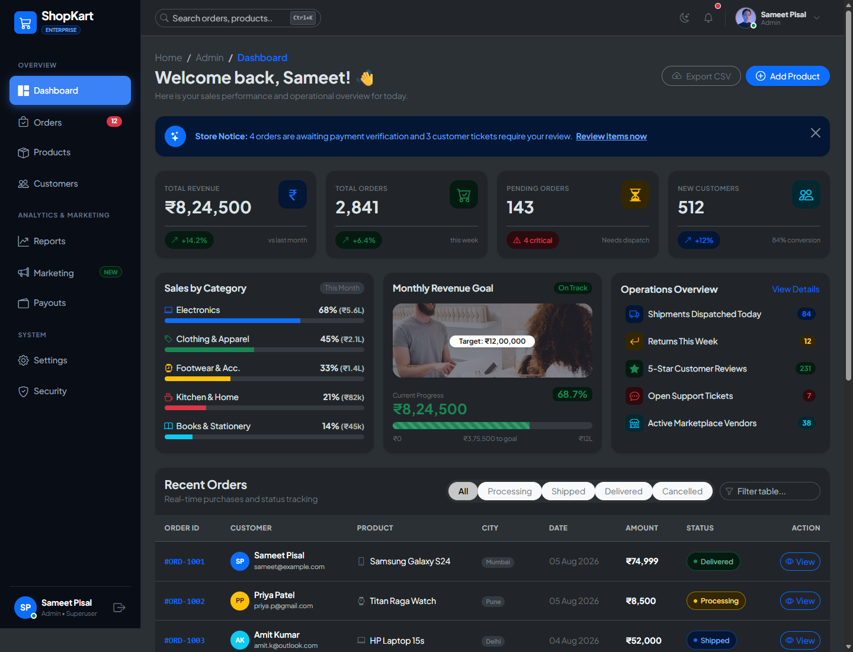
Figure 6: Full Desktop Dashboard Overview (Dark Theme)
4. CORE SOURCE CODE SNIPPETS
4.1 Responsive Layout & Sidebar Structure (HTML & Bootstrap):
<!-- 12-Column Responsive Layout with Sticky Desktop Sidebar -->
<div class="container-fluid p-0">
<div class="row g-0">
<!-- Desktop Sidebar (Hidden on Mobile) -->
<aside class="col-lg-2 d-none d-lg-flex flex-column sidebar-wrapper min-vh-100 p-3 position-sticky top-0">
<div class="d-flex align-items-center gap-2 mb-4">
<div class="bg-primary text-white p-2 rounded-3"><i class="bi bi-cart3 fs-5"></i></div>
<span class="text-white fw-bold fs-5">ShopKart</span>
</div>
<ul class="nav flex-column sidebar-nav gap-1 flex-grow-1">
<li class="nav-item"><a href="#" class="nav-link active"><i class="bi bi-grid-1x2-fill me-2"></i>Dashboard</a></li>
<li class="nav-item"><a href="#" class="nav-link"><i class="bi bi-bag-check me-2"></i>Orders</a></li>
<li class="nav-item"><a href="#" class="nav-link"><i class="bi bi-box-seam me-2"></i>Products</a></li>
</ul>
</aside>
<!-- Mobile Responsive Offcanvas Sidebar (<992px) -->
<div class="offcanvas offcanvas-start sidebar-wrapper" tabindex="-1" id="mobileSidebar">
<!-- Offcanvas Mobile Navigation Body -->
</div>
<!-- Main Dashboard Workspace -->
<main class="col-lg-10 col-12 min-vh-100 d-flex flex-column"> ... </main>
</div>
</div>

4.2 Statistics in Cards Markup (Bootstrap Card Utilities):
<!-- Responsive KPI Statistics Cards -->
<div class="row g-3 mb-4">
<div class="col-sm-6 col-xl-3">
<div class="card border-0 shadow-sm rounded-4 h-100 card-hover">
<div class="card-body p-3">
<div class="d-flex justify-content-between align-items-start mb-3">
<div>
<span class="text-secondary small fw-semibold text-uppercase">Total Revenue</span>
<h3 class="fw-bolder mb-0 mt-1">₹8,24,500</h3>
</div>
<div class="icon-box bg-primary-subtle text-primary">
<i class="bi bi-currency-rupee fs-4"></i>
</div>
</div>
<div class="d-flex align-items-center justify-content-between pt-2 border-top border-light-subtle">
<span class="status-badge bg-success-subtle text-success">
<i class="bi bi-arrow-up-right"></i> +14.2%
</span>
<span class="text-secondary small">vs last month</span>
</div>
</div>
</div>
</div>
</div>

4.3 Custom CSS Styling & Responsive Handling (CSS3):
/* Clean Formal Dashboard CSS */
body {
font-family: 'Plus Jakarta Sans', system-ui, sans-serif;
background-color: var(--bs-tertiary-bg);
}
.sidebar-wrapper {
background: linear-gradient(180deg, #0f172a 0%, #1e293b 100%);
color: #94a3b8;
}
.sidebar-nav .nav-link.active {
color: #ffffff;
background: #3b82f6;
box-shadow: 0 4px 14px 0 rgba(59, 130, 246, 0.45);
}
.card-hover {
transition: transform 0.22s ease, box-shadow 0.22s ease;
}
.card-hover:hover {
transform: translateY(-4px);
box-shadow: 0 12px 28px rgba(0, 0, 0, 0.09) !important;
}

4.4 Native Bootstrap 5.3 Theme Switcher (JavaScript):
// Light / Dark Mode Toggle using Bootstrap 5.3 data-bs-theme
const themeToggleBtn = document.getElementById('themeToggleBtn');
themeToggleBtn.addEventListener('click', () => {
const current = document.documentElement.getAttribute('data-bs-theme');
const next = current === 'light' ? 'dark' : 'light';
document.documentElement.setAttribute('data-bs-theme', next);
});

5. CONCLUSION
A responsive e-commerce administration dashboard was successfully engineered using HTML5, CSS3, and Bootstrap 5.3. All requirements specified in the problem statement—including a persistent sidebar with mobile offcanvas support, responsive grid layout, and key statistics presented in clean card components—have been fully implemented and verified.

