Name : Sameh Raouf Helmy

E-mail : [samehraouf2000@gmail.com](mailto:samehraouf2000@gmail.com)

------------------------------------------------------------------------------------------------------------------------------------------

Order Fulfillment Process Case Study

**Proposed Organizational Chart of the Company**

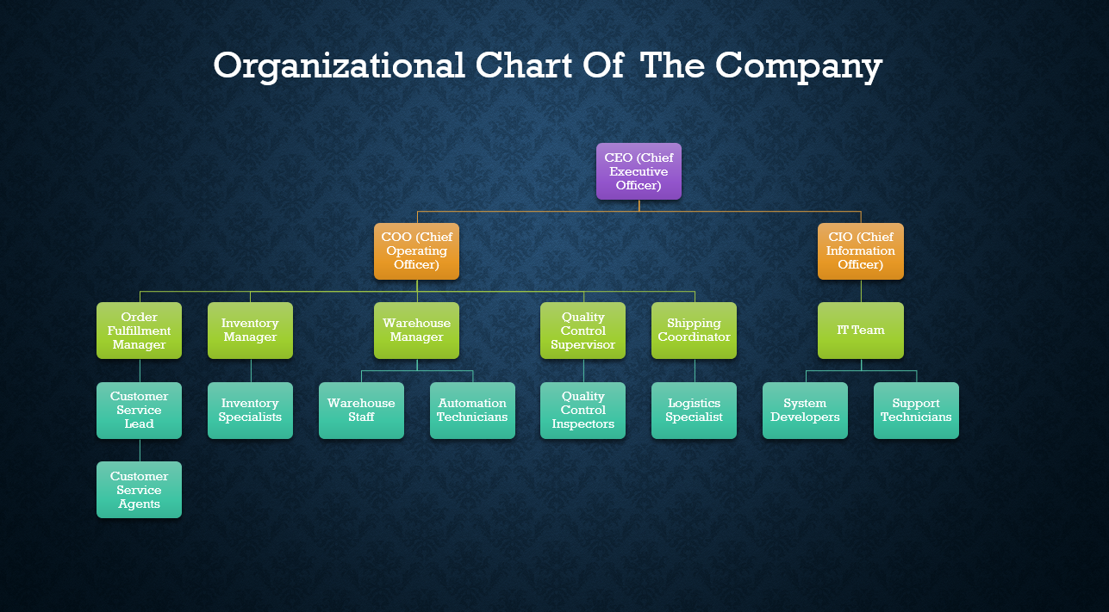

**1. Executive Level**

* **CEO (Chief Executive Officer)**
  + Provides strategic leadership, oversees company performance, and ensures alignment with the business goals.
* **COO (Chief Operating Officer)**
  + Manages day-to-day operations, including the order fulfillment process, ensuring efficiency and meeting customer demands.
* **CIO (Chief Information Officer)**
  + Oversees the implementation and maintenance of automated systems, ensuring smooth integration of technology in operations.

**2. Operations Division**

* **Order Fulfillment Manager**
  + Oversees the entire order fulfillment process, ensuring inter-departmental coordination to meet customer expectations.
  + **Reports to:** COO

**3. Functional Teams**

**a. Customer Service Department**

* **Customer Service Lead**
  + Supervises customer service agents and manages escalations or discrepancies in order details.
* **Customer Service Agents**
  + Verify customer details, confirm payments, and communicate with customers regarding order updates, issues, or delays.

**b. Inventory Management Department**

* **Inventory Manager**
  + Ensures accurate real-time stock tracking, manages inventory allocation, and avoids stockouts.
* **Inventory Specialists**
  + Update stock levels, check product availability, and coordinate with the warehouse team for inventory fulfillment.

**c. Warehouse Operations**

* **Warehouse Manager**
  + Supervises warehouse operations, including item gathering, packing, and labeling.
* **Warehouse Staff**
  + Pick, pack, and label orders accurately to match order details.
* **Automation Technicians**
  + Maintain and troubleshoot automation systems used in warehouse operations.

**d. Quality Control Department**

* **Quality Control Supervisor**
  + Ensures quality standards are met and oversees the final inspection process.
* **Quality Control Inspectors**
  + Perform manual and automated checks to verify the accuracy, quantity, and condition of orders.

**e. Shipping Department**

* **Shipping Coordinator**
  + Assigns carriers, generates shipping labels, and updates shipment details in the system.
* **Logistics Specialist**
  + Monitors deliveries, updates tracking systems, and ensures on-time order delivery.

**f. IT Team (Under CIO)**

* **System Developers**
  + Develop and maintain automated systems that streamline operations and improve efficiency.
* **Support Technicians**
  + Provide technical support to departments, ensuring smooth system functionality and resolving issues.

------------------------------------------------------------------------------------------------------------------------------------------

Current State Process Management Diagram (As-Is)

The following BPMN diagram represents the current state of the **E-commerce Order Fulfillment** process:

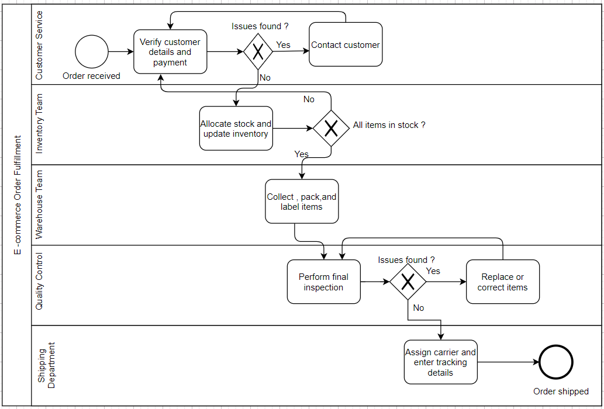

**Key Processes Explained**

1. **Customer Service**
   * Verifies customer details and payment information.
   * If issues arise, they contact the customer directly.
2. **Inventory Team**
   * Allocates stock and updates inventory records.
   * Confirms if all ordered items are in stock.
3. **Warehouse Team**
   * Collects, packs, and labels items for shipping.
4. **Quality Control**
   * Performs a final inspection to identify any issues with the items.
   * If issues are found, items are replaced or corrected before proceeding.
5. **Shipping Department**
   * Assigns a carrier and enters the tracking details.
   * Ships the order to complete the process

------------------------------------------------------------------------------------------------------------------------------------------

Gap Analysis

The following **Gap Analysis** highlights the strengths, weaknesses, and areas for improvement for the **E-commerce Order Fulfillment** process:

**1. Strengths**

1. **Defined Workflow**
   * The process has a well-documented and structured sequence of steps, ensuring clarity and accountability at each stage.
2. **Customer Communication**
   * Proactive communication with customers helps address order issues like stock unavailability in a timely manner, improving customer satisfaction.
3. **Quality Assurance**
   * Manual quality control checks minimize the chances of defective or incorrect items being shipped to customers.
4. **Departmental Segmentation**
   * The division of labor across specialized teams (Customer Service, Inventory, Warehouse, Quality Control, and Shipping) ensures that each aspect of the order process receives focused attention.

**2. Weaknesses**

1. **Time-Consuming Manual Processes**
   * The reliance on manual tasks, such as verification, quality checks, and inventory updates, slows down order fulfillment, especially during peak periods.
2. **Error-Prone System**
   * Human errors in manual checks can lead to incorrect, delayed, or incomplete orders.
3. **Lack of Real-Time Inventory Management**
   * Inventory updates are not synchronized in real-time, leading to delays in stock availability checks and order processing.
4. **Limited Scalability**
   * The current manual workflow struggles to accommodate increasing order volumes as the business expands.
5. **Inconsistent Data Sharing**
   * The absence of integrated systems causes communication gaps between departments, such as Customer Service and Inventory Management.
6. **Dependency on Human Intervention**
   * Heavy reliance on staff to carry out critical processes introduces bottlenecks, particularly during staff shortages.

**3. Areas of Improvement**

1. **Automation of Key Processes**
   * Introduce automation for order verification, stock updates, and quality control to increase efficiency and reduce processing time.
     + *Example: Implement workflow automation tools like ERP systems or RPA (Robotic Process Automation).*
2. **Real-Time Inventory Management**
   * Integrate a dynamic inventory management system to track stock in real-time and automatically flag shortages.
     + *Example: Use cloud-based inventory systems to synchronize updates across all departments.*
3. **Streamlined Communication**
   * Implement a centralized platform for seamless and real-time information sharing across departments, improving inter-departmental collaboration.
     + *Example: Deploy a CRM or ERP tool that integrates customer, inventory, and warehouse data.*
4. **Error Reduction Through Technology**
   * Adopt barcode scanners, RFID systems, or automated picking tools to improve accuracy in item selection, labeling, and packaging.
     + *Example: Implement warehouse management systems (WMS) with barcode scanning.*
5. **Scalability**
   * Redesign processes to handle higher order volumes efficiently with minimal human intervention.
     + *Example: Use automation and AI-driven tools to scale fulfillment operations without compromising on speed or accuracy.*
6. **Customer Experience Enhancement**
   * Provide customers with real-time updates on order status, tracking information, and issue resolution.
     + *Example: Integrate order tracking systems that offer automated notifications to customers.*

------------------------------------------------------------------------------------------------------------------------------------------

Key Improvements for Future State (To-Be)

1. **Automated Processes**:
   * Introduce automated verification for customer details and payment confirmation.
   * Implement automated inventory updates in real-time to improve stock accuracy.
2. **Real-Time Communication**:
   * Use automated notifications to update customers on order status and inventory availability.
3. **Integrated Systems**:
   * Ensure seamless information flow between the E-commerce System, Warehouse, and Shipping Departments using a centralized platform.
4. **Quality Control Automation**:
   * Deploy barcode/RFID scanning to automate item selection, labeling, and quality checks.

**BPMN Diagram of the Future State (To-Be)**

**Key Changes in the Workflow:**

1. **System Enhancements**:
   * Replace manual processes like inventory checking and order verification with automated systems.
   * Include a decision point for system-driven real-time inventory availability.
2. **Warehouse Efficiency**:
   * Automate item scanning and label printing.
   * Use technology for error-free quality control checks.
3. **Enhanced Customer Experience**:
   * Add real-time notifications for tracking order progress, shipping updates, and delivery timelines.

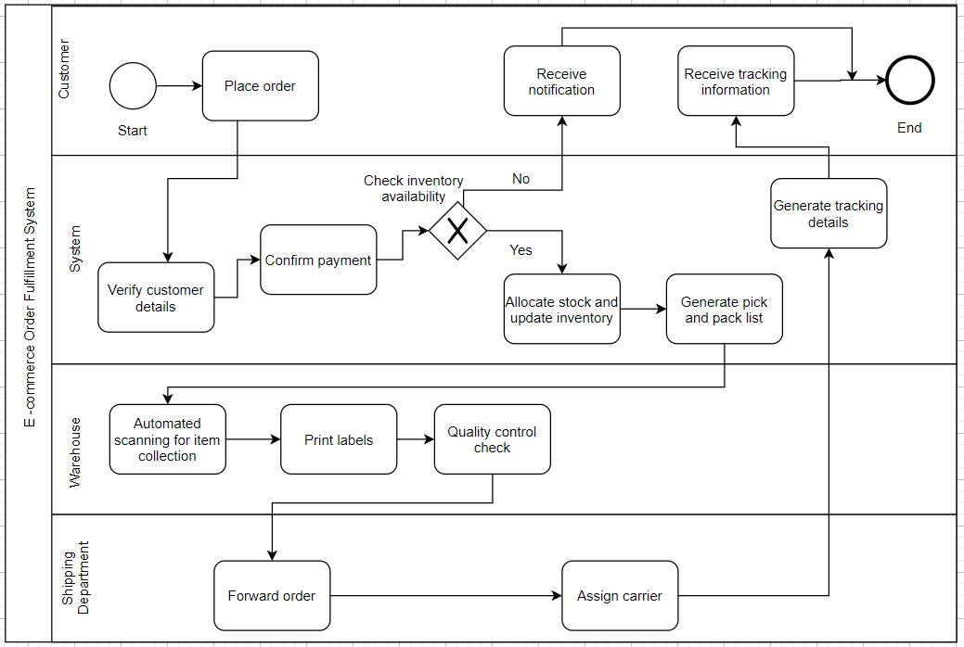

**Future State BPMN Workflow**:

1. **Customer**:
   * Place Order → Receive Notification → Receive Tracking Information → End.
2. **E-commerce System**:
   * Verify Customer Details (Automated) → Confirm Payment → **Check Real-Time Inventory**.
     + If Yes → Allocate Stock and Update Inventory → Generate Pick and Pack List.
     + If No → Notify Customer and Update Inventory Availability.
3. **Warehouse**:
   * **Automated Item Scanning** → Print Labels → Automated Quality Control Check → Forward Order to Shipping.
4. **Shipping Department**:
   * Assign Carrier → Generate Tracking Details → Send to System → Notify Customer.

------------------------------------------------------------------------------------------------------------------------------------------

**Future State (To-Be) Description**

The **To-Be order fulfillment process** for the e-commerce company represents an optimized, automated system designed to address inefficiencies in the current manual workflow. By leveraging **automation**, **real-time data integration**, and **streamlined communication**, the company aims to improve accuracy, speed, and scalability within its order fulfillment operations. Below is a detailed breakdown of the future state:

**1. Order Placement**

* **Customer Action**: Customers place orders through the e-commerce platform, triggering the automated order fulfillment process.
* **System Response**: The system instantly captures the order, passing relevant data such as customer details, items ordered, and payment status to subsequent steps without manual intervention.

**2. Automated Order Verification**

* **System Action**: The system automatically verifies customer details, payment status, and item availability in real time.
  + **Payment Issues**: If payment fails or details are incomplete, the system notifies customer service to address the issue and inform the customer.
  + **Item Unavailability**: If an item is unavailable, the system alerts customer service to suggest alternatives or inform the customer of delays.

**3. Real-Time Inventory Management**

* **System Action**: The inventory management system updates stock levels automatically as orders are placed and processed.
  + Real-time inventory checks ensure accurate stock availability.
  + If an item is out of stock, the system triggers an alert to customer service and updates the inventory status immediately.
* Stock levels are dynamically updated as items are allocated to orders, ensuring up-to-date information is available at all times.

**4. Automated Stock Allocation**

* **System Action**: The system allocates stock for each item in the order based on availability and priority.
  + Reserved items are reflected in the inventory updates.
  + In cases of insufficient stock, the system suggests alternatives or notifies customer service for further action.

**5. Automated Item Picking and Packing**

* **Warehouse Action**: The warehouse system selects items using automated tools such as robots, conveyors, or barcode/RFID scanners.
  + The system generates packing instructions for the warehouse team, minimizing errors and ensuring accurate item selection.
  + Items are packed and labeled with customer order details, including tracking information.

**6. Automated Quality Control**

* **System Action**: Integrated quality control processes use AI-driven tools, such as visual recognition systems or RFID scans, to verify item accuracy and condition.
  + Automated checks ensure items meet quality standards and match order details.
  + Discrepancies are flagged instantly, prompting the warehouse team to correct issues before shipping.

**7. Automated Shipping Preparation**

* **System Action**: The system assigns a carrier automatically based on delivery location, requirements, and priority.
  + Shipping labels and tracking numbers are generated automatically.
  + Shipping details are updated in the system, and notifications are sent to the customer with tracking numbers and delivery estimates.

**8. Customer Notification**

* **System Action**: Once the order is shipped, the system sends real-time notifications to customers.
  + Notifications include tracking information, order status updates, and estimated delivery dates.
  + Customers are kept informed throughout the process, reducing inquiries to customer service.

**Benefits of the Future State:**

1. **Speed and Efficiency**: Automation reduces time spent on order verification, stock allocation, quality checks, and packing, enabling the company to handle larger volumes quickly.
2. **Error Reduction**: Technologies like barcode scanners, RFID systems, and AI-driven quality control minimize human errors, improving order accuracy.
3. **Real-Time Data**: Real-time inventory management ensures stock levels are current, preventing stockouts and over-ordering.
4. **Scalability**: The automated workflow supports scalability, allowing the company to manage increased demand without requiring additional manual labor.
5. **Customer Satisfaction**: Faster fulfillment, improved accuracy, and proactive communication enhance the overall customer experience, fostering satisfaction and loyalty.

------------------------------------------------------------------------------------------------------------------------------------------

Functional and Non-functional Requirements

**Functional Requirements**

Functional requirements define the specific behaviors, features, and functionalities that the system must support:

**1. Order Placement and Processing**

* The system must allow customers to place orders through the e-commerce platform (website or mobile app).
* The system should automatically capture and process order details such as customer information, product selection, and payment status.
* The system must validate customer information, including shipping address and payment confirmation.

**2. Order Verification**

* The system must verify order details, including customer information, product availability, and payment status in real-time.
* The system must notify customer service automatically if there are issues (e.g., incorrect/incomplete details, payment failure, or unavailable items).

**3. Inventory Management**

* The system must automatically update inventory levels in real-time as orders are placed and processed.
* The system must provide real-time alerts for low stock, out-of-stock items, and inventory discrepancies.
* The system must allocate stock based on availability and notify customer service in case of insufficient stock.

**4. Automated Stock Allocation**

* The system must reserve items from inventory once the order is verified.
* If stock is insufficient, the system must automatically suggest alternatives or trigger alerts to customer service.

**5. Picking and Packing Automation**

* The system must integrate with automated picking systems (e.g., robots, conveyors) to select items for packing.
* The system must generate packing instructions and labels to minimize manual errors.
* The system should label packages accurately with customer order details and tracking information.

**6. Quality Control**

* The system must automate quality checks, including visual inspections or AI-driven verification of order content, condition, and quantity.
* Discrepancies must be flagged automatically, and the relevant team must be notified for resolution.

**7. Shipping and Delivery**

* The system must automatically assign a carrier based on delivery requirements, location, and shipping priority.
* The system must generate shipping labels and tracking numbers.
* Shipping details, including tracking information and delivery estimates, must be shared with customers.

**8. Customer Notifications**

* The system must send automatic notifications to customers for order confirmation, shipment tracking, and delivery updates.
* Customers should receive real-time updates at key stages (e.g., order placed, shipped, out for delivery).

**9. Reporting and Analytics**

* The system must provide reporting tools to track order fulfillment performance, inventory status, and shipping updates.
* Performance reports must identify bottlenecks and inefficiencies.

**Non-Functional Requirements**

Non-functional requirements describe the system's operational characteristics to ensure performance, security, and scalability:

**1. Performance**

* The system must process customer orders, including verification and inventory updates, in under 2 seconds.
* The system must handle thousands of orders per minute, especially during peak demand.

**2. Scalability**

* The system must scale to accommodate increased order volume, larger inventories, and a growing customer base without performance degradation.
* The system must allow integration of new product categories, geographic expansions, and additional warehouses.

**3. Availability**

* The system must ensure 99.9% uptime to prevent order fulfillment interruptions.
* Automated failover mechanisms and backups must ensure business continuity during technical failures.

**4. Reliability**

* The system must process orders accurately under all load conditions.
* Built-in error detection and automated error handling must resolve minor issues and flag major problems for immediate attention.

**5. Security**

* The system must comply with security protocols (e.g., SSL, encryption) to protect sensitive customer data.
* Role-based authentication and authorization must control access to critical system features.

**6. Usability**

* The system must provide an intuitive interface requiring minimal training for employees.
* Dashboards must offer clear and actionable insights for administrators to monitor operations.

**7. Compliance**

* The system must comply with regulations like GDPR for data privacy and PCI DSS for secure payment processing.
* International shipping processes must adhere to relevant shipping and customs regulations.

**8. Maintainability**

* The system architecture must be modular to facilitate updates, patches, and new feature additions.
* Logging and monitoring must enable quick issue detection, diagnosis, and resolution.

**9. Integration**

* The system must integrate with third-party tools, such as payment gateways, CRMs, and shipping carriers.
* The system must support API-based integrations for seamless data exchange with ERP platforms and other external systems.

**10. Response Time**

* Customer interactions (e.g., order confirmation, inventory status updates) must have a response time of under 2 seconds.
* Processing delays in orders, inventory updates, and shipping must be minimized for timely fulfillment.

------------------------------------------------------------------------------------------------------------------------------------------

Select a Function from Functional Requirements and Create a User Story for It

**Title:** Real-Time Inventory Management and Stock Updates

**As a** warehouse manager,  
**I want** the system to automatically update inventory levels in real-time when an order is placed,  
**So that** I can ensure accurate stock availability and prevent overselling or stockouts.

**Acceptance Criteria:**

1. **Automatic Update of Inventory:**
   * When an order is placed, the system should automatically reduce the corresponding stock levels for each item in the inventory.
   * The updated inventory levels should reflect the quantities reserved for the order.
2. **Real-Time Notifications:**
   * If inventory levels fall below a predefined threshold for any product, the system should trigger a real-time alert to the warehouse manager or relevant personnel.
   * The system should notify the warehouse manager of any discrepancies between actual stock and the expected stock after the order update.
3. **Stock Level Validation:**
   * The system should automatically validate stock availability in real-time during the order processing stage to ensure that all items are in stock.
   * If any item is out of stock or insufficient for the order, the system should notify customer service to inform the customer about the unavailability.
4. **Integration with Inventory Systems:**
   * The system should integrate with existing inventory management tools or ERP systems to ensure seamless updates of stock levels across all platforms.
5. **User Interface (UI):**
   * The warehouse manager should be able to view real-time inventory levels through an intuitive dashboard that updates automatically when orders are processed.
   * The dashboard should allow easy filtering and sorting of inventory to quickly identify out-of-stock or low-stock items.

**Benefits:**

* **Efficiency:** Reduces manual inventory tracking and minimizes errors due to stockouts or overselling.
* **Customer Satisfaction:** Ensures that customers are notified promptly if an item is unavailable, allowing them to choose alternatives or expect delays.
* **Cost Savings:** Helps prevent overstocking or understocking, optimizing inventory management and reducing excess storage costs.

This user story encapsulates the functionality of real-time inventory management, ensuring that the company can efficiently track and manage its inventory while improving operational accuracy and customer satisfaction.

------------------------------------------------------------------------------------------------------------------------------------------