Project details

Make a square with size 4X4 by using 4 or 5 pieces. The pieces can be rotated or flipped and all pieces should be used to form a square. Example sets of pieces. There may be more than one possible solution for a set of pieces, and not every arrangement will work even with a set for which a solution can be found. Examples using the above set of pieces... Rotate piece D 90 degree then flip horizontal {R 90 + F H} \*\*\*\*\*\*\*\*\*\*\*\*\*\*\*\*\*\*\*\*\*\*\*\*\*\*\*\*\*\*\*\*\*\*\*\*\*\*\*\*\*\*\*\*\*\*\*\*\*\*\*\*\*\*\*\*\*\*\*\*\*\*\*\*\*\*\*\*\*\*\*\*\*\*\*\*\*\*\*\*\*\*\*\*\*\*\*\*\*\*\*\*\*Input: The first line contains number of pieces. Each piece is then specified by listing a single line with two integers, the number of rows and columns in the piece, followed by one or more lines which specify the shape of the piece. The shape specification consists of 0 or 1 characters, with the 1 character indicating the solid shape of the puzzle (the 0 characters are merely placeholders). For example, piece A above would be specified as follows:

2 3

111

101

Output: Your program should report all solution, in the format shown by the examples below. A 4-row by 4-column square should be created, with each piece occupying its location in the solution. The solid portions of piece #1 should be replaced with 1' characters, of piece #2 with 2' characters. Sample output that represents the figure above could be:

1 1 1 2

1 4 1 2

3 4 2 2

3 4 4 2

For cases which have no possible solution simply report "No solution possible". You must provide many sample inputs (many text files) during the discussion time, to test your project on many samples. Each text file represents one problem to be solved.

* Get all probability of shapes order

Shape1 Shape2 Shape3 Shape4

Shape2 Shape1 Shape3 Shape4

Shape3 Shape1 Shape2 Shape4

…

Shape3 Shape2 Shape4 Shape1

Shape2 Shape3 Shape4 Shape1

If we have 4 shapes , then we have 24 possibilities 🡺 !4

* Rotate the possibilities

We rotate the first shape and then you get all the possibilities again .

Shape1ROTATED Shape2 Shape3 Shape4

Shape2 Shape1ROTATED Shape3 Shape4

…

Shape4 Shape2 Shape3 Shape1ROTATED

Shape3 Shape2 Shape4 Shape1ROTATED

Shape2 Shape3 Shape4 Shape1ROTATED

We rotate the second shape and then you get all the possibilities again .

Shape1ROTATED Shape2ROTATED Shape3 Shape4

Shape2ROTATED Shape1ROTATED Shape3 Shape4

…

Shape2ROTATED Shape3 Shape4 Shape1ROTATED

The same way to get all the possibilities for the third and fourth

We start making more than one square of these possibilities

* Put the shape in the box

Move step by step inside the box , When we reach a free space, we start by examining the places corresponding to the area of the shape in the square

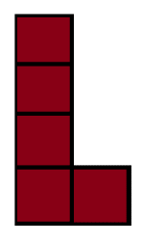

ex.

1. We want use this shape in the previous square

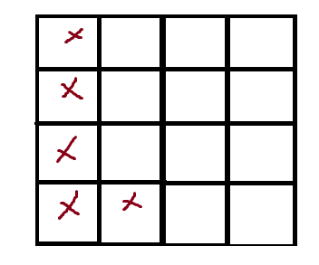We find that the first cell in the box is empty , We specify the places that the shape will occupy in the box, starting with the cell we found .

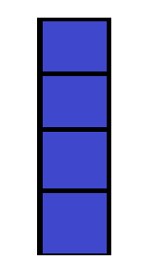If we find that the shape will be completely added, we add it .

2. We want use this shape in the previous square

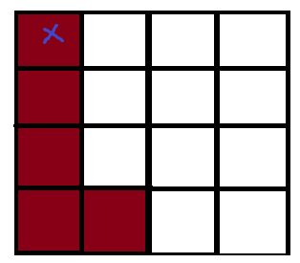We will find that the first cell in the box is occupied, so we will move to the next

We find that the second cell in the box is empty , and we specify the places that the shape will occupy in the box, starting with the cell we found .

We find that the shape will not be added because of the last cell .

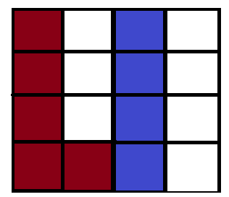

Now we need to move to a new cell, which is the third cell, which is empty .

we find that the shape will be completely added , So this is the right place .

We repeat this process with all the shapes until the square is filled. If it is not filled, we try other ordinal possibilities until it is filled. If it is not filled, we find that the given set of shapes cannot be a 4 x 4 square of them.

* Gui Description

add shapes id in every owns field and add name of square

then press add , it will be add to database

fill the field with id of shapes that you want to test , to know If there is a square 4×4 formed of them

You can choose a pre-registered square shape to test it.

Just click on the list and choose the name of a square from them and then click on “Result”.

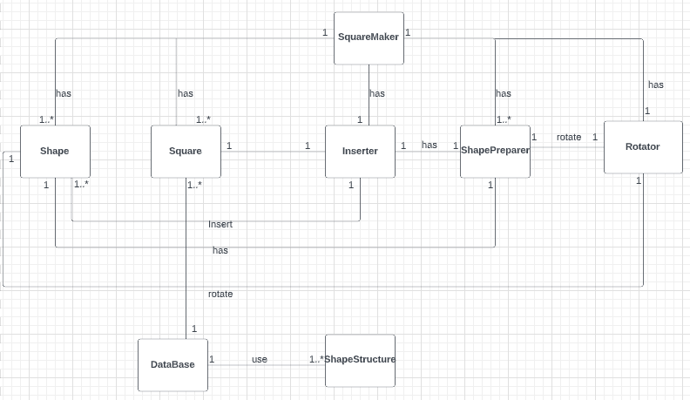Class diagram

s

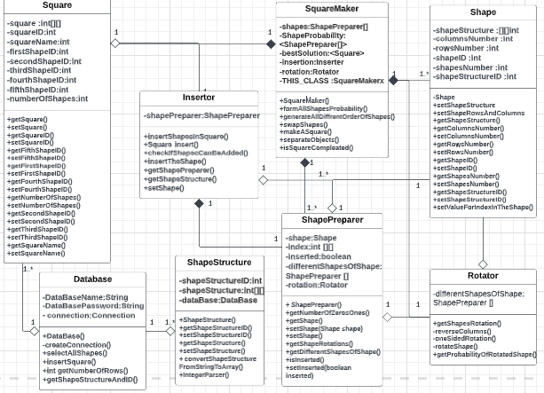

Database schema