# Task 1:

Virtual network with 2 subnet validation passed:

Virtual network deployed:

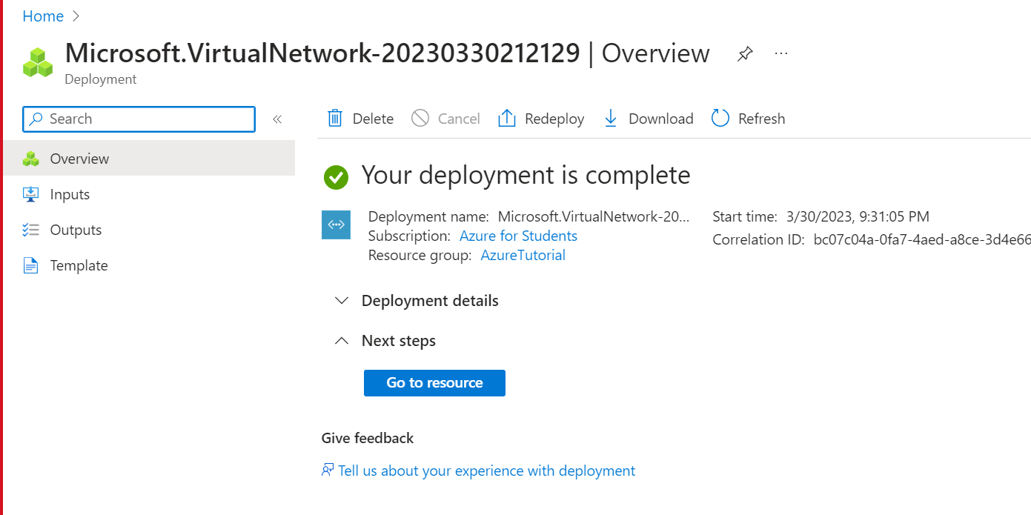

16 IPs are allocated to both subnets (5 IPs are reserved by azure for gateway, dns and other purposes)

# Task 2:

VM deployed on subnet:

SQL database created on azure:

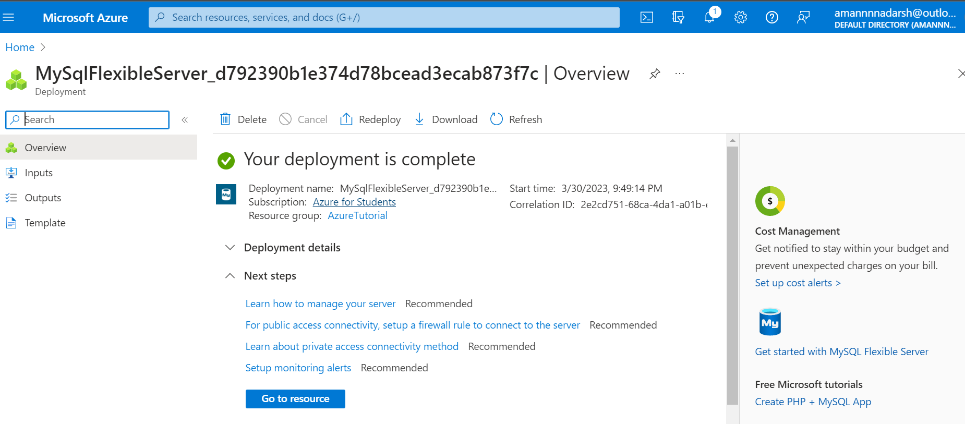

Database accessible from inside machine:

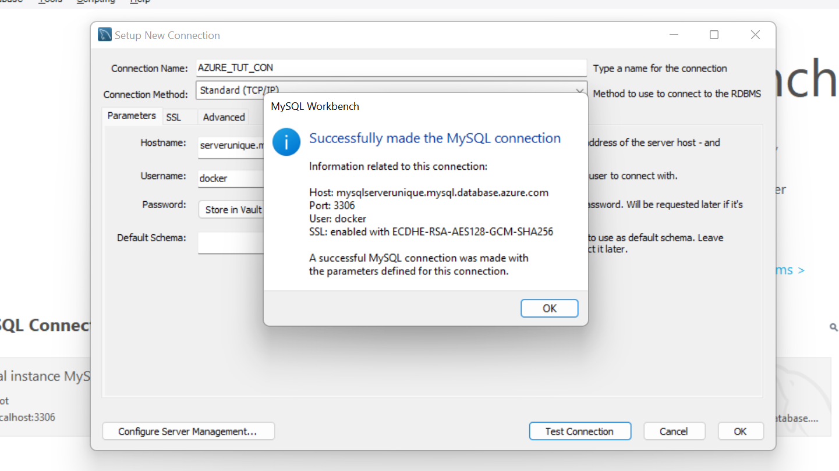

Code deployed through VM:

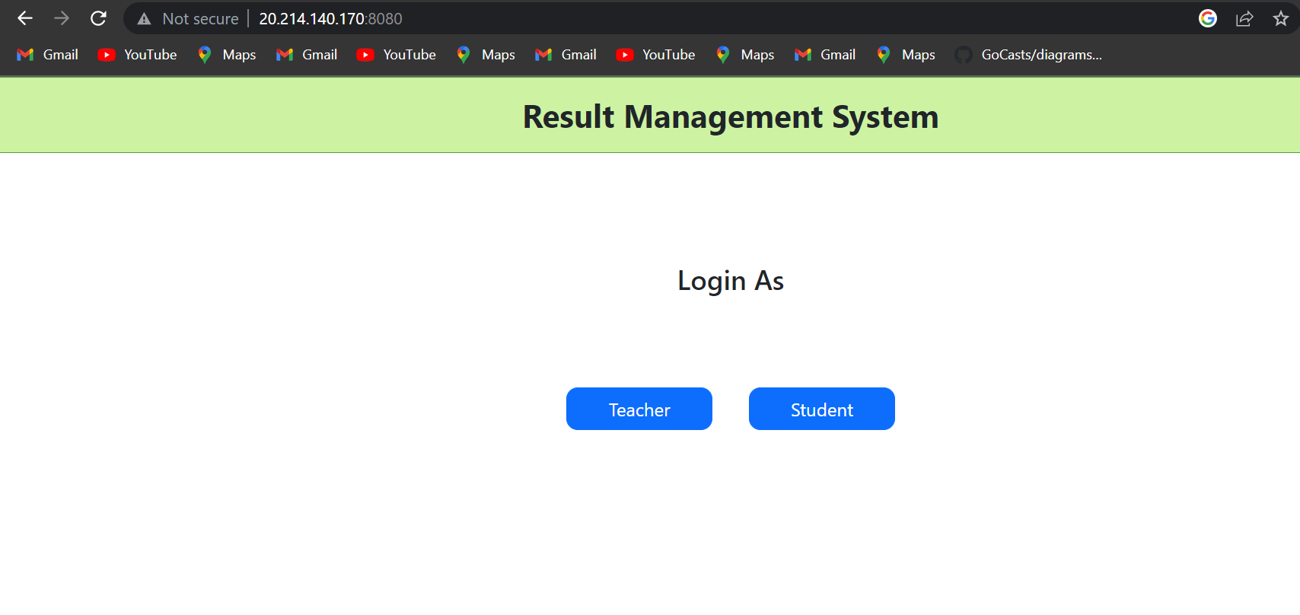

# Task3:

Created app service:

Pushed and deployed code from local git

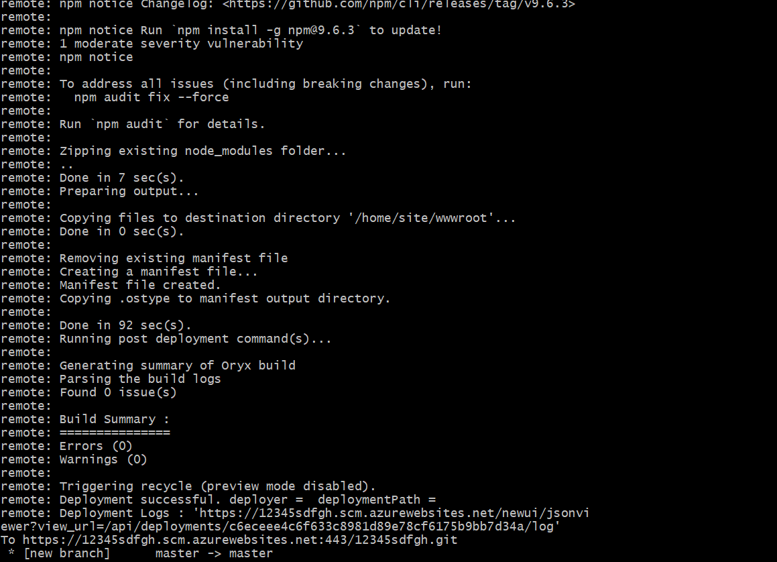

Application accessible through the web:

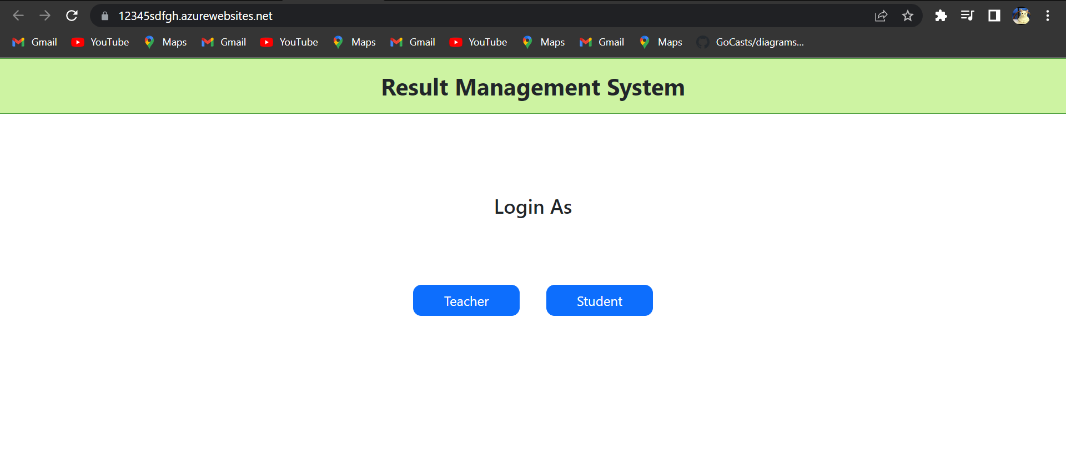

# Task 4:

Create an azure Kubernetes service resource container.

Connect to the azure cli (bash or powershell):

Connect to the cluster:

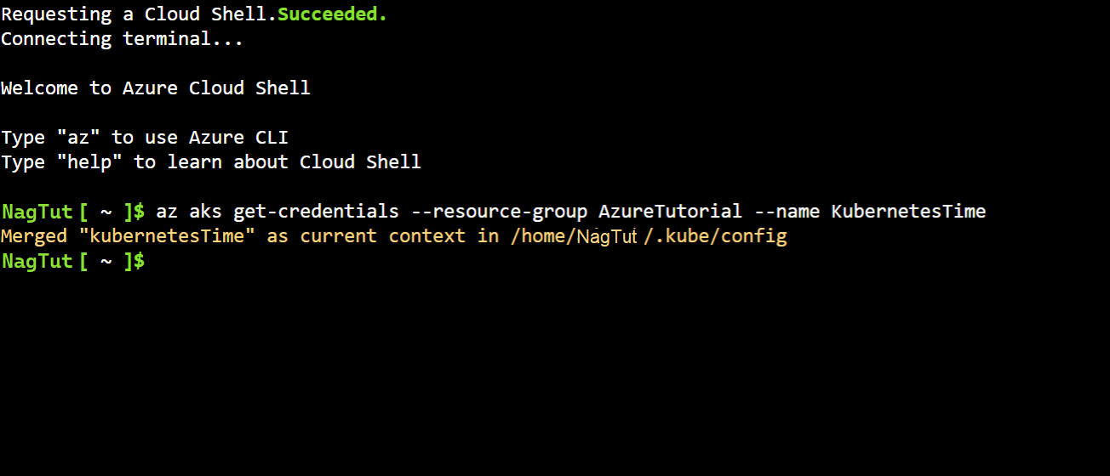

upload deployment and service yamls of the docker image:

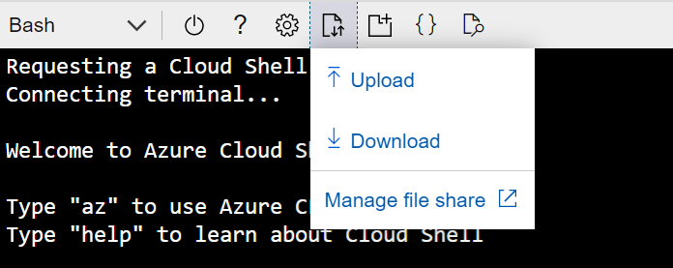

Apply the deployment and service files through kubectl apply -f command:

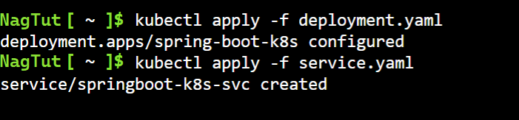

Get deployment details through kubectl get pods and kubectl get svc :

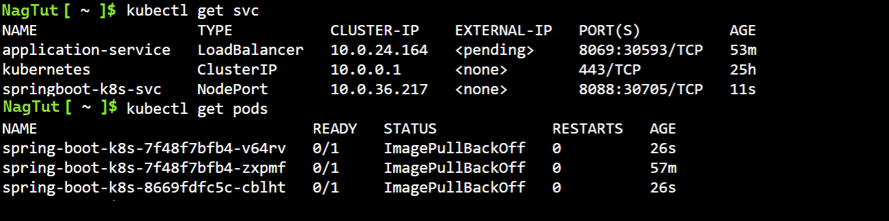

Expose the port after the status of the service is changed to “Ready”:



Go to the port and check the service:

# Task 5:

Function app creation:

Creation of blob trigger and container:

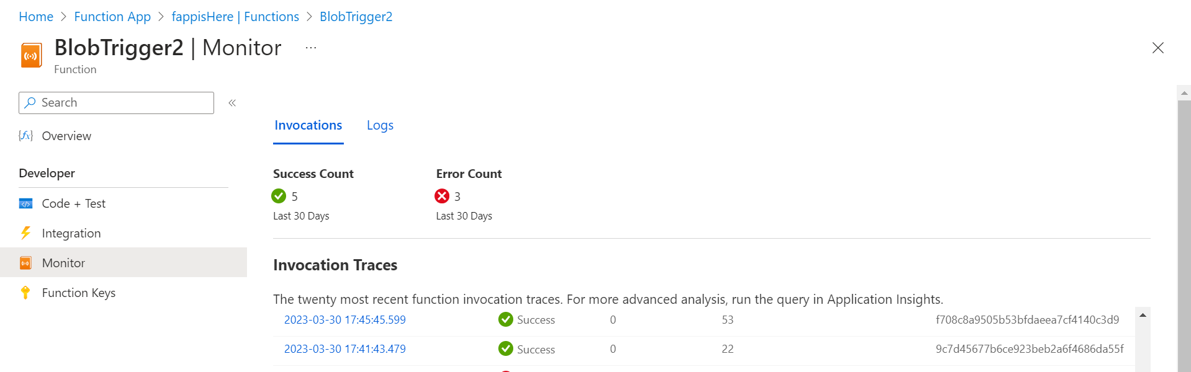

Uploading file in container:

Function triggered:

