GitHub public repository URL: <https://github.com/Sameony/kubernetes>

Docker hub link: [sameeris123/dockerdemo - Docker Image | Docker Hub](https://hub.docker.com/r/sameeris123/dockerdemo)

Docker image:

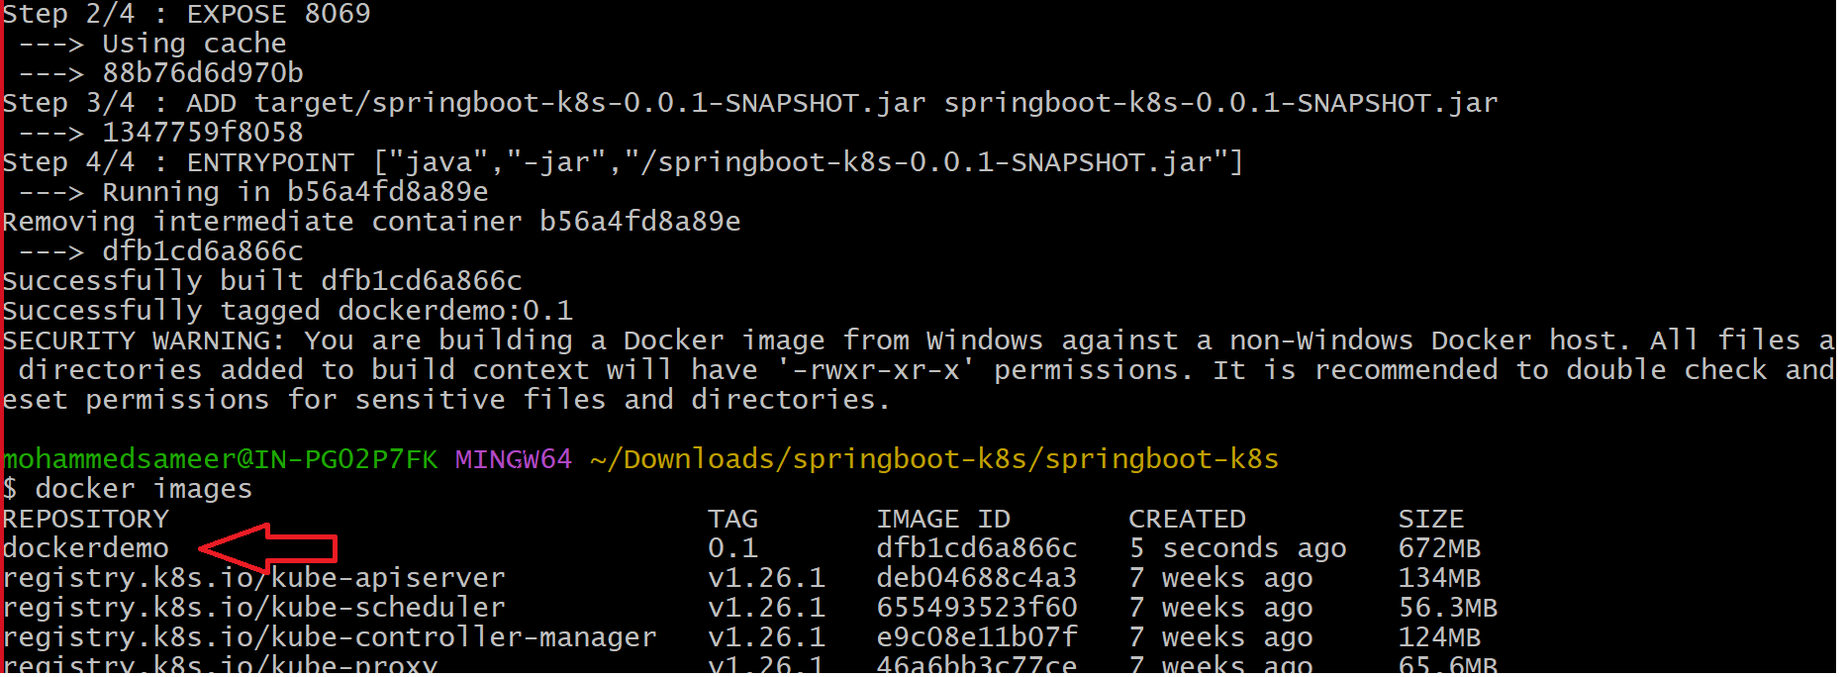

Image on dockerhub(dockerdemo):

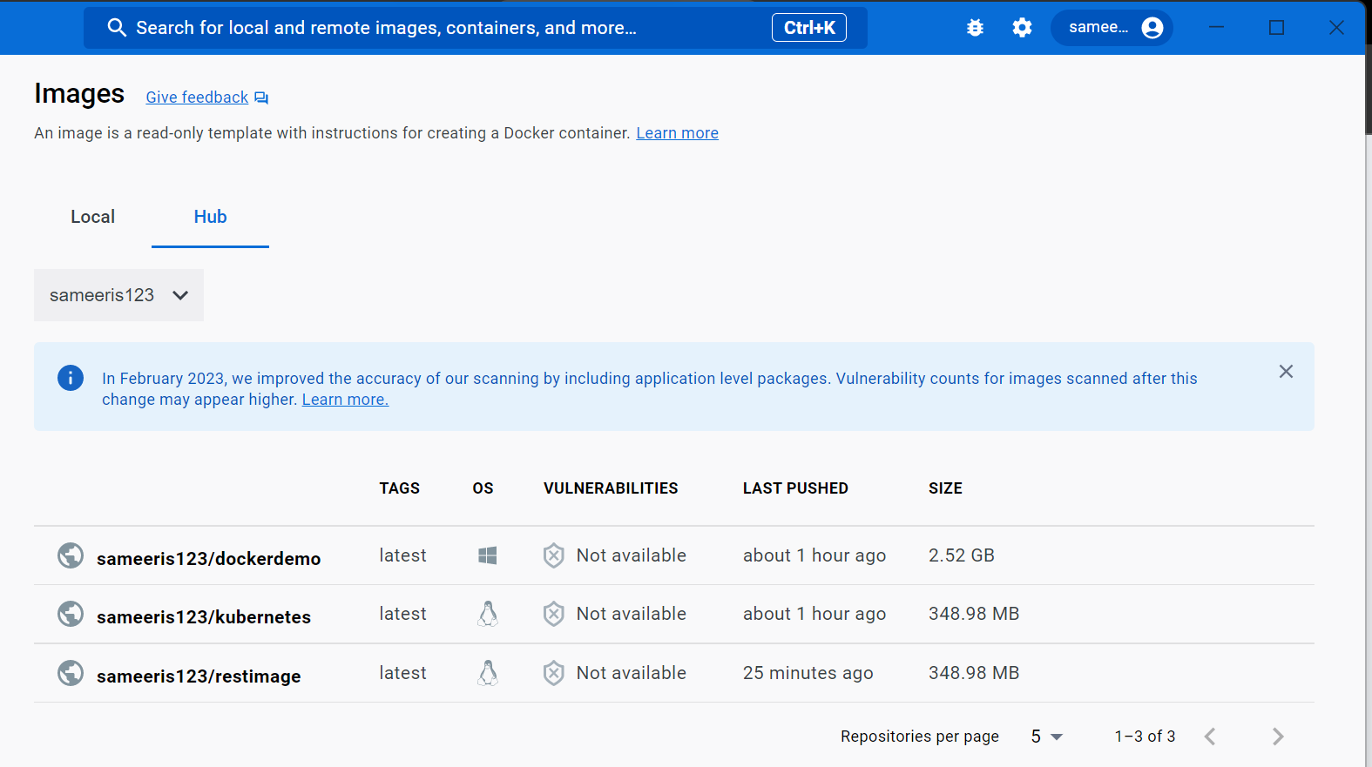

Deployment created:



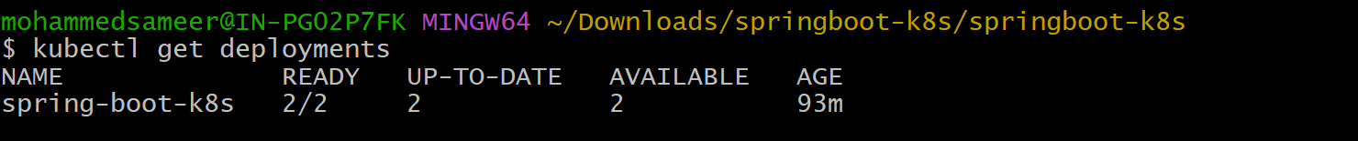

Service created:

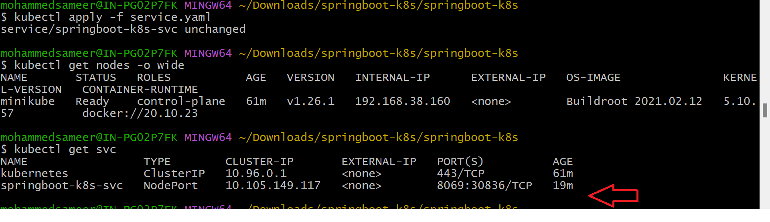

Service running on port specified by kubectl:

