I built an AI agent, then built an eval harness that caught it lying to itself.
Not dramatically — the quiet way that matters in production systems. My agent reached the correct decision while silently skipping a step it was explicitly told to always attempt. The outcome looked fine. The reasoning behind it didn't. I only caught it because I'd built something to check both.
Background
Every company with a support inbox has the same bottleneck: someone reads each ticket, figures out what it's about, and decides whether it needs a standard answer or a specialist. That first step — triage — doesn't need deep expertise, but it does need judgment, at high volume, constantly.
Get it wrong one way, and simple issues sit in a queue a machine could've cleared. Get it wrong the other way, and complex cases get a generic answer that doesn't fix anything — or worse, confidently wrong information.
So I built a support-ticket triage agent to understand that challenge firsthand — deliberately with no framework, no LangChain, no CrewAI. Raw Anthropic API, a hand-written reasoning loop, so I'd actually understand the mechanics most frameworks abstract away.
The core is a tool-calling reasoning loop (Diagram 1 ) — the agent runs in a cycle: send the conversation state to the model, let it decide which tool to call next, execute that tool, log the results , feed the result back, repeat, until it reaches a terminal decision. Four tools sit behind this: 1. Classify ticket, 2. Search knowledge base 3. propose_resolution, and 4. two terminal actions, route_to_queue/escalate.
The code base is mainly contains 3 modules(Diagram 2) –
- agent_loop.py - the orchestrator: the main loop, the tool-dispatch logic, the duplicate-call guard, the system prompt setup , max attempts , handling unforeseen scenarios.
- tools.py – defines tool functions which are
  - Classify case based on confidentiality, severity etc.
  - Search knowledge base – connects to RAG pipeline to get the data from ingested data.
  - Propose resolution (Diagram 3) - it's the real decision engine. It runs three independent confidence layers in sequence:
    - a hard category/urgency rule, (L1)
    - a retrieval-confidence threshold from RAG, and (L2)
    - a self-reported confidence from model. (L3)
  - Routing / escalating tool.
A case only auto-resolves if propose resolution clears all three gateways; any single layer blocking will be either routed to or escalated.

- trace.py – defines functions to log the requests and responses at each stage.

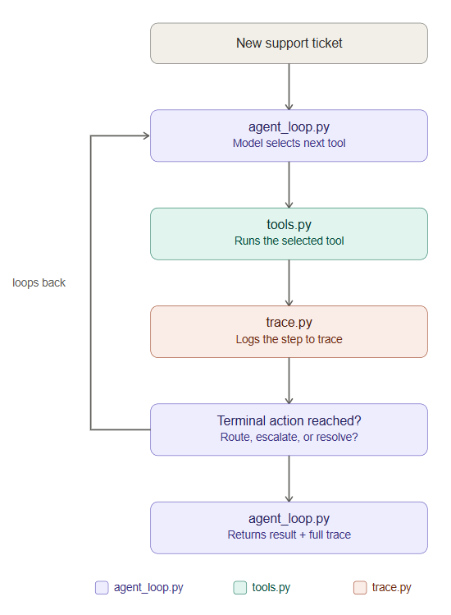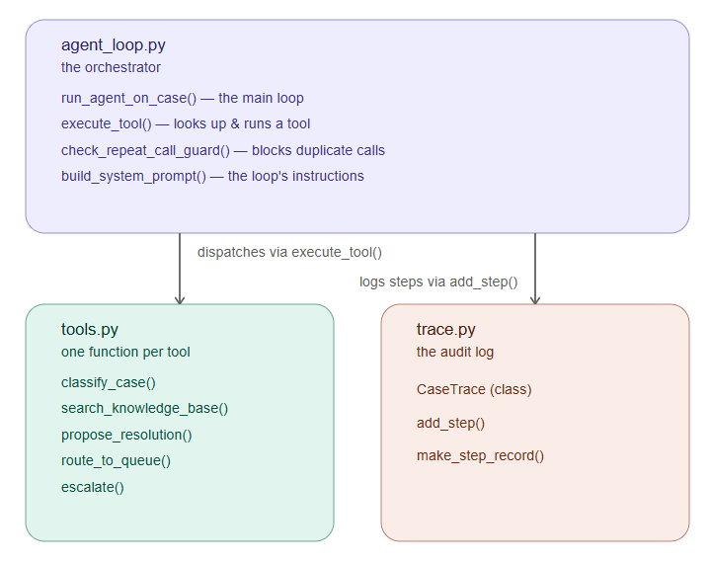

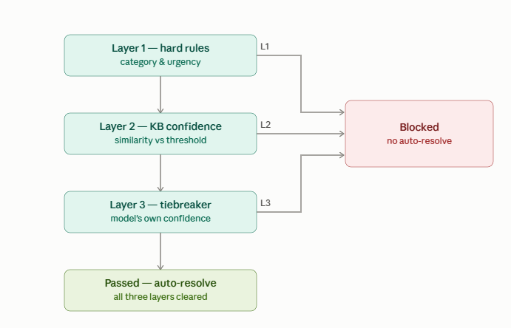
How efficient is this implementation – In what scenarios it fails.
To test it , I built an eval harness with two independent checks against a labeled dataset:
- Pass 1 — outcome match: did the case land on the correct final decision matching my test data in terms of final outcome match , tool sequence followed or not , layered check applicable (Pass 2).
- Pass 2 — process verification: did the tool sequence followed and executed the required order, and did propose_resolution's three layers produce the verdicts they should have?

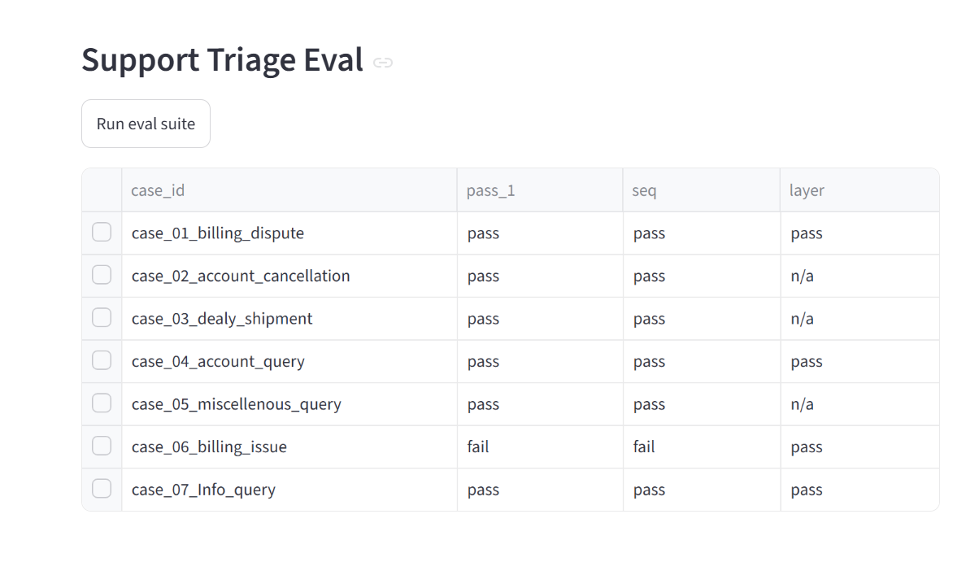
Pass 2 – case 01 is rightly blocked as it is a billing dispute and needs a human intervention.
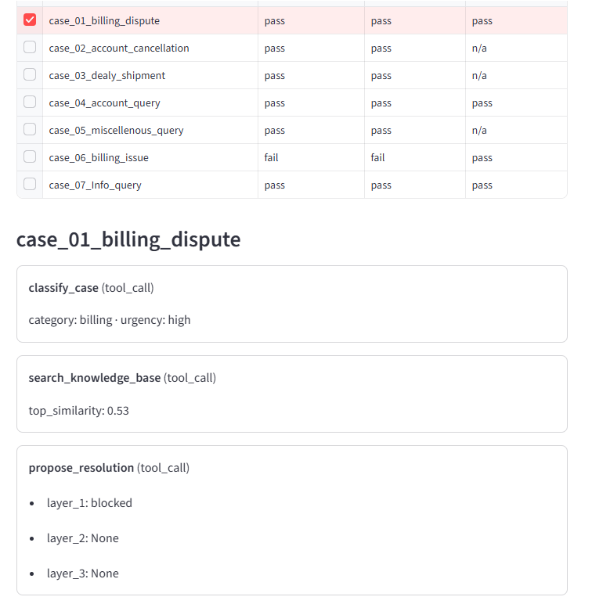

Pass 2 is the one that actually caught indeterministic scenarios. One test case — a customer disputing a duplicate charge while also asking to cancel — is designed to trigger escalation, since it bundles two distinct issues. Pass 1 said it passed(escalation): correct final action. Pass 2 disagreed: the agent had skipped propose_resolution entirely (3 layered check), despite an explicit system-prompt rule that it must always be attempted first.
Right answer. Wrong process. Exactly the gap a two-pass eval exists to surface, and exactly the kind of thing that's invisible if you only check outcomes. The real fix isn't prompt-wording — it's the Anthropic API's tool_choice parameter, which can force a specific tool call based on the its context.

What matters -
Anyone can wire an LLM into a loop and get plausible output. What's harder — and what actually matters when AI systems make decisions with real consequences — is knowing precisely when a system is reliable, when it isn't, and having evidence for both.

