Supplementary material

# 1-Calibration using SiO2, 100nm nanoparticles:

The use of calibrated of nanoparticles of known size allow to verify the validity of single particles trajectory analysis. As described in the main text paper, we are interests in the estimation of the size of particles and the interferometric signal resulting from single trajectory analysis. The diffusion coefficient which depends on the hydrodynamic radius is estimated based on the linear fitting of the mean squared displacement curve of each trajectory (we also present the example in which we estimate the diffusion coefficient of the ensemble average of the particles).

In Fig. 1, we show the SPT analysis of $SiO_{2}$ NPs of 100 nm in diameter in water solution (Polysciences, USA), with a concentration of ${10}^{9} particles/ml$. Fig. 1a shows the mean squared displacement curves for each individual trajectory. In this experiment, we counted 806 detected particles for a single acquisition of 500 frames with a lag time between frames of Δt = 2ms. Fig. 1b shows the histogram of the maximum interferometric signal for each trajectory, carrying information about the size and refractive index of the NPs; the histogram follows a normal distribution with an average and standard deviation values of 108.7 a.u. and 9.6 a.u. respectively. The histogram of β values obtained from the power law fit, shown in the insert of Fig. 1c, confirms the Brownian nature of the NPs diffusion (β = 1.009 ± 0.019), and validates using a linear fit of the MSD curves to obtain the diffusion coefficient D, whose histogram of values is shown as the main plot in Fig. 1c.

In addition to the SPT analysis performed on each individual trajectory, we can also compute the ensemble mean squared displacement curve, MSD, if we assume all the NPs to be of the same size. This is shown in Fig. 1d, together with a linear fit of the curve to compute the ensemble diffusion coefficient Densemble = 3.85 µm2/s. This value is very close to the average value found on the individual trajectories analysis, indicating the monodispersity of the solution. Using MSD curves we can retrieve the diffusion coefficient of the particles which depends on the hydrodynamic radius; size and shape of the particles.

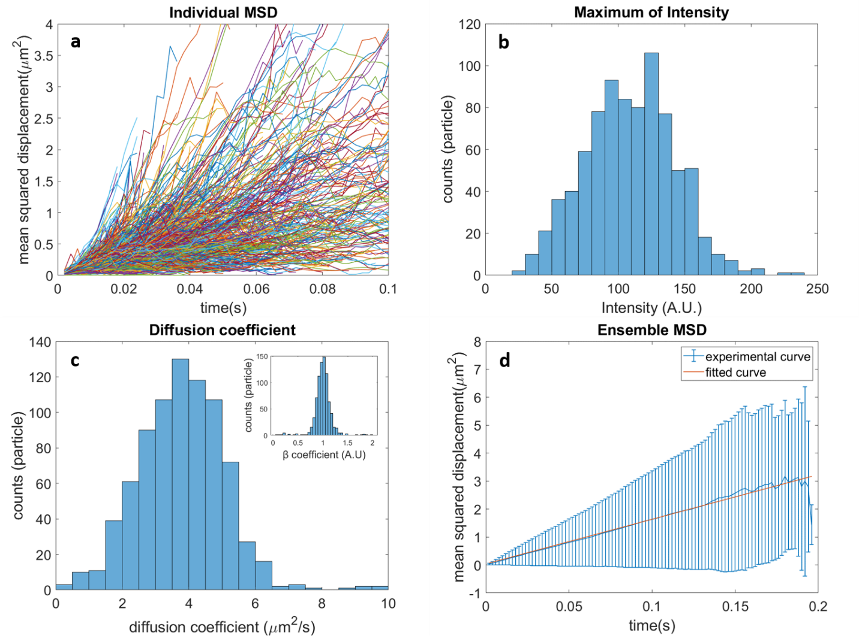

**Fig 1**: Validation of the single particle analysis using 100 nm diameter *SiO2* particles (a) Individual mean squared displacement (MSD) curves of particle trajectories. (b) Histogram of distribution of the absolute maximum of intensity per trajectory, average estimated value 108.7±9.61 a.u. (c) Histogram of the fitted diffusion coefficient resulting from individual MSD; average estimated value 3.82 ±1.01 ${μm}^{2}/s$.The inset histogram represents the fitted beta coefficient with an average of 1.009 ±0.019. (d) Plot of the ensemble average MSD of all the trajectories and the linear fitting of the MSD, average fitted diffusion coefficient the second and the first 20% of the data points is 3.85 ${μm}^{2}/s$. The data results from 806 tracked trajectories, 500 frames acquisitions at 500 frames/s.

# 2-characterization of the reaction between viruses and antibodies:

2-1 Estimation of the dissociation constant between antigen-antibody:

The binding forces between specific antibodies and their targeted proteins depend on molecular properties of the interacting species. On a molecular scale, the dissociation constant Kd can be described by the ratio between the concentration of product and reagents of a chemical reaction at the equilibrium state:

$Ab+ Ag⇌ AbAg$ (Eq. 1a)

$K_{d}=\frac{1}{K_{a}}=\frac{\left[Ab\right] \left[Ag\right]}{\left[AbAg\right]}$ (Eq. 1b)

$Rate Equation=-\frac{∆\left[Ab\right]}{∆ t}=-\frac{∆\left[Ag\right]}{∆ t}=\frac{∆\left[AbAg\right]}{∆ t}$ (Eq. 1c)

Where $Ab$, $Ag$, $AbAg$ represent antibodies molecules, antigen molecules and the recombination of both molecules. $K_{a}$, $K_{d}$ are the association and dissociation constants respectively

2-2- Disappearance of virus particles in presence of antibodies:

On a higher scale, the interaction between viruses and antibodies can be represented as:

$x Ab+y V⇌z Ab V+…aggregation$ (Eq. 2c)

$Rate Equation=-\frac{1}{x} \frac{∆\left[Ab\right]}{∆ t}= -\frac{1}{y} \frac{∆\left[V\right]}{∆ t}$ (Eq. 2d)

Where $x$, $y$, $z$ are the stoichiometric coefficients of the reaction for each species: antibodies, viruses and virus-antibodies aggregates respectively. Fig2 shows the variation of the disappearance rate of virus depending on the concentration of antibodies in the solution.

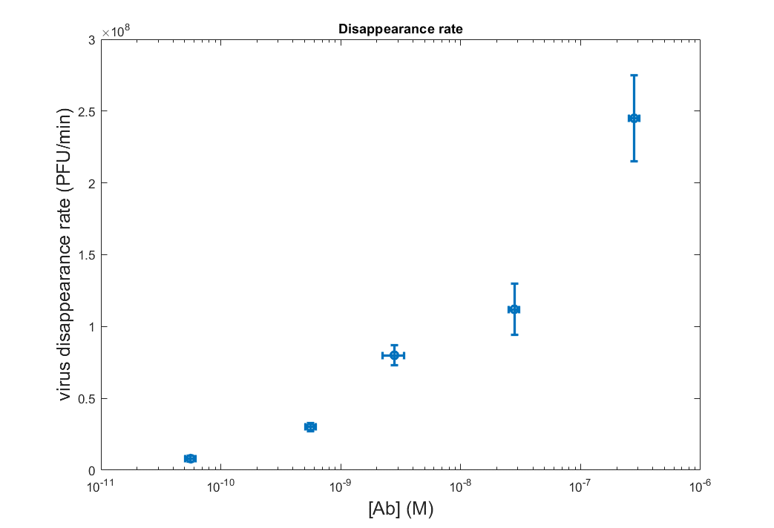**Fig 2**: Disappearance rate of viruses as a function of concentration of antibodies presented in the solution sample

# 3- Visualization 1: Interaction between T5phages and anti major capsid protein (scale bar=5µm)

# 4- Preprocessing of direct images:

The intensity detected on the CMOS camera, depends mainly on the reference signal collected by the objective lens and directed by the tube lens to the camera. As described in the main text, the detected intensity consists of the reference signal, light coming from the LED and did not interact with the sample, the scattered intensity coming from the sample only which is very weak compared to the reference light intensity and the intensity of interest: the interferometric intensity.

The interferometric intensity represent a small variation of the offset background composed of the reference light coming from the LED. We first normalize each image from the stack to a 4000 value to reduce the temporal variation of the camera. Then, we calculate the average frame value of the stack and suppress this frame value from each image of the stack. At this stage, we can already see bright and dark spots representing the nanoparticles in the solution. The last step consists of removing unwanted stripes coming from the detector itself. To do so, we apply a Fourier Transform of the image and mask the frequencies corresponding to these stripes, we inverse Fourier Transform the image and thus we remove the stripes without affecting the signal of interest.

We automated the process in code written on ImageJ, it is called “postprocessing” and can be used as a macro script directly in imageJ.

# 5- Detection and tracking code for single particle trajectories:

The detection of single spots from the background has been widely studied in single particle fluorescence microscopy. We therefore use a code that we initially developed for fluorescence and we modified the code to fit our application.

The usual code used for fluorescence allows the detection of bright spots on offset background, we are interested in detecting bright (positive value spots) and dark (negative value spots) spots simultaneously in the same image frame. We therefore apply the sub-pixel detection of single bright spots and then apply the detection for the inverse of the image of interest and therefore detect the sub pixel position of dark spots. In our analysis, we impose a threshold corresponding to 3* std(background noise of the frame).

The position of the detected bright and dark spots are then used indifferently for the tracking algorithm. The intensity of the spot depends on the axial position of the particle in the solution. This approach allows to follow the particles in the whole volume of detection.

The code that we are using is adapted from MTT code[1], [2], the modification consist of detecting bright and dark spots separately and consider the detections spots indifferently for the tracking process.

The code “Batch_modified_version2” is tested on Matlab 2018a version. The output file consists of a Matlab structure that is used for the evaluation of single trajectory cleaning code. The single trajectory code called “evalSPT” allows to evaluate single trajectories found in the localization and tracking code.

# 6- Single particle trajectories analysis:

The analysis of single particle trajectories takes single trajectories as input as allow to retrieve some of the diffusivity parameters of the particles. We are mainly interested in the size and the interferometric intensity of the particles. We rely on the mean squared displacement curve to find the size of individual particles in the solution sample. In brief, we apply first a linear fitting to the logarithmic mean squared displacement of each trajectory. If the slop of the fitted curve is about 1. We then apply a linear fitting (a*x+b) to the mean squared displacement curve and we can therefore estimate the diffusion coefficient using the a coefficient. The b coefficient usually depends on the localization error of single particle detection which can be neglected compared to the fitted diffusion coefficient (10^-3). We would like to note that for the estimation of the diffusion mobility of the particles of interest consists of the second data point and the first 25% of the data points of each trajectory.

The analysis software allows to have MSD from single trajectories as well as ensemble average MSD. This code allows to estimate the linearity behavior of the MSD by fitting the logarithmic MSD of single trajectories. The Matlab software is called “msd_analysis_DRAWING” is tested on Matlab 2018a and 2021a versions.

**References:**

[1] A. Sergé, N. Bertaux, H. Rigneault, and D. Marguet, “Dynamic multiple-target tracing to probe spatiotemporal cartography of cell membranes,” *Nat Methods*, vol. 5, no. 8, pp. 687–694, Aug. 2008, doi: 10.1038/nmeth.1233.

[2] J. B. Grimm *et al.*, “A general method to improve fluorophores for live-cell and single-molecule microscopy,” *Nat Methods*, vol. 12, no. 3, pp. 244–250, Mar. 2015, doi: 10.1038/nmeth.3256.