# 

# 

# 

# Abstract:

In the dynamic realm of entertainment, film studios continuously confront the task of anticipating audience preferences and formulating astute decisions regarding film production. Our initiative, "Cinemalytics," endeavors to tackle this challenge by leveraging predictive analytics to offer counsel to film studios. Specifically, Cinemalytics offers guidance on the optimal platforms for releasing their movies, particularly in light of the increasing popularity of streaming services since the onset of the COVID-19 pandemic. Moreover, it furnishes an approximate forecast of revenue. Through the fusion of relevant data and analysis tools,our goal is to furnish actionable insights and influence decision-making processes within the industry.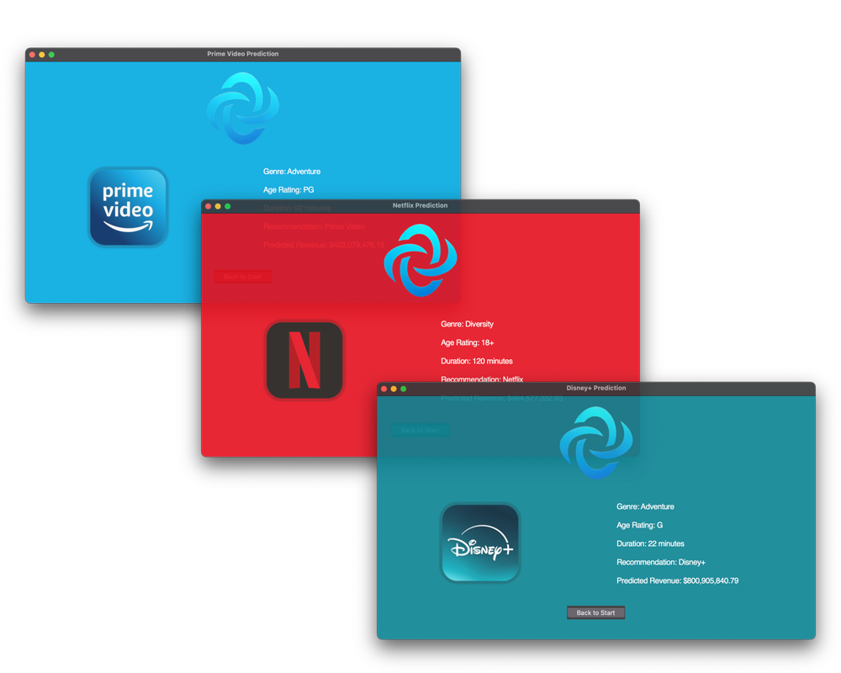

# Introduction:

In today's rapidly evolving entertainment landscape, one question looms large for film studios: why release more movies on streaming platforms ? The answer lies in the undeniable surge in demand for streaming services as audiences increasingly turn to digital platforms for their entertainment needs, the traditional models of film distribution are being reshaped. This paradigm shift has prompted film studios to reevaluate their strategies and adapt to meet the evolving preferences of their audience. Cinemalytics aims to revolutionize the film industry by leveraging data analytics coupled with machine learning to better understand the audience and their preferred platform. By analyzing a vast array of film-related data (e.g revenue, number of viewed movies by genre) our platform equips studios with the information needed to engage in strategic decision-making relevant to business matters.

# Methods:

1. **Data Handling:** We meticulously curated and refined data from diverse sources, employing sophisticated techniques including data cleaning and merging datasets to ensure comprehensive aggregation for analysis.
2. **Data Visualization:** By utilizing various visualization tools we were able to analyze different aspects of the given data. Thus the team was able to formulate hypotheses towards the upcoming predictions for the learning machines.
3. **Learning Machine / Training Model:** Our data predicts revenue and platform choices based on two different learning machines which aim to aid decision-makers in navigating film production and distribution with confidence and strategic insight.
4. **GUI:** We designed a user-friendly platform that provides studios with a clear overview - based on fixed criteria which are linked with our data - of what their ideal platform would be.

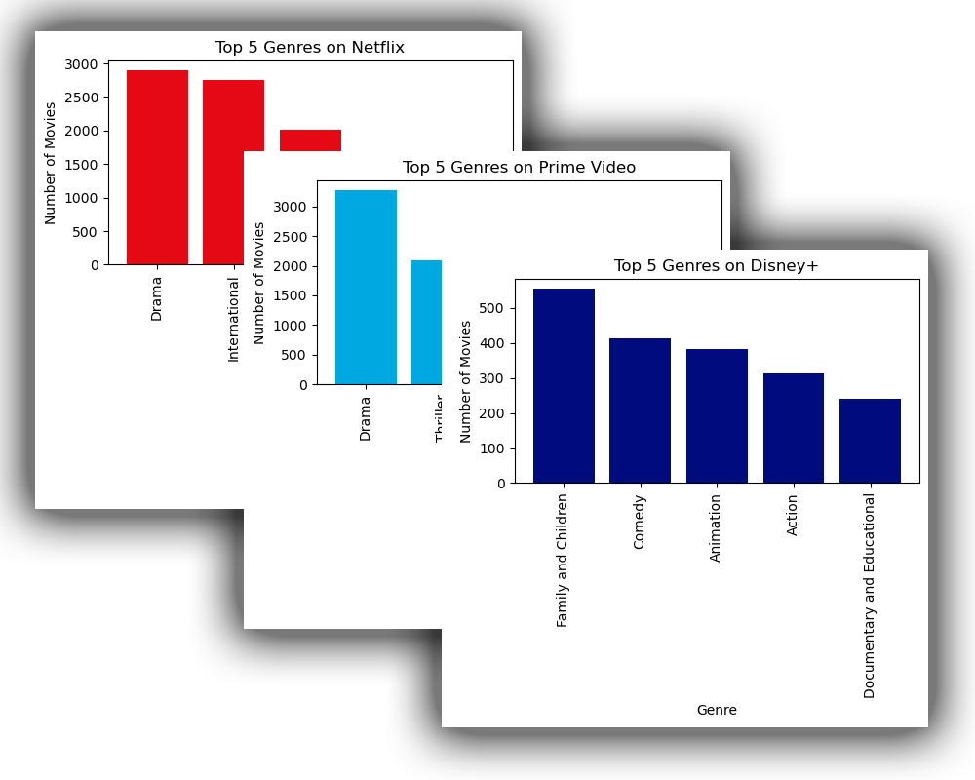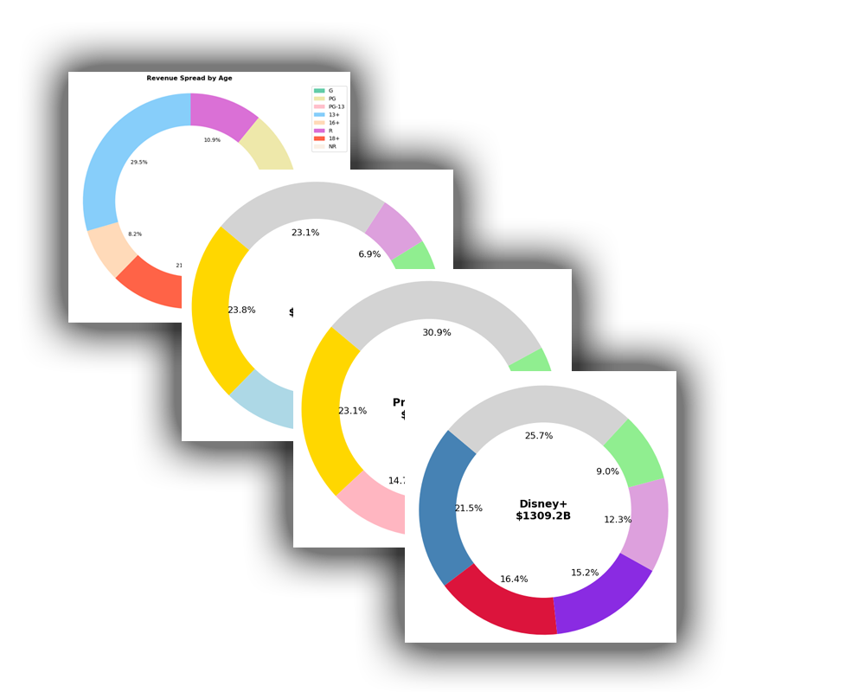

# 

# 

# Results:

Our efforts resulted in a user-friendly GUI-Application development driven by our thoroughly trained learning machine. The app excels in forecasting the ideal platform and estimating a rough revenue - all guided by the predetermined criteria by us and client. Through seamless integration of these models with the data provided by our client, our solution is an ideal prediction in the clients interest - maximizing revenue.