Algorithms And Programming

Algorithms And Programming

Author: Samet KARAŞ

## Algorithms And Programming

### Week-1 (Introduction to the Algorithm)

#### Spring Semester, 2022-2023

Download [DOC](week-1.en.md_doc.pdf), [SLIDE](week-1.en.md_slide.pdf), [PPTX](week-1.en.md_slide.pptx)

### Introduction to the Algorithm

* What is the Algorithm ?

## **What is the Algorithm ?**

### Algorithm

* **Algorithm’s Definition** The algorithm is the path that is designed to solve a certain problem or achieve a certain goal.In mathematics and computer science, it is the set of finite operations defined to perform a job, which, when it starts from an initial state, ends in a clearly defined final state. It is often used in computer programming, and the basis of all programming languages is based on the algorithm. At the same time, the algorithm is a step-by-step presentation of behavior that will solve a single problem, commands or statements that perform basic tasks, and attention should be paid to the sequence of these steps. There are two approaches to solving a problem: algorithmic and heuristic (herustic). In the algorithmic approach, the most appropriate method is selected from the possible methods for the solution and what needs to be done is revealed step by step. To specify the algorithm; texturally, 2 methods are used, namely a plain expression and a flow diagram. Algorithms can be operated by computers through a programming language.

### Algorithm

* 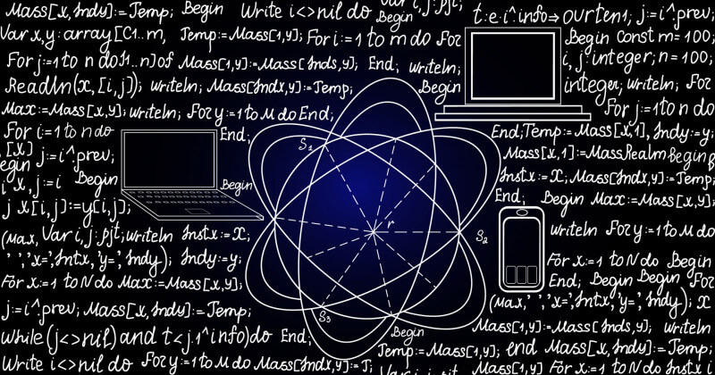
* center h:400px

**TODO** DO MORE RESEARCH !

## References

* https://www.linkedin.com/in/samet-kara%C5%9F-585999251/

$End−Of−Week−1$