Algorithms And Programming

Algorithms And Programming

Author: Samet KARAŞ

## Algorithms And Programming

### Week-2 (Introduction to Programming)

#### Spring Semester, 2022-2023

Download [DOC](week-2.en.md_doc.pdf), [SLIDE](week-2.en.md_slide.pdf), [PPTX](week-2.en.md_slide.pptx)

### Introduction to Programming

* What Is Programming ?

## **What Is Programming**

### Programming

* **Definition of Programming** Programming is the commands, words, arithmetic operations that tell the computer how to behave to the hardware, directing the computer. In other words, programming is the name given to the process of writing, testing and maintaining computer programs.

Programming is done in a programming language. This programming language can be a high-level language such as Java and C#, as well as C, assembly and, in some cases, machine language. The written source code is usually made executable on a specific system with the help of a compiler and linker. In addition, the source code can be run line-by-line without the need to compile it with the help of an interpreter.

* Whether you have logical errors in programs that are written or orthographic reading the compiler finds any errors that it finds to help improve the program by showing the user an error or run the program and representing the result, also according to the type of feature that can accommodate many other (by hovering the mouse over a variable to show the properties of the variable when the function is highlighted in the code when it was written to be able to find the function and go to the line, to make it easier to read the code to get the code to create labels with the help of a region, etc.) are platforms.

### Programming

* 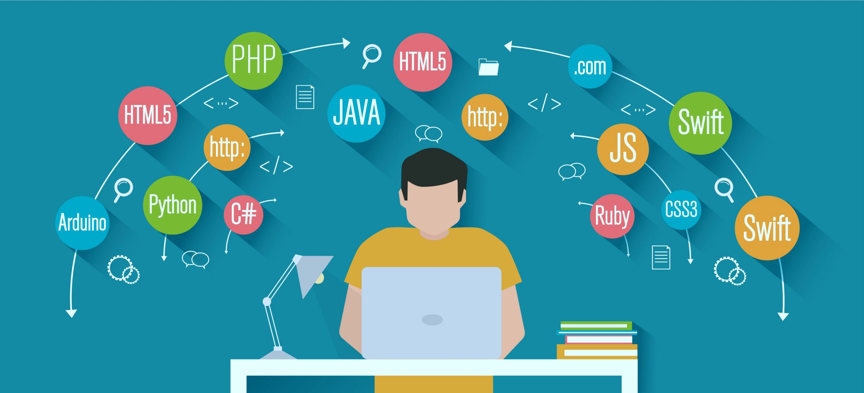
* center h:400px

**TODO** DO MORE RESEARCH

## References

* https://www.linkedin.com/in/samet-kara%C5%9F-585999251/

$End−Of−Week−2−Module$