Proje Adı | Eğitim Kurumu Kayıt Sistemi
Proje Konusu | Yeni Öğrenci Başvuru ve Kayıt Süreci
Proje Çözüm Adı | SAT242516014

Proje ‘Çözüm Gezgini (Solution Explorer)’ penceresinin (alt klasörler ve dosyalar dahil olacak şekilde) ekran görüntüsünü resim olarak ekleyiniz
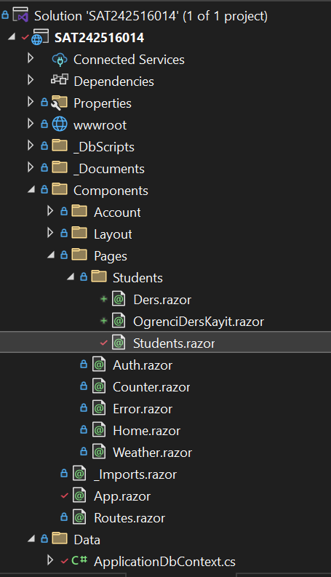 | 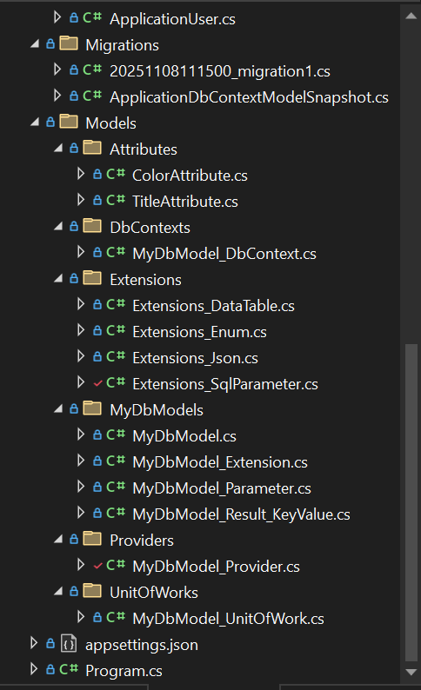

Projede oluşturulan arabirimlerin (interface) C# kodlarını yazınız.
public interface IMyDbModel
{
string Message { get; set; }
IMyDbModel_Parameter Parameters { get; set; }
IDictionary<object, object> OrderByItems { get; set; }
}
public interface IMyDbModel<T> : IMyDbModel where T : class, new()
{
IEnumerable<T> Items { get; set; }
}
public interface IMyDbModel_Parameter
{
string OrderBy { get; set; }
int PageNumber { get; set; }
int PageSize { get; set; }
int TotalPageCount { get; }
int TotalRecordCount { get; set; }
IDictionary<string, object> Params { get; set; }
IDictionary<string, string> Where { get; set; }
}

public interface IMyDbModel_Result_KeyValue<TKey, TValue>
{
TKey Key { get; set; }
TValue Value { get; set; }
}
public class MyDbModel_Result_KeyValue<TKey, TValue> : IMyDbModel_Result_KeyValue<TKey, TValue>
{
public TKey Key { get; set; }
public TValue Value { get; set; }
}
public interface IMyDbModel_Provider
{
ValueTask<IMyDbModel<TResult>> Execute<TResult>(IMyDbModel<TResult> myResultModel,
string spName = "",
bool isPagination = true) where TResult : class, new();

ValueTask<IMyDbModel<TResult>> Execute<TResult>(string spName = "",
params (string Key, object Value)[] parameters)
where TResult : class, new();

ValueTask<IEnumerable<TResult>> GetItems<TResult>(string spName = "",
params (string Key, object Value)[] parameters)
where TResult : class, new();

ValueTask<IEnumerable<TResult>> SetItems<TResult>(string spName = "",
params (string Key, object Value)[] parameters)
where TResult : class, new();
}
public interface IMyDbModel_UnitOfWork
{
Task Execute<T>(IMyDbModel<T> myDbModel, string spName = "", bool isPagination = true)
where T : class, new();
}

Projede oluşturulan sınıfların (class) C# kodlarını yazınız.
Uyarı : Sınıf içerisinde metotların sadece isim ve parametreleri yazılacak.
Örnek : public async Task MethodAsync(parameters…) { return null; }
public sealed class MyDbModel<T> : IMyDbModel<T> where T : class, new()
{
public MyDbModel() : this(1, 10, "")
{
}

public MyDbModel(int pageNumber, int pageSize, string orderBy)
{
Parameters = MyDbModel_Parameter.Create(pageNumber, pageSize, orderBy);
OrderByItems = this.GetOrderByItems();
Items = new List<T>();
}

public IMyDbModel_Parameter Parameters { get; set; }
public IDictionary<object, object> OrderByItems { get; set; }
public IEnumerable<T> Items { get; set; }
public string Message { get; set; }
}
internal sealed class MyDbModel_Parameter : IMyDbModel_Parameter
{
public static MyDbModel_Parameter Create(int pageNumber, int pageSize, string orderBy) => new(pageNumber, pageSize, orderBy);
private MyDbModel_Parameter(int pageNumber, int pageSize, string orderBy)
{
PageNumber = pageNumber;
PageSize = pageSize;
OrderBy = orderBy;

if (Params == null) Params = new Dictionary<string, object>();
if (Where == null) Where = new Dictionary<string, string>();
}

public int PageNumber { get; set; }
public int PageSize { get; set; }
public int TotalRecordCount { get; set; }
public int TotalPageCount => (int)Math.Ceiling(TotalRecordCount / (double)(PageSize <= 0 ? 1 : PageSize));
public string OrderBy { get; set; }
public IDictionary<string, object> Params { get; set; }
public IDictionary<string, string> Where { get; set; }
}
public class MyDbModel_Result_KeyValue<TKey, TValue> : IMyDbModel_Result_KeyValue<TKey, TValue>
{
public TKey Key { get; set; }
public TValue Value { get; set; }
}
public static class MyDbModel_Extension
{
public static IDictionary<object, object> GetOrderByItems<E>(this MyDbModel<E> myDbModel) where E : class, new()
{
var sortByItems = new Dictionary<object, object>();

return sortByItems;
}

}

public class MyDbModel_Result_KeyValue<TKey, TValue> : IMyDbModel_Result_KeyValue<TKey, TValue>
{
public TKey Key { get; set; }
public TValue Value { get; set; }
}
public class MyDbModel_Provider(IMyDbModel_UnitOfWork myDbModel_UnitOfWork) : IMyDbModel_Provider
{
public async ValueTask<IMyDbModel<TResult>> Execute<TResult>(IMyDbModel<TResult> myResultModel,
string spName = "",
bool isPagination = true) where TResult : class, new()

public async ValueTask<IMyDbModel<TResult>> Execute<TResult>(string spName = "",
params (string Key, object Value)[] parameters)
where TResult : class, new()

public async ValueTask<IEnumerable<TResult>> GetItems<TResult>(string spName = "",
params (string Key, object Value)[] parameters)
where TResult : class, new() =>
(await this.Execute<TResult>(spName, parameters)).Items;

public async ValueTask<IEnumerable<TResult>> SetItems<TResult>(string spName = "",
params (string Key, object Value)[] parameters)
where TResult : class, new() =>
(await this.Execute<TResult>(spName, parameters)).Items;

public sealed class MyDbModel_UnitOfWork<TDbContext>(TDbContext context) : IMyDbModel_UnitOfWork where TDbContext : DbContext
{
private readonly DbContext _context = context;

public async Task Execute<T>(IMyDbModel<T> myDbModel,
string spName = "",
bool isPagination = true)
where T : class, new()
public class MyDbModel_DbContext(DbContextOptions<MyDbModel_DbContext> options) : DbContext(options)
{
}
public static class Extensions_DataTable
{
public static IEnumerable<T> DataTableToList<T>(this DataTable table) where T : class
{
}

public static T GetObject<T>(this DataRow row, List<string> columnsName) where T : class
{
}
}
public static class Extensions_Enum
{
public static string Color<T>(this T value)
{
}

public static string Title<T>(this T value)
{
}
}
public static class Extensions_Json
{
public static T JsonToItem<T>(this string jsonItem)
{
}

public static string ItemToJson<T>(this T item)
{
}

public static List<T> JsonToList<T>(this string json)
{
}

public static string ListToJson<T>(this List<T> list)
{
}
}
public static class Extensions_SqlParameter
{

#region ToSqlParameter_Table_Type_Dictionary
public static SqlParameter ToSqlParameter_Table_Type_Dictionary<TKey, TValue>(
this IDictionary<TKey, TValue> dictionary,
string parameterName,
string parameterTypeName = "",
int length = 0,
SqlDbType sqlDbType = SqlDbType.Structured,
ParameterDirection direction = ParameterDirection.Input)
{
}

public static SqlParameter ToSqlParameter_Data_Type<T>(
this T value,
string parameterName,
ParameterDirection direction = ParameterDirection.Input,
SqlDbType sqlDbType = SqlDbType.NVarChar)
{
}
public class ColorAttribute(string color) : Attribute
{
public string Color { get; set; } = color;
}

public class TitleAttribute(string title) : Attribute
{
public string Title { get; set; } = title;
}

appsettings.json dosyasında “DefaultConnection” ifadesini projenize göre yazınız
"ConnectionStrings": {
"DefaultConnection": "Server=localhost,1445;Database=SAT242516014;User Id=sa;Password=Oo_454545;MultipleActiveResultSets=true;PersistSecurityInfo = true;TrustServerCertificate = true;Encrypt = true;"

Program.cs dosyasında, gerekli servis kayıtlarını yapan C# kodlarını yazınız.
builder.Services.AddDbContext<MyDbModel_DbContext>(options => options.UseSqlServer(connectionString));

builder.Services.AddScoped<IMyDbModel_UnitOfWork, MyDbModel_UnitOfWork<MyDbModel_DbContext>>();

builder.Services.AddScoped(typeof(IMyDbModel<>), typeof(MyDbModel<>));

builder.Services.AddScoped<IMyDbModel_Provider, MyDbModel_Provider>();

App.razor bileşeninde, gerekli C# kodlarını yazınız
<body>
<Routes @rendermode="@RenderModeForPage"/>
<script src="_framework/blazor.web.js"></script>
</body>

@code {

[CascadingParameter] private HttpContext HttpContext { get; set; } = default!;

private IComponentRenderMode? RenderModeForPage =>
HttpContext.Request.Path
.StartsWithSegments("/Account")
? null
: InteractiveServer;

}

Projenizde oluşturmuş olduğunuz bileşenlerin tasarım ve C# kodlarını yazınız (Blazor Component)
NOT: daha fazla bileşen için, aşağıdaki tabloyu çoğaltınız.
Bileşen Adı | Students
Tasarım Kodları | @page "/students"  <h1>Students</h1>  <hr />  @if (_myDbModel != null)  {  <h4 class="text-@_operation.Color()">  @_operation.Title()  </h4>  <hr />  @if (!string.IsNullOrEmpty(_myDbModel.Message))  {  <h1 class="text-warning">  @_myDbModel.Message  </h1>  }  @if (_operation == Operations.List)  {  <table class="table table-striped">  <thead>  <tr>  <th>  <button class="btn btn-outline-@Operations.Add.Color()"  @onclick="() => OnClick_Operation(Operations.Add)">  @Operations.Add.Title()  </button>  </th>  @foreach (var prop in GetProperties<Model>())  {  <th>@prop.Name</th>  }  </tr>  </thead>  <tbody>  @foreach (var item in _myDbModel.Items)  {  <tr>  <td>  <div class="btn-group">  @foreach (var operation in new[] { Operations.Update, Operations.Remove })  {  <button class="btn btn-outline-@operation.Color()"  @onclick="() => OnClick_Operation(operation, item.Id)">  @operation.Title()  </button>  }  </div>  </td>  @foreach (var prop in GetProperties<Model>())  {  <td>  @if (prop.PropertyType == typeof(DateTime?))  {  @(((DateTime?)prop.GetValue(item))?.ToString("dd.MM.yyyy"))  }  else  {  @(prop.GetValue(item))  }  </td>  }  </tr>  }  </tbody>  </table>  }  @if (new[] { Operations.Add, Operations.Update, Operations.Remove }.Contains(_operation))  {  @foreach (var prop in GetProperties<Model>().Where(p => p.Name != "Id"))  {  <div class="input-group mb-1" style="width: 300px!important;">  <div class="input-group-text" style="width: 100px!important;">@prop.Name</div>  @if (prop.PropertyType == typeof(DateTime?))  {  <input type="date" class="form-control"  value="@( ((DateTime?)_model[prop.Name])?.ToString("yyyy-MM-dd") )"  @onchange="@((e) => OnChange_Input(prop.Name, e.Value))" />  }  else  {  @switch (prop.Name)  {  case "Numara":  <input type="tel" class="form-control"  value="@(_model[prop.Name])"  maxlength="10"  @oninput="@((e) => OnChange_Input(prop.Name, e.Value))" />  break;  case "Tc":  <input type="tel" class="form-control"  value="@(_model[prop.Name])"  maxlength="11"  @oninput="@((e) => OnChange_Input(prop.Name, e.Value))" />  break;  default:  <input type="text" class="form-control"  value="@(_model[prop.Name])"  @onchange="@((e) => OnChange_Input(prop.Name, e.Value))" />  break;  }  }  </div>  }  <div class="btn-group" style="width: 300px!important;">  <button class="btn btn-outline-@Operations.Cancel.Color()"  style="width: 100px!important;"  @onclick="() => OnClick_Cancel()">  @Operations.Cancel.Title()  </button>  <button class="btn btn-@_operation.Color()"  style="width: 200px!important;"  @onclick="() => OnClick_Save()">  @_operation.Title()  </button>  </div>  }  }
C# Kodları | @using System.Reflection  @using Microsoft.JSInterop  @using System.Linq  @using Attributes  @using Extensions  @using MyDbModels  @using Providers  @inject IMyDbModel<Model> _myDbModel  @inject IMyDbModel_Provider _myDbModel_Provider  @inject IJSRuntime JS  @code {  #region Fields  Operations _operation = Operations.List;  Model _model = new();  #endregion  #region OnAfterRenderAsync  protected override async Task OnAfterRenderAsync(bool firstRender)  {  if (firstRender)  {  await GetItems();  }  }  #endregion  #region GetItems  async Task GetItems()  {  _operation = Operations.List;  await _myDbModel_Provider  .Execute<Model>(_myDbModel, "sp_Students");  StateHasChanged();  }  #endregion  #region OnClick_ Input, Operation, Save, Cancel  // GÜNCELLEME 2. BÖLÜM: 'Number' ve 'Tc' için sayısal filtreleme eklendi  private void OnChange_Input(string name, object value)  {  var prop = typeof(Model).GetProperty(name);  var stringValue = value?.ToString() ?? string.Empty; // Gelen değeri string'e çevir  // Gelen değer bir tarih alanı içinse...  if (prop.PropertyType == typeof(DateTime?))  {  if (DateTime.TryParse(stringValue, out DateTime dt))  {  prop.SetValue(_model, dt);  }  else  {  prop.SetValue(_model, null);  }  }  // Number ve Tc alanları için sayısal filtreleme  else if (name == "Numara" || name == "Tc")  {  // LINQ kullanarak string içindeki sadece rakamları al  var filteredValue = new string(stringValue.Where(char.IsDigit).ToArray());  // HTML 'maxlength' zaten kısıtlıyor ama C# tarafında da garantileyim  if (name == "Numara" && filteredValue.Length > 10)  {  filteredValue = filteredValue.Substring(0, 10);  }  else if (name == "Tc" && filteredValue.Length > 11)  {  filteredValue = filteredValue.Substring(0, 11);  }  prop.SetValue(_model, filteredValue);  }  else  {  // Diğer tüm alanlar (Name, Surname, Email vb.)  prop.SetValue(_model, stringValue);  }  }  private void OnClick_Operation(Operations operation, int? id = 0)  {  _operation = operation;  if (_operation == Operations.Add)  _model = new Model();  else  _model = _myDbModel  .Items  .FirstOrDefault(f => f.Id == id) ?? new Model();  }  private async void OnClick_Save()  {  var jsonvalues = _model.ItemToJson();  var results = await _myDbModel_Provider  .SetItems<MyDbModel_Result_KeyValue<string, bool>>("sp_Student_Add_Update_Remove"  , ("operation", _operation.ToString().ToLower())  , ("jsonvalues", jsonvalues)  );  var result = results.FirstOrDefault();  await JS.InvokeVoidAsync("alert", $"{result.Key} : {result.Value}");  await GetItems();  }  private void OnClick_Cancel() => _operation = Operations.List;  #endregion  #region Models  private IEnumerable<PropertyInfo> GetProperties<T>() where T : class, new() =>  typeof(T)  .GetProperties()  .Where(p => p.GetIndexParameters().Length == 0);  // 1. ADIM: Model sınıfı GÜNCELLENDİ  class Model  {  public int Id { get; set; }  public string Ad { get; set; }  public string Soyad { get; set; }  public string Email { get; set; }  public string Numara { get; set; }  public DateTime? DoğumTarihi { get; set; } // string -> DateTime?  public string Tc { get; set; }  public object this[string name]  {  get => this.GetType().GetProperty(name).GetValue(this);  set => this.GetType().GetProperty(name).SetValue(this, value);  }  }  #endregion  #region Enums  enum Operations  {  //attribute  [Color("info"), Title("List")] List,  [Color("success"), Title("Add")] Add,  [Color("warning"), Title("Update")] Update,  [Color("danger"), Title("Remove")] Remove,  [Color("dark"), Title("Cancel")] Cancel  }  #endregion
Ekran Görüntüleri  UYARI:  Resim boyutlarının çok büyük olmamasına dikkat ediniz | 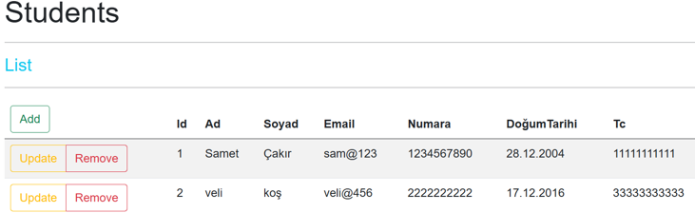
 | 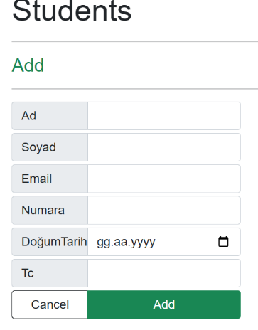 | 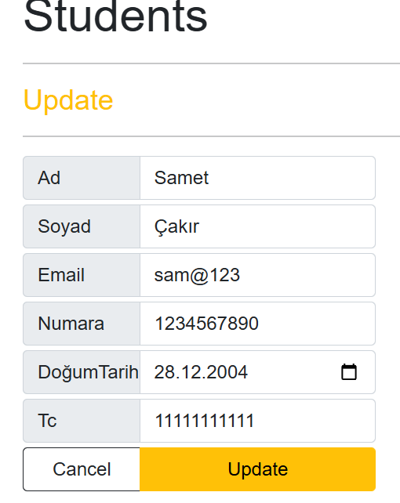 | 