THEORETICAL CONFLICT ANALYSIS UNIT
What Would Win
Product planning, simulation specification and Codex handoff
A transparent one-versus-X simulator for serious-looking answers to absurd questions.

Version | 0.1 — working prototype handoff
Prepared | 17 July 2026
Owner / host | Sam · samfa12.com
Implementation | React · TypeScript · Vite · static hosting

Product promise: Put one creature against an effectively unlimited number of another creature, state the assumptions, and return a serious-looking, transparent, textual estimate of what would win.

Entertainment model · peak-adult profiles · no graphic violence

Document map
Use Word’s Navigation pane to jump between numbered sections. The map below lists the primary sections in this handoff.
• 1. Executive summary
• 2. Locked product decisions
• 3. Problem, opportunity and differentiation
• 4. Product principles
• 5. Audience and jobs to be done
• 6. MVP scope
• 7. Core user journey
• 8. Information architecture and interface
• 9. Functional requirements
• 10. Simulation model
• 11. Data strategy
• 12. Database field dictionary
• 13. Content, safety and trust boundaries
• 14. Technical architecture
• 15. Hosting on samfa12.com
• 16. Analytics and viral loop
• 17. Testing strategy
• 18. Launch acceptance criteria
• 19. Roadmap
• 20. Ordered Codex backlog
• 21. Risks and mitigations
• 22. Open research questions
• 23. Reference foundation
• 24. Definition of done for the next Codex session
• Appendix A. Delivered artifact inventory
• Appendix B. Prototype calibration snapshot
• Appendix C. Public-beta release checklist

Product promise: Put one creature against an effectively unlimited number of another creature, state the assumptions, and return a serious-looking, transparent, textual estimate of what would win.

1. Executive summary
What Would Win is a free, mobile-friendly web application for resolving absurd hypothetical conflicts such as “100 duck-sized horses versus one horse-sized duck.” Its tone is deliberately mock-serious, but its method is not a random joke generator. The app separates physical measurements, authored combat attributes, scaling assumptions, battlefield conditions and uncertainty. A deterministic model creates the underlying matchup, then seeded Monte Carlo trials introduce biological and tactical variation. The final report explains the winner, probability, expected duration, losses, decisive factors, model limitations and the opposing quantity required for an approximately even contest.
The first release is deliberately constrained to one profile versus X copies of one opposing profile. That shape is easy to understand, strongly shareable and technically compatible with extreme quantities. The working prototype accepts ordinary integers, scientific notation and expressions such as 10^100. Large forces are represented in logarithmic space and through an effectiveness exponent; the browser never attempts to instantiate every combatant.
The handoff includes:
- a working static web demo with no server dependency;
- a curated MVP-100 database: 64 living animals, 8 extinct animals, 24 fantasy or mythological profiles and 4 generic human profiles;
- CSV and JSON data exports plus JSON Schemas;
- seven behavioural calibration scenarios and automated tests;
- this product and model specification;
- a Codex-oriented implementation guide and ordered backlog.
The prototype is an entertainment model, not a scientific prediction, animal-welfare guide, military tool or authoritative zoological database. Its most important product behaviour is transparency: users can see which assumptions make the result change.

2. Locked product decisions
Decision | Locked direction
Product name | What Would Win
Emotional tone | Serious scientific or intelligence-report presentation applied to absurd questions
Core battle shape | One contestant versus X copies of one opposing contestant
Main output | Instant, mostly textual result; no battle animation required
Scientific posture | Detailed and inspectable model, while clearly labelled as entertainment and assumption-sensitive
Launch categories | Living animals, extinct animals, public-domain or generic fantasy creatures, and generic humans
Quantity | No displayed upper limit; conceptual warning beyond physically meaningful forces
Size controls | Normal, named presets, exact target mass and relative linear scale
Resizing assumptions | Strict biology, functional scaling and magical scaling, selected by the user
Controls | Simple controls by default; advanced dossier for all normalized stats and tactical conditions
Result depth | Four user-selectable levels; greater depth runs more uncertainty trials
Baseline specimen | Representative high-end / peak healthy adult, disclosed prominently
Violence | Abstract and textual; incapacitation, retreat or surrender rather than graphic injuries
Persistence | Shareable URL, downloadable result image and JSON, local browser history; no account
Distribution | Free viral web toy hosted by Sam on samfa12.com

3. Problem, opportunity and differentiation
The “who would win?” format is familiar, but existing experiences generally fall into one of three groups: visual battle sandboxes, games with preset units, or generative text/video that does not expose a calculation. The opportunity is a lightweight product that feels like a cross between a laboratory instrument, an intelligence briefing and a shareable joke.
The differentiator is not a claim that hypothetical creature combat can be known precisely. It is the ability to make assumptions explicit and repeatable. A user should be able to answer questions such as:
- Does the answer change under strict biological scaling?
- How many group members are needed before the result becomes close?
- Is the group losing because it cannot penetrate armour, cannot reach a flying opponent, or cannot bring all members into contact?
- Does an ambush, storm, fortification or limited ammunition change the verdict?
- Which numbers are measurements, which are normalized model inputs and which are fantasy assumptions?
This makes the app useful as entertainment, debate resolution, casual systems thinking and an accessible demonstration of modelling uncertainty.

4. Product principles

4.1 Show the assumptions
Every result must identify the scaling mode, specimen convention, quantity aggregation, battlefield setup and major data limitations. Advanced users should be able to inspect a technical calculation record.

4.2 Calculate first, narrate second
The numerical engine chooses the outcome. Text generation explains the output; it must not invent a winner independently. The initial demo uses deterministic templates so it works offline and remains reproducible.

4.3 Make absurd scale safe and fast
The app must accept quantities far beyond JavaScript's safe integer range. It should calculate with log10(N) and aggregate-force rules instead of allocating one object per combatant.

4.4 Preserve the joke without pretending certainty
The visual identity may be authoritative, but the copy must reserve uncertainty, especially for fantasy creatures, extinct reconstructions and extreme resizing. A raw trial tally and a displayed uncertainty-adjusted probability are separate values.

4.5 Keep violence abstract
Use “incapacitated,” “forced retreat,” “unable to continue” and “expected losses.” Avoid visible wounds, gore and cruelty framing. The result should be funny because of the premise and analytical seriousness, not because of suffering.

4.6 Every shared result should reproduce
A shared URL encodes the complete scenario and seed. Opening it should recreate the same deterministic state and sampled result, subject only to explicit model-version changes.

5. Audience and jobs to be done

Primary audience: curious sharers
A person sees or invents an absurd matchup and wants a fast result worth posting in a group chat. They need a clear winner, a strong visual result card and one or two surprising reasons.

Secondary audience: debate optimizers
A user wants to change assumptions until a disputed matchup becomes fair. They need sliders, terrain and scaling modes, a 50/50 quantity estimate and transparent logic.

Tertiary audience: model explorers
A technically curious user wants to inspect formulas, raw trial rates, confidence assumptions and the data record. They need a technical report and downloadable JSON.

Core jobs
1. “Set up my hypothetical in under a minute.”
2. “Give me a result that feels reasoned rather than arbitrary.”
3. “Show me which assumption changed the answer.”
4. “Tell me how many opponents would make it a fair fight.”
5. “Let me share or save the exact scenario without making an account.”

6. MVP scope

6.1 Included in the working prototype
- One selected solo profile versus X identical group profiles.
- 100 built-in profiles, grouped by living, extinct, fantasy and generic human.
- Arbitrary positive whole-number quantities expressed as integers, 1e100 or 10^100.
- Normal, named, exact-mass and relative-linear size controls.
- Strict, functional and magical scaling modes.
- Simple sliders: aggression, intelligence and teamwork/coordination.
- Presets: natural baseline, enraged, disciplined, exhausted and armoured.
- Advanced control of attack, defence, durability, agility, stamina, intelligence, aggression, coordination, morale, armour and multi-target capability.
- Terrain, weather, starting distance, preparation time, day/night, ambush, defensive position, escape and resources/ammunition.
- Four report-depth choices with 400, 1,500, 5,000 or 15,000 trials.
- Winner probability, uncertainty band, duration, group losses, solo risk and 50/50 quantity.
- Textual reconstruction, decisive factors, strengths, vulnerabilities, assumptions and technical ledger.
- Re-rollable seeded uncertainty.
- Share URL, downloadable PNG, downloadable JSON and local history.
- Responsive desktop and mobile layout.

6.2 Explicit MVP non-goals
- Multiple creature types on one team.
- More than two sides.
- Animated or real-time combat.
- User accounts, cloud saves, public galleries or moderation systems.
- Natural-language creature generation.
- Persistent named custom creatures. The prototype's overrides already demonstrate base-profile modification and structured stat editing; saveable custom entries are the next feature.
- A fully sourced per-field zoological research database.
- Named living people, children, real protected groups or modern franchise characters in the built-in database.
- Claims of scientific, veterinary or military validity.

7. Core user journey

7.1 Fast path
1. Choose the solo contestant.
2. Choose the opposing contestant and quantity.
3. Set each side's size.
4. Select the resizing law.
5. Choose terrain, weather and starting distance.
6. Select report depth.
7. Run the simulation.
8. Read the result and share the link or result image.
Target time for a first result: under 45 seconds for a new user.

7.2 Advanced path
1. Complete the fast setup.
2. Open Advanced dossier.
3. Configure preparation, ambush, defensive position, resources and escape.
4. Override normalized stats for either side.
5. Run a transparent or technical report.
6. Compare the raw trial rate, displayed probability and technical power terms.
7. Re-roll the uncertainty sample or copy the scenario URL.

7.3 Future custom-profile path
1. Select a base profile.
2. Choose Clone as custom.
3. Enter a name and category.
4. Edit physical measurements, capabilities, attacks, traits and normalized scores.
5. Review warnings for inconsistent inputs.
6. Save locally and use it in either side of a scenario.
7. Export the custom profile as JSON.

8. Information architecture and interface
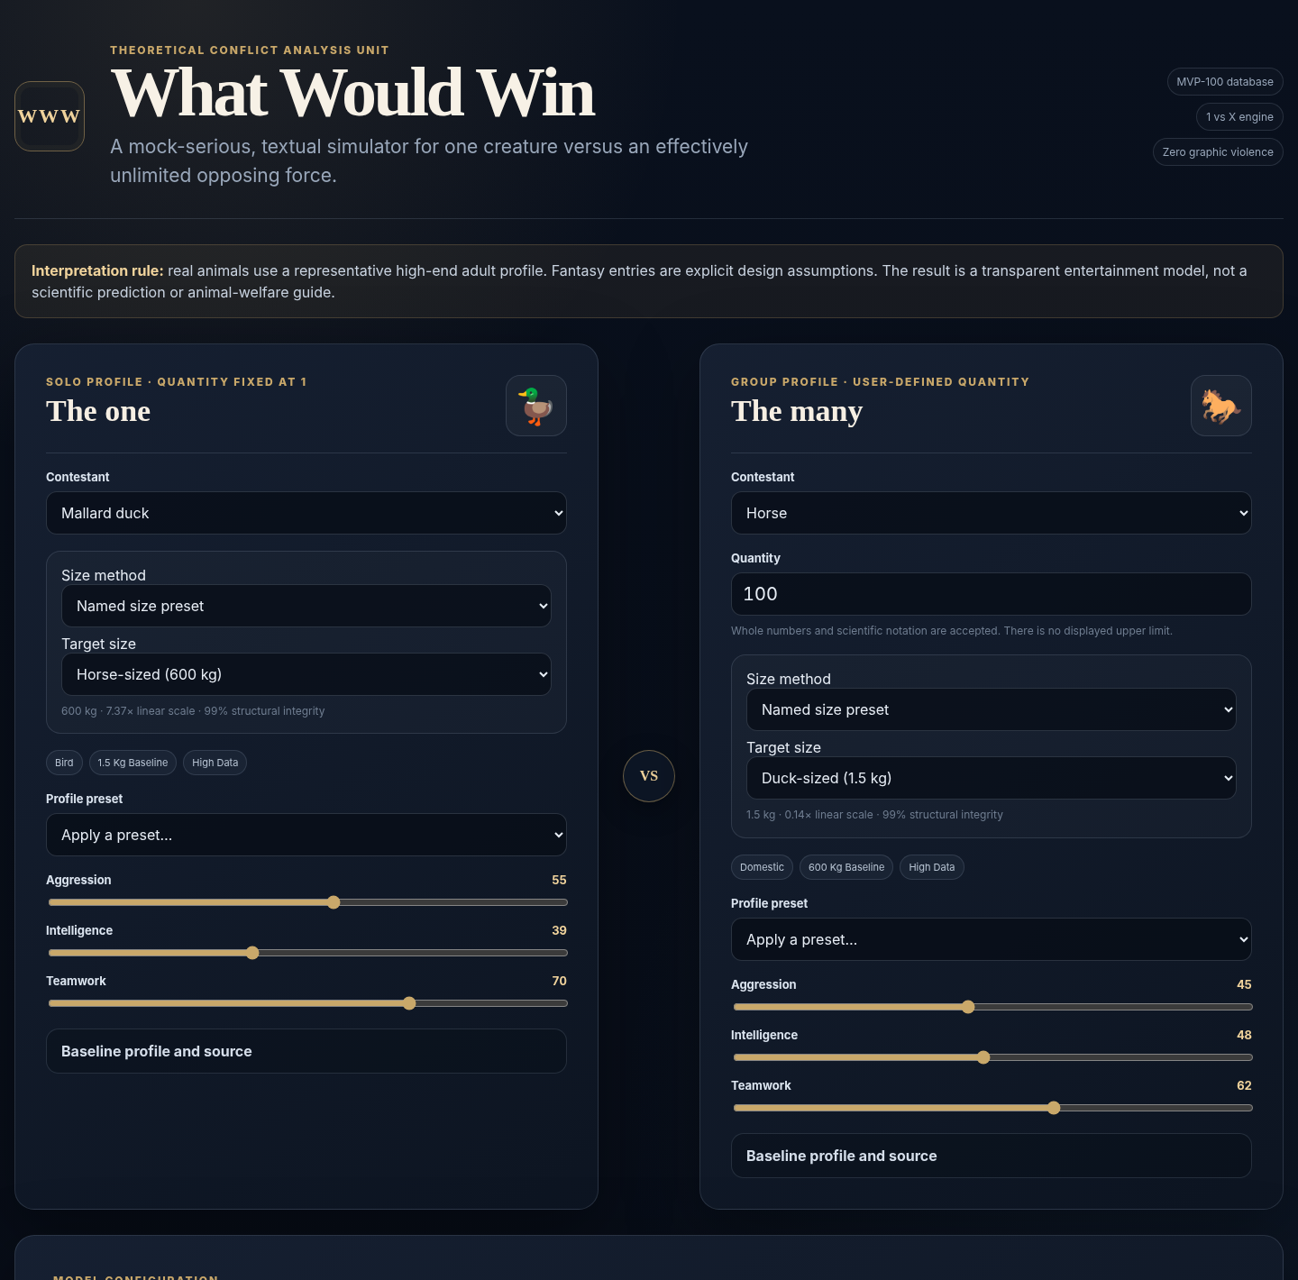
Figure 1. Working desktop prototype: contestant dossiers and primary controls.
The application is a single-page tool with four vertical regions:
1. Header and interpretation rule — establishes the mock-serious tone and makes the peak-adult convention and entertainment disclaimer visible before interaction.
2. Contestant dossiers — side-by-side on desktop and stacked on mobile. “The one” is fixed at quantity one; “The many” accepts arbitrary quantity text.
3. Model configuration — resizing law, environment, report depth and the expandable advanced dossier.
4. Result and history — verdict first, then deeper explanation according to selected report depth, followed by local history.

8.1 Visual language
- Dark navy background suggests an analysis console rather than a game arena.
- Warm gold accents imply official seals, archival documents and intelligence briefings.
- Serif display type provides mock gravitas; compact sans-serif text keeps controls readable.
- Cards use clear borders and restrained spacing rather than cartoon panels.
- Creature emoji are incidental locators, not the primary visual style.

8.2 Accessibility requirements
- All controls require visible labels and keyboard operation.
- Results use text and numeric labels, not colour alone.
- The probability bar must retain readable percentages on each side.
- Focus states must be visible.
- aria-live announces a new result.
- Advanced content uses semantic details and summary elements.
- Minimum supported viewport is 360 CSS pixels.
- Before public launch, test with axe, keyboard-only navigation, VoiceOver and NVDA.

9. Functional requirements

FR-1: contestant selection
The user can select any built-in profile for the solo or group side. Options are grouped by kind. The selected profile exposes baseline mass, speed, reach, attack modes, traits, confidence and an orientation source.
Acceptance: changing a selection updates the dossier immediately; running the model uses the new profile.

FR-2: arbitrary quantity
The group quantity accepts positive whole numbers, scientific notation and power notation. Internally it resolves to log10(quantity) and, only where safe, an approximate JavaScript number.
Acceptance: 100, 1e100 and 10^100 are valid; zero, negative and prose values fail with a useful error; the UI never freezes because of quantity magnitude.

FR-3: size configuration
Each side supports:
- normal profile mass;
- named target masses: mouse 0.04 kg, duck 1.5 kg, dog 30 kg, human 100 kg, horse 600 kg and elephant 6,000 kg;
- exact target mass in kilograms;
- relative linear scale, where mass changes with the cube of linear scale.
The UI shows target mass, linear scale and structural integrity.

FR-4: scaling law
The user selects one law for both sides:
- Strict biology: resized bodies receive structural penalties inspired by allometric and square-cube constraints.
- Functional scaling: the creature remains viable and mobile with moderated scaling effects.
- Magical scaling: function is preserved and capability can rise aggressively with mass.
This is a modelling switch, not a claim that one interpretation is objectively correct.

FR-5: profile modifiers
Simple controls expose aggression, intelligence and coordination. The advanced dossier exposes every normalized stat. Presets apply coherent bundles of overrides without mutating the baseline database.

FR-6: battlefield setup
The user can choose terrain, weather, distance, preparation, day/night, ambush, defensive position, escape and available resources. Each variable must have an observable route into the calculation or be removed from the UI.

FR-7: report effort
The user chooses:
Level | Trials | Content
Verdict | 400 | Winner and core metrics
Assumptions | 1,500 | Adds reconstruction and limits
Transparent | 5,000 | Adds factors, strengths, vulnerabilities and source context
Technical | 15,000 | Adds full calculation ledger

The trial count is a product-control proxy for simulation effort. Because the engine is lightweight, all four levels currently complete in-browser without blocking for a meaningful period.

FR-8: result report
Every result includes a winner, model win rate, probability band, expected duration, expected group losses, solo incapacitation/retreat risk and 50/50 group size. Deeper modes add explanation and technical values.

FR-9: share and export
A share link encodes the scenario. PNG export creates a 1200 × 630 result card. JSON export includes scenario, contestant records and result. Local history stores the latest 12 runs without an account.

FR-10: reproducibility
The scenario contains a seed. Re-running the same scenario and seed reproduces the sampled result. New uncertainty sample increments the seed while retaining all other inputs.

10. Simulation model

10.1 Modelling posture
The engine is a calibrated game model with biologically inspired structure. It is not a biomechanics solver and does not model individual anatomy, wounds or exact spatial trajectories. Its purpose is to make assumptions internally consistent, inspectable and computationally cheap.
All constants in this section are versioned design parameters. They should be changed only with a calibration note and regression-test update.

10.2 Pipeline
1. Parse quantity and convert it to log10(N).
2. Resolve each selected creature and user overrides.
3. Resolve target mass and linear scale.
4. Apply the selected scaling law to structural integrity, speed and reach.
5. Convert physical and normalized inputs into single-combatant log power.
6. Apply environment, distance and pre-battle adjustments.
7. Aggregate the group with a sublinear effectiveness exponent.
8. Apply matchup interactions: armour penetration, area control, flight/range access, venom immunity, contact limits and escape.
9. Run seeded Monte Carlo trials around the deterministic values.
10. Reserve explicit probability weight for unmodelled uncertainty.
11. Generate metrics and a templated textual explanation.

10.3 Quantity representation
For a quantity N, the engine primarily stores:
q = log10(N)
This permits conceptual quantities such as 10^100 without overflow. When N exceeds the range in which physical battlefield geometry, logistics and planetary constraints are meaningful, the report displays a conceptual-scale warning. The result then means “aggregate combat pressure under this abstract model,” not a literal staged event.

10.4 Size resolution
Let M0 be representative baseline mass and M target mass.
- Normal: M = M0
- Named preset: M = preset mass
- Exact: M = user-entered kilograms
- Relative: M = M0 × L^3, where L is the user-entered linear scale
The resolved linear scale is:
L = cube_root(M / M0)
Reach scales approximately with L. Speed and structural integrity depend on the selected law.
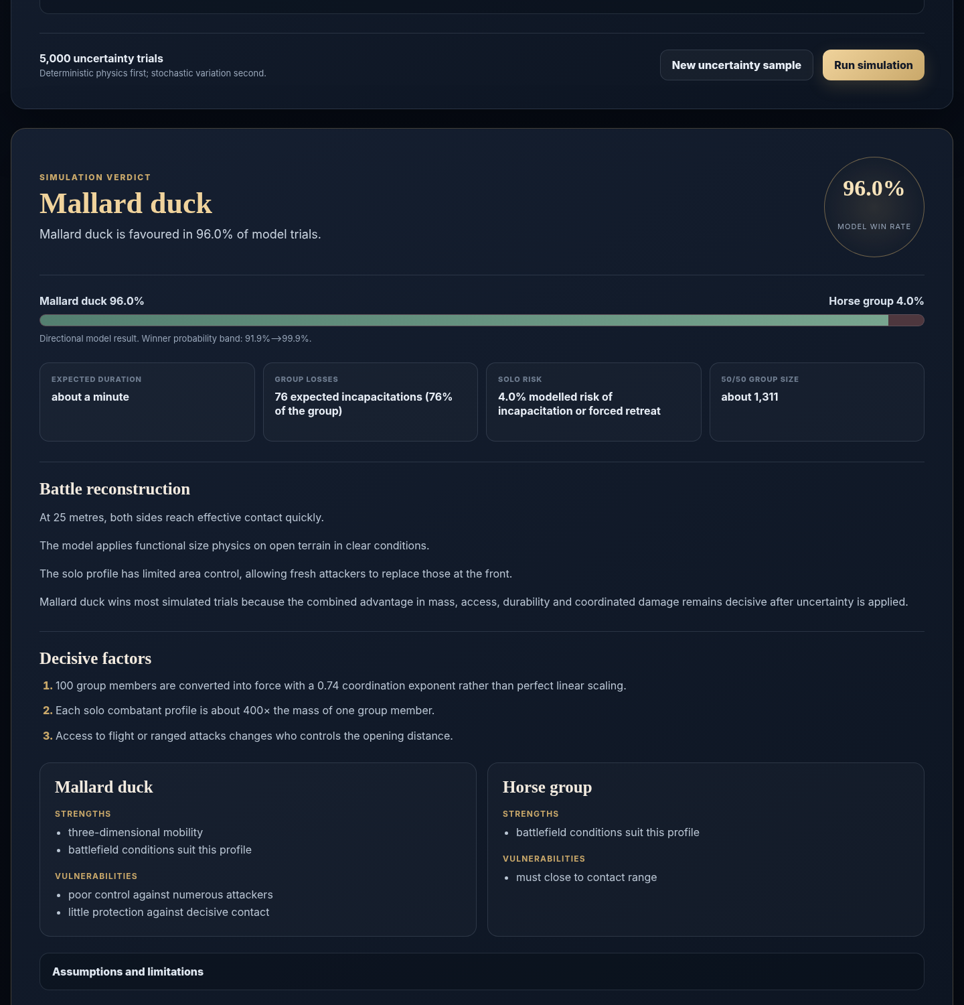
Figure 2. Working desktop prototype: textual verdict, metrics and transparent explanation.

10.5 Structural integrity
- Magical scaling uses an integrity factor of 1.08.
- Functional scaling uses 0.99.
- Strict scaling applies an exponential penalty for enlargement and a gentler penalty for extreme reduction, clamped to 0.06–1.00.
The current strict implementation is:
I = exp(-0.22 × max(0,L-1)^1.12) × exp(-0.035 × max(0,1/L-1)^0.58)
This is inspired by allometric constraints but is not an empirically fitted universal law. Allometry concerns how biological traits and processes change with body size; real scaling differs by tissue, locomotor mode and taxon. Production refinement should fit separate functions for terrestrial, flying and aquatic profiles rather than treating one formula as final.

10.6 Speed scaling
The current multiplicative speed factors are:
- Magical: clamp(L^0.08, 0.65, 2.2)
- Functional: clamp(L^0.18, 0.35, 3.5)
- Strict: clamp(L^0.34 × I^0.42, 0.05, 3.2)
These values intentionally prevent speed from rising in direct proportion to size.

10.7 Single-profile log power
Normalized attack quality combines attack, aggression, agility, speed, reach, intelligence, multi-target capability and stamina. Defence quality combines defence, durability, armour, stamina, agility, morale and intelligence.
The current core terms are:
mass_term = 0.61 × log10(M + 0.02)
quality_term = log10(0.42 + 2.2 × attack_quality) + 0.7 × log10(0.5 + 1.75 × defence_quality)
single_log_power = mass_term + quality_term + log10(environment) + log10(integrity) + log10(special)
The special factor covers flight, venom, range, regeneration, area effects, armour, construct/undead resistance and available ammunition. It is deliberately bounded.

10.8 Group aggregation
Perfectly linear scaling would assume every member attacks effectively at once. That is implausible for most large groups. Group force is therefore:
group_log_power = member_log_power + E × log10(N) + adjustments
The effectiveness exponent E begins at:
E = 0.58 + 0.0018 × coordination
Bonuses apply for swarm/eusocial behaviour, pack hunting, formation discipline, open terrain and suitable aquatic conditions. Penalties apply in confined terrain. The exponent is clamped to 0.62–0.94.
This exponent is one of the most sensitive product parameters. It should eventually be estimated by archetype and validated against synthetic benchmark scenarios rather than shared globally.

10.9 Matchup interactions
The deterministic layer also applies:
- Penetration penalty: compares group attack with solo defence, durability, armour and mass barrier; range, venom and penetrating attack modes can reduce the penalty.
- Solo area control: multi-target score, mass ratio and area-effect traits reduce the group's ability to accumulate pressure.
- Coordination pressure: coordinated groups replace front-line attackers and exploit angles more effectively.
- Range and closing: ranged profiles gain at long initial distances; slow melee profiles pay a small closing cost.
- Flight access: a side with uncontested flight receives a major advantage.
- Environment: habitat match, terrain, weather and time of day affect each side separately.
- Preparation, ambush and defence: intelligent profiles convert preparation into a bounded advantage.
- Resources: ranged capability is discounted as ammunition/resources fall.
- Escape: a small advantage goes to the more mobile side and expected losses decline.

10.10 Monte Carlo layer
Each trial samples normally distributed variation around solo and group deterministic log power. Noise is larger for low-confidence and modelled profiles. A shared tactical swing moves the two sides in opposite directions for a trial. The seeded pseudo-random generator makes a scenario reproducible.
The raw solo trial rate uses light Bayesian smoothing:
p_raw = (solo_wins + 0.5) / (trials + 1)
The prototype then prevents raw trial dominance from masquerading as complete knowledge:
p_display = 0.5 + (p_raw - 0.5) × C
where C is:
- 0.92 when both profiles have high-confidence real-world data;
- 0.86 for other non-fantasy pairings;
- 0.88 when fantasy is present;
- 0.99 for conceptual-scale quantities, where the aggregate mathematical imbalance itself may dominate even though the scenario is physically impossible.
This “epistemic compression” is visible in the assumptions and technical record. Future versions should replace these fixed values with uncertainty distributions tied to each field and archetype.

10.11 Probability band
The report combines sampling standard error with an explicit model floor. Conceptual quantities and lower-confidence profiles receive wider bands. The band should be described as a model sensitivity band, not a frequentist confidence interval for real-world outcomes.

10.12 50/50 quantity
The engine finds the opposing quantity at which deterministic group log power first meets solo log power. It searches in logarithmic space, expanding the upper bound and then applying binary search. The result is an approximate model crossover, not a promise that the displayed probability at that exact integer is 50.0% after stochastic compression.

10.13 Duration and losses
Duration is a heuristic based on closing speed, quantity load, durability and attack rate. Group losses blend expected loss fractions in solo-win and group-win branches, then apply the probability weighting. At conceptual scales, these values are mathematical labels rather than physically staged counts.

11. Data strategy

11.1 Prototype database composition
The MVP-100 is selected for scenario value, not taxonomic completeness:
- 64 living animals covering megafauna, apex predators, packs, domestic animals, birds, aquatic specialists, venom, flight and swarms;
- 8 extinct animals covering iconic dinosaurs and Pleistocene megafauna;
- 24 generic or public-domain mythological creatures covering giants, dragons, regeneration, constructs, undead, magic and colossal aquatic profiles;
- 4 generic humans covering unarmed, trained, armoured melee and ranged archetypes.
The selection intentionally maximizes mechanics coverage: body mass, armour, speed, reach, flight, aquatic movement, range, venom, regeneration, coordination, area control and unusual scale.

11.2 Peak-adult convention
Each real profile represents a large, healthy, combat-capable adult. It is not the species mean and not the largest anecdotal specimen. Where sexual dimorphism matters, the profile generally follows the larger or more combat-relevant adult form, but the current dataset does not yet store sex explicitly. This convention must remain visible in the interface and documentation.

11.3 Physical fields versus model scores
Physical or semi-physical fields: representative peak mass, body length, body/shoulder height, burst speed and effective reach.
Normalized model scores: attack, defence, durability, agility, stamina, intelligence, aggression, coordination, morale, armour and multi-target capability.
The 0–100 scores are authored inputs. They are not direct zoological measurements and should never be exported or described as scientific facts without that qualifier.

11.4 Current provenance status
The prototype includes one orientation URL and confidence label per row. These references are enough for navigation during development but are not a production provenance system. Many orientation links point to broad reference pages; normalized scores were manually authored for model coverage.

11.5 Production provenance model
A production record should store evidence per field:
- value, units and allowed range;
- typical, high-adult and low/high distribution values;
- sex, age class and subspecies/population;
- source title, authors, publisher, URL or DOI, publication date and access date;
- quoted measurement definition;
- transformation or assumption used;
- confidence and reviewer;
- data licence and reuse conditions.
Recommended sources include PanTHERIA for mammalian life-history and ecological traits, Animal Diversity Web for orientation and cited natural-history sources, museum or peer-reviewed reconstructions for extinct species, and explicit authored design bibles for fantasy profiles. Source conflicts should be preserved as ranges rather than silently averaged.

11.6 Fantasy policy
The built-in database uses generic and public-domain mythology. Named modern franchise characters should not be shipped without licensing. A user may create a private custom equivalent, but public galleries would require moderation and an IP-reporting process.
Fantasy profiles use data_confidence: modelled and must expose their design assumptions. “Fire,” “petrification,” “regeneration” and similar traits are mechanics tags, not attempts to infer a canonical version across every story.

12. Database field dictionary
Field | Type | Purpose
id | slug | Stable application identifier
name | string | User-facing profile name
kind | enum | animal, extinct, fantasy, human
category | string | UI and balancing grouping
icon | string | Lightweight visual locator
representative_peak_mass_kg | number | High-adult baseline mass
body_length_m | number | Approximate body length
shoulder_or_body_height_m | number | Approximate principal height
burst_speed_kph | number | Short-duration movement speed
effective_reach_m | number | Contact or built-in ranged reach abstraction
attack | 0–100 | Ability to inflict decisive harm per opportunity
defense | 0–100 | Avoidance, blocking and positional defence
durability | 0–100 | Ability to continue after adverse contact
agility | 0–100 | Acceleration, turning and precise movement
stamina | 0–100 | Sustained output and recovery
intelligence | 0–100 | Tactical adaptation and planning
aggression | 0–100 | Willingness to initiate and sustain attack
coordination | 0–100 | Teamwork and formation effectiveness
morale | 0–100 | Resistance to fear, rout and surrender
armor | 0–100 | Passive physical protection
multi_target | 0–100 | Ability to control or affect multiple opponents
habitats | string array | Environment matching tags
attack_modes | string array | Mechanically relevant attacks
traits | string array | Capabilities and archetype tags
capability booleans | boolean | Flight, aquatic, venom, range, regeneration and construct/undead
data_confidence | enum | high, medium, low, modelled
source_label | string | Provenance warning or source description
source_url | URL | Orientation reference
model_notes | string | Assumptions and cautions

Machine-readable constraints are provided in data/creature.schema.json and data/scenario.schema.json.

13. Content, safety and trust boundaries

Allowed built-in content
- real animal species and extinct species;
- generic adult humans and abstract historical-style equipment profiles;
- generic or public-domain fantasy creatures;
- abstract fictional and historical mass conflict without graphic depiction.

Excluded or restricted content
- named living people;
- children;
- targeting of real protected groups;
- scenarios framed as instructions for animal cruelty or real violence;
- modern franchise characters without permission;
- graphic wounds, gore or celebratory suffering.

Trust copy
Every public result should include a compact statement equivalent to:
Entertainment model using representative peak-adult profiles and authored assumptions. It is not a scientific prediction, welfare guide or instruction for real-world harm.

Fantasy and conceptual-scale results need additional warnings.

14. Technical architecture

14.1 Current stack
- React 19.2.7
- React DOM 19.2.7
- TypeScript 7.0.2
- Vite 8.1.5
- Vitest 4.1.10
- Static JSON data
- Browser APIs: URLSearchParams, localStorage, Clipboard and Canvas
Versions are pinned in app/package.json and app/package-lock.json for reproducible handoff. Before a production release, verify runtime and browser support because these dependencies will continue to evolve.

14.2 Repository layout
what-would-win-handoff/
├── app/
│ ├── src/
│ │ ├── components/ UI panels and result report
│ │ ├── data/ bundled creature and test JSON
│ │ ├── simulation/ quantity, PRNG, engine and share codec
│ │ ├── test/ Vitest regression tests
│ │ ├── App.tsx
│ │ ├── styles.css
│ │ └── types.ts
│ ├── dist/ production static build
│ ├── package.json
│ └── package-lock.json
├── data/ editable CSV/JSON, schemas and fixtures
├── docs/ planning and Codex documentation
└── scripts/ data generation/maintenance utility

14.3 Key modules
- simulation/quantity.ts parses arbitrary quantities and formats log quantities.
- simulation/random.ts supplies deterministic hashing, seeded PRNG and normal sampling.
- simulation/engine.ts resolves profiles, calculates deterministic power, runs trials and builds reports.
- simulation/share.ts serializes and restores scenarios in URLs.
- components/CreaturePanel.tsx handles profile, size and simple controls.
- components/StatControls.tsx renders normalized stat inputs.
- components/ResultPanel.tsx renders depth-sensitive output.

14.4 Static-first rationale
The current product needs no database, authentication or remote AI call. A static deployment is cheap, fast, private and resistant to backend failure. It also allows the entire initial experience to run locally after page load.
A backend becomes justified when the product adds public galleries, moderated uploads, analytics beyond simple page events, cloud accounts, source-research pipelines or AI-assisted custom profile generation.

14.5 Performance targets
- Initial compressed JS under 150 kB where practical; current build is roughly 84 kB gzip for JavaScript plus 4 kB gzip for CSS.
- First result interaction under 100 ms on a recent desktop and under 300 ms on a typical mobile device for 15,000 trials.
- No main-thread allocation proportional to group quantity.
- Largest Contentful Paint under 2.5 seconds on a normal 4G connection after hosting compression and cache headers.

15. Hosting on samfa12.com

Build
cd app
npm ci
npm run test
npm run typecheck
npm run build

Upload the contents of app/dist/ to the intended document root or subdirectory. The Vite configuration uses relative asset paths, so the build works in a subdirectory as well as the domain root.

Recommended production setup
- HTTPS only.
- Brotli or gzip for HTML, CSS and JavaScript.
- Long immutable cache for hashed files in assets/.
- Short cache for index.html.
- Content Security Policy that permits same-origin scripts/styles and data: only where required for exported canvas content.
- A custom 404 fallback to index.html only if route-based navigation is added later. Current share links use query parameters and do not require a history fallback.
- Add Open Graph/Twitter metadata and a default social image before launch.
- Add a privacy page explaining local history and any analytics.

Suggested paths
- https://samfa12.com/what-would-win/ — app
- https://samfa12.com/what-would-win/about — methodology and disclaimers, once route support exists
- https://samfa12.com/what-would-win/data — data methodology, not a raw promise of scientific authority

16. Analytics and viral loop
Use privacy-conscious analytics and avoid storing full custom scenario text unless disclosed. Useful events:
- simulation run;
- report-depth selection;
- advanced dossier opened;
- share-link copied;
- result PNG downloaded;
- result JSON downloaded;
- history restored;
- quantity classified as ordinary, large or conceptual;
- profile category pair, using IDs rather than free text.
Primary metrics:
- simulation runs per visit;
- share actions per completed run;
- return visits within seven days;
- percentage using advanced controls;
- percentage trying a second assumption or re-roll;
- top built-in matchups;
- mobile completion rate.
The strongest viral loop is: see absurd result → open reproducible scenario → change one assumption → share counter-result.

17. Testing strategy

17.1 Automated tests already included
- quantity parsing and rejection;
- scientific-notation formatting;
- seven matchup acceptance bands;
- technical trial-count selection;
- deterministic reproducibility with the same seed;
- deterministic power stability across different uncertainty seeds.
The fixtures are behavioural calibration bands, not assertions of objective biological truth.

17.2 Required next tests
- strict versus functional versus magical scaling changes expected integrity and result direction;
- long-distance ranged advantage and depleted-ammunition reversal;
- flight access against a non-ranged ground group;
- aquatic mismatch on deep-ocean terrain;
- low coordination scaling worse than swarm/formation profiles;
- URL round-trip for every size method and advanced field;
- localStorage corruption recovery;
- PNG export smoke test;
- keyboard and accessibility automation;
- performance test at 15,000 trials and extreme log10(N).

17.3 Calibration protocol
1. Maintain a balanced benchmark suite across archetypes rather than tuning to one famous question.
2. Record the reason for every coefficient change.
3. Run sensitivity analysis to identify dominant parameters.
4. Avoid “correcting” outputs solely to match online consensus.
5. Have at least one zoology/biomechanics reviewer assess real-animal inputs and one game-systems reviewer assess fun and legibility.
6. Version the engine and preserve old shared results or visibly mark model-version changes.

18. Launch acceptance criteria
A public beta is ready when:
- a new user can complete and share the default scenario on desktop and mobile;
- all P0 tests pass on the deployment build;
- invalid quantities fail safely;
- report depth visibly changes content and trial count;
- the same share URL reproduces the same result;
- no built-in profile violates the content/IP policy;
- every creature has a source label, notes and confidence value;
- the peak-adult and entertainment-model disclosures are visible before and after a run;
- keyboard navigation and screen-reader smoke testing pass;
- the app has a privacy statement and no undisclosed remote data transfer;
- a model version is included in exported JSON.

19. Roadmap

Phase 0 — handoff prototype (delivered)
Static React demo, MVP-100 data, deterministic-plus-Monte-Carlo model, exports, history, documentation and calibration tests.

Phase 1 — trustworthy beta
- add model versioning to scenarios and exports;
- introduce per-field provenance and data validation;
- add saveable custom profiles cloned from built-ins;
- improve archetype-specific allometry and group exponents;
- run accessibility and performance hardening;
- add Open Graph result preview generation;
- add a methodology/about view.

Phase 2 — shareability
- compact URL encoding and optional short links;
- scenario comparison mode (“strict vs magical”);
- embeddable result cards;
- featured matchup prompts without a public unmoderated gallery;
- search and filters across the creature database;
- local collections and favourites.

Phase 3 — deeper modelling
- mixed-team advanced army builder;
- explicit spatial/contact-front model;
- per-field uncertainty distributions;
- sensitivity charts;
- separate flying, terrestrial and aquatic scaling models;
- optional AI assistant that proposes structured custom stats while the deterministic engine remains authoritative.

Phase 4 — community, only with moderation capacity
- accounts and cloud saves;
- moderated public gallery;
- voting, remixes and model-version comparisons;
- transparent reporting and IP takedown workflow.

20. Ordered Codex backlog

P0 — harden the delivered prototype
1. Add MODEL_VERSION and DATA_VERSION constants to exported results and share URLs.
2. Add JSON Schema validation during data generation and tests.
3. Add URL codec round-trip tests and graceful handling of oversized/corrupt query strings.
4. Add unit tests for each scaling law, environment modifier, flight/range access and ammunition.
5. Replace manual HTML canvas line wrapping with a tested export-card component or robust text fitting.
6. Add accessible focus styles, skip link and automated axe checks.
7. Fix any browser-compatibility issues found in Safari iOS and Firefox.
8. Add a build-size and simulation-duration check to CI.
9. Add an about/methodology panel containing the critical disclaimer and model version.
10. Establish a changelog for coefficient changes.

P1 — custom profile builder
1. Add a CustomCreature type compatible with the base schema and a custom: ID namespace.
2. Implement “Clone selected profile.”
3. Build structured physical, capability, attack-mode, trait and normalized-stat editing.
4. Validate ranges and flag inconsistent combinations rather than silently changing them.
5. Save custom profiles in versioned localStorage.
6. Include referenced custom profiles inside shared scenario payloads.
7. Add JSON import/export and delete/duplicate controls.
8. Make custom profiles private by default and display a “user-authored” confidence label.

P1 — data quality
1. Replace single-row orientation URLs with per-field provenance records.
2. Add sex/age/subspecies and distribution fields.
3. Build a script that reports missing values, outliers, duplicate IDs and unknown tags.
4. Define a controlled vocabulary for habitats, attack modes and traits.
5. Review the top 30 most-used profiles first.
6. Record licences for source datasets and do not redistribute restricted source content.

P2 — modelling research
1. Split group exponent parameters by swarm, pack, formation, herd and uncoordinated crowd.
2. Replace global strict-scaling logic with locomotor archetype functions.
3. Create a contact-front model based on body footprint, reach and terrain capacity.
4. Model incapacitation thresholds and rate limits separately from aggregate power.
5. Add global sensitivity analysis and display the top uncertain inputs.
6. Evaluate whether probability compression should emerge from field-level distributions rather than fixed coefficients.

21. Risks and mitigations
Risk | Consequence | Mitigation
False scientific authority | Users treat outputs as facts | Persistent disclaimers, source confidence, raw vs adjusted probability, methodology page
Overfitting to memes | Engine behaves badly outside famous cases | Diverse calibration suite and coefficient changelog
Poor data provenance | Trust and licensing problems | Per-field sources, licences and reviewer workflow
Fantasy IP complaints | Removal requests or brand risk | Generic/public-domain built-ins; private user customs; moderation before gallery
Extreme quantity nonsense | Misleading casualties or duration | Conceptual-scale warning and separate logistics mode in future
URL payload growth | Links become too long, especially with customs | Compression, short-link service or share JSON upload later
Local data loss | Users lose saved customs/history | Clear local-only copy and JSON export
Mobile complexity | Advanced UI becomes overwhelming | Progressive disclosure and fast path kept above advanced dossier
Coefficient regressions | Unexpected result shifts | Engine/data versioning and behavioural tests
Harmful scenario use | Cruelty or targeting concerns | Abstract language, content rules, gallery moderation and no named living people

22. Open research questions
- What group-effectiveness function best represents contact saturation across different body-size ratios?
- Can reach, footprint and terrain produce a better contact-front estimate than the current exponent alone?
- Which physical measures most reliably predict combat-relevant durability without inventing false precision?
- How should flight endurance and ranged ammunition interact with very large ground groups?
- What uncertainty distributions are appropriate for extinct reconstructions and fantasy profiles?
- How should surrender, fear and escape be modelled separately from physical incapacitation?
- At what scale should the app switch from “combat” to “logistics/ecology” and refuse a literal duration estimate?
These are product-research questions, not blockers. The delivered model provides a clear baseline against which more sophisticated approaches can be tested.

23. Reference foundation
The model is informed by, but not a direct implementation of, the following source categories:
1. Nature Scitable, Allometry: The Study of Biological Scaling — https://www.nature.com/scitable/knowledge/library/allometry-the-study-of-biological-scaling-13228439/
2. National Research Council / NCBI Bookshelf, Allometry: Body Size Constraints in Animal Design — https://www.ncbi.nlm.nih.gov/books/NBK218080/
3. Jones et al., PanTHERIA: a species-level database of life history, ecology and geography of extant and recently extinct mammals, DOI 10.1890/08-1494.1 — https://doi.org/10.1890/08-1494.1
4. PanTHERIA dataset collection — https://doi.org/10.6084/m9.figshare.c.3301274.v1
5. University of Michigan, Animal Diversity Web — https://animaldiversity.org/
6. US EPA, Guiding Principles for Monte Carlo Analysis — https://www.epa.gov/risk/guiding-principles-monte-carlo-analysis
7. NIST Technical Note 1900, Simple Guide for Evaluating and Expressing the Uncertainty of NIST Measurement Results — https://nvlpubs.nist.gov/nistpubs/TechnicalNotes/NIST.TN.1900.pdf
These references justify the use of size-aware modelling, structured trait data and explicit uncertainty. They do not validate the prototype's combat coefficients. Those coefficients remain documented game-design assumptions pending calibration and expert review.

24. Definition of done for the next Codex session
The next session should begin by running the existing tests and reading docs/CODEX_HANDOFF.md. A successful first iteration should:
1. preserve all current passing tests;
2. add model/data versioning;
3. add schema validation and at least five new interaction tests;
4. implement the first saveable custom-profile slice or clearly document why a smaller prerequisite is required;
5. update this document and the changelog whenever the formula or data contract changes;
6. produce a deployable dist/ directory for samfa12.com.

Appendix A. Delivered artifact inventory
Artifact | Location | Purpose
Production-ready source | app/src/ | React/TypeScript UI and simulation engine
Static deployment build | app/dist/ | Files to upload to the web host
Dependency lock | app/package-lock.json | Reproducible package installation
Creature database | data/creatures.json / .csv | Application and editable data formats
Data contracts | data/*.schema.json | Machine-readable record validation
Calibration fixtures | data/test_scenarios.json / .csv | Behavioural acceptance bands
Full product plan | docs/What_Would_Win_Product_Plan.* | Product, model, data and roadmap specification
Codex handoff | docs/CODEX_HANDOFF.md | Continuation instructions and paste-ready prompt
Data dictionary | data/DATA_DICTIONARY.md | Field semantics and editing rules
QA report | docs/QA_REPORT.md | Build, test and visual-check status
Maintenance scripts | scripts/ | Data and document generation utilities

Appendix B. Prototype calibration snapshot
These are deterministic seeded results from the delivered 5,000-trial transparent mode. They are regression observations, not declarations of objective truth.
Scenario | Solo model probability | Delivered verdict
Horse-sized mallard duck vs 100 duck-sized horses | 96.0% | Mallard duck
African bush elephant vs 20 gray wolves | 96.0% | African bush elephant
Silverback gorilla vs 50 mallard ducks | 95.1% | Silverback gorilla
Western dragon vs 200 prepared archers | 88.5% | Western dragon
Tyrannosaurus rex vs 1,000 roosters | 93.0% | Tyrannosaurus rex
Kraken vs 20 orcas in deep ocean | 53.6% | Kraken; close and assumption-sensitive
Stone golem vs 10^100 house mice | 0.5% | Mouse aggregate; conceptual-scale warning

A coefficient change should be assessed across the whole set. A change that makes one meme answer feel better but damages unrelated archetypes is a regression, not an improvement.

Appendix C. Public-beta release checklist
- Confirm code and data licences.
- Add model and data version constants.
- Run schema validation, tests, typecheck and production build.
- Complete keyboard, axe, VoiceOver/NVDA, Safari iOS and Firefox checks.
- Replace or strengthen provenance for the most frequently used profiles.
- Add privacy, methodology and contact/reporting pages.
- Add Open Graph metadata and a default social preview.
- Configure HTTPS, compression, cache headers and monitoring on samfa12.com.
- Test copied share links from a clean browser profile.
- Test PNG and JSON downloads on mobile and desktop.
- Publish a changelog and retain the previous deploy for rollback.

Handoff status
The supplied prototype builds successfully, passes its automated calibration suite and has been visually checked at desktop and mobile widths. The next high-value work is model/data versioning, schema validation in CI and saveable custom profiles.

