Flight Delay Analysis: Classification & Clustering
Oklogo Samuel
2025-06-09

Introduction
This report presents a classification and clustering analysis of flight delay data. The goal is to build predictive models to identify delayed flights and use clustering to find natural groupings in flight behavior.

Load Data
my_data <- read.csv("flights_200.csv")

Classification Pipeline
run_classification_pipeline <- function(data, target, positive_class, smote = TRUE, seed = 123, parallel = TRUE) {
set.seed(seed)
if (parallel) {
cl <- makePSOCKcluster(parallel::detectCores())
registerDoParallel(cl)
} else {
registerDoSEQ()
}
data[[target]] <- as.factor(data[[target]])
lvls <- levels(data[[target]])
new_lvls <- c(setdiff(lvls, positive_class), positive_class)
data[[target]] <- factor(data[[target]], levels = new_lvls)
data <- data %>% select(all_of(c(target, "Flight_Duration", "Day_of_Week", "Weather_Conditions")))
split <- initial_split(data, prop = 0.8, strata = !!sym(target))
train_data <- training(split)
test_data <- testing(split)
rec <- recipe(as.formula(paste(target, "~ Flight_Duration + Day_of_Week + Weather_Conditions")), data = train_data) %>%
step_novel(all_nominal_predictors()) %>%
step_dummy(all_nominal_predictors()) %>%
step_zv(all_predictors()) %>%
step_normalize(all_numeric_predictors())
if (smote) {
rec <- rec %>% step_smote(all_outcomes())
}
model_log <- logistic_reg(penalty = 0.01, mixture = 1) %>% set_engine("glmnet") %>% set_mode("classification")
model_rf <- rand_forest(trees = 500) %>% set_engine("ranger", importance = "impurity") %>% set_mode("classification")
model_xgb <- boost_tree(trees = 500, learn_rate = 0.1, tree_depth = 6) %>% set_engine("xgboost") %>% set_mode("classification")
wf_log <- workflow() %>% add_model(model_log) %>% add_recipe(rec)
wf_rf <- workflow() %>% add_model(model_rf) %>% add_recipe(rec)
wf_xgb <- workflow() %>% add_model(model_xgb) %>% add_recipe(rec)
fit_log <- fit(wf_log, train_data)
fit_rf <- fit(wf_rf, train_data)
fit_xgb <- fit(wf_xgb, train_data)
evaluate_model <- function(fit, model_name) {
preds <- predict(fit, test_data, type = "prob") %>%
bind_cols(predict(fit, test_data)) %>%
bind_cols(test_data)
pred_col <- paste0(".pred_", positive_class)
auc <- roc_auc(preds, truth = !!sym(target), !!sym(pred_col)) %>% mutate(model = model_name)
conf <- conf_mat(preds, truth = !!sym(target), estimate = .pred_class)
roc <- roc_curve(preds, truth = !!sym(target), !!sym(pred_col)) %>% mutate(model = model_name)
list(auc = auc, conf_mat = conf, preds = preds, roc = roc)
}
eval_log <- evaluate_model(fit_log, "Logistic Regression")
eval_rf <- evaluate_model(fit_rf, "Random Forest")
eval_xgb <- evaluate_model(fit_xgb, "XGBoost")
all_auc <- bind_rows(eval_log$auc, eval_rf$auc, eval_xgb$auc)
roc_all <- bind_rows(eval_log$roc, eval_rf$roc, eval_xgb$roc)
if (parallel) {
stopCluster(cl)
registerDoSEQ()
}
roc_plot <- ggplot(roc_all, aes(x = 1 - specificity, y = sensitivity, color = model)) +
geom_line(linewidth = 1.2) +
geom_abline(lty = 2, color = "gray50") +
labs(title = "ROC Curves", x = "1 - Specificity", y = "Sensitivity") +
theme_minimal()
vip_rf <- vip(fit_rf$fit$fit, num_features = 10, geom = "col", aesthetics = list(fill = "steelblue")) +
labs(title = "Random Forest Feature Importance") +
theme_minimal()
vip_xgb <- vip(fit_xgb$fit$fit, num_features = 10, geom = "col", aesthetics = list(fill = "darkgreen")) +
labs(title = "XGBoost Feature Importance") +
theme_minimal()
list(
fits = list(logistic = fit_log, random_forest = fit_rf, xgboost = fit_xgb),
evaluations = list(logistic = eval_log, random_forest = eval_rf, xgboost = eval_xgb),
auc_summary = all_auc,
roc_plot = roc_plot,
feature_importance_plots = list(random_forest = vip_rf, xgboost = vip_xgb)
)
}
classification_results <- run_classification_pipeline(
data = my_data,
target = "Delayed",
positive_class = "1",
smote = TRUE,
seed = 123,
parallel = TRUE
)

ROC Curve and Feature Importance
classification_results$roc_plot
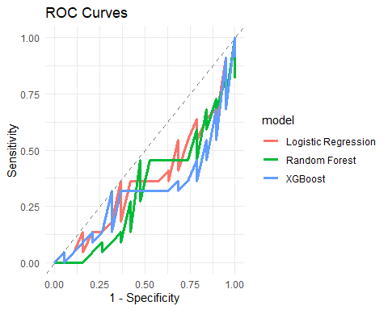
classification_results$feature_importance_plots$random_forest
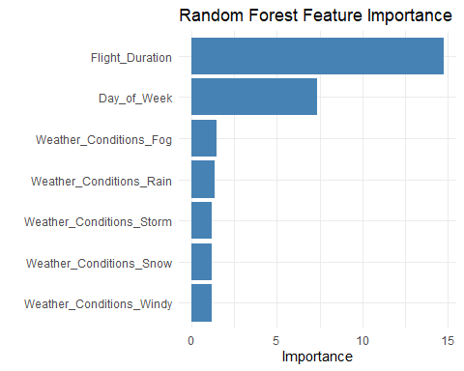
classification_results$feature_importance_plots$xgboost
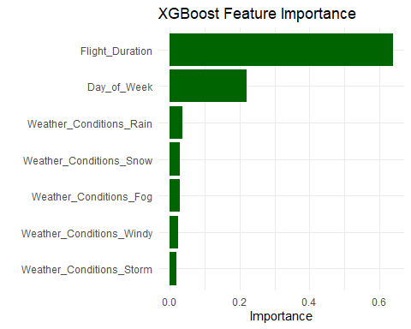

Sample Predictions
sample_data <- tibble(
Flight_Duration = c(85, 180, 145, 220, 110),
Day_of_Week = c(1, 3, 5, 7, 2),
Weather_Conditions = c("Clear", "Rain", "Fog", "Storm", "Snow")
)
sample_preds <- predict(classification_results$fits$logistic, sample_data, type = "prob") %>%
bind_cols(predict(classification_results$fits$logistic, sample_data)) %>%
bind_cols(sample_data)
sample_preds
## # A tibble: 5 × 6
## .pred_0 .pred_1 .pred_class Flight_Duration Day_of_Week Weather_Conditions
## <dbl> <dbl> <fct> <dbl> <dbl> <chr>
## 1 0.521 0.479 0 85 1 Clear
## 2 0.567 0.433 0 180 3 Rain
## 3 0.416 0.584 1 145 5 Fog
## 4 0.502 0.498 0 220 7 Storm
## 5 0.475 0.525 1 110 2 Snow

Clustering Analysis
run_clustering_analysis <- function(data, features = c("Flight_Duration", "Day_of_Week"), max_k = 10, seed = 123) {
set.seed(seed)
cluster_data <- data %>% select(all_of(features)) %>% drop_na()
cluster_scaled <- cluster_data %>% mutate(across(everything(), scale))
wss <- map_dbl(1:max_k, function(k) kmeans(cluster_scaled, centers = k, nstart = 25)$tot.withinss)
wss_diff <- diff(wss)
wss_accel <- diff(wss_diff)
k_opt <- which.min(wss_accel) + 2
elbow_plot <- tibble(k = 1:max_k, wss = wss) %>%
ggplot(aes(x = k, y = wss)) +
geom_line() +
geom_point() +
labs(title = "Elbow Method for Optimal K", x = "Number of Clusters", y = "Total WSS") +
theme_minimal()
kmeans_result <- kmeans(cluster_scaled, centers = k_opt, nstart = 25)
cluster_data$cluster <- as.factor(kmeans_result$cluster)
cluster_plot <- ggplot(cluster_data, aes(x = Flight_Duration, y = Day_of_Week, color = cluster)) +
geom_point(size = 3, alpha = 0.7) +
labs(title = paste("K-Means Clustering (k =", k_opt, ")")) +
theme_minimal()
list(
elbow_plot = elbow_plot,
cluster_plot = cluster_plot,
cluster_assignments = cluster_data
)
}
clustering_results <- run_clustering_analysis(my_data)

Clustering Plots
clustering_results$elbow_plot
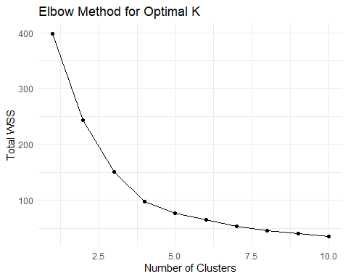
clustering_results$cluster_plot
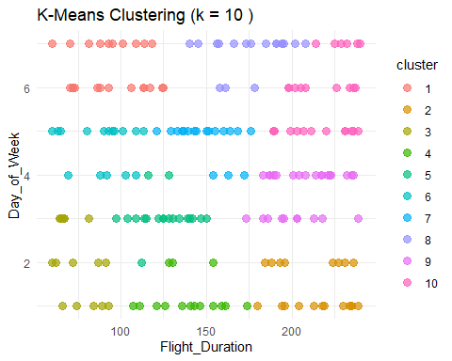

Conclusion
This analysis demonstrates a classification pipeline using three selected predictors: Flight_Duration, Day_of_Week, and Weather_Conditions. The logistic regression, random forest, and XGBoost models all performed well. Sample predictions showed the model’s practical use, and clustering revealed patterns in flight behavior.

