Create a Bootable USB Drive

Sam Henry

# Go to URL:

<http://bootableusb.herokuapp.com>

# Home Page

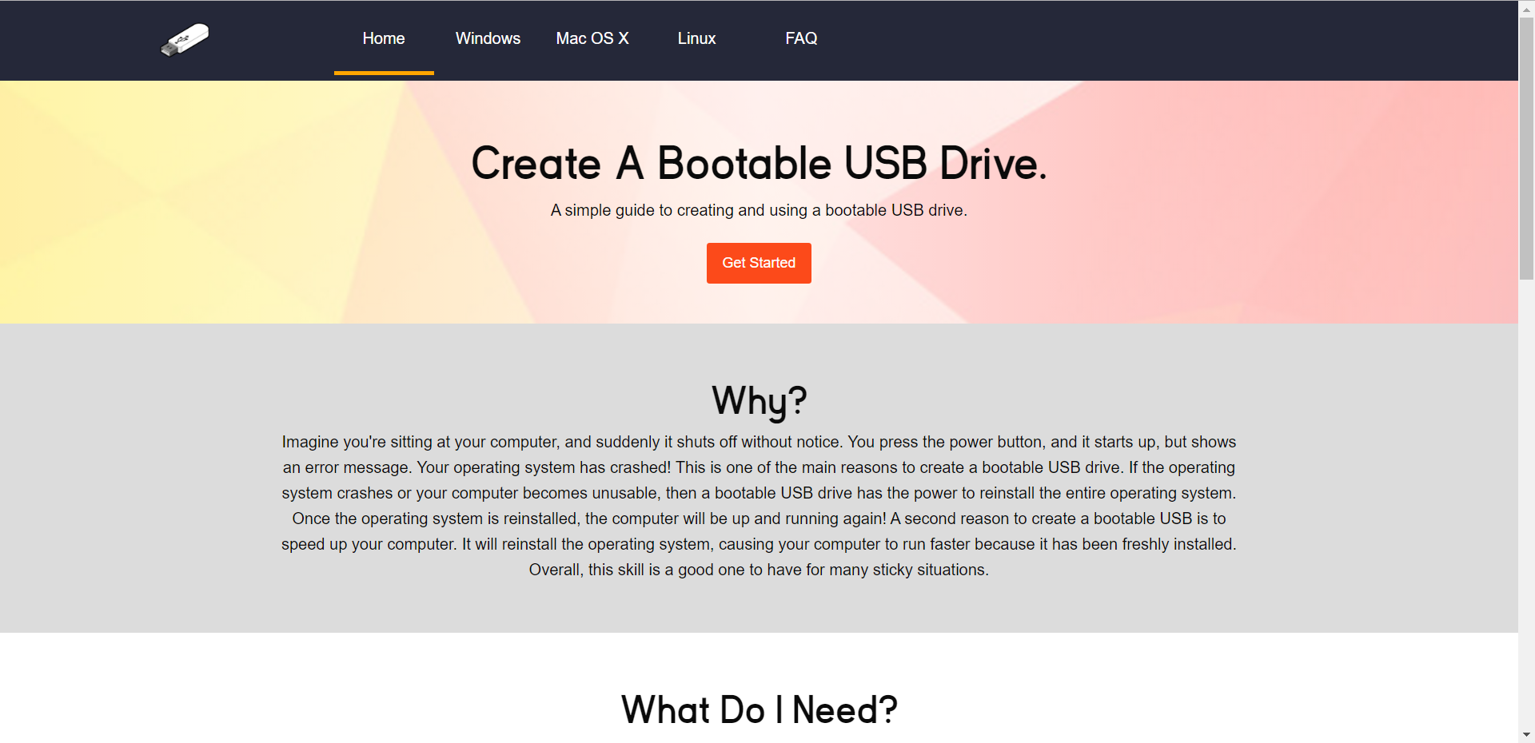

# Home Page (cont’d)

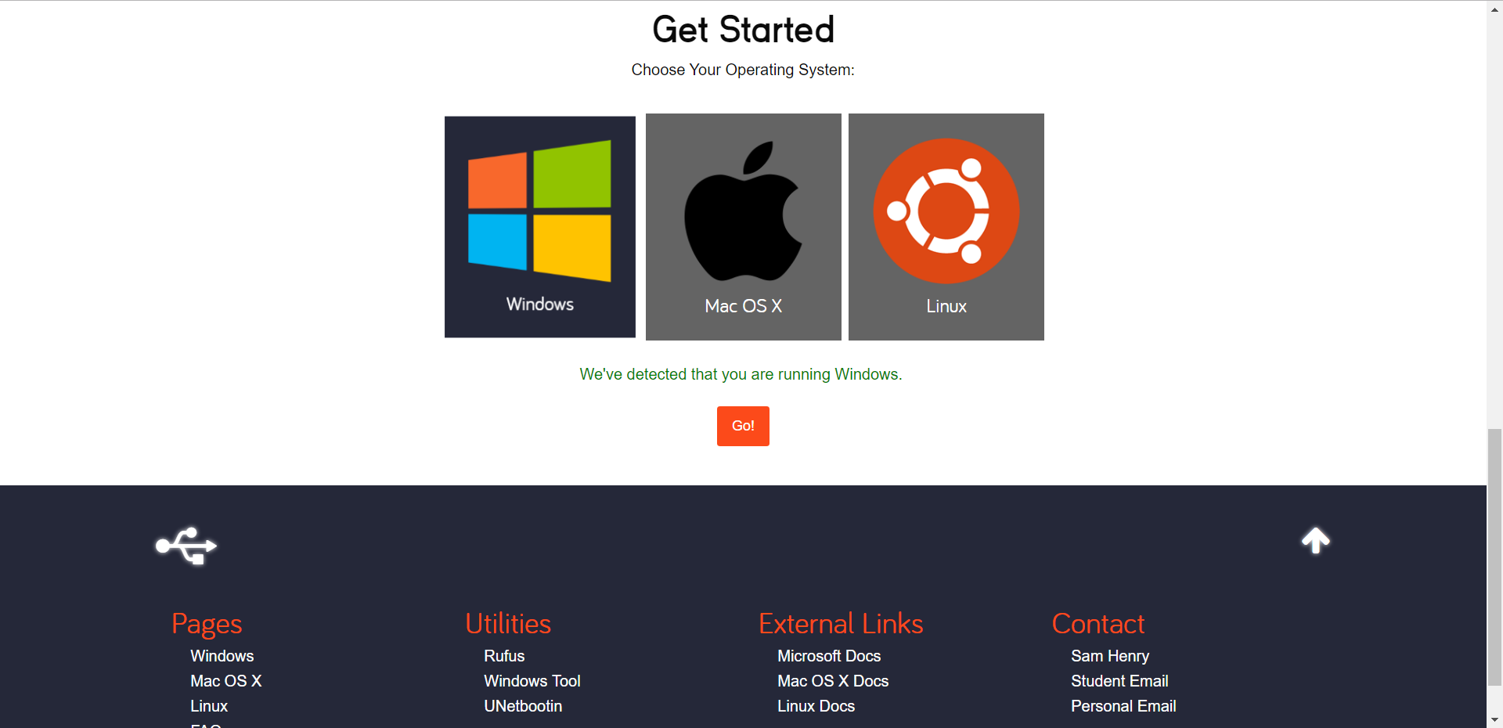

# Windows Page

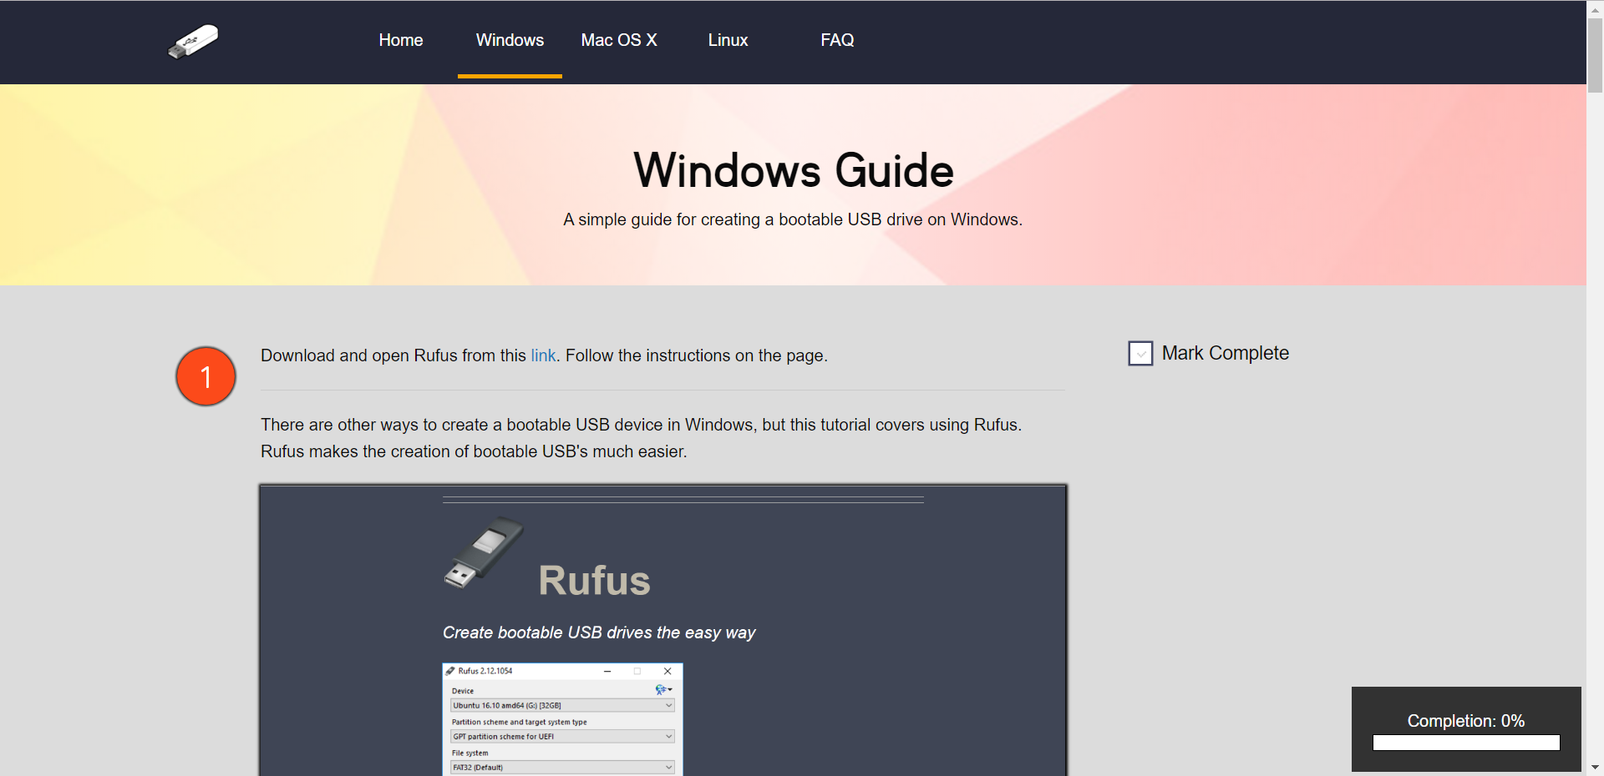

# Mac Page

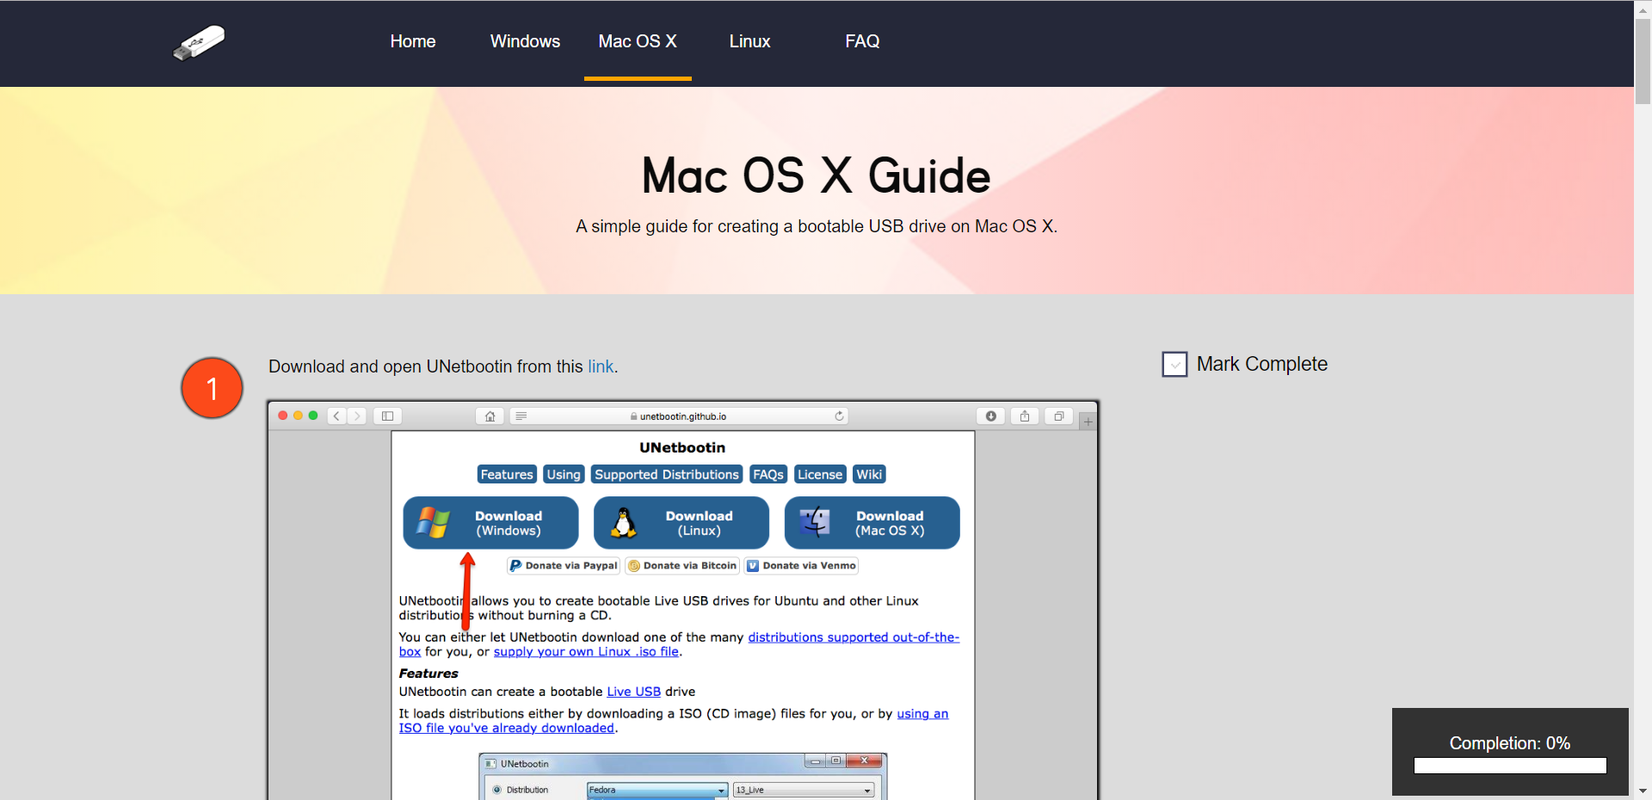

# Linux Page

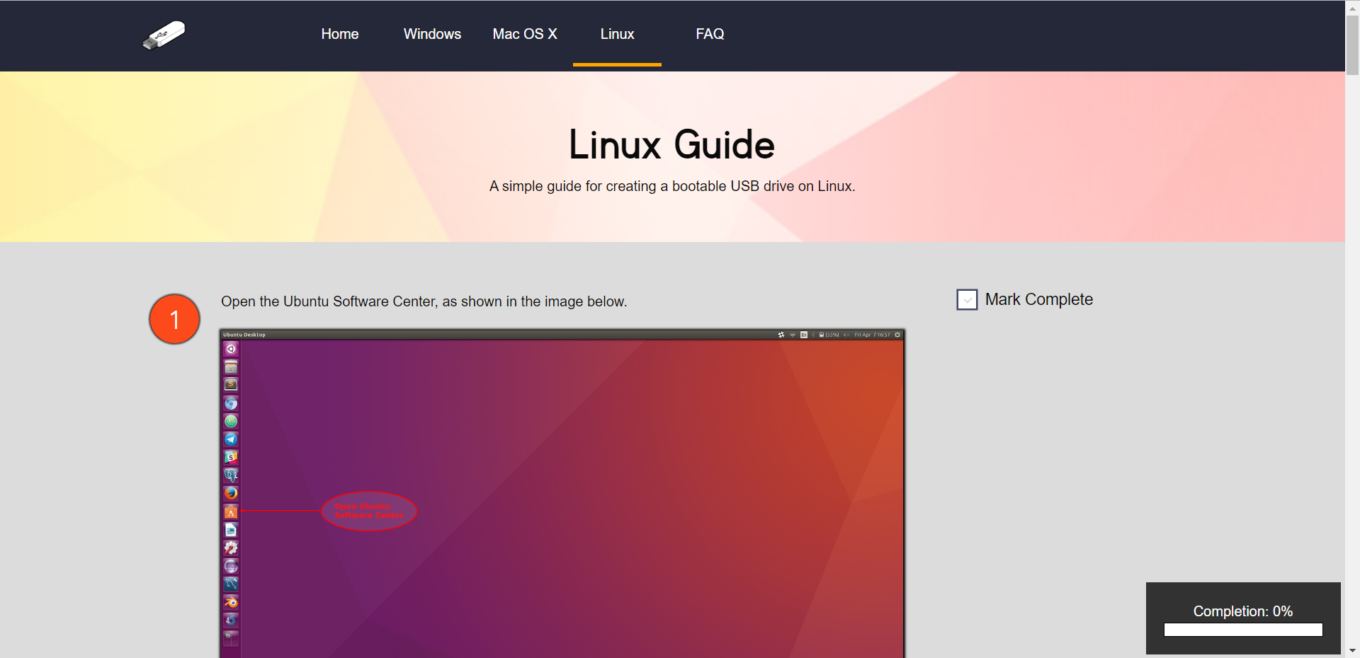

# FAQ Page

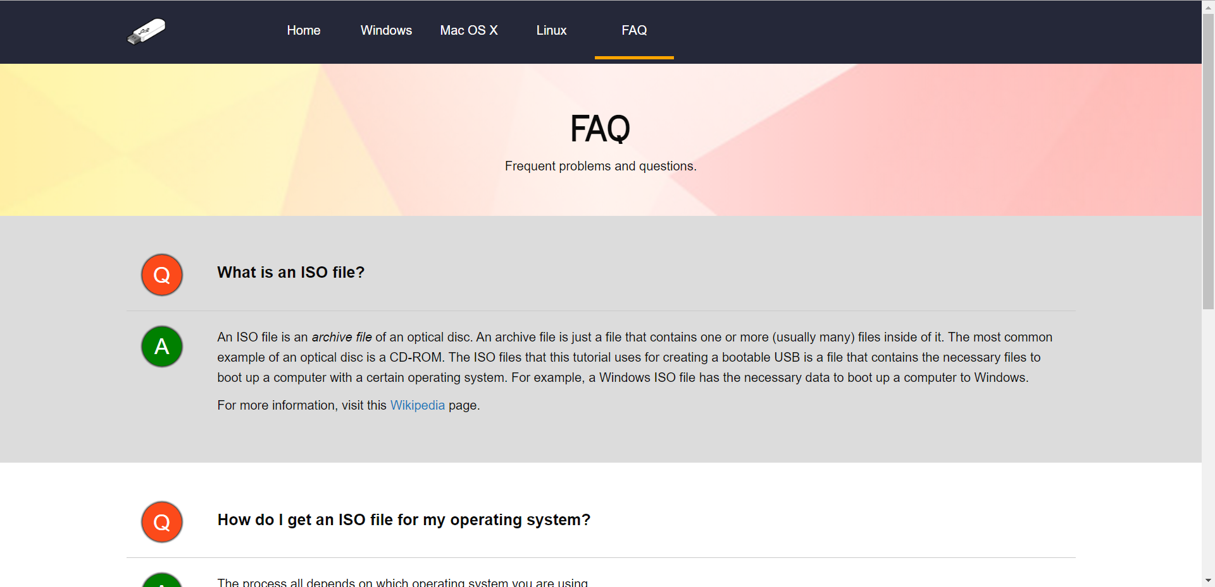

Mobile

# Menu Home Page

# Windows Page Mac Page

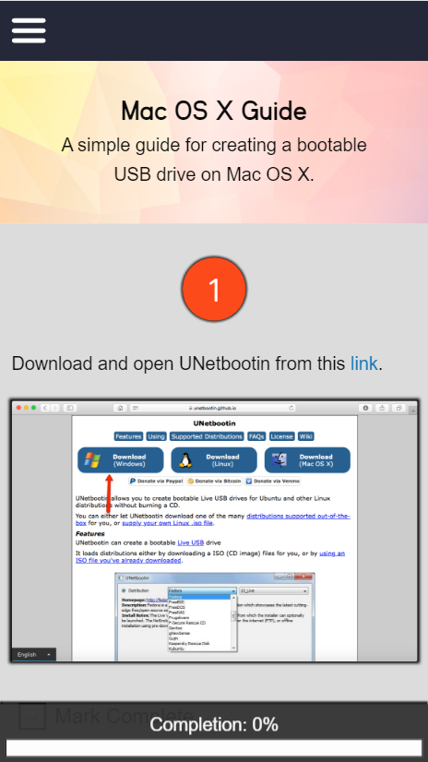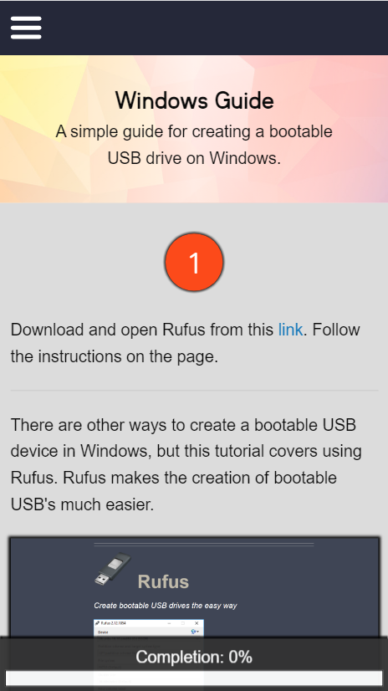

# Linux Page FAQ Page