Major Project Proposal

To: Dr. Blake Spence

From: Sam Henry

Subject: A proposal for the major project in *Technical Writing*

Date: 02/21/17

# PURPOSE

I propose to develop a website with information on how to create a bootable USB drive. This website will be an active site located at <https://techwriting.herokuapp.com>. The site is for anyone interested in creating a bootable USB drive. The reader does not have to be computer savvy. Rather, he or she can follow step-by-step instructions. The purpose of this major project is to bring together the concepts taught in *Technical Writing* by applying them to an actual project.

# BACKGROUND

This material is beneficial in many cases. First, if a user’s computer crashes or dies, he or she can create a bootable USB to reinstall the operating system. After reinstalling the operating system, the computer should be usable again. Secondly, if the computer becomes slow or hard to use, a clean install will generally speed it up. Lastly, it is beneficial to create a bootable USB if a virus cannot be removed from a computer. If the virus is taking over, the user can reinstall the operating system, which makes the computer usable again. The audience is intended for any computer user who has a need to fix a computer. The user does not have to understand computer jargon or terminology. Rather, he or she will follow a low level, easy guide to create a bootable USB drive. The website itself will be available through search engines or a link. A user can search for how to fix a computer, and the website should be one of the results.

# PROPOSED PROGRAM

My project will consist of a website containing step-by-step instructions on how to create a bootable USB drive. There are many uses for this topic, such as re-installing an operating system (like Windows) or even running a check on a computer. The website itself will run on a framework called Django, which is a powerful system designed to support production-level websites.

Over the first few weeks of the project, I plan on learning more about Django. It will take time to understand how to get it up and running to support the website. Django uses a programming language called Python for the web development. It is easy to use compared to other web languages like PHP, and it should be relatively simple to set up and use for the purposes of this project.

After setting up Django, I will do more research on how to create bootable USB drives for other operating systems besides Windows. I already know how to create one on Windows, but I would also like the website to have information on Linux and Mac OS X. Once I have enough information to create content for the website, I will start developing the website itself.

I would like the website to have a very modern design with an easy-to-read color scheme. It will use different shades of two major colors for the design. Each page will have a header consisting of links to each operating system’s instructions for creating a bootable USB. Each page will contain step-by-step instruction with screenshots for the page’s specific operating system. The picture below shows a rough idea for the structure of the website.

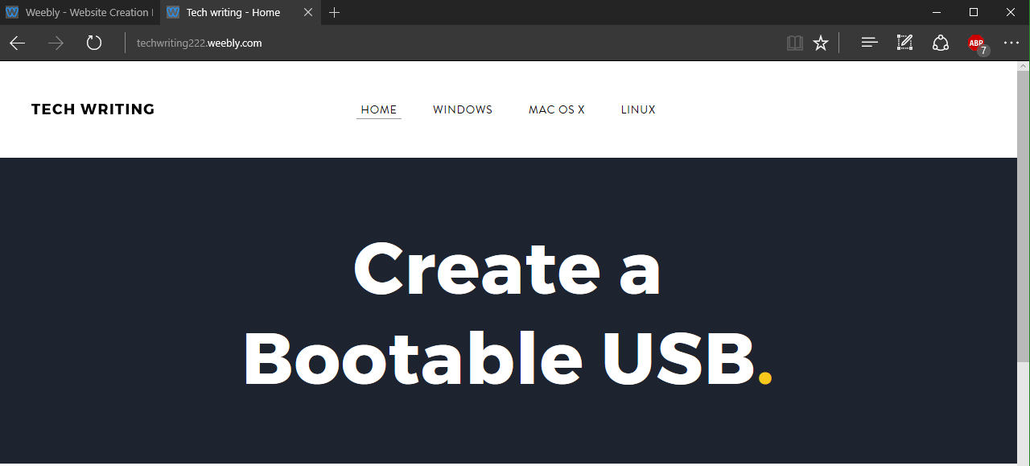

Once I have finished the structure of the website, I will begin adding content. The content should take about two to three weeks to fill in. It will consist of instructions that are easy to read so that any user, even one not familiar with computers, can follow closely. Along with the instructions, screenshots will follow each step. The screenshots will help the end user see exactly what the textual instructions say to do. Because of the screenshots, the reader does not have to read and understand very specific details or jargon of computers. Rather, he or she can look at images to see what to type and click.

After finishing adding content to the site, it will be nearing completion. The last week of the project will consist of checking for grammar or instructional errors and cleaning up the design. Once the site fits the requirements and I feel satisfied with it, I will write the report and turn it in.

# QUALIFICATIONS AND EXPERIENCE

This project will help me as a computer scientist in several ways. Whenever someone’s computer dies, I will have the knowledge to fix it, even if it is not an operating system I am comfortable with. I have created many bootable USB drives on Windows, but I do not currently know how to create one on Mac OS X or Linux systems.

# BUDGET

* **1-2 Weeks:** Get the Django framework set up
* **1-2 Weeks:** Research more about bootable USB drives
* **2-4 Weeks:** Create the structure of the website
* **2-3 Weeks:** Add content and screenshots to the site
* **1 Week:** Finalize and clean up the site

# SOURCES

* **For Mac**: <https://support.apple.com/en-us/HT201372>
* **For Linux**: <https://www.howtogeek.com/191054/how-to-create-bootable-usb-drives-and-sd-cards-for-every-operating-system/>