**Code (HTML tags)**

* Use **Robots meta tag**
  + Default value is follow, index
  + <meta name=”robots” content=[parameter]>
  + E.g <meta name=”robots” content=[follow,noindex]>
* Use **canonical link element** to avoid duplicate content
  + If you have the same content on multiple pages on your website, you’ll have duplicate content
  + A canonical tag (aka "rel canonical") is a way of telling search engines that a specific URL represents the master copy of a page.
  + Add canonical url to all pages.
  + For e.g. crawler can reach a specific page using the following url:
    - www.pykih.com/mohit
    - www.pykih.com/mohitnihalani
    - www.pykih.com/organiziation/mohit
  + To avoid crawling issues use canonical tags:
  + Add a rel=canonical link from the non-canonical page to the canonical one. So if we picked the shortest URL as our canonical URL, the other URL would link to the shortest URL in the <head> section of the page – like this:
  + <link rel="canonical" href="http://pykih.com/mohit/" />
* Use descriptive **alt tags** for the url
  + Always add alt tags for the images
  + In case of a **linked image**, the alt text should be the title of the page it’s linking to.
  + Alt tag should contain keyphrase.
* Use **structured data**
  + **Use** [**schema.org**](https://schema.org/)to loop for structured data markup supported by the search engines.
  + Use JSON-ld to create structured markup and insert that markup in head of the page:
  + E.g. markup of recipe

<script type="application/ld+json">

{

"@context": "http://schema.org",

"@type": "Recipe",

"author": "John Smith",

"cookTime": "PT1H",

"datePublished": "2009-05-08",

"description": "This classic banana bread recipe comes from my mom -- the walnuts add a nice texture and flavor to the banana bread.",

"image": "bananabread.jpg",

"recipeIngredient": [

"3 or 4 ripe bananas, smashed",

"1 egg",

"3/4 cup of sugar"

],

"interactionStatistic": {

"@type": "InteractionCounter",

"interactionType": "http://schema.org/Comment",

"userInteractionCount": "140"

},

"name": "Mom's World Famous Banana Bread",

"nutrition": {

"@type": "NutritionInformation",

"calories": "240 calories",

"fatContent": "9 grams fat"

},

"prepTime": "PT15M",

"recipeInstructions": "Preheat the oven to 350 degrees. Mix in the ingredients in a bowl. Add the flour last. Pour the mixture into a loaf pan and bake for one hour.",

"recipeYield": "1 loaf",

"suitableForDiet": "http://schema.org/LowFatDiet"

}

</script>

* + Use tools such as [Structure Data testing](https://search.google.com/structured-data/testing-tool/u/0/) to check any errors in JSON-LD.
* Add keywords on the **h1 tag** of the page.
* Include **meta tags** such as **meta description** and **meta title** and make sure these contains keywords.
* Make sure that **title** tag of every page is different.
* Add descriptive **anchor text.**
  + **Anchor text** which links to other pages should contain keywords of the page and should describe what the page is about.
  + Never just link the url.
* Use **geo meta tags** to let search engines know your location.
* While creating pagination always add **rel=”next”** and **rel=”prev”** in the link tag.

**Images**

* **Preparing your Images**
  + Find and select the right image.
    - Always find unique and original images which matches your mission or topic of content.
  + Choose a right file name
    - Google uses the file name to determine what an image is about. That’s why you should use your focus keyphrase in the image file name.
    - **Note** that you should always start your file name with your main keyphrase
  + **Choose right Format**

|  |  |
| --- | --- |
| **Format** | **Usefulness** |
| JPEG | larger photos or illustrations |
| PNG | To preserve background transparency |
| WebP | Produce high-quality results with smaller file sizes |
| SVG | For logos and icons |

* + **Scale your images**
    - Resize all the images to the size you want to display.
  + **Resize your images** 
    - Make sure that scaled image is compressed so it is served in the smallest file size possible.
    - Reduce the size of images is by removing the Exif data
    - Tools are mentioned in tools section.
  + Use **responsive image.**
    - This means you serve a different image per screen width.
    - For example, with responsive images, you serve a small image to visitors using a mobile device, while for the same article, you serve a larger image to visitors using a larger screen desktop

**Url’s**

* Describe your content
  + A user should be able to make an accurate guess about the content of a web page simply by reading the URL.
  + To accomplish this, a URL should include an accurate phrase or term that pertains to the page content.
* Include Keywords in URL.
* Use hyphens to separate words
* Use lowercase letters
* Keep urls short
* Always use **absolute** url not the relative ones.
* Use **subdirectory structure** rather than **subdomain structure.**
  + **Better:** http://www.example.com/topic
  + **Not - optimized:** http://topic.example.com
* Minimize dynamic url strings
* Make correct use of **canonical tags.**
* Modify URLs so that they don’t look like they’re pointing to dynamic pages.
  + Fix the problem by removing characters such as ?, #, !, *, %, and & and reducing the number of parameters to one.
  + If there are such types of url use **mod_rewrite** to create restful URL architecture.

**Robots.txt**

* Use only to block the complete sub-directory otherwise search engine will not be able to crawl sites and this will impact rank.
* **Never** prevent crawlers to crawl css and js file until necessary.
* List all the XML sitemaps. (**important**)
* Use google search console to check and validate robots.txt file.

**XML sitemaps**

* Create xml sitemaps which contains all the URL of the page.
* Add this sitemap on google webmaster which helps google to crawl all your pages.
* Format of XML sitemap is

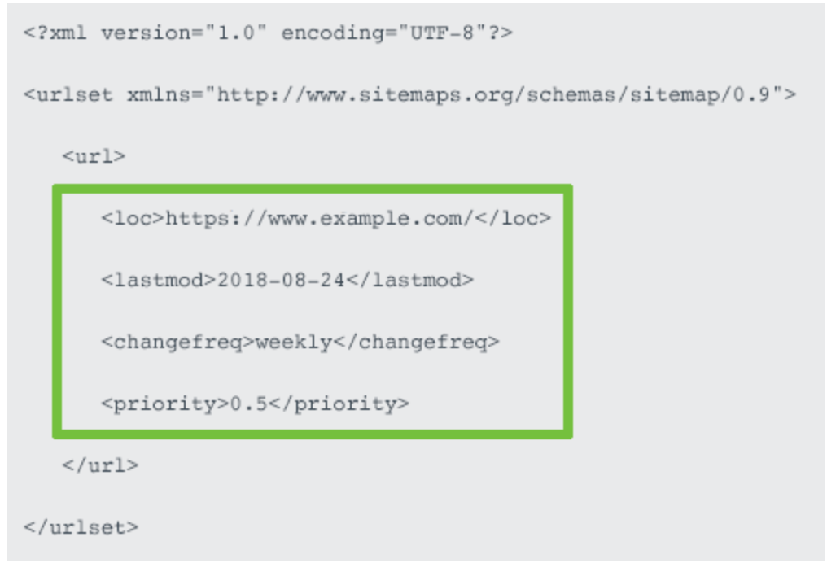

* + Should contain **location tag.**
    - Should accurately reflect your site protocol (**http or https)** and if you have chosen to include or exclude **www.**
  + **Last modified date**
  + **Priority Tag**
* Limitations of XML sitemap
  + A maximum of 50000 urls
  + Uncompressed file size of 50mb
* After creating sitemap add them to google, yahoo and bing webmaster tools.
* Add your sitemap path to **robots.txt file.**
  + 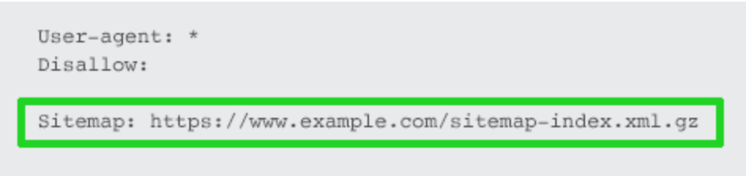
* **Optimizing sitemap**
  + Only include SEO relevant pages in sitemap.
  + **Exclude:**
    - Non-canonical pages.
    - Duplicate pages.
    - Paginated pages.
    - Parameter or session ID based URLs.
    - Site search result pages.
    - Reply to comment URLs.
    - Share via email URLs.
    - URLs created by filtering that are unnecessary for SEO.
    - Archive pages.
    - Any redirections (3xx), missing pages (4xx) or server error pages (5xx).
    - Pages blocked by robots.txt.
    - Pages with noindex.
    - Resource pages accessible by a lead gen form (e.g., white paper PDFs).
    - Utility pages that are useful to users, but not intended to be landing pages (login page, contact us, privacy policy, account pages, etc.).
* If number of url exceeds then use [sitemap index file](https://support.google.com/webmasters/answer/75712?hl=en).
  + Use descriptive sitemap names that reflect your site structure.
  + Don’t set the sitemap name as sitemap1, sitemap2, sitemap3, instead follow the structure of your website and name accordingly,
  + Such as project sitemap should be **/sitemap/projects,** organization should be **/sitemap/organization.**
* If you have **video** in the website then create a seperate **video sitemap.**

**.htaccess file:**

* Create a page in which the errors will return from. Example:

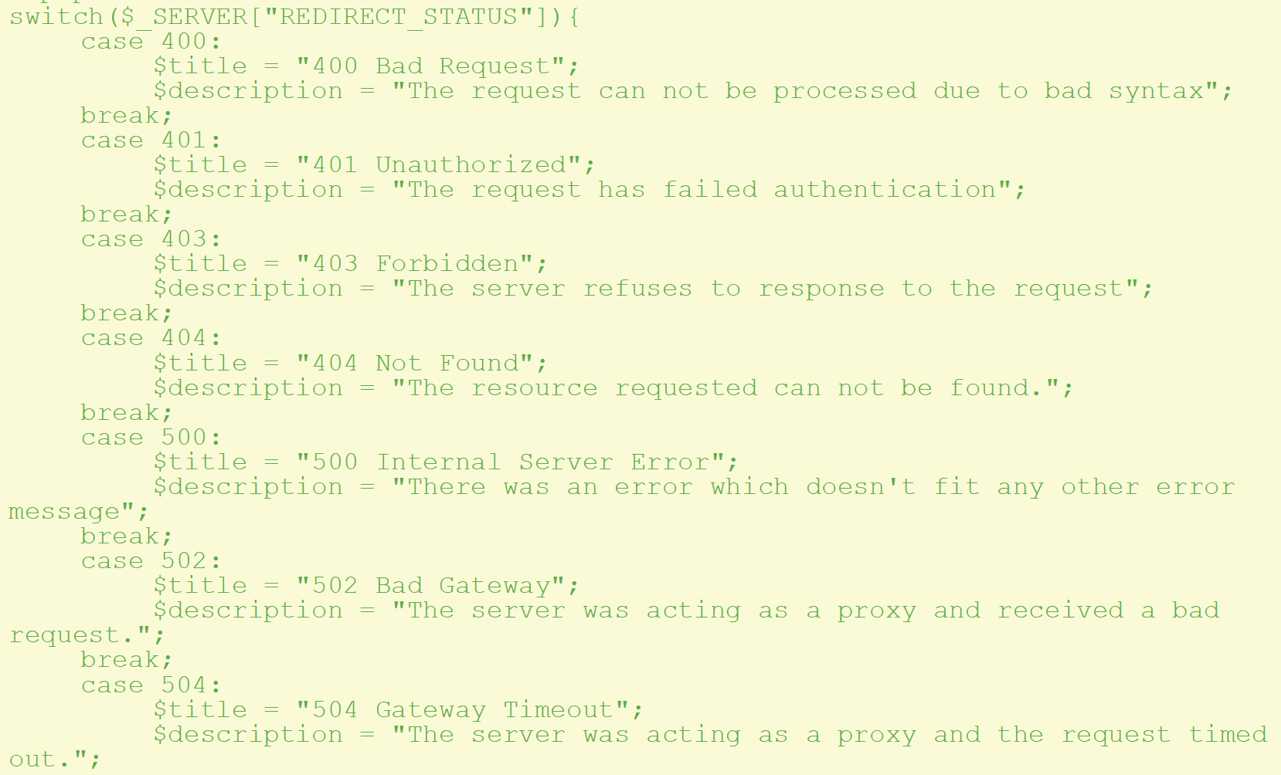T

* Redirect all the error codes to the following page:

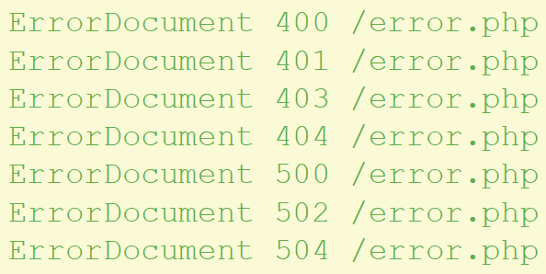

**Metrics for Checking**

* **Speed**
  + Loading time of the site should be less.
  + Tools for site-speed:-
    - Web page test
    - [Google PageSpeed Insights](https://developers.google.com/speed/pagespeed/insights/)
    - Google lighthouse
    - Pingdom tools
  + Things to improve site-speed:-
    - Enable compression of your website file using compressing tools such as [GZIP](https://www.gnu.org/software/gzip/).
    - Minify css, javascript, HTML
    - Reduce redirects
    - Remove render blocking javascript
* Security
  + Website secured with SSL.
  + Use of HTTPS over HTTPS.
* Crawlability
* Accessibility
  + Test your site with disabling styles
    - See if the quality and semantics of HTML are done right.
    - There is a logical grouping of elements and the structure is clear
  + Unplug your mouse and use the keyboard for navigation
    - Any user interface, including websites, should be fully operable regardless of the device used to interact with.
  + Check the contrast
    - The most frequently used requirement for this is to guarantee a contrast of at least 4.5:1 between text and background.
    - Very big text can have a lower ratio of 3:1.
    - Check contrast on [color contrast analyser](https://developer.paciellogroup.com/resources/contrastanalyser/).
  + Use accessibility evaluation tools
    - [Webaim Wave](https://wave.webaim.org/extension/)
    - [Deque Axe](https://www.deque.com/axe/)
* Conversion Rate Optimization
  + User Testing
    - Perform A/B testing
  + Consider putting a small survey and visitors some questions such as. ‘What’s the goal of your visit today?’ Or: ‘What’s keeping you from buying this product?’.

**Tools**

|  |  |
| --- | --- |
| **FOR** | **Tools** |
| **Keyphrase Searching** | * Using Google Adwords Keyword Planner, * Yoast Suggest * Google Trends * Internal search engine * [Answerthepublic](https://answerthepublic.com/) * [Bing keyword Research](https://www.bing.com/toolbox/keywords) |
| **Sitespeed Checking** | * Web page test * Google PageSpeed Insights * Google lighthouse * Pingdom tools |
| **Structured Data** | * [**JSON-LD**](https://json-ld.org/) * Schema.org * [google structured data markup](https://search.google.com/structured-data/testing-tool/u/0/) |
| **Structured Data testing** | * [Structure Data testing](https://search.google.com/structured-data/testing-tool/u/0/) |
| **SEO Tools** | Google analytics, google search console |
| **Crawlability Check** | Google search console. |
| Accessibility evaluation tools | * [Webaim Wave](https://wave.webaim.org/extension/) * [Deque Axe](https://www.deque.com/axe/) |
| User testing for CRO (conversion rate optimization) | [abtestguide.com](https://abtestguide.com/calc/). |
| Reducing image file size | * [ImageOptim](https://imageoptim.com/mac) * [JPEGmini](https://www.jpegmini.com/) * [jpeg.io](http://jpeg.io) * [Kraken.io](https://kraken.io/) |
| Compression of File | [GZIP](https://www.gnu.org/software/gzip/). |
| Mobile friendly test | [Mobile friendly test](https://search.google.com/test/mobile-friendly) |
| Google Webmaster | <https://www.google.com/webmasters/#?modal_active=none> |
| Sitemap | [Sitemap Index](https://support.google.com/webmasters/answer/75712?hl=en)  [Schema Sitemap](https://www.sitemaps.org/protocol.html)  [Creating Site Map](https://support.google.com/webmasters/answer/156184) |
| Submitting Sites | [Google](https://www.google.com/webmasters/tools/submit-url)  [Bing](http://www.bing.com/toolbox/submit-site-url) |
| Page Speed | [Google Page Speed](https://developers.google.com/speed/pagespeed/insights/) |
| Website Crawler | [Screaming Frog](https://www.screamingfrog.co.uk/seo-spider/) |
| A/B Testing | [AB Test Guide](https://abtestguide.com/calc/). |

**Mobile Friendliness**

* + Is your website compatible with mobile.
  + Test loading time on mobile devices.
  + Design for mobile
    - Don't use flash and pop ups.
  + Use google [Mobile friendly test](https://search.google.com/test/mobile-friendly) to check mobile friendly.
  + Responsive Design
    - Site should be adjustable on the screen on which it is viewed on.
  + Do not restrict users to view content.
  + Dynamic Serving
    - With this method, you have two versions of your Web site: one for smartphones, and another for larger devices. The Web server decides which version to send when a page is requested.
  + Separate Urls:
    - In this case, you have two versions of your site. The server directs the user to the most appropriate site, on a different URL, depending on the device.
  + <https://moz.com/learn/seo/mobile-optimization>

**Keywords:**

* Use keywords in folder names and filenames, and in page files and image files.
* Use keywords near top of the page.
* Place keywords into <**H**> (heading) tag.
* Use ***bold*** and ***italic*** keywords.
* Keywords should be between 1%-5% of the page overall content.
* Use keywords in meta tags of the page.
* Only one keyword or keyphrase per page.
* Use different keyphrase or keyword for different pages.
* Links between pages within your site contain keywords.
* Use synonyms and different word forms such as singulars and plurals instead of just
* Use tools such as
  + [Google Adwords Keywords Planner](https://adwords.google.com/%20KeywordPlanner)
  + [Bing Keywords Research Tool](https://www.bing.com/toolbox/keywords)

**Site Structure:**

* Identify most important pages/projects of the website.
  + Link most important pages from home pages.
* Minimize cluttering the homepage.
* Logo links to the homepage.
* Descriptive navigation links.
  + Is the internal anchor text used in navigation links descriptive and aligned with keyword goals?.
* Divide content **in Categories and Sub-Categories**
  + Add categories on the homepage and also on the main menu of the site.
  + **Name of the category** should resemble the search terms used by your **audience.**
  + **Thumb rule** for categories is that no category should be twice the size of any other category.
  + Are all targeted keywords properly represented in site navigation.
* Create Easy Navigation for the users:
  + Breadcrumbs
    - Visible above the title of the post.
  + Tags
    - Limit the amount of tags you use;
    - Make sure tags are used more than one/two
    - Make sure tags are visible.
  + Make sure every pages contains some links to other pages.
  + **Anchor tags** should be clear and specific. It should reflect the context of the page it is linked to.
  + **Anchor text** is one of the most important, specify the **page heading** in this.
  + Identify the corner store pages and create most links toward that.
* **URL** structure should be in harmony with the site navigation structure,
* Make sure don't use canonical tags in the paginated pages.
* Primary target distance.
  + Run a screaming frog crawl and filter content by *html* and *sort crawl ascending* and check if there are any important pages more then **two levels of the homepage.**

**UX:**

|  |  |
| --- | --- |
| **Do’s** | **Don’ts** |
| Make your buttons look like buttons | Don’t write: ‘Click here to (…)’.Button should state clear call-to-action, for example: ‘buy this product’, ‘contact us’, ‘log in’, ‘activate’, and ‘download’. |
| Links should have a different color than the rest of the text, but this shouldn’t be the only visual means of indicating it’s a link | Don’t make users guess where their click takes them |
| Communicate with the words your users use | Make the items descriptive. Don’t call an item ‘employment opportunities’, call it ‘jobs’. |
| make sure important pages on your site are no more than three clicks away from your homepage. |  |
| Make sure people can always find their way back out of the rabbit hole they go into. |  |
| Provide users with some kind of map which they can use to navigate. For e.g. using **breadcrumbs.** |  |
| If there is a search box, make it easier to find. |  |

**Copywriting:**

* **Checklist to keep in mind while writing your post:**
  + **Length**
    - Your text contains 300 to 800 words.
    - Preparation
    - Your text has a clear purpose.
    - Your central message is clear and formulated at the correct places.
    - You use a tone appropriate for your audience.
  + **Keyword**
    - You use your keywords at the right places.
    - You use your keyword an adequate amount of times.
  + **Structure**
    - The subtopics of your text are discussed in a logical order.
    - Your paragraphs are well-structured.
    - In each paragraph, you discuss only one topic.
    - You use subheadings correctly.
  + **Readability**
    - You use synonyms to avoid using the same word over and over.
    - Your sentences are not too long.
    - Your sentences show variation in length, structure and beginning words.
    - You use transition words correctly.
    - Your paragraphs are of adequate length.
    - You avoid passive voice whenever possible
    - You avoid complex words whenever possible
  + **Style**
    - Your writing style is consistent.
    - You use concrete language.
    - You use examples correctly (if applicable).
    - You use asides correctly (if applicable).
    - The humor you used is appropriate (if applicable).
    - Metaphors and expressions are used in moderation (if applicable).
    - After you started with an anecdote or case study, you have rounded things up in the final paragraph (if applicable).
  + **Typography**