ANTLR TEST CASES

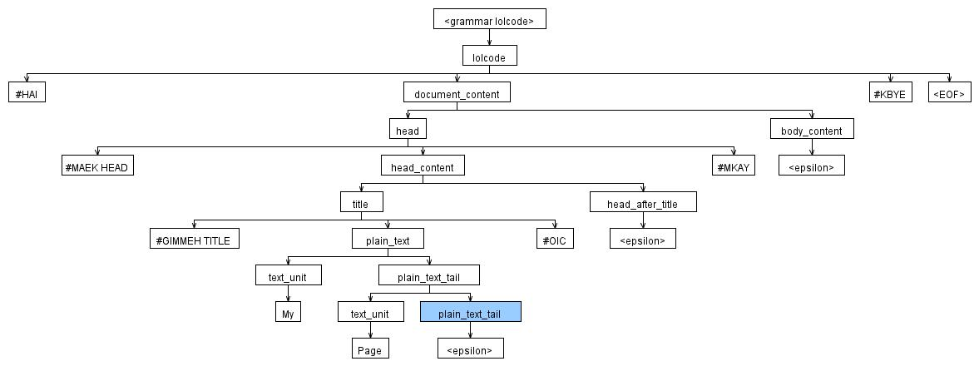
Test Case 1 – Valid Head and Title

Input:
#HAI
#MAEK HEAD
#GIMMEH TITLE My Page #OIC
#MKAY
#KBYE

Expected Result: Valid
Actual Result: Accepted by ANTLR

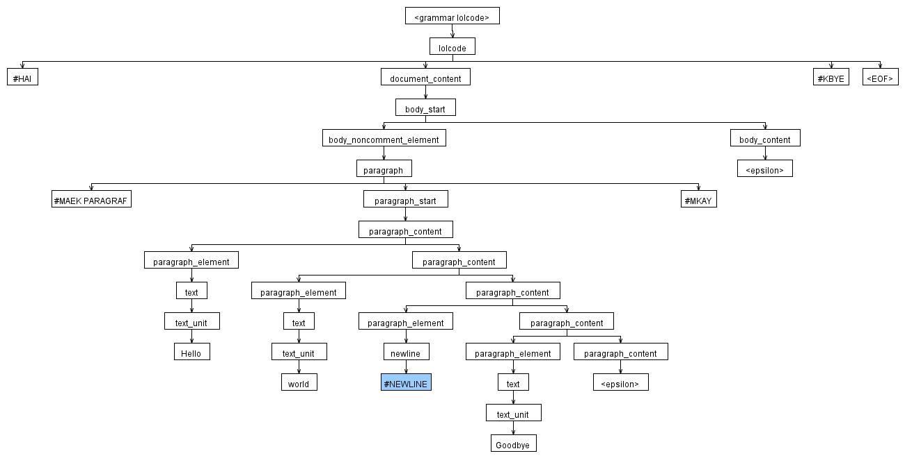
Test Case 2 – Valid Paragraph and Newline
Expected Result: Valid
Actual Result: Accepted by ANTLR

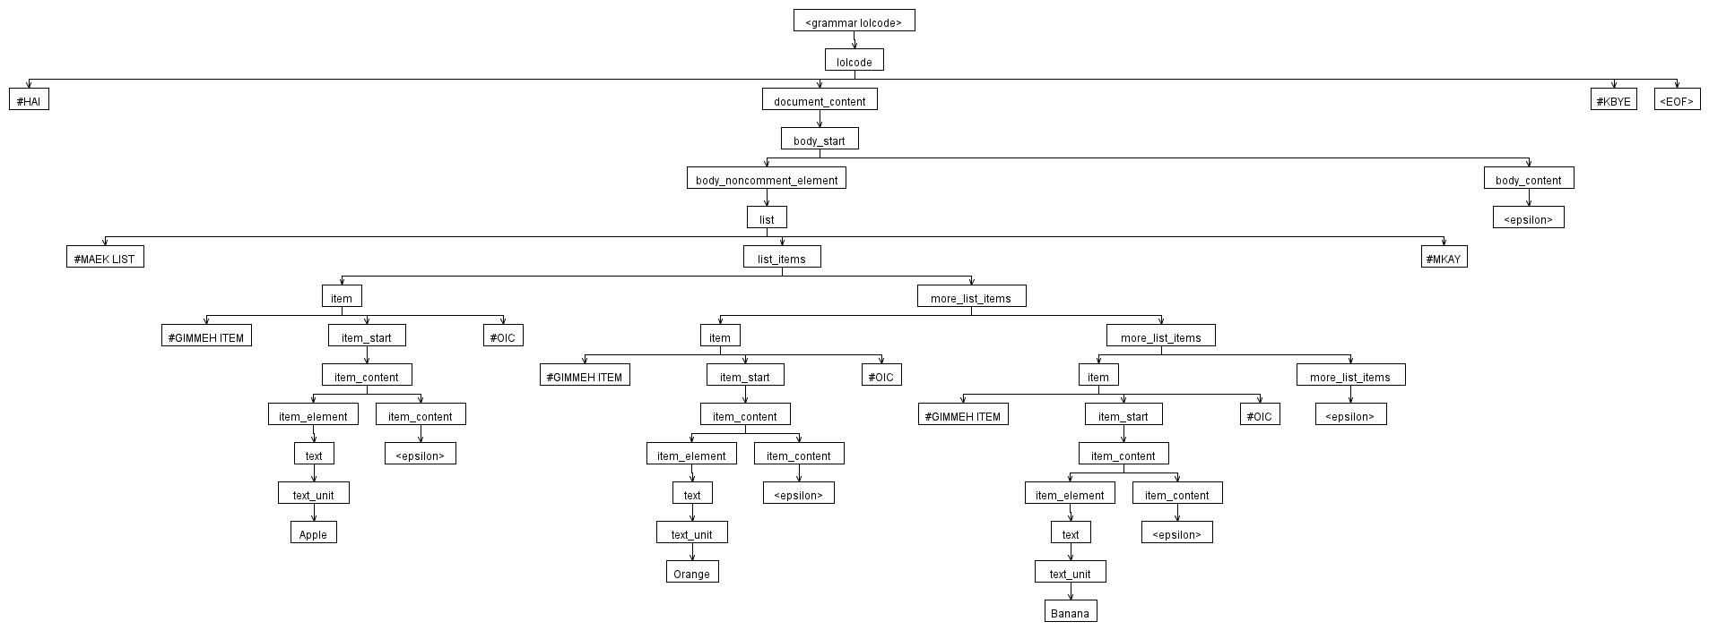

Test Case 3 – Valid List
Expected Result: Valid
Actual Result: Accepted by ANTLR
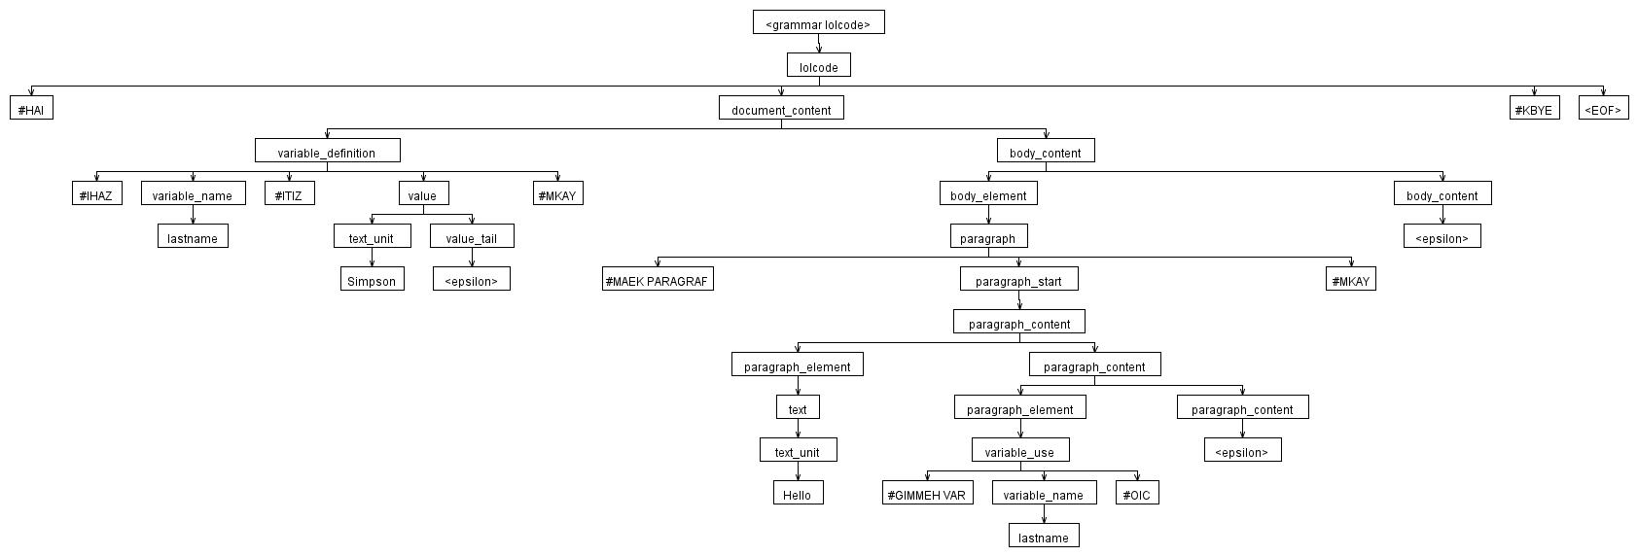
Test Case 4 – Valid Variable Definition and Use
Expected Result: Valid
Actual Result: Accepted by ANTLR

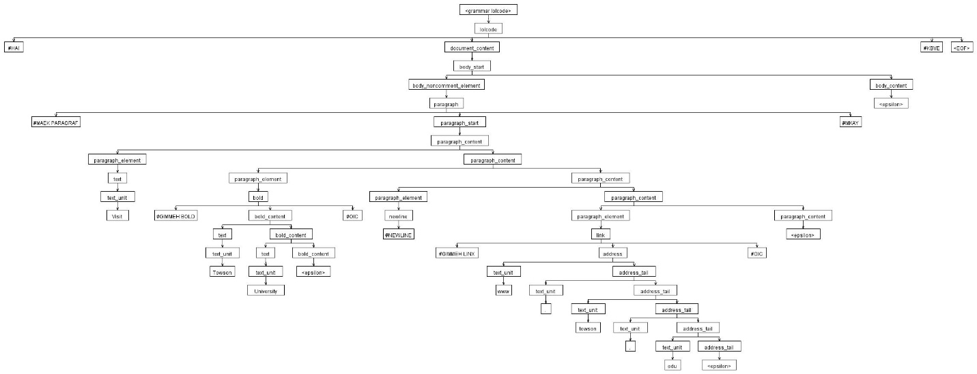
Test Case 5 – Full Project Example
Expected Result: Valid
Actual Result: Accepted by ANTLR

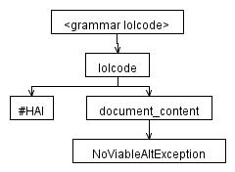
Test Case 6 – Title Outside Head
Expected Result: Invalid
Actual Result: Rejected by ANTLR
Reason: A title must occur inside a head block.

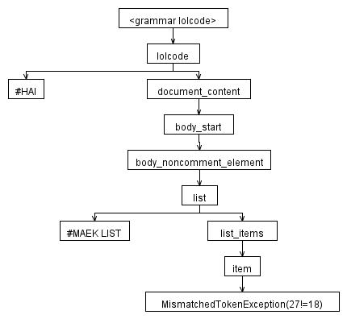
Test Case 7 – Empty List
Expected Result: Invalid
Actual Result: Rejected by ANTLR
Reason: A list must contain at least one list item.

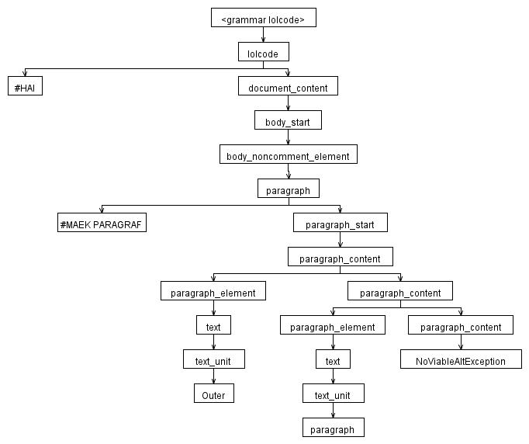
Test Case 8 – Nested Paragraph
Expected Result: Invalid
Actual Result: Rejected by ANTLR
Reason: A paragraph cannot contain another paragraph.

