**Hackathon Project Phases Template**

**Project Title:**

AI-Powered Ethical Decision-Making Simulations with Mistral

**Team Name:**

Neural Ethicists

**Team Members:**

P.L.V. Samhitha

M. Vinuthna

K. Srinidhi

N. Vaishnavi Laxmi

P. Vishnu Priya

# **Phase-1: Brainstorming & Ideation**

**Objective:**

Develop an AI-based ethical decision-making system ensuring fairness and transparency.

**Key Points:**

1. **Problem Statement:** Businesses struggle with ethical, fair, and unbiased AI decision-making.
2. **Proposed Solution:** AI-driven simulations using Mistral for transparent decision-making.
3. **Target Users:** Businesses, policymakers, HR, finance, and compliance teams.
4. **Expected Outcome:** Ethical AI adoption, bias-free decisions, and regulatory compliance.

# **Phase-2: Requirement Analysis**

**Objective:** Define technical and functional requirements.

**Key Points:**

1. **Technical Requirements:** Mistral AI, TensorFlow, PyTorch, React.js, Node.js, AWS/GCP, APIs.
2. **Functional Requirements: Ethical decision simulations, bias detection, explainable AI reports.**
3. **Constraints & Challenges:** Data bias risks, AI interpretability, computational costs, real-time processing.

# **Phase-3: Project Design**

**Objective:** Develop the system architecture and user flow.

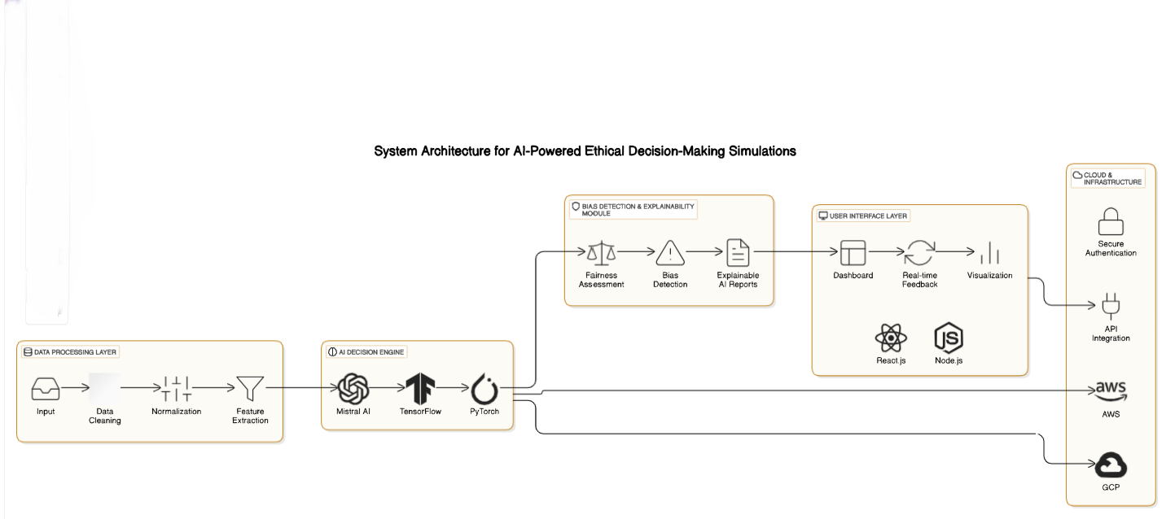

**Key Points:**

1. **System Architecture:** AI processes ethical scenarios, detects biases, and provides justifications.
2. **User Flow:** User inputs case, AI processes decision, simulations run, and recommendations are displayed.
3. **UI/UX Considerations:** Intuitive dashboards, real-time feedback, and decision tracking.

## **Phase-4: Project Planning**

**Objective:**

|  |  |  |  |  |  |  |  |
| --- | --- | --- | --- | --- | --- | --- | --- |
| **Sprint** | **Task** | **Priority** | **Duration** | **Deadline** | **Assigned To** | **Dependencies** | **Expected**  **Outcome** |
| Sprint 1 | Environment Setup  & API Integration | 🔴 High | 6 hours  (Day 1) | End of Day  1 | K. Srinidhi | Google API Key,  Python, Streamlit setup | API connection established & working |
| Sprint 1 | Frontend UI Development | 🟡  Medium | 2 hours  (Day 1) | End of Day  1 | N. Vaishnavi laxmi | API response format finalized | Basic UI with input fields |
| Sprint 2 | AI Model integration & decision processing | 🔴 High | 3 hours  (Day 2) | Mid-Day 2 | P.L.V. Samhitha | API response, UI elements ready | Search functionality with filters |
| Sprint 2 | UI Enhancements & dash board integration | 🔴 High | 1.5 hours  (Day 2) | Mid-Day 2 | P. Vishnu Priya | API logs, UI inputs | Improved API stability |
| Sprint 3 | Testing, Debugging & performance optimization | 🟡  Medium | 1.5 hours  (Day 2) | Mid-Day 2 | M. Vinuthna | API response, UI layout completed | Responsive UI, better user experience |
| Sprint 3 | Final Presentation  & Deployment | 🟢 Low | 1 hour  (Day 2) | End of Day  2 | Entire Team | Working prototype | Demo-ready project |

**Objective:** Break down development tasks for efficient completion.

**Sprint Planning with Priorities:**

Sprint 1 - Setup & Integration: API integration, environment setup.

Sprint 2 - Core Features & Debugging: Implement decision-making AI, bias detection, simulations. Sprint 3 - Testing, Enhancements & Submission: UI refinement, final debugging, deployment.

# **Phase-5: Project Development**

**Objective:** Implement core features of the ethical AI system.

**Key Points:**

1. **Technology Stack:** Mistral AI, Python, TensorFlow, PyTorch, React.js, AWS/GCP.
2. **Development Process:** Implement API authentication, AI decision models, fairness assessment.

3.**Challenges & Fixes:** Handling biased data, optimizing response times, ensuring

explainability.

# **Phase-6: Functional & Performance Testing**

|  |  |  |  |  |  |
| --- | --- | --- | --- | --- | --- |
| **Test Case ID** | **Category** | **Test Scenario** | **Expected Outcome** | **Status** | **Tester** |
| TC-001 | Functional  Testing | Input ethical dilemma scenario and get AI generated decision | AI should provide a fair and explainable decision | ✅ Passed | K. Srinidhi |
| TC-002 | Functional  Testing | Check biased detection mechanism with a biased case | System should flag biased decisions and suggest connections | ✅ Passed | N.Vaishnavi Laxmi |
| TC-003 | Performance  Testing | API response time under  800ms | AI should return results within the time limit | ⚠ Needs Optimization | M. Vinuthna |
| TC-004 | Bug Fixes & Improvements | Ensure fairness in AI recommendations | AI decisions should align with ethical principles | ✅ Fixed | P.Vishnu priya |
| TC-005 | Final Validation | Ensure decision reports are correctly displayed on the dash board | Reports should be clear and readable on all devices | ❌ Failed - UI broken on mobile | P.L.V. Samhitha |
| TC-006 | Deployment  Testing | Deploy the system on AWS/GCP and verify accessibility | The app should be available online for users | 🚀 Deployed | DevOps |

**Objective:** Ensure that the AI-powered decision-making system works as expected.

**Key Points:**

1. **Functional Testing:** Validate AI decision accuracy, fairness assessment, ethical compliance.
2. **Performance Testing:** Measure response time, API load testing, scalability checks.
3. **Bug Fixes & Improvements:** Debug incorrect AI recommendations, UI enhancements performance optimizations.

# **Final Submission**

Deliverables:

1. Project Report following the hackathon template.
2. Demo Video (3-5 Minutes).
3. GitHub/Code Repository Link.
4. Presentation summarizing the solution