**Output :**

**# ith Order Statistic using Quicksort**

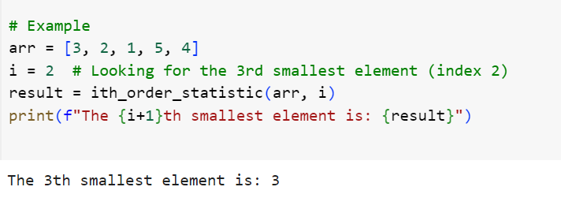

**# Stack Implementation**

**# Queue Implementation**

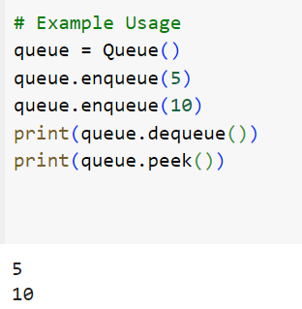

**# Singly Linked List Implementation**

