LAB 1 – REQUIREMENTS ENGINEERING & UML USE-CASE MODELLING
Problem Statement #18 – Clinical Trial Subject Recruitment Engine
Name: Samhitha Kanth
SRN: PES1UG24AM245

1. Requirements Table
Req ID | Type | Description | Priority | Acceptance Criteria | Rationale
FR-001 | Functional | The system shall evaluate a trial candidate's survey responses against the trial protocol's inclusion/exclusion criteria and classify eligibility status. | High | For every submitted survey, the system displays Eligible or Ineligible; if Ineligible, all failed criteria are listed. | Core recruitment pre-screening function.
FR-002 | Functional | The system shall allow a Clinical Researcher to record and track a candidate's informed consent milestones. | High | A researcher can record each required milestone with status and date, and the saved status is visible in the candidate record. | Informed consent tracking is required.
FR-003 | Functional | The system shall allow a Clinical Researcher to view screening results and the specific criteria that caused an Ineligible classification. | High | An Ineligible record lists every failed criterion; an Eligible record shows no failed criterion. | Researchers need evidence for recruitment decisions.
FR-004 | Functional | The system shall allow a Clinical Researcher to record and view visit compliance logs for each recruited subject. | Medium | Completed, missed, or overdue visit status and date are saved and shown in the compliance history. | Visit compliance logs are required.
FR-005 | Functional | The system shall allow a Trial Candidate to submit the required pre-screening survey and view the resulting eligibility status. | High | After a valid survey is submitted, responses are stored and the eligibility classification is displayed. | Required for automated pre-screening.
NFR-001 | Nonfunctional | The recruitment database shall comply with 21 CFR Part 11 electronic record requirements, including cryptographic audit trails. | High | Security tests verify that record changes create tamper-evident audit records containing action, user, and timestamp. | Explicit security/compliance requirement.
NFR-002 | Nonfunctional | The system shall return an eligibility classification for a valid screening submission within 3 seconds under simulated peak load. | High | At least 95% of valid screening submissions receive a result within 3 seconds during peak-load testing. | Provides a measurable performance target.

Peer Critique / Revision Notes
- FR-001: Explicit eligibility result and failed criteria make the requirement testable.
- FR-002: Consent status and date provide measurable evidence.
- FR-003: Screening evidence is clearly specified for researcher review.
- FR-004: Visit statuses and dates are concrete and verifiable.
- FR-005: Survey submission and resulting classification are directly testable.
- NFR-001: Audit-record contents make compliance verification concrete.
- NFR-002: Response time and peak-load percentage give a measurable performance target.

2. UML Use-Case Diagram
The diagram below follows the simple Draw.io structure shown in the reference example, with the two actors and the required «include» and «extend» relationships.
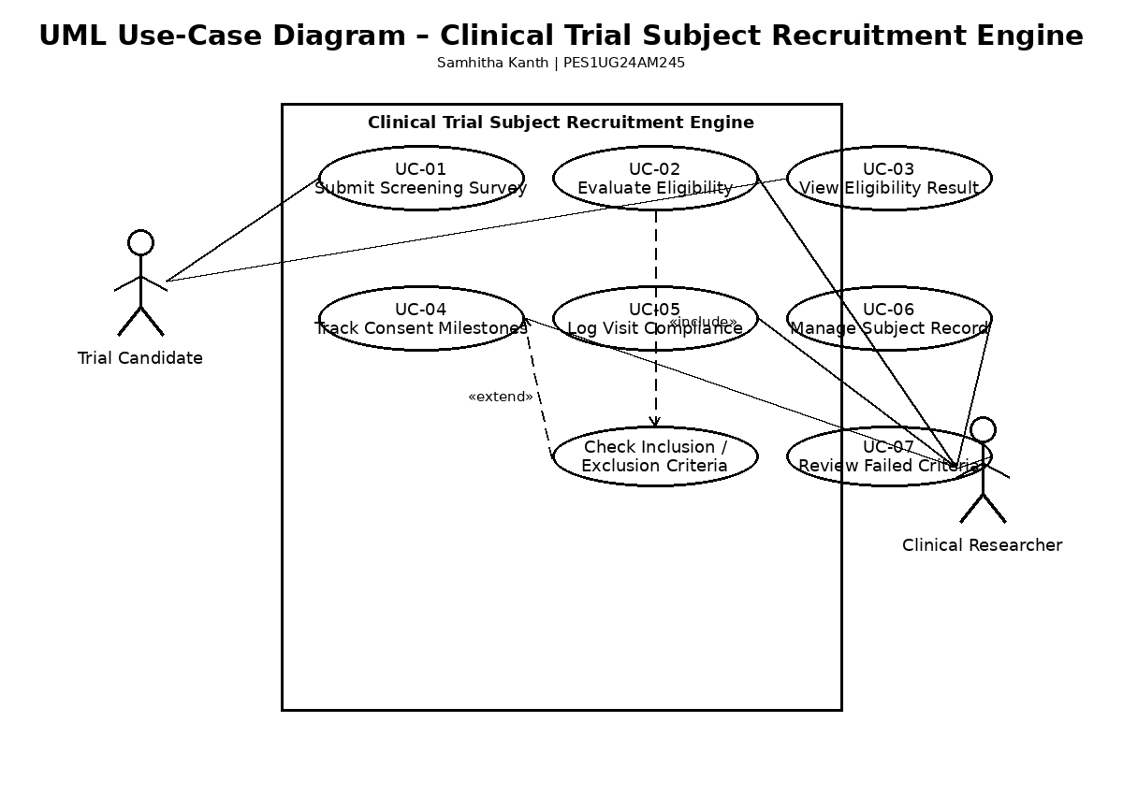

3. Use-Case Flow Specification

Use Case: Pre-Screen Candidate for Clinical Trial
Use Case ID | UC-01: Pre-Screen Candidate
Primary Actor | Trial Candidate
Supporting Actor | Clinical Researcher
Goal | Evaluate a candidate against trial inclusion/exclusion criteria and record eligibility.

Preconditions
The trial protocol and inclusion/exclusion criteria are available, and the Trial Candidate can access the required pre-screening survey.

Postconditions
Survey responses and eligibility status are stored. The result is available to the Clinical Researcher; failed criteria are recorded for an Ineligible result.

Main Success Scenario
- Trial Candidate opens the pre-screening survey.
- System displays the required eligibility questions.
- Trial Candidate enters the required responses and submits the survey.
- System validates all mandatory responses.
- System evaluates the responses against the trial inclusion/exclusion criteria.
- System classifies the candidate as Eligible or Ineligible.
- System stores the responses and eligibility result.
- System displays the eligibility status to the Trial Candidate.
- Clinical Researcher opens and reviews the candidate record.
- Use case ends successfully.

Alternate Flow – Candidate Is Ineligible
- At Step 6, one or more criteria are not satisfied.
- System classifies the candidate as Ineligible.
- System identifies and records the specific failed criteria.
- System displays the Ineligible status and failed criteria.
- Clinical Researcher reviews the stored screening result.

4. Editable Draw.io Source Code
The following is the editable Draw.io XML source used to create the UML diagram. It can be opened/imported in diagrams.net (draw.io).
<mxGraphModel dx="1000" dy="1000" grid="1" gridSize="10" guides="1" tooltips="1" connect="1" arrows="1"
fold="1" page="1" pageScale="1" pageWidth="827" pageHeight="1169" math="0" shadow="0">
<root>
<mxCell id="0" />
<mxCell id="1" parent="0" />
<mxCell id="SystemBoundary" value="Clinical Trial
Subject Recruitment Engine" style="swimlane;whiteSpace=wrap;html=1;startSize=23;" vertex="1" parent="1">
<mxGeometry x="240" y="80" width="360" height="520" as="geometry" />
</mxCell>
<mxCell
id="ActorCandidate" value="Trial Candidate"
style="shape=umlActor;verticalLabelPosition=bottom;verticalAlign=top;html=1;outlineConnect=0;" vertex="1"
parent="1">
<mxGeometry x="100" y="160" width="30" height="60" as="geometry" />
</mxCell>
<mxCell id="ActorResearcher" value="Clinical Researcher"
style="shape=umlActor;verticalLabelPosition=bottom;verticalAlign=top;html=1;outlineConnect=0;" vertex="1"
parent="1">
<mxGeometry x="680" y="420" width="30" height="60" as="geometry" />
</mxCell>
<mxCell id="UC_SubmitSurvey" value="Submit Screening Survey"
style="ellipse;whiteSpace=wrap;html=1;" vertex="1" parent="SystemBoundary">
<mxGeometry x="110"
y="60" width="140" height="50" as="geometry" />
</mxCell>
<mxCell id="UC_EvaluateEligibility"
value="Evaluate Eligibility" style="ellipse;whiteSpace=wrap;html=1;" vertex="1" parent="SystemBoundary">
<mxGeometry x="110" y="170" width="140" height="50" as="geometry" />
</mxCell>
<mxCell
id="UC_CheckCriteria" value="Check Inclusion/Exclusion Criteria" style="ellipse;whiteSpace=wrap;html=1;"
vertex="1" parent="SystemBoundary">
<mxGeometry x="210" y="270" width="140" height="50"
as="geometry" />
</mxCell>
<mxCell id="UC_ViewResult" value="View Eligibility Result"
style="ellipse;whiteSpace=wrap;html=1;" vertex="1" parent="SystemBoundary">
<mxGeometry x="10"
y="270" width="140" height="50" as="geometry" />
</mxCell>
<mxCell id="UC_TrackConsent"
value="Track Consent Milestones" style="ellipse;whiteSpace=wrap;html=1;" vertex="1"
parent="SystemBoundary">
<mxGeometry x="110" y="380" width="140" height="50" as="geometry" />
</mxCell>
<mxCell id="UC_LogVisit" value="Log Visit Compliance"
style="ellipse;whiteSpace=wrap;html=1;" vertex="1" parent="SystemBoundary">
<mxGeometry x="110"
y="455" width="140" height="50" as="geometry" />
</mxCell>
<mxCell id="UC_ManageRecord"
value="Manage Subject Record" style="ellipse;whiteSpace=wrap;html=1;" vertex="1" parent="SystemBoundary">
<mxGeometry x="210" y="380" width="140" height="50" as="geometry" />
</mxCell>
<mxCell
id="UC_ReviewFailed" value="Review Failed Criteria" style="ellipse;whiteSpace=wrap;html=1;" vertex="1"
parent="SystemBoundary">
<mxGeometry x="210" y="455" width="140" height="50" as="geometry" />
</mxCell>
<mxCell id="Assoc_Candidate_Submit" edge="1" parent="1" source="ActorCandidate"
target="UC_SubmitSurvey">
<mxGeometry width="50" height="50" relative="1" as="geometry" />
</mxCell>
<mxCell id="Assoc_Candidate_Result" edge="1" parent="1" source="ActorCandidate"
target="UC_ViewResult">
<mxGeometry width="50" height="50" relative="1" as="geometry" />
</mxCell>
<mxCell id="Assoc_Researcher_Evaluate" edge="1" parent="1" source="ActorResearcher"
target="UC_EvaluateEligibility">
<mxGeometry width="50" height="50" relative="1" as="geometry" />
</mxCell>
<mxCell id="Assoc_Researcher_Consent" edge="1" parent="1" source="ActorResearcher"
target="UC_TrackConsent">
<mxGeometry width="50" height="50" relative="1" as="geometry" />
</mxCell>
<mxCell id="Assoc_Researcher_Visit" edge="1" parent="1" source="ActorResearcher"
target="UC_LogVisit">
<mxGeometry width="50" height="50" relative="1" as="geometry" />
</mxCell>
<mxCell id="Assoc_Researcher_Record" edge="1" parent="1" source="ActorResearcher"
target="UC_ManageRecord">
<mxGeometry width="50" height="50" relative="1" as="geometry" />
</mxCell>
<mxCell id="Assoc_Researcher_Result" edge="1" parent="1" source="ActorResearcher"
target="UC_ViewResult">
<mxGeometry width="50" height="50" relative="1" as="geometry" />
</mxCell>
<mxCell id="Rel_Include_Criteria" value="&amp;lt;&amp;lt;include&amp;gt;&amp;gt;"
style="html=1;verticalAlign=bottom;labelBackgroundColor=none;endArrow=open;endFill=0;dashed=1;rounded=0;"
edge="1" parent="SystemBoundary" source="UC_EvaluateEligibility" target="UC_CheckCriteria">
<mxGeometry width="160" relative="1" as="geometry" />
</mxCell>
<mxCell id="Rel_Extend_Failed"
value="&amp;lt;&amp;lt;extend&amp;gt;&amp;gt;"
style="html=1;verticalAlign=bottom;labelBackgroundColor=none;endArrow=open;endFill=0;dashed=1;rounded=0;"
edge="1" parent="SystemBoundary" source="UC_ReviewFailed" target="UC_ViewResult">
<mxGeometry
width="160" relative="1" as="geometry">
<Array as="points">
<mxPoint x="280" y="320" />
</Array>
</mxGeometry>
</mxCell>
</root>
</mxGraphModel>

Student: Samhitha Kanth | SRN: PES1UG24AM245

