Lab 5: Static Code Analysis
Campus Shuttle Timetable & Fleet Tracker (shuttle_system.py)
Samhitha Kanth, PES1UG24AM245

1. Objective and setup
Used Pylint, Bandit and Flake8 to find and fix quality, security and style problems in shuttle_system.py from the assigned repo SETAPESU26/L5_07_campus_shuttle. Tools were run inside a Python virtual environment (Python 3.12).

2. Program behaviour before the fixes
Running the original program showed problems that no tool flagged: negative and text passenger counts were accepted (-6, "full"), R2 ended up with a negative trip, and the program crashed with KeyError: 'R3' after the route was removed.

3. Results summary
Tool | Before | After
Pylint | 6.25 / 10 (18 messages) | 10.00 / 10
Bandit | 2 issues (Low) | No issues identified
Flake8 | 10 violations | 0 violations

4. Commits
Commit | Tool | What changed
8b6587c | Bandit | Removed try/except/pass (B110), secrets.choice instead of random.choice (B311), added input validation and error handling. Includes the before reports.
d8866bb | Flake8 | Fixed E302 and E305 (blank lines) and E501 (line length).
1b0c18e | Pylint | Docstrings, snake_case rename, f-strings, with open(...), mutable default, removed global and unused argument, __main__ guard. Includes the after reports, issues.md and reflection.md.

5. Issue table
Rows marked “manual” were found by running the program, not by a tool. Line numbers refer to the original starter file.
# | Issue | Type | Line(s) | Description | Fix Approach | Commit
1 | Silent try/except/pass (Bandit B110, Pylint W0702, Flake8 E722) | Security / Bug | 26-30 | A bare except: followed by pass swallowed every error in underused_routes. It hid the TypeError caused by the string "full" and the divide-by-zero on routes with no trips. | Removed the try/except. Added an explicit if route["trips"] check, and average_load now raises a clear ValueError for unknown routes or routes with no trips. | 1 (Bandit)
2 | No input validation (manual) | Bug | 11-14, 49-50 | add_trip_log accepted -6 and "full" as passenger counts, so R2’s average was -1 (wrongly flagged as under-used because of bad data) and R3 held a string. | Reject non-integers, booleans, negative counts and unknown routes with ValueError. main() catches and reports rejected trips. | 1 (Bandit)
3 | Crash on removed route (manual) | Bug | 55-58 | After remove_route("R3"), average_load("R3") raised an unhandled KeyError. Looking up an unknown route in the prompt also crashed. | average_load validates the route. main() handles unknown routes and prints a friendly message instead of a traceback. | 1 (Bandit)
4 | random for driver selection (Bandit B311) | Security (Low) | 35 | random.choice is not a cryptographically secure generator, so Bandit flags it. | Replaced with secrets.choice. | 1 (Bandit)
5 | Lines out of PEP 8 layout (Flake8 E302 x7, E305) | Style | 11, 16, 19, 23, 33, 37, 45, 60 | One blank line between top-level functions, and one before the module-level main() call. | Two blank lines around top-level definitions. | 2 (Flake8)
6 | Line too long (Flake8 E501) | Style | 13 | Log line was 82 characters, limit is 79. | Wrapped the expression across two lines (later rewritten as a short f-string in commit 3). | 2 (Flake8)
7 | Mutable default argument (Pylint W0102) | Bug | 11 | logs=[] is created once and shared across every call, so logs from separate calls piled up in one list. | Default changed to None and a fresh list is created inside the function. | 3 (Pylint)
8 | Missing docstrings (Pylint C0114, C0116 x7) | Maintainability | 1, 11, 16, 19, 23, 33, 37, 45 | Module and all functions had no docstring. | Added a module docstring and a docstring for each function. | 3 (Pylint)
9 | assignDriver naming (Pylint C0103) | Style | 33 | camelCase name violates snake_case convention. | Renamed to assign_driver and updated the caller. | 3 (Pylint)
10 | Unused argument route_id (Pylint W0613) | Quality | 33 | The parameter was never used, so any value (even an invalid route) returned a driver. | Function now validates the route with route_id. Driver list moved to a DRIVERS constant. | 3 (Pylint)
11 | % string formatting (Pylint C0209) | Style | 13 | Old-style formatting where an f-string is clearer. | Converted to an f-string. | 3 (Pylint)
12 | File handling (Pylint R1732 x2, W1514 x2) | Resource / Quality | 39-43 | Files opened without with (second handle was never closed) and without an explicit encoding. | Use with open(..., encoding="utf-8") and json.dump. | 3 (Pylint)
13 | global routes and pointless reload (Pylint W0603) | Design | 37-43 | sync_fleet_data wrote the file, read it straight back and replaced the global with an identical copy. | Dropped the global and the reload; the function now only writes the file. Behaviour is unchanged. | 3 (Pylint)
14 | Script runs on import (manual) | Design | 60 | main() was called at module level, so importing the file ran the whole program. | Wrapped in if __name__ == "__main__":. | 3 (Pylint)

6. Verification
After the last commit: Pylint 10.00/10, Bandit reports “No issues identified”, Flake8 output is empty, and the program runs end to end without a traceback. Before and after reports are included for all three tools.

6.1 Tool output on my machine (Windows, Python 3.12.10)
Pylint 4.1.3, Bandit 1.9.4 and Flake8 7.4.1 were run on the final shuttle_system.py:
> pylint shuttle_system.py
------------------------------------
Your code has been rated at 10.00/10
> bandit -r shuttle_system.py
Test results:
No issues identified.
Code scanned:
Total lines of code: 82
Total lines skipped (#nosec): 0
Run metrics:
Total issues (by severity):
Undefined: 0
Low: 0
Medium: 0
High: 0
> flake8 shuttle_system.py
(no output - no violations)

6.2 Program output before and after
Before (original file, pressing Enter at the prompt): the program accepted bad data and crashed.
Driver for R1: Imran
Underused: ['R2']
R1 average: 30.0
Route to look up (Enter for R2): Trips on R2 : [4, -6]
Traceback (most recent call last):
...
KeyError: 'R3'
After (fixed file): bad trips are rejected, and the program finishes without a traceback.
Rejected trip: invalid passenger count: -6
Rejected trip: invalid passenger count: 'full'
Driver for R1: Imran
Underused: ['R2']
R1 average: 30.0
Route to look up (Enter for R2): Trips on R2 : [4]
R3 average unavailable: unknown route: R3

6.3 Git commits and push (screenshots)
Three commits, one per tool, on top of the starter commit (hashes shown are from before the author details were updated):
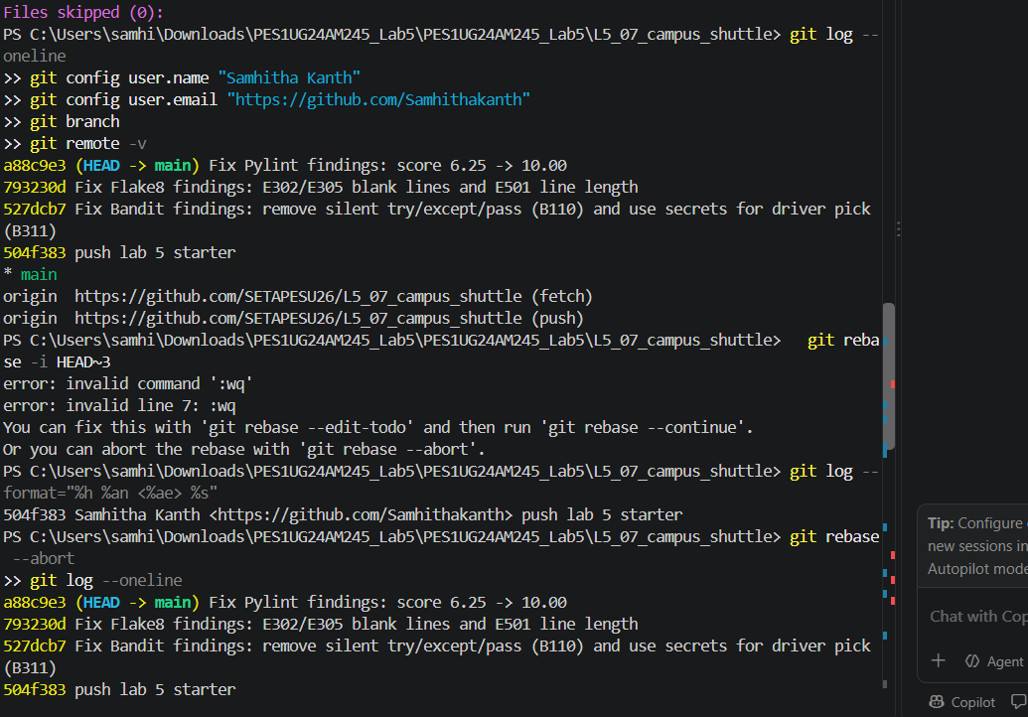
Git log showing the three commits
Re-authoring the commits with my name and email, then checking the log:
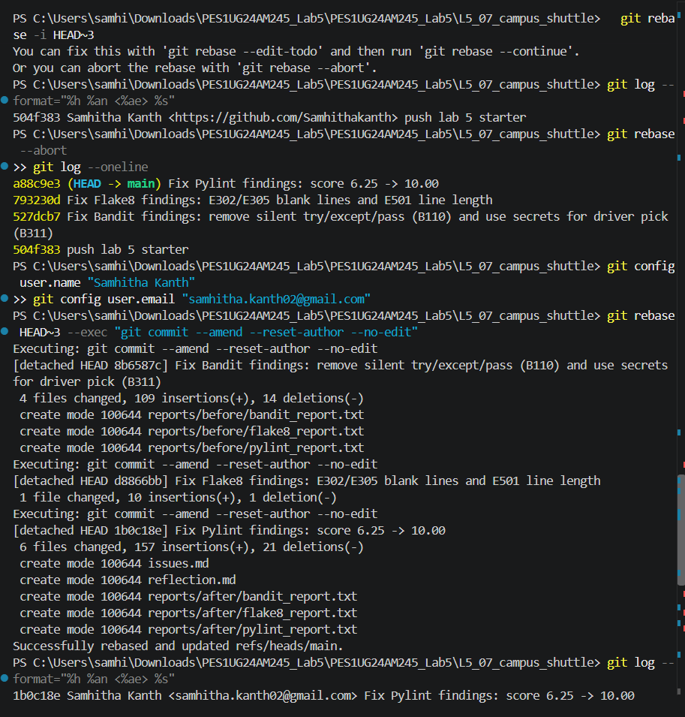
Rebase with author reset and git log
Pushing to GitHub: the push to the instructor’s repo was denied (403), so the work was pushed to the lab5 branch of my own repo SE_PES1UG24AM245:
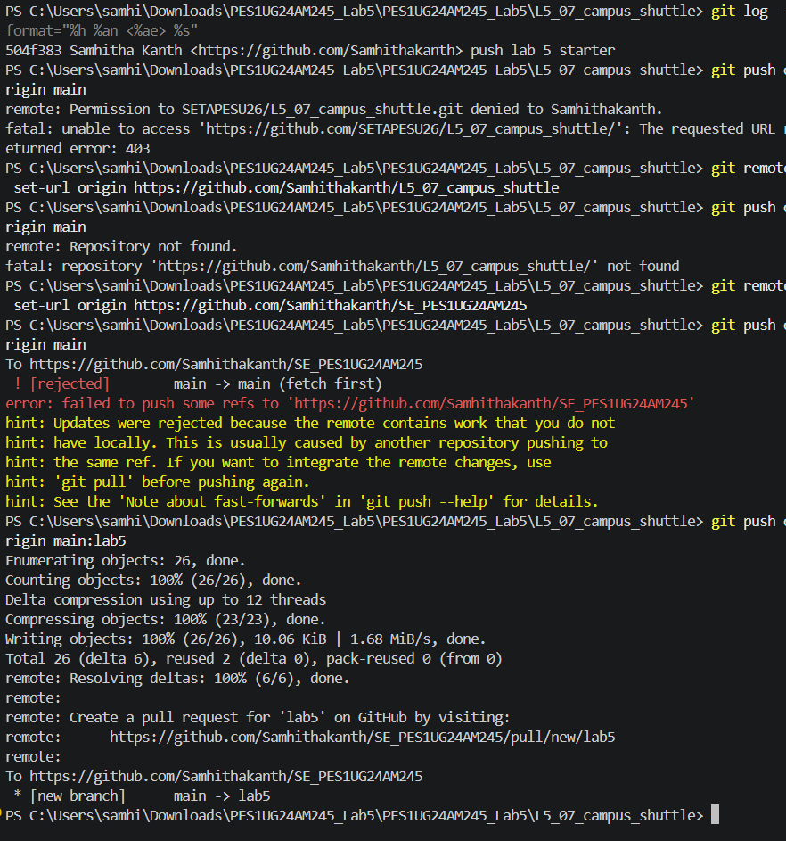
Git push to the lab5 branch

7. Reflection

1. Which issues were the easiest and which were the hardest to fix?
The easiest were the mechanical ones: Flake8’s blank-line and line-length warnings, the missing docstrings, the assignDriver rename and switching to an f-string. Each one has an obvious, local fix that does not change behaviour. The hardest was the bare except: pass that Bandit flagged. Deleting it is easy, but doing so exposed why it was there: bad data (-6, "full") was getting into the system and the exception handler was hiding the damage. The real fix was to validate input at the point of entry and make average_load fail with clear messages. The unused route_id and the odd write-then-reload in sync_fleet_data also needed thought about what the code was meant to do.

2. Did the tools report any false positives?
Bandit’s B311 on random.choice is a false positive in practice: picking a shuttle driver is not a security decision, so a non-cryptographic generator is fine. I switched to secrets.choice anyway because it costs nothing and gives a clean report, but a # nosec B311 with a justification would also have been reasonable. Pylint’s missing-docstring and naming messages are not bugs, but they are valid maintainability findings. No other result was wrong.

3. How would you integrate static analysis into a real workflow?
Run Flake8 and Pylint locally through a pre-commit hook so style and quality problems are caught before a commit exists. Run all three tools in CI (for example GitHub Actions) on every pull request and fail the build on Bandit findings, Flake8 errors or a Pylint score below an agreed threshold. Keep the tool configuration (.pylintrc, setup.cfg, Bandit config) in the repo so the whole team uses the same rules, and document any suppressions with a reason.

4. What tangible improvements did you see after the fixes?
The numbers: Pylint went from 6.25 to 10.00, Bandit from 2 findings to 0 and Flake8 from 10 violations to 0. More importantly, the behaviour improved. The original program crashed with a KeyError at the end, accepted negative and text passenger counts, and flagged R2 as under-used partly because of a -6 entry. The cleaned version rejects bad data with clear messages, no longer shares one log list between calls, closes its files properly, can be imported without running, and finishes without a traceback. The tools did not flag the validation and crash problems directly, so running the program and reading its output was just as important as the static analysis.

