National Textile University, Faisalabad



Department of Computer Science

Name | Muhammad Sami-ur-Rehman
Class | BSCS 4th
Section | B
Registration No | 24-NTU-CS-1194
Lab Report | 8
Course Name | HCI AND Computer Graphics
Submitted To | Sir Ali Bahir

QUESTION NO.1 :
CODE :
import numpy as np
import matplotlib.pyplot as plt
from mpl_toolkits.mplot3d import Axes3D

vertices = np.array([
[-1, -1, -1],
[ 1, -1, -1],
[ 1, 1, -1],
[-1, 1, -1],
[-1, -1, 1],
[ 1, -1, 1],
[ 1, 1, 1],
[-1, 1, 1]
])

edges = [
(0,1), (1,2), (2,3), (3,0),
(4,5), (5,6), (6,7), (7,4),
(0,4), (1,5), (2,6), (3,7)
]

fig = plt.figure()
ax = fig.add_subplot(111, projection='3d')

for edge in edges:
points = vertices[list(edge)]
ax.plot(points[:,0], points[:,1], points[:,2], 'black')

ax.scatter(vertices[:,0], vertices[:,1], vertices[:,2], color='red')

ax.set_xlabel('X')
ax.set_ylabel('Y')
ax.set_zlabel('Z')

ax.set_title("3D Cube (2x2x2)")

plt.show()
OUTPUT:

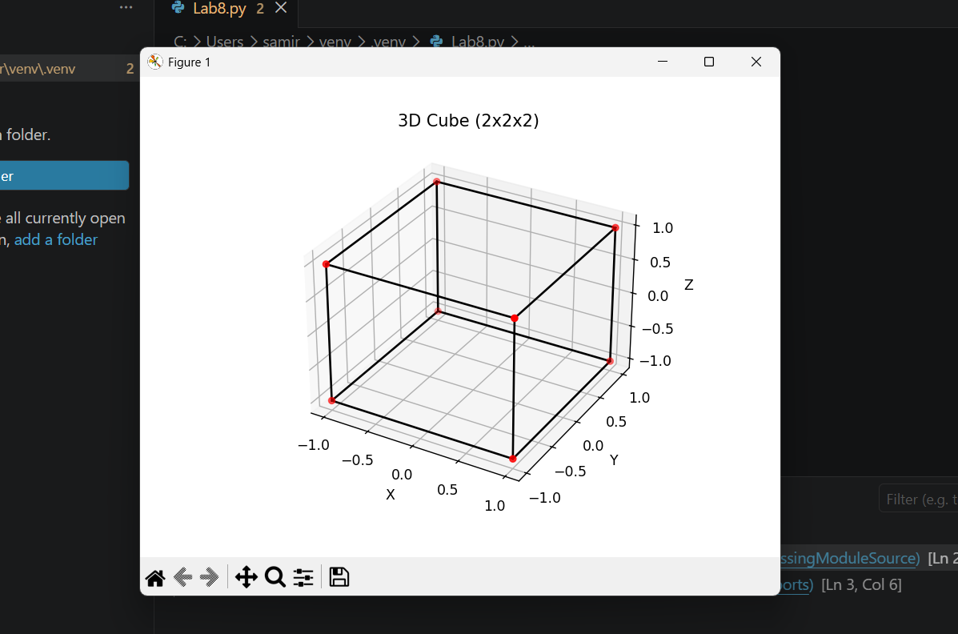
QUESTION NO.2 :
CODE :
import numpy as np
import matplotlib.pyplot as plt

r = 1.5

u = np.linspace(0, 2 * np.pi, 50)
v = np.linspace(0, np.pi, 50)

x = r * np.outer(np.cos(u), np.sin(v))
y = r * np.outer(np.sin(u), np.sin(v))
z = r * np.outer(np.ones(np.size(u)), np.cos(v))

fig = plt.figure()
ax = fig.add_subplot(111, projection='3d')

ax.plot_surface(x, y, z)

ax.set_title("3D Sphere (Radius = 1.5)")
ax.set_xlabel('X')
ax.set_ylabel('Y')
ax.set_zlabel('Z')

plt.show()

OUTPUT:
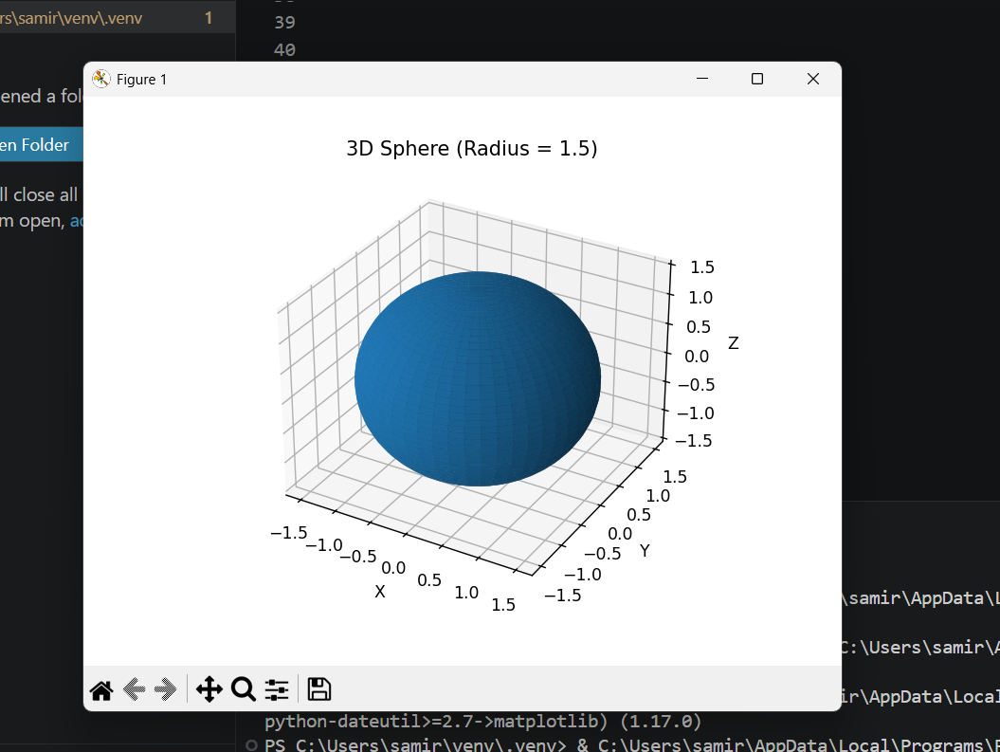

QUESTION NO.3 :
CODE :
import numpy as np
import matplotlib.pyplot as plt

r = 1
h = 3

theta = np.linspace(0, 2 * np.pi, 50)
z = np.linspace(0, h, 50)

theta, z = np.meshgrid(theta, z)

x = r * np.cos(theta)
y = r * np.sin(theta)

fig = plt.figure()
ax = fig.add_subplot(111, projection='3d')

ax.plot_surface(x, y, z)

theta_circle = np.linspace(0, 2*np.pi, 100)
x_circle = r * np.cos(theta_circle)
y_circle = r * np.sin(theta_circle)

ax.plot(x_circle, y_circle, 0)

ax.plot(x_circle, y_circle, h)

ax.set_title("3D Cylinder (r=1, h=3)")
ax.set_xlabel('X')
ax.set_ylabel('Y')
ax.set_zlabel('Z')

plt.show()

OUTPUT:
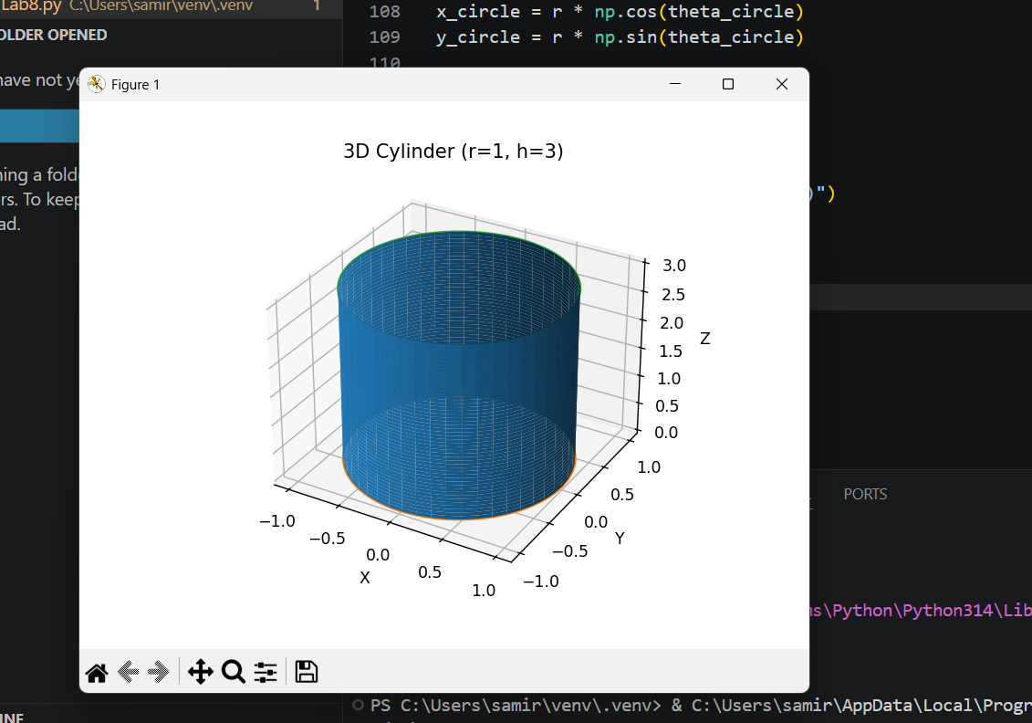

QUESTION NO.4:
CODE :

import numpy as np
import matplotlib.pyplot as plt

fig = plt.figure()
ax = fig.add_subplot(111, projection='3d')

cube = np.array([
[-1,-1,-1],[1,-1,-1],[1,1,-1],[-1,1,-1],
[-1,-1,1],[1,-1,1],[1,1,1],[-1,1,1]
])

cube = cube + np.array([0, 0, 0])

edges = [(0,1),(1,2),(2,3),(3,0),
(4,5),(5,6),(6,7),(7,4),
(0,4),(1,5),(2,6),(3,7)]

for e in edges:
pts = cube[list(e)]
ax.plot(pts[:,0], pts[:,1], pts[:,2], 'red')

r = 1
u = np.linspace(0, 2*np.pi, 30)
v = np.linspace(0, np.pi, 30)

x = r * np.outer(np.cos(u), np.sin(v))
y = r * np.outer(np.sin(u), np.sin(v))
z = r * np.outer(np.ones(np.size(u)), np.cos(v))

x = x + 2
y = y + 2
z = z + 0

ax.plot_surface(x, y, z, color='blue')

r = 1
h = 3

theta = np.linspace(0, 2*np.pi, 30)
z = np.linspace(0, h, 30)

theta, z = np.meshgrid(theta, z)

x = r * np.cos(theta)
y = r * np.sin(theta)

x = x + 2
y = y + 2
z = z + 1

ax.plot_surface(x, y, z, color='green')

ax.set_title("3D Transformations: Translation, Scaling, Rotation")
ax.set_xlabel("X")
ax.set_ylabel("Y")
ax.set_zlabel("Z")

plt.show()

OUTPUT:
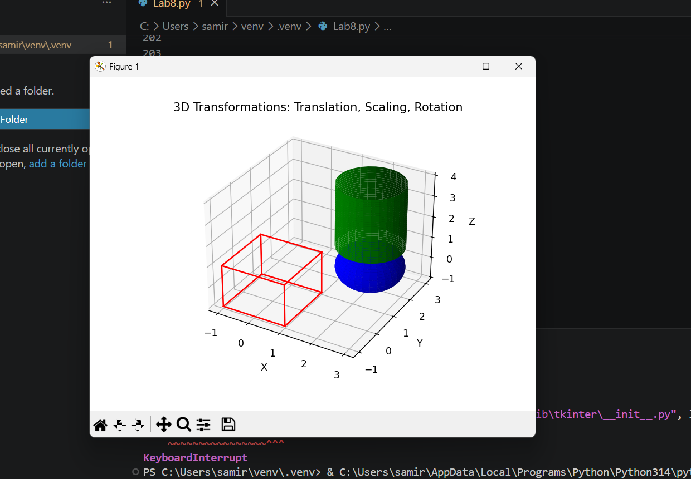

QUESTION NO.5 :
CODE :
import numpy as np
import matplotlib.pyplot as plt

fig = plt.figure()
ax = fig.add_subplot(111, projection='3d')

cube = np.array([
[-1,-1,-1],[1,-1,-1],[1,1,-1],[-1,1,-1],
[-1,-1,1],[1,-1,1],[1,1,1],[-1,1,1]
])

cube = cube + np.array([-3, 0, 0])

edges = [(0,1),(1,2),(2,3),(3,0),
(4,5),(5,6),(6,7),(7,4),
(0,4),(1,5),(2,6),(3,7)]

for e in edges:
pts = cube[list(e)]
ax.plot(pts[:,0], pts[:,1], pts[:,2], color='red')

r = 1.5
u = np.linspace(0, 2*np.pi, 40)
v = np.linspace(0, np.pi, 40)

x = r * np.outer(np.cos(u), np.sin(v))
y = r * np.outer(np.sin(u), np.sin(v))
z = r * np.outer(np.ones(np.size(u)), np.cos(v))

x = x + 2
y = y + 0
z = z + 0

ax.plot_surface(x, y, z, color='blue')

r = 1
h = 3

theta = np.linspace(0, 2*np.pi, 40)
z = np.linspace(0, h, 40)

theta, z = np.meshgrid(theta, z)

x = r * np.cos(theta)
y = r * np.sin(theta)

x = x + 6
y = y + 0
z = z + 0

ax.plot_surface(x, y, z, color='green')

ax.set_title("Combined 3D Scene (Cube, Sphere, Cylinder)")
ax.set_xlabel("X")
ax.set_ylabel("Y")
ax.set_zlabel("Z")

plt.show()

OUTPUT:
