MASTER DOCUMENT for (pre)processing EEG data for EPI-Infant project.
Sami Auno, 22/01/20, BABA Center, University of Helsinki, Finland

0.1. Setting up Brainstorm and adding subjects.

- In Brainstorm, make ‘New Protocol’. Use protocol’s default anatomy and one channel file per acquisition.
  - You may change the default path to somewhere else if you whish, especially if you lack storage space on your computer
- Add at least one new subject. You may add all subjects that you will be processing.
  - If you have several measurements of the same subject but at different ages (eg. 1 year, 2 year) each of these will have to use separate head model, and thus entirely separate protocol.
  - Name subject locigally, for example ‘EPI_01_1y’

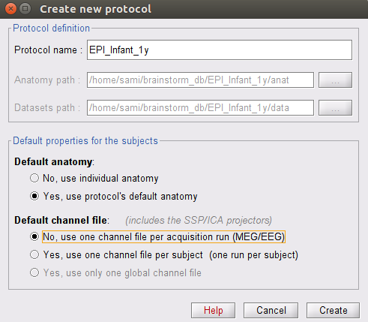
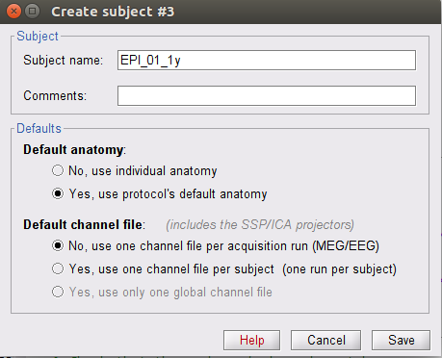

0.2. Setting up Anatomy
- In Anatomy tap, right click Default anatomy and select Use template and from there eg Oreilly_1y if you’re analysing 1 year olds.
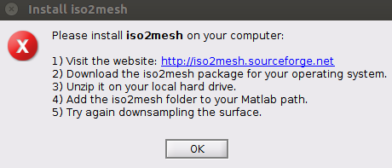
- The cortex must be downsampled and remeshed. For this, you need iso2mesh library. See instructions in image.
  - To downsample and remeshe:
    - Right click ‘cortex’
    - Select ‘Less vertices...’
    - Use 10 000 or 8 000 vertices, depending on the age.
    - Select iso2mesh/CGAL library. Make sure that the library is in your Matlab’s search path.
    - This will create file called ‘cortex_iso2mesh_[number of vertices]V’. Make sure it is active (green in Brainstorm GUI), if not, double click to activate.
- You also need smoothened cortex.
  - Open your newly created iso2mesh cortex.
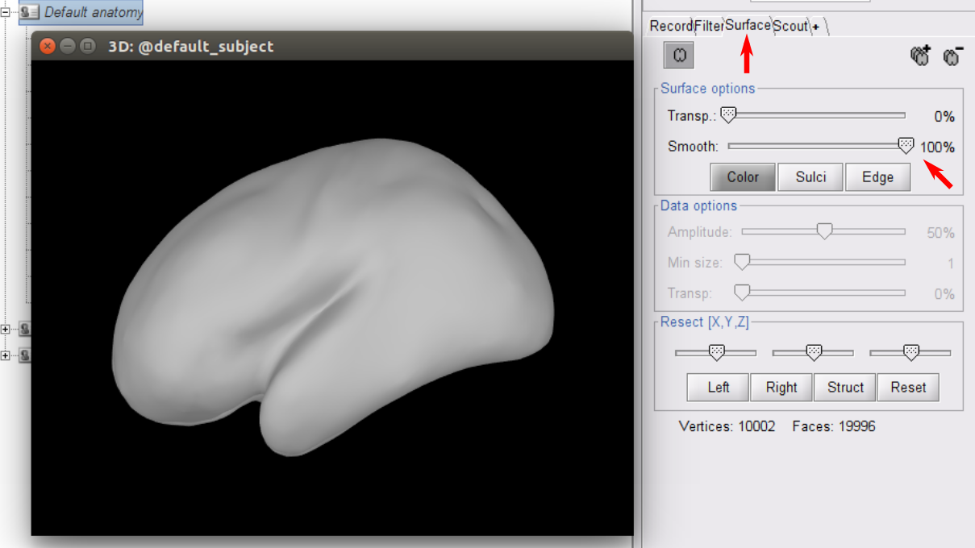
  - Go to ‘Surface’ tab and crank the ‘Smooth’ slider to 100%.
  - Right click the 3D image, select ‘Snapshot’ -> ‘Save surface: Cortex’
  - Now you have new cortex in the database.
  - Rename it to something descriptive like ‘cortex_iso2mesh_[number of vertices]V_smooth’.
  - Reactivate (make green) the remeshed (not smoothed) cortex.

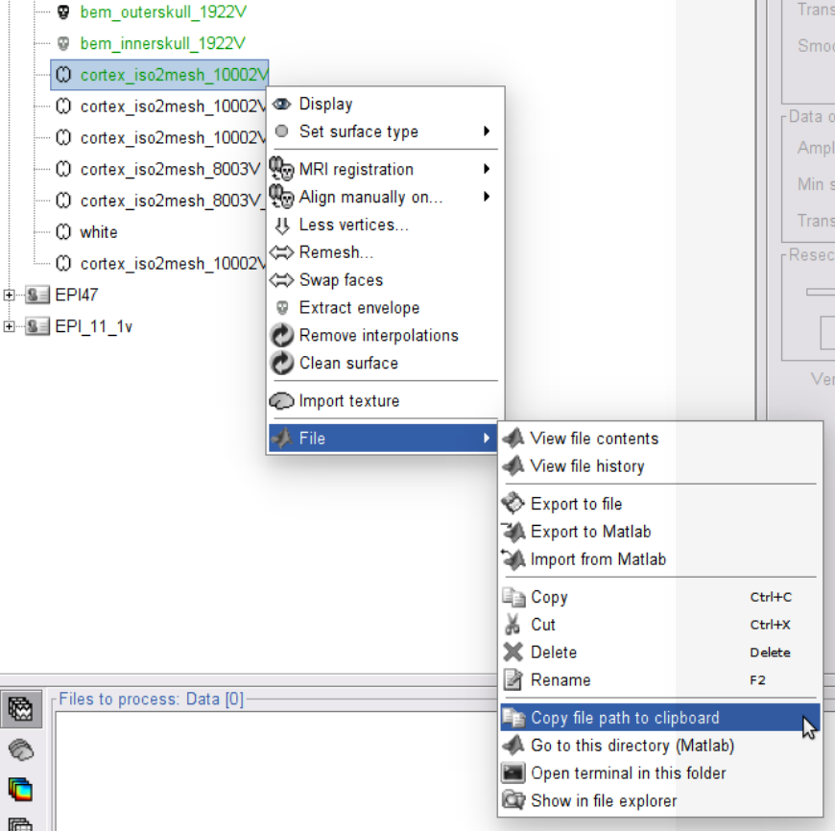
0.2.1. Selecting files for analysis
- Later you will need to get the path to different files you need to process or that are required for processing.
- Selecting one file:
  - In Brainstorm GUI, right click the file you want path to
  - Select ‘File’ - > ‘Copy file path to clipboard’. Now you can paste the path to, for example, matlab script.

0.3. Add EEG data to subjects
- In Brainstorm GUI, go to ‘Functional data’ tab
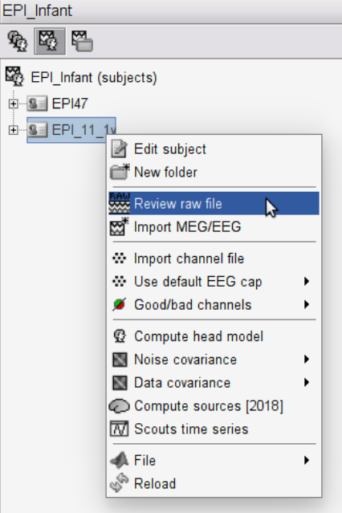
- Rigth click the subject folder to which you want add EEG data.
- Click ‘Review raw file’. Then navigate to your data file.
- Repeat this for each subject.

0.4. Setting up EEG Layout
- Loading premade layout:
  - Layouts for Oreilly_1y, 64-channel cap are saved in EEG_layout/layout_EPI_Infant_64_Oreilly_1y. The one used in the project is the 20191101 version.
  - Navigate to to the RAW data folder in the GUI and right click the channel file (eg. ‘ANT standard position’), then ‘Add EEG positions’, Import from file.
- Making your own layout
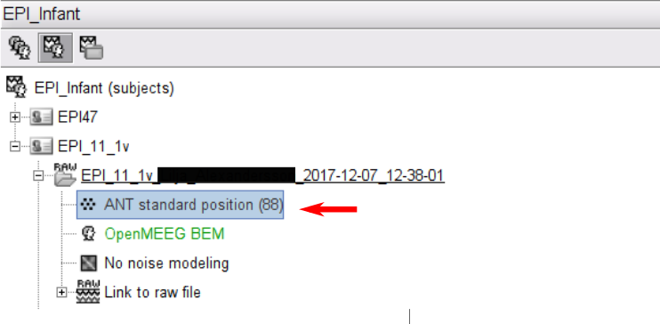
  - In the ‘Add EEG positions’, there are premade layouts from different manufactorers. If you’re lucky, yours is there too. If you’re not that lucky, you may select the one that is closest to yours.
  - When layout has been selected, again right click the channel file, and select ‘MRI registration’ -> ‘Edit...’
  - First ‘Project electrodes on the surface’ to get better fit. Then you may manually move each electrode to better fit your layout and add new electrodes.
  - Save your new layout. Export it to folder EEG_layouts/[descriptive name for your layout] by again right clickin the channel file, selecting ‘File’ -> ‘Export to file’

0.5. Creating Custom Parcellation
- The code, main_parcellation.m can be found in ‘custom_parcellation’ folder.
- You need the paths to scalp file (in Brainstorm: ‘bem_head_[number]V’) and to the smoothened cortex file
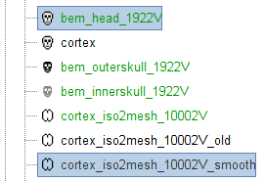
- Select an adequate number of parcels per hemisphere and some descriptive name for your new atlas (Brainstorm jargon, means parcellation).
- Run the first two sections of the code so that you get ‘Parcellation’ matrix.
  - The Cx_atlas() function will create parcellation and plot results.
  - You may run this as many times as you like until you are happy with the result.
  - When you are happy with the parcellation (where your parcels are located, how many there are, etc.) comment the Cx_atlas() out just in case. You don’t want to accidentally run it again and lose your atlas...
- Run the next part (‘Hemisphere and other info’). It plots the parcellation and colors parcels according to the indexing you have given. Here you must change the parcel indexing so that it matches the anatomical regions. This must be done by hand. Change the indecis, run this section, check what matches and what doesn’t, change indexing, run again, and so on.
  - Do this until the coloring matches anatomical regions that you want.
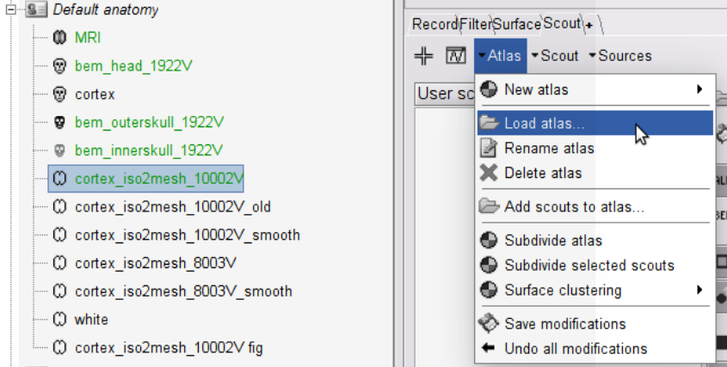
- Next run the rest of the code. This makes Brainstorm compatible atlas and saves it to the folder where this script is located.
  - Next import this newly created atlas to your cortex.
  - Make sure the cortex you are using is active in Brainstorm (is green)
  - Open that cortex.
  - Navigate to ‘Scout’ tab.
  - Click ‘ Altas’ and select ‘Load atlas...’.
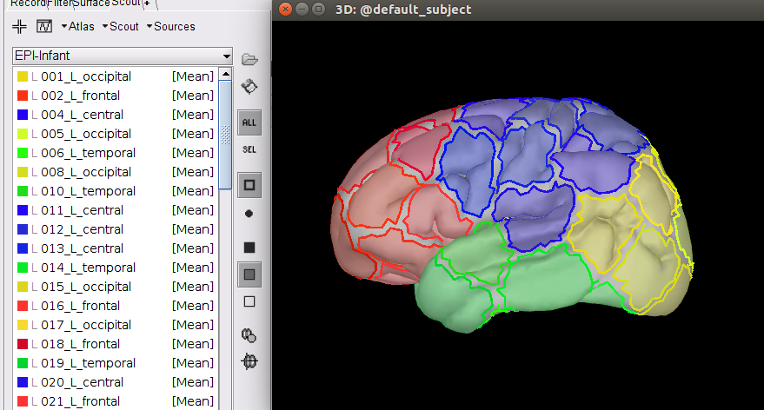
  - Navigate and select your newly created and saved atlas.
  - Check the results in Brainstorm. If you’re not happy, repeat the above process.

0.6. Calculate Head Model
- Navigate to your RAW data folder in the GUI and right click the ‘Link to raw file’ and then ‘Compute head model’.
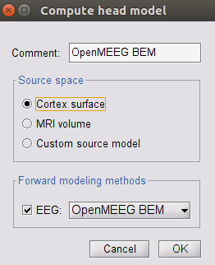
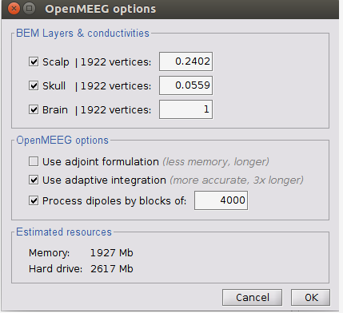
- Select ‘Cortex surface’ and in the Forward modeling methods -selection ‘OpenMEEG BEM’.
- OpenMEEG might require some installation first. If you’re prompted this, do it.
- The conductivities are shown in the image. These correspond to 1.79 S/m, 0.1 S/m, and 0.43 S/m for intracranial (brain), skull, and scalp respectively.
- This process takes a while. Sit back and relax.
- This will create you a headmodel file named ‘OpenMEEG BEM’ in the same folder as the raw data and the channel files are.
- Make sure that this head model file is active (green in the navigator).

0.7. Calculate Inverse Model
- To calculate inverse model, you need noise covariance matrix.
  - In one subject, right click the ‘Link to raw file’, click ‘Noise covariance’, and then ‘No noise modeling (identity matrix)’.
- Next, for the same subject, again right click the ‘Link to raw file’, and select ‘Compute sources [2018]’.
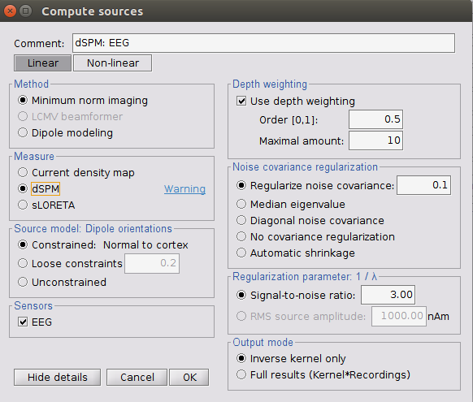
- Select dSPM as measure. The parameters are shown in the screenshot:
- This creates you source projection for the data you calculated this. We don’t care about the data, only about the inverse operator that is saved in the source space solution file. This will be used for every subject.
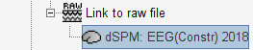

0.8. Calculate Collapse Operator
- Collapse operator is used to downsample the source space data to parcel level.
- For reference, see: Tokariev et al. Preterm Birth Changes Networks of Newborn Cortical Activity. Cerebral Cortex. 2018;29(2):814–26. and the supplemental information
- The script (‘process_CollapseOperator.m’) can be found in the master folder.
- You need the paths to the head model and the inverse model (refer to 0.2.1)
- Make sure that Brainstorm is running before you run this script. It uses Brainstorm functions so Brainstorm must be running.
- To create the dummy signals for this, use the same sampling frequency (fs) as your downsampled EEG signal will be.
- This will create a vector that has as many elements as there are sources (vertices) in your source model. Each element has a weight (scalar between 0 and 1) that tells you how much the source contributes to the parcel signal.
- This Collapse operator is then saved to the HeadModel file automatically.

0.9. Calculate Fidelity Operator
- For reference, see: Tokariev et al. Preterm Birth Changes Networks of Newborn Cortical Activity. Cerebral Cortex. 2018;29(2):814–26. and the supplemental information
- The script (‘process_FidelityOperator.m’) can be found in the master folder.
- Again, Brainstorm must be running, at least at the begining of the script.
- The script again requires paths to the head model and the inverse model.
- Use the same parameters as were used when calculating the collapse operator.
- This script is divided into three parts:
  - Calculate weighted phase lag index (wpli) between each parcel when the the parcel signals are completely random
    - It repeats this multiple (~100) times so that a baseline random distribution of wpli values between all parcels can be formed
  - Calculate wpli so that two parcels are perfectly phase correlated and all the rest are random.
    - This is repeated for all parcel pairs separately, and this process is repeated multiple (~100) times. This now again creates distribution of wplis but this time for perfectly phase correlated pairs.
    - This part takes time (multiple days!). So be prepared.
  - Calculate the Fidelity Operator by comparing the results of the correlated wpli distribution to the baseline and checking parcel-parcel connections are statistically significant
- The resulting FidelityOperator is saved to the Headmodel file. It is a masking matrix.

1.0. Preparations and requirements for the actual processing pipeline
- You need:
  - Have added all subjects and linked the raw data to these subjects in Brainstorm
  - Have calculated Head model, Inverse model, Collapse operator, and Fidelity operator for one subject. These are used in the analysis of all subsequent subjects

1.1. Preprocess data, process_step1.m
- This script is located in the master folder.
- It requires the paths to raw data files.
- Check also that the Channel names matches the ones that are defined in your channel file.
  - The script will not process files where the channel file doesn’t match.
- You need to go through each EEG in Brainstorm and manually select and mark bad channels for the bad channel interpolation to work
- This script will:
  - Check channel names
  - Broadband filters the data
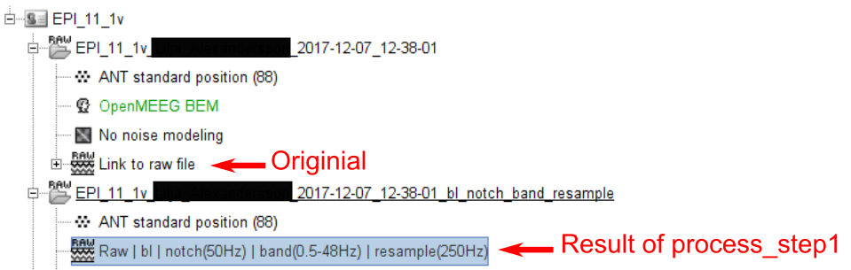
  - Remove DC (baseline correstion)
  - Downsample data
  - Interpolates bad channels
  - Finds and saves spindles
  - Re-reference data to average montage
  - Adds some date tags
  - Delete intermediate files from Brainstorm
- The script makes a new folder under the subject. This folder contains the same channel file and a new raw data file. This is the resulting file. ICA (if wanted) is performed on this file.

1.3. Preprocess data, process_step2.m
- This script calculates the functional networks. It calculates four different metrices and more can be easily added to the script: Phase Locking Value, debiased weighted Phase Lag Index, Correlation Coefficient, and orthogonal Correlation Coefficient

