Bitcoin price prediction

# Introduction

Have you heard about Bitcoin and cryptocurrency? Everyone from governments to grandmothers are talking about it. Bitcoin’s popularity has increased so much over the last few years.

What is Bitcoin?

Bitcoin (₿) is a decentralized digital currency which is money without government. The transaction is verified by network nodes through cryptography. At the same time, it is recorded in a public distributed ledger called blockchain. Through this, Bitcoin is be transferred purely peer-to-peer, which in other words, people-to-people transfer system.

Is it popular?

Bitcoin was created in 2009 with the price $0.01. In 17 Sep, 2014, the price kept going up from $457 to $28,886 per coin.

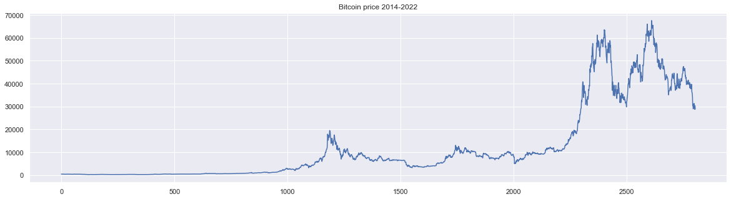

Why is Bitcoin so popular?

Bitcoin has two characteristics that no other currency in the world has: Decentralization and Transparency. It means that you are exclusively owner of your money. You have access to deposit and withdraw money whenever you want. Banks and other third parties are not involved.

Is Bitcoin a good investment?

Bitcoin Supply is Limited. There are only 21million Bitcoins available in total, and 17.6million have already been mined. It is not possible that every can own one Bitcoin. It the demand rises, the Price can only increase since there is limited supply.

# Subjects and methods

The trading strategy for Bitcoin is buy at low price then sell at high price. This leads to a further question: how can we better predict the Bitcoin price? In this study, we are going to present several methods, compare their predictions, and choose finally the best model.

1. Literature review on using ARIMA model for Bitcoin price prediction

Wirawan et al. (2019) use the Autoregressive Integrated Moving Average (ARIMA) method to make predictions of Bitcoin future price changes, for data ranges from May 1, 2013 to June 7, 2019. They claim that ARIMA method is capable of generating high accuracy in short-term predictions. They find that ARIMA (4,1,4) model generates the smallest Mean Absolute Percentage Error (MAPE), 0.87 for the next one-day prediction and 5.98 for the next seven days. Their conclusion is that the ARIMA (4,1,4) model is feasible to predict Bitcoin for one to seven days ahead.

Hua (2020) compare the accuracy of bitcoin price in prediction based on two methods: Long Short term Memory (LSTM) network and ARIMA model. They concludes that ARIMA is quite efficient in making prediction in one-day prediction; but the precision rate would decrease for five-day prediction.

However, McNally et al. (2018) compared linear ARIMA model and LSTM and RNN models in predicting the Bitcoin daily price. The ARIMA model has a 100% precision but with a 53.74% RMSE. They concludes that ARIMA model performs poorly compare to LSTM and RNN models, in predicting 30 days into the future.

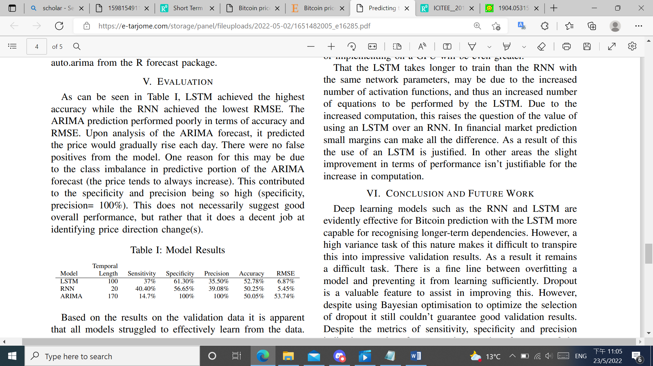

Azari (2019) show that ARIMA outperforms RNN in short time periods, e.g. 1-day, for the price of bitcoin, but they observe large prediction errors for a long-term prediction.

Yamak et al. (2019) show that the ARIMA model gave better results than the deep learning-based regression models in predicting Bitcoin's price. The results show that ARIMA gives the best results at 2.76% and 302.53 for MAPE and RMSE respectively.

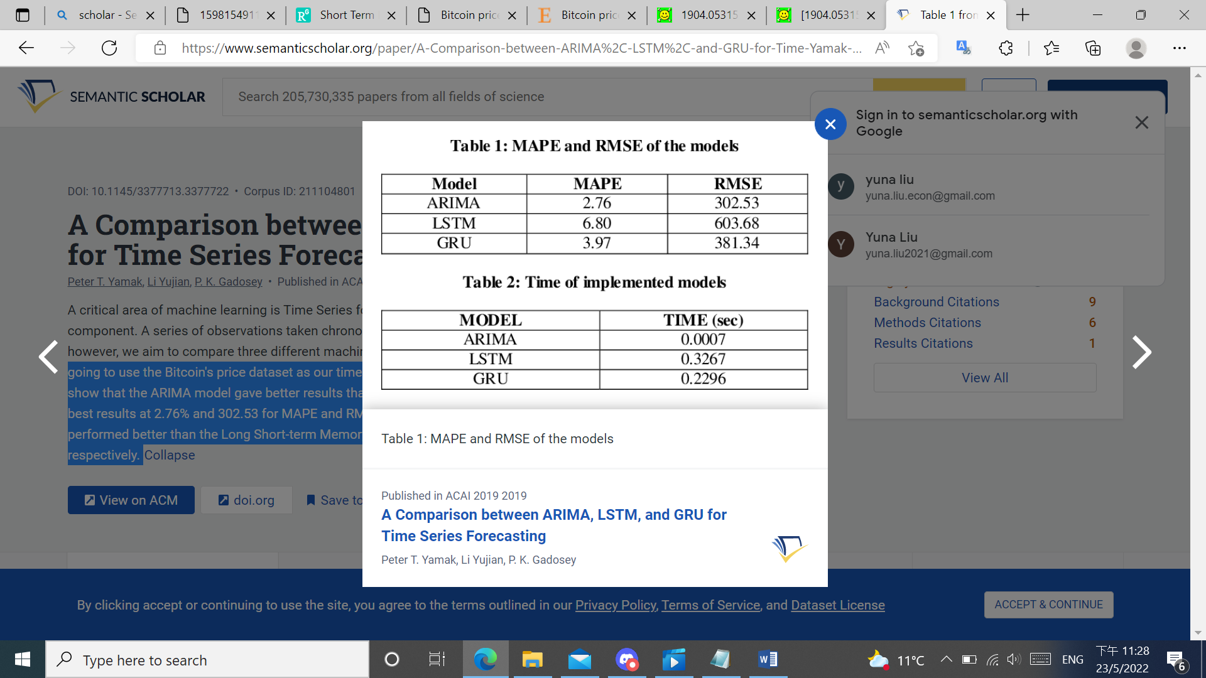

1. Introduction of ARIMA model

In the statistical analysis of time series, an autoregressive integrated moving average (ARIMA) model is a generalization of an autoregressive moving average (ARMA) model. A requirement to use ARMA model is that the series should be stationary, therefore the past pattern could be used to predict the future pattern. In the motive to get stationary series, the raw data is “integrated” which is exactly the “I” in ARIMA model. Integrated means the number of times need to difference a series in order to achieve stationary. A simple example is ARIMA(0,1,0) in the sense that I=1:

$$Y_{t}=X_{t}-X_{t-1}$$

ARMA model refers to autoregressive–moving-average model. It is a tool for understanding and predicting future values in time series.

The AR part involves regressing the variable on its own lagged (i.e., past) values. A simple example is AR(1) model:

$$Y_{t}=C+φ_{1}Y_{t-1}+ε_{t}$$

The MA part involves modeling with lagged errors. A simple example is MA(1) model:

$$Y_{t}=C+θ_{1}ε_{t-1}+ε_{t}$$

Only using AR part fails to adjust quickly to unexpected shocks. On the other hand, only using MA part lacks the baseline to perform good prediction. Mixing both AR and MA models is usually referred to as the ARMA(p,q) model where p is the order of the AR part and q is the order of the MA part:

$$Y_{t}=C+φ_{1}Y_{t-1}+φ_{2}Y_{t-2}+…+φ_{p}Y_{t-p}+θ_{1}ε_{t-1}+θ_{2}ε_{t-2}+…+θ_{q}ε_{t-q}+ε_{t}$$

ARMA model has the benefit to account both the previous values and how far off the previous value from the previous prediction.

1. The process of implementing ARIMA model

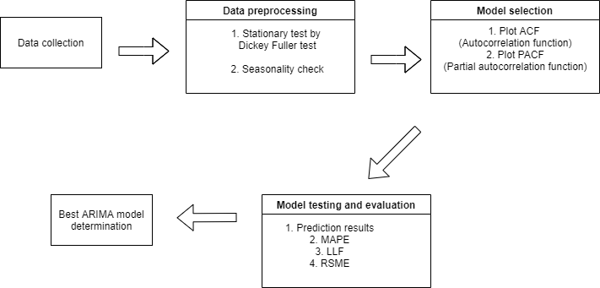

# References

1. I. M. Wirawan, T. Widiyaningtyas and M. M. Hasan, Short Term Prediction on Bitcoin Price Using ARIMA Method, 2019 International Seminar on Application for Technology of Information and Communication (iSemantic), 2019, pp. 260-265, doi: 10.1109/ISEMANTIC.2019.8884257.
2. Hua, Y. (2020). Bitcoin price prediction using ARIMA and LSTM. E3S Web of Conferences.
3. S. McNally, J. Roche and S. Caton, "Predicting the Price of Bitcoin Using Machine Learning," 2018 26th Euromicro International Conference on Parallel, Distributed and Network-based Processing (PDP), 2018, pp. 339-343, doi: 10.1109/PDP2018.2018.00060.
4. Yamak, P.T., Yujian, L., & Gadosey, P.K. (2019). A Comparison between ARIMA, LSTM, and GRU for Time Series Forecasting. ACAI 2019.
5. Azari, A. (2019). Bitcoin Price Prediction: An ARIMA Approach. ArXiv, abs/1904.05315.