Bitcoin price prediction

# Introduction

Have you heard about Bitcoin and cryptocurrency? Everyone from governments to grandmothers are talking about it. Bitcoin’s popularity has increased so much over the last few years.

What is Bitcoin?

Bitcoin (₿) is a decentralized digital currency which is money without government. The transaction is verified by network nodes through cryptography. At the same time, it is recorded in a public distributed ledger called blockchain. Through this, Bitcoin is be transferred purely peer-to-peer, which in other words, people-to-people transfer system.

Is it popular?

Bitcoin was created in 2009 with the price $0.01. In 17 Sep, 2014, the price kept going up from $457 to $28,886 per coin.

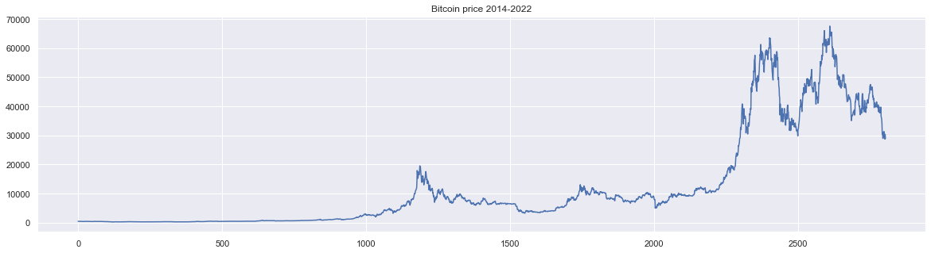

Why is Bitcoin so popular?

Bitcoin has two characteristics that no other currency in the world has: Decentralization and Transparency. It means that you are exclusively owner of your money. You have access to deposit and withdraw money whenever you want. Banks and other third parties are not involved.

Is Bitcoin a good investment?

Bitcoin Supply is Limited. There are only 21million Bitcoins available in total, and 17.6million have already been mined. It is not possible that every can own one Bitcoin. It the demand rises, the Price can only increase since there is limited supply.

# Subjects and methods

The trading strategy for Bitcoin is buy at low price then sell at high price. This leads to a further question: how can we better predict the Bitcoin price? In this study, we are going to present several methods, compare their predictions, and choose finally the best model.

# References