 [Translated from Romanian to English - www.onlinedoctranslator.com](https://www.onlinedoctranslator.com/en/?utm_source=onlinedoctranslator&utm_medium=docx&utm_campaign=attribution)

**Project Bible**

Content

1. Description 3

1.1 Books of the Bible 3

1.1.1 For the Galatians button 4

1.1.2 For the Ephesians button 4

1.1.3 For the Philippines button 5

1.1.3 For the Colossians button 5

1.2 Advanced search 6

1.3 Verse of the day 6

1.4 The exit button 7

2. Bibliography 7

# Description

The application I created is a GUI that looks like this:

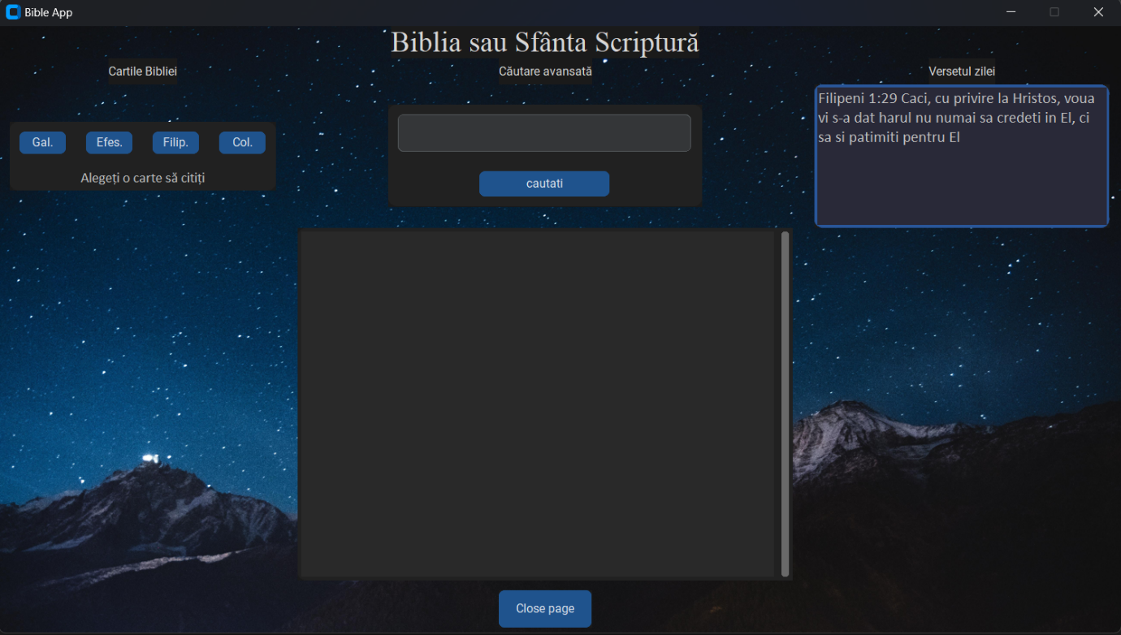

The image above shows the following:

## 1.1 Books of the Bible

In the upper left part we are shown 4 buttons for 4 books of the Bible (Galatians, Ephesians, Philippians, Colossians). The user will be able to read one of the implemented Bible books by pressing the button with the name of the desired book.

When the user will press the button for the book he wants to read, for each button I will open a new window and he will be able to read the entire content of the book.

Within each window will appear the title of the book, a series of buttons representing the chapters of the book, and a window displaying all the verses in each chapter. When the user presses button 1, the text window will show all the verses from chapter 1 that he can read, when he presses button 2, all the verses from chapter 2 will appear, etc.

### 1.1.1 For the Galatians button

### 1.1.2 For the Ephesians button

### 1.1.3 For the Philippines button

### 1.1.3 For the Colossians button

## Advanced search

In the middle part of the first image I implemented an advanced search. As you can see, I implemented a search box accompanied by a button and at the same time a textbox. The user will have the opportunity to search for a word in the search box, after which he will press the button and the program will show him two alternatives in the respective textbox.

If the word is found in the books of the Bible, then in the textbox it will show all the verses where the word or expression is found, if the word is not found in the books of the Bible, then a message will appear in the textbox which will tell him that the word is not found as in the images below.

The user will be able to search for a word or phrase as many times as they want.

## Verse of the day

In the upper right part of the first image we have implemented a textbox in which the verse of the day is displayed. The program automatically sees the year and the day of the year in which we are and depending on that chooses a verse from the books of the Bible and displays it in the respective textbox.

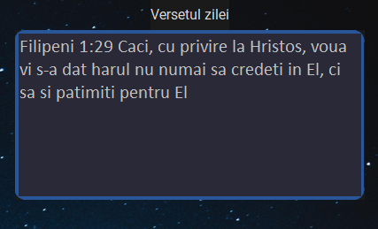

## 1.4 The exit button

Finally, for each individual page we implemented a page exit button.



# Bibliography

[tkinter — Python interface to Tcl/Tk — Python 3.11.1 documentation](https://docs.python.org/3/library/tkinter.html)

[GitHub - TomSchimansky/CustomTkinter: A modern and customizable python UI-library based on Tkinter](https://github.com/TomSchimansky/CustomTkinter)

[Python GUI's With TKinter - YouTube](https://www.youtube.com/playlist?list=PLCC34OHNcOtoC6GglhF3ncJ5rLwQrLGnV)

[python - StackHowTo](https://stackhowto.com/category/python/)

[Python Programming Language - GeeksforGeeks](https://www.geeksforgeeks.org/python-programming-language/?ref=ghm)