**Project – IR Sensor**

**Project idea:**

Measuring the movement of an object using an IR sensor and then implementing it in a parking system.

**What is an IR sensor?**

It is an electronic device that can, for example, measure the heat of an object or detect its movement.

This type of sensor is similar to human visual senses to detect obstacles.

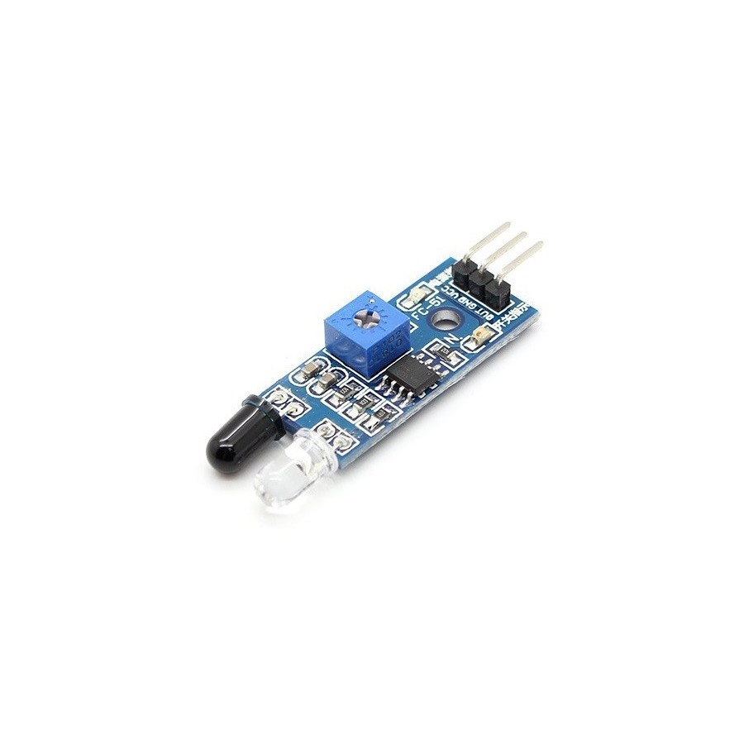

Fig. 1 IR sensor module

The IR sensor module consists of two main elements: an LED as emitter and a photodiode as receiver.

**What is the working principle of the IR sensor?**

An infrared sensor includes two parts, namely the emitter and the receiver (emitter and receiver), so it is collectively called an optocoupler or photocoupler. Here, the IR LED is used as the emitter, while the IR photodiode is used as the receiver.

The photodiode used in this is very sensitive to infrared light generated by an infrared LED. The resistance of the photodiode and the output voltage can be changed in proportion to the infrared light obtained. This is the fundamental working principle of the IR sensor.

The light generated by the infrared LED hits the solid surface and bounces back to the photodiode.

As shown below, the IR sensor circuit module contains 5 main elements:

* IR LED
* Photodiode
* 100 kohm resistance
* Buzzer
* 3 LEDs of different colors for approximating the distance (RED, YELLOW, GREEN)

IR sensor circuit diagram.

Fig. 2 Scheme used

Fig. 3 Physical scheme implemented

An infrared sensor consisting of 4 emitting LEDs and a receiving LED is a similar arrangement to a passive infrared (PIR) sensor, but with a more specific design. This configuration can be used to detect changes in the level of infrared light in the environment, which can suggest the presence or absence of an object or heat source. Here's how it generally works:

1. **Emitter LEDs (IR LEDs):**

* The 4 emitting LEDs are designed to emit infrared light in the spectrum invisible to the human eye.
* These LEDs can emit constantly or be activated at regular intervals.

1. **LED Receiver:**

* The receiver LED is sensitive to infrared radiation and can detect changes in its intensity.
* When an object or heat source is in range of the sensor, the level of infrared light detected by the receiving LED increases.

1. **Processing Circuit:**

* The data from the receiver LED is sent to a processing circuit.
* This circuit (Arduino board) receives a value on the analog port A0, following which these values are transmitted on the serial port.

1. **Output or Triggering Signal:**

* Depending on the level of infrared light detected, the sensor can produce an output signal.
* This signal can be used to trigger certain actions, such as lighting an indicator LED or activating other electronic devices.

**Operation in stages:**

1. **Infrared Emission:** The 4 emitting LEDs emit infrared light.
2. **Reception** : The receiver LED receives infrared light reflected from objects in the environment.
3. **Change Detection** : If there are changes in the level of infrared light received (such as the presence of a warm object), the sensor reacts.
4. **Output or Signal:** A signal is generated, signaling the presence or absence of an object or heat source.

**The utility of the infrared sensor:**

Infrared sensors have a variety of applications due to their ability to detect infrared radiation emitted by objects. Here are some of the common applications of infrared sensors:

* **Security and Motion Detection Systems:**

Infrared sensors are used in security systems to detect motion. When a person or other object enters the sensor's field of view, it detects temperature changes and activates an alarm system.

* **Automatic Lighting:**

Infrared sensors are used in automatic room lighting. When a sensor detects motion or presence, it turns on lighting to save energy when not needed.

* **Control of Electronic Devices:**

Infrared sensors are used in televisions, remote controls, and other devices to detect infrared signals emitted by remote controls. They allow control of electronic devices through gestures or signals.

* **Automatic Air Conditioning Systems:**

Infrared sensors are used in air conditioning systems to detect human presence and adjust temperature or ventilation according to current needs.

* **Security Systems in Automobiles:**

In vehicles, infrared sensors can be used to detect the presence of passengers and to control devices such as airbags or climate systems.

* **Surveillance cameras:**

Infrared sensors are used in surveillance cameras to capture images in low light or total darkness, using invisible infrared light to illuminate the area.

* **Liquid Level Detection:**

Infrared sensors can be used to detect the level of liquid in containers. They can emit a signal when the liquid level reaches or exceeds a certain limit.

* **Medical devices:**

Infrared sensors are used in medical devices to measure body temperature or monitor patients' vital signs.

* **Contactless Entry Systems:**

Infrared sensors are used in various contactless entry applications, such as automatic doors, sensor faucets, and other devices that respond to human presence without requiring direct touch.

**Arduino code used:**

int IRpin = A0;

int IRemitter = 2 ;

int LedRed = 3 ;

int LedYellow = 4 ;

int LedGreen = 5 ;

constant int Buzzer = 11 ;

int ambientIR;

int obstacleIR;

int value[150];

int distance;

void setup(){

  Serial.begin(9600);

  pinMode(IRemitter,OUTPUT);

  pinMode(LedRed,OUTPUT);

  pinMode(LedYellow,OUTPUT);

  pinMode(LedGreen,OUTPUT);

  digitalWrite(IRemitter,LOW);

  pinMode(Buzzer,OUTPUT);

  digitalWrite(Buzzer,LOW);

}

void loop(){

  distance = -readIR(150) - 39;

  Serial.println(distance);

  flags();

  buzzer();

}

int readIR(int times){

  for(int x=0;x<times;x++){

    digitalWrite(IRemitter,LOW);           // turning the IR LEDs off to read the IR coming from the ambient

    delay(1);                                             // minimum delay necessary to read values

    ambientIR = analogRead(IRpin);  // storing IR coming from the ambient

    digitalWrite(IRemitter,HIGH);          // turning the IR LEDs on to read the IR coming from the obstacle

    delay(1);                                             // minimum delay necessary to read values

    obstacleIR = analogRead(IRpin);  // storing IR coming from the obstacle

    value[x] = ambientIR-obstacleIR;   // calculating changes in IR values and storing it for future average

  }

  for(int x=0;x<times;x++){        // calculating the average based on the "accuracy"

    distance+=value[x];

  }

  return(distance/times);            // return the final value

}

void flags(){

  if( distance <= 10){

    digitalWrite(LedGreen,HIGH);

    digitalWrite(LedYellow,LOW);

    digitalWrite(LedRed,LOW);

  }

  else if(distance > 10 && distance < 20){

    digitalWrite(LedGreen,LOW);

    digitalWrite(LedYellow,HIGH);

    digitalWrite(LedRed,LOW);

    }

  else{

    digitalWrite(LedGreen,LOW);

    digitalWrite(LedYellow,LOW);

    digitalWrite(LedRed,HIGH);

  }

}

void buzzer() {

  if (distance >= 20) {

    tone(Buzzer, 1000);

  }

  else if (distance < 20 && distance > 10) {

    noTone(Buzzer);

    tone(Buzzer, 500);

    digitalWrite(Buzzer, HIGH);

    delay(100);

    digitalWrite(Buzzer, LOW);

    delay(100);

  }

  else {

    noTone(Buzzer);

  }

}

**Codul utilizat Matlab:**

close all;

clear all;

clc;

s = serialport('COM3', 9600);

fopen(s);

i = 1;

while(1)

data(i) = str2double(fscanf(s));

if i <= 150

plot(data, 'LineWidth', 1.5);

else

plot(data(end - 150: end), 'LineWidth', 1.5);

end

xlabel('Time');

ylabel('Analog read');

title('IR Senzor Graph');

ylim = [0 50];

pause(0.00000001);

i = i + 1;

end

**

Fig. 4 Mat material

Fig. 5 Glossy material

Fig. 6 Room temperature

Fig. 7 Outside temperature

Fig. 8 Light on and light off

**Difficulties encountered**

* If we simply place the transmitter next to the receiver, then the receiver will receive the radiation from the transmitter continuously and thus signal that an object is detected. To solve this problem, I put it on the receiver as in the picture.
* If we use only one emitter, then the receiver will receive the radiation more difficult because the angle between the two components is very important. To solve this problem I used 4 IR LEDs.
* The type of material that approaches the senor is also very important. In one way it reacts to a matte material and in another way to a glossy material.
* Also, the temperature influences the quality of the sensor results.