B E Y O N D M E A N - V A R I A N C E
Run the optimiser locally

What?
This is a step-by-step guide to run the optimizer locally on your machine at full speed with no cloud sleep or timeouts.

Why?
The heaviest computations needed for institutional-grade optimisations rely on high grid resolution. The process can be interrupted by the hosting Streamlit Community Cloud, which sleeps when idle and can time out or reboot.
The hosted version at the live app remains ideal for light simulations and quick, approximate results that rely on low to medium grid resolution.

How?

Before you start — a one-time check
You need Python 3.9 or newer. Check by opening Command Prompt and typing:
python --version
If it’s missing, install it from python.org and tick “Add Python to PATH” during setup.

Step 1 Get the files from GitHub
Open the repository, click the green Code button, choose Download ZIP, then extract the folder somewhere easy, e.g. Documents\behavioral-portfolio-optimizer-main (GitHub adds the “-main”).

https://github.com/SamiJeddou/behavioral-portfolio-optimizer

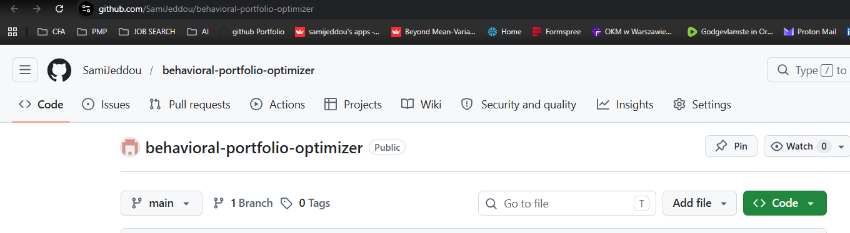

GitHub: the green “Code” button ▸ “Download ZIP”

Step 2 Open a terminal in that folder
Open the extracted folder in File Explorer — the one that contains app.py and requirements.txt. Click into the address bar, type cmd, and press Enter. A Command Prompt opens already inside that folder. (Or hold Shift, right-click in the folder, and choose “Open in Terminal”.)

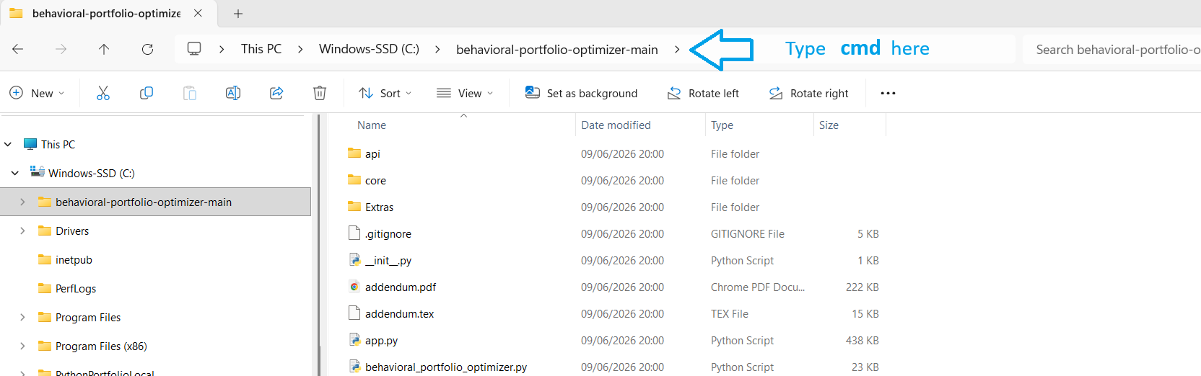

Command Prompt open inside the project folder
Step 3 Install the dependencies (first time only)
This downloads the libraries the app needs — about 1–2 minutes. You only do it once.
python -m pip install -r requirements.txt
Step 4 Run the app
Launch it — your browser opens automatically at http://localhost:8501. If it doesn’t, copy that address into your browser.
python -m streamlit run app.py

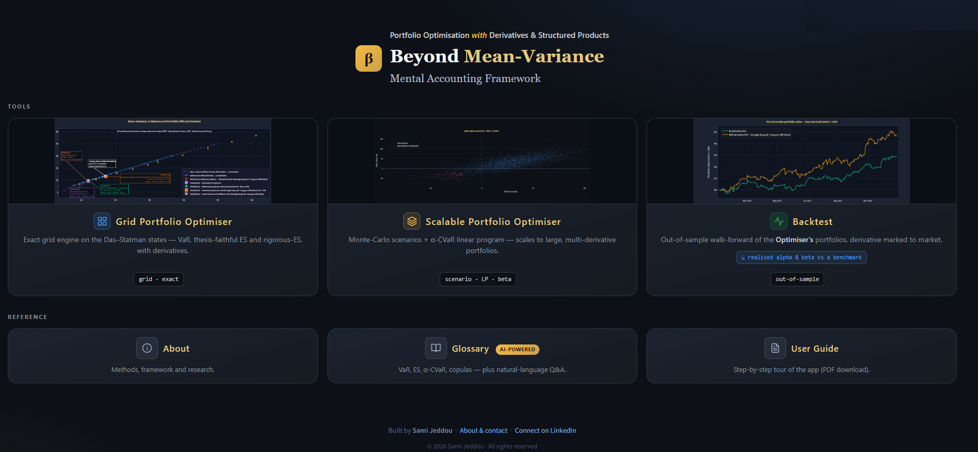

The optimiser running in your browser at localhost:8501
Everyday use Stop & restart
Stop the app with Ctrl + C in the Command Prompt. To run it again another day, just repeat Step 2 and Step 4 — the install in Step 3 is one-time.

Tips & troubleshooting
- Use python -m pip and python -m streamlit (not bare pip / streamlit) to avoid PATH issues.
- If python isn’t recognised, try py instead, or reinstall Python with “Add to PATH” ticked.
- Don’t refresh the browser mid-computation — let a run finish.
- Use Standard resolution for speed; High / Turbo for final precision.
- Everything runs on your machine: full speed, no cloud sleep or timeouts.
macOS / Linux
Same steps — open Terminal in the folder and use python3 instead of python:
python3 -m pip install -r requirements.txt

python3 -m streamlit run app.py

