# Collision detection and response algorithms

## Introduction

Collision detection algorithms seek to calculate when, where and how moving objects come into contact with each other. Collision response algorithms seek to resolve these detected collisions according to the laws of physics. Ericson (2005) identifies and discusses a variety of fields where collision detection and response algorithms are utilised, including computer games, physical / engineering simulations and robotics.

Collision detection and response algorithms are used in computer games in order to maintain the illusion that the world is composed of objects which interact with each other according to the laws of physics. Without collision detection, it would not be possible to build realistic environments, since objects would freely pass through each other whenever they come into contact.

In a similar manner, collision detection and response algorithms are used in simulations of physical events, or simulations in engineering. Here, they are used to model interactions between objects with greater realism than in computer games. For example, they might be used to simulate the deformation of a car upon crashing into a solid object such as a wall. In robotics, collision detection and resolution are used for finding suitable pathspredicting and avoiding real-world collisions,

These different fields tend to have different performance requirements for a collision detection and response algorithm (Ericson, 2005). In the case of computer games, performance takes priority over precision since collisions must be resolved in real time. So long as performance is adequate, and there are no noticeable visual flaws in the implementation, this is sufficient. Physical / engineering simulations are not calculated in real time, and are more likely to require completely realistic results. As such, precision would be more important than performance.

In robotics, both performance and precision are likely to be important. It may be possible to pre-calculate potential collisions where a robot’s field of movement is restricted i.e. on a factory line. However, if the robot must dynamically calculate a path, then it will need to predict and resolve collisions in real time.

*Excellent introduction, >10 relevant references quoted and reflected upon demonstrating a critical understanding of the concepts associated with applying and implementing a*

*collision detection algorithms*

## Code listing

### coreMath.h

#include <math.h>

/**

* @file

*

* The core contains utility functions, helpers and a basic set of

* mathematical types.

*/

#ifndef CORE_MATH

#define CORE_MATH

class Vector2

{

public:

/** Holds the value along the x axis. */

float x;

/** Holds the value along the y axis. */

float y;

public:

/** The default constructor creates a zero vector. */

Vector2() : x(0), y(0) {}

/**

* The explicit constructor creates a vector with the given

* components.

*/

Vector2(const float x, const float y)

: x(x), y(y) {}

const static Vector2 GRAVITY;

const static Vector2 UP;

float operator[](unsigned i) const

{

if (i == 0) return x;

return y;

}

float& operator[](unsigned i)

{

if (i == 0) return x;

return y;

}

/** Adds the given vector to this. */

void operator+=(const Vector2& v)

{

x += v.x;

y += v.y;

}

/**

* Returns the value of the given vector added to this.

*/

Vector2 operator+(const Vector2& v) const

{

return Vector2(x + v.x, y + v.y);

}

/** Subtracts the given vector from this. */

void operator-=(const Vector2& v)

{

x -= v.x;

y -= v.y;

}

/**

* Returns the value of the given vector subtracted from this.

*/

Vector2 operator-(const Vector2& v) const

{

return Vector2(x - v.x, y - v.y);

}

/** Multiplies this vector by the given scalar. */

void operator*=(const float value)

{

x *= value;

y *= value;

}

/** Returns a copy of this vector scaled the given value. */

Vector2 operator*(const float value) const

{

return Vector2(x*value, y*value);

}

/*

* Multiplies each component of the vector by the inverse of the value

* and returns the result

*/

Vector2 operator/(const float value) const

{

return Vector2(x*(1.0f / value), y*(1.0f / value));

}

/**

* Calculates and returns a component-wise product of this

* vector with the given vector.

*/

Vector2 componentProduct(const Vector2 &vector) const

{

return Vector2(x * vector.x, y * vector.y);

}

/**

* Performs a component-wise product with the given vector and

* sets this vector to its result.

*/

void componentProductUpdate(const Vector2 &vector)

{

x *= vector.x;

y *= vector.y;

}

/**

* Calculates and returns the scalar product of this vector

* with the given vector.

*/

float scalarProduct(const Vector2 &vector) const

{

return x*vector.x + y*vector.y;

}

/**

* Calculates and returns the scalar product of this vector

* with the given vector.

*/

float operator *(const Vector2 &vector) const

{

return x*vector.x + y*vector.y;

}

/**

* Adds the given vector to this, scaled by the given amount.

*/

void addScaledVector(const Vector2& vector, float scale)

{

x += vector.x * scale;

y += vector.y * scale;

}

/** Gets the magnitude of this vector. */

float magnitude() const

{

return sqrt(x*x + y*y);

}

/** Gets the squared magnitude of this vector. */

float squareMagnitude() const

{

return x*x + y*y;

}

/** Limits the size of the vector to the given maximum. */

void trim(float size)

{

if (squareMagnitude() > size*size)

{

normalise();

x *= size;

y *= size;

}

}

/** Turns a non-zero vector into a vector of unit length. */

void normalise()

{

float l = magnitude();

if (l > 0)

{

(*this) *= ((float)1) / l;

}

}

/** Returns the normalised version of a vector. */

Vector2 unit() const

{

Vector2 result = *this;

result.normalise();

return result;

}

/** Checks if the two vectors have identical components. */

bool operator==(const Vector2& other) const

{

return x == other.x &&

y == other.y;

}

/** Checks if the two vectors have non-identical components. */

bool operator!=(const Vector2& other) const

{

return !(*this == other);

}

/**

* Checks if this vector is component-by-component less than

* the other.

*

* @note This does not behave like a single-value comparison:

* !(a < b) does not imply (b >= a).

*/

bool operator<(const Vector2& other) const

{

return x < other.x && y < other.y;

}

/**

* Checks if this vector is component-by-component less than

* the other.

*

* @note This does not behave like a single-value comparison:

* !(a < b) does not imply (b >= a).

*/

bool operator>(const Vector2& other) const

{

return x > other.x && y > other.y;

}

/**

* Checks if this vector is component-by-component less than

* the other.

*

* @note This does not behave like a single-value comparison:

* !(a <= b) does not imply (b > a).

*/

bool operator<=(const Vector2& other) const

{

return x <= other.x && y <= other.y;

}

/**

* Checks if this vector is component-by-component less than

* the other.

*

* @note This does not behave like a single-value comparison:

* !(a <= b) does not imply (b > a).

*/

bool operator>=(const Vector2& other) const

{

return x >= other.x && y >= other.y;

}

/** Zero all the components of the vector. */

void clear()

{

x = y = 0;

}

/** Flips all the components of the vector. */

void invert()

{

x = -x;

y = -y;

}

};

#endif // CORE_H

### app.h

class Application

{

protected:

int height;

int width;

float nRange;

float timeinterval;

public:

virtual void initGraphics();

virtual void display();

virtual void update();

virtual void resize(int width, int height);

int getheight();

int getwidth();

float getTimeinterval();

void setTimeinterval(float timeint);

};

### app.cpp

#include <gl/glut.h>

#include "app.h"

int Application::getwidth()

{

return width;

}

int Application::getheight()

{

return height;

}

float Application::getTimeinterval()

{

return timeinterval;

}

void Application::setTimeinterval(float timeinterval)

{

Application::timeinterval = timeinterval;

}

void Application::initGraphics()

{

glClearColor(0.0f, 0.0f, 0.0f, 1.0f);

}

void Application::display()

{

glClear(GL_COLOR_BUFFER_BIT | GL_DEPTH_BUFFER_BIT);

glMatrixMode(GL_MODELVIEW);

glLoadIdentity();

}

void Application::update()

{

glutPostRedisplay();

}

void Application::resize(int width, int height)

{

//nRange = 100.0f;

GLfloat aspectRatio = (GLfloat)width / (GLfloat)height;

// Prevent a divide by zero

if (height == 0) height = 1;

// Set Viewport to window dimensions

glViewport(0, 0, width, height);

// Reset coordinate system

glMatrixMode(GL_PROJECTION);

glLoadIdentity();

//Establish clipping volume (left, right, bottom, top, near, far)

if (width <= height)

{

Application::width = nRange;

Application::height = nRange / aspectRatio;

glOrtho(-nRange, nRange, -nRange / aspectRatio, nRange / aspectRatio, -nRange*2.0f, nRange*2.0f);

}

else

{

Application::width = nRange*aspectRatio;

Application::height = nRange;

glOrtho(-nRange*aspectRatio, nRange*aspectRatio, -nRange, nRange, -nRange*2.0f, nRange*2.0f);

}

// Reset the modelview matrix

glMatrixMode(GL_MODELVIEW);

glLoadIdentity();

}

### particle.h

/**

* A particle is the simplest object that can be simulated in the

* physics system.

*/

#ifndef PARTICLE_H

#define PARTICLE_H

#include "coreMath.h"

#include <vector>

class Particle

{

protected:

float inverseMass;

float radius;

//True if particle is a sphere, false if it is a convex polygon

bool sphere = true;

//Stores vertices, width and height of the particle (unless it is a sphere, in which case no vertices are stored)

std::vector<Vector2> vertices;

float width;

float height;

Vector2 position;

Vector2 velocity;

Vector2 forceAccum;

Vector2 acceleration;

public:

void integrate(float duration);

void setMass(const float mass);

float getMass() const;

void setInverseMass(const float inverseMass);

float getInverseMass() const;

bool hasFiniteMass() const;

//Allows vertices of shape to be set and retrieved.

//Particle defaults to sphere shape, but the user can set vertices to create a convex polygon instead

void setVertices(std::vector<Vector2>& vertices);

std::vector<Vector2>& getVertices();

//Allows shape's width and height to be set and retrieved

void setWidthAndHeight(float w, float h);

float getWidth();

float getHeight();

//Tells caller whether this particle is a sphere or not

bool isSphere();

void setPosition(const float x, const float y);

void setPosition(const Vector2 &position);

Vector2 getPosition() const;

void getPosition(Vector2 *position) const;

void setRadius(const float r);

float getRadius() const;

void setVelocity(const Vector2 &velocity);

void setVelocity(const float x, const float y);

Vector2 getVelocity() const;

void getVelocity(Vector2 *velocity) const;

void setAcceleration(const Vector2 &acceleration);

void setAcceleration(const float x, const float y);

Vector2 getAcceleration() const;

void clearAccumulator();

void addForce(const Vector2 &force);

};

#endif

### particle.cpp

#include "particle.h"

#include <math.h>

#include <assert.h>

#include <float.h>

void Particle::integrate(float duration)

{

// We don't integrate things with zero mass.

if (inverseMass <= 0.0f)

return;

assert(duration > 0.0);

position.addScaledVector(velocity, duration);

// Work out the acceleration from the force

Vector2 resultingAcc = acceleration;

resultingAcc.addScaledVector(forceAccum, inverseMass);

// Update linear velocity from the acceleration.

velocity.addScaledVector(resultingAcc, duration);

//velocity *= pow(0.9f, duration);

//velocity *= 0.95;

// Clear the forces.

clearAccumulator();

}

//Set particle to be a different shape (instead of the default sphere shape).

//Takes a reference to a vector containing the desired vertices

void Particle::setVertices(std::vector<Vector2>& vertices)

{

sphere = false;

Particle::vertices.resize(vertices.size());

for (int i = 0; i < vertices.size(); i++)

{

Particle::vertices[i].x = vertices[i].x;

Particle::vertices[i].y = vertices[i].y;

}

}

//Returns the vertices of the shape

//If shape is a sphere, an empty vector will be returned

std::vector<Vector2>& Particle::getVertices()

{

if (!sphere)

return vertices;

else

return std::vector<Vector2>();

}

void Particle::setWidthAndHeight(float w, float h)

{

width = w;

height = h;

}

float Particle::getWidth()

{

return width;

}

float Particle::getHeight()

{

return height;

}

//Tells the caller if the shape is a sphere or not

bool Particle::isSphere()

{

return sphere;

}

void Particle::setMass(const float mass)

{

assert(mass != 0);

Particle::inverseMass = ((float)1.0) / mass;

}

float Particle::getMass() const

{

if (inverseMass == 0) {

return DBL_MAX;

}

else {

return ((float)1.0) / inverseMass;

}

}

void Particle::setInverseMass(const float inverseMass)

{

Particle::inverseMass = inverseMass;

}

float Particle::getInverseMass() const

{

return inverseMass;

}

bool Particle::hasFiniteMass() const

{

return inverseMass >= 0.0f;

}

void Particle::setPosition(const float x, const float y)

{

position.x = x;

position.y = y;

}

void Particle::setPosition(const Vector2 &position)

{

Particle::position = position;

}

Vector2 Particle::getPosition() const

{

return position;

}

void Particle::getPosition(Vector2 *position) const

{

*position = Particle::position;

}

void Particle::setRadius(const float r)

{

radius = r;

}

float Particle::getRadius() const

{

return radius;

}

void Particle::setVelocity(const float x, const float y)

{

velocity.x = x;

velocity.y = y;

}

void Particle::setVelocity(const Vector2 &velocity)

{

Particle::velocity = velocity;

}

Vector2 Particle::getVelocity() const

{

return velocity;

}

void Particle::getVelocity(Vector2 *velocity) const

{

*velocity = Particle::velocity;

}

void Particle::setAcceleration(const Vector2 &acceleration)

{

Particle::acceleration = acceleration;

}

void Particle::setAcceleration(const float x, const float y)

{

acceleration.x = x;

acceleration.y = y;

}

Vector2 Particle::getAcceleration() const

{

return acceleration;

}

void Particle::clearAccumulator()

{

forceAccum.clear();

}

void Particle::addForce(const Vector2 &force)

{

forceAccum += force;

}

### ParticleCollision.h

#pragma once

#include "pcontacts.h"

#include "particle.h"

#include <vector>

using namespace std;

class ParticleCollision : public ParticleContactGenerator

{

private:

//Total number of particles in array

const int NUM_PARTICLES;

//Pointer to the first element of the particle array (saves passing in an entire array to ParticleCollision object)

Particle* particles;

//Default restitution value

float restitution = 0.9;

//Far borders of the convex polygon created by the Minkowski difference.

//Recalculated for every collision where at least one particle is not a circle.

vector<Vector2> MDVertices;

public:

//When instantiating particle collision object, tell it how many other particles there are to collide with

//and give it a pointer to first particle in the array.

ParticleCollision(int numParticles, Particle* arrayPtr);

void setRestitution(float restitution) { this->restitution = restitution; }

//Add all of the particle's current contact data to the relevant ParticleContact objects

unsigned addContact(ParticleContact *contact, unsigned limit);

//Determine if one particle and another are touching

bool checkCollision(Particle& particle1, Particle& particle2, float distance);

//Calculate vertices for Minkowski difference of two particles and return it as a vector of Vector2 objects

vector<Vector2> calcMinkowskiDifferenceVertices(Particle& particle1, Particle& particle2);

//Calculates 8 of a sphere particle's vertices (this gives an imperfect representation of the shape, but

//is close enough for our purposes)

vector<Vector2> estimateSphereVertices(Particle& particle) const;

//Determines whether the origin lies within the bounds of the calculated Minkowski difference

bool polygonContainsOrigin(vector<Vector2>& vertices);

};

### ParticleCollision.cpp

#include "pcontacts.h"

#include "ParticleCollision.h"

#include <gl/glut.h>

using namespace std;

ParticleCollision::ParticleCollision(int numParticles, Particle* arrayPtr) : NUM_PARTICLES(numParticles)

{

particles = arrayPtr;

}

unsigned ParticleCollision::addContact(ParticleContact *contact, unsigned limit)

{

//const static float restitution = 1.0f;

unsigned used = 0;

for (int i = 0; i < NUM_PARTICLES; i++)

{

Vector2 pos1 = particles[i].getPosition();

float radius1 = particles[i].getRadius();

Vector2 velocity1 = particles[i].getVelocity();

float mass1 = particles[i].getMass();

for (int j = 0; j < NUM_PARTICLES; j++)

{

//Particle cannot collide with itself

if (i == j)

continue;

Vector2 pos2 = (particles[j]).getPosition();

Vector2 velocity2 = (particles[j]).getVelocity();

float radius2 = (particles[j]).getRadius();

float mass2 = (particles[j]).getMass();

//Distance from sphere 2 to sphere 1

Vector2 sphereDistanceVec = pos1 - pos2;

float distance = sphereDistanceVec.magnitude();

if (checkCollision(particles[i], particles[j], distance))

{

// We have a collision

contact->contactNormal = sphereDistanceVec.unit();

contact->restitution = restitution;

contact->particle[0] = &particles[i];

contact->particle[1] = &particles[j];

if (particles[i].isSphere() && particles[j].isSphere())

contact->penetration = (radius1 + radius2) - distance;

else if (!particles[i].isSphere() || !particles[j].isSphere())

{

Vector2 closestPoint = MDVertices[0];

float interPenetrationDist = 100;

//Find closest point of Minkowski difference to origin and calculate inter-penetration from it

for (int i = 1; i < MDVertices.size(); i++)

{

float temp = (Vector2(0, 0) - MDVertices[i]).magnitude();

if (temp < interPenetrationDist)

interPenetrationDist = temp;

}

contact->penetration = interPenetrationDist;

}

used++;

contact++;

}

}

}

return used;

}

bool ParticleCollision::checkCollision(Particle& particle1, Particle& particle2, float distance)

{

//Simple check for collision between two spheres

if (particle1.isSphere() && particle2.isSphere())

{

//If length of sphereDistanceVec <= (radius1 + radius2), then spheres have collided or inter-penetrated

if (distance <= particle1.getRadius() + particle2.getRadius())

return true;

else

return false;

}

//One of the shapes is a convex polygon, so check for collision using Minkowski difference

else

{

//Calculate vertices of Minkowski difference between two particles

MDVertices = calcMinkowskiDifferenceVertices(particle1, particle2);

//Check if Minkowski difference contains the origin or not

bool collision = polygonContainsOrigin(MDVertices);

return collision;

}

}

/*

Code used in this function to detect whether the Minkowski difference contains origin is based on

code written by W Randolph Franklin. See https://wrf.ecse.rpi.edu//Research/Short_Notes/pnpoly.html.

Method is based on projecting a ray through the polygon from the origin and working out

whether it is inside or outside the polygon by the number of edges it intersects.

*/

bool ParticleCollision::polygonContainsOrigin(vector<Vector2>& vertices)

{

bool collision = false;

for (int i = 0, j = vertices.size() - 1; i < vertices.size(); j = i++)

{

if (((vertices[i].y>0) != (vertices[j].y>0)) &&

(0 < (vertices[j].x - vertices[i].x) * (0 - vertices[i].y) / (vertices[j].y - vertices[i].y) + vertices[i].x))

collision = !collision;

}

return collision;

}

vector<Vector2> ParticleCollision::calcMinkowskiDifferenceVertices(Particle& particle1, Particle& particle2)

{

vector<Vector2> particle1Vertices;

vector<Vector2> particle2Vertices;

vector<Vector2> minkowskiDiffVertices;

//Populate particle1Vertices vector. If particle1 == sphere, estimate vertices. Else, retrieve particle1's stored vertices

if (particle1.isSphere())

particle1Vertices = estimateSphereVertices(particle1);

else

particle1Vertices = particle1.getVertices();

//Populate particle2Vertices vector. If particle2 == sphere, estimate vertices. Else, retrieve particle2's stored vertices

if (particle2.isSphere())

particle2Vertices = estimateSphereVertices(particle2);

else

particle2Vertices = particle2.getVertices();

//Populate vector of Minkowski difference vertices with particle 1 vertices - particle 2 vertices

for (int i = 0; i < particle1Vertices.size(); i++)

for (int j = 0; j < particle2Vertices.size(); j++)

minkowskiDiffVertices.push_back((particle1Vertices[i] + particle1.getPosition()) - (particle2Vertices[j] + particle2.getPosition()));

return minkowskiDiffVertices;

}

//calculate 8 of the vertices of a sphere particle (cannot calculate all, since a circle has infinite vertices)

vector<Vector2> ParticleCollision::estimateSphereVertices(Particle& particle) const

{

vector<Vector2> vertices;

float radius = particle.getRadius();

vertices.push_back(Vector2(-radius, 0));

vertices.push_back(Vector2(radius, 0));

vertices.push_back(Vector2(0, -radius));

vertices.push_back(Vector2(0, -radius));

vertices.push_back(Vector2(1, 1).unit() * radius);

vertices.push_back(Vector2(-1, 1).unit() * radius);

vertices.push_back(Vector2(-1, -1).unit() * radius);

vertices.push_back(Vector2(1, -1).unit() * radius);

return vertices;

}

### pcontacts.h

/*

* Interface file for the contact resolution system for particles.

*

*/

#ifndef PCONTACTS_H

#define PCONTACTS_H

#include "particle.h"

class ParticleContactResolver;

/**

* A Contact represents two objects in contact (in this case

* ParticleContact representing two Particles).

*/

class ParticleContact

{

/**

* The contact resolver object needs access into the contacts to

* set and effect the contact.

*/

friend ParticleContactResolver;

public:

/**

* Holds the particles that are involved in the contact. The

* second of these can be NULL, for contacts with the scenery.

*/

Particle* particle[2];

/**

* Holds the normal restitution coefficient at the contact.

*/

float restitution;

/**

* Holds the direction of the contact in world coordinates.

*/

Vector2 contactNormal;

/**

* Holds the depth of penetration at the contact.

*/

float penetration;

protected:

/**

* Resolves this contact, for both velocity and interpenetration.

*/

void resolve(float duration);

/**

* Calculates the separating velocity at this contact.

*/

float calculateSeparatingVelocity() const;

private:

/**

* Handles the impulse calculations for this collision.

*/

void resolveVelocity(float duration);

};

/**

* The contact resolution routine for particle contacts. One

* resolver instance can be shared for the whole simulation.

*/

class ParticleContactResolver

{

protected:

/**

* Holds the number of iterations allowed.

*/

unsigned iterations;

/**

* This is a performance tracking value - we keep a record

* of the actual number of iterations used.

*/

unsigned iterationsUsed;

public:

/**

* Creates a new contact resolver.

*/

ParticleContactResolver(unsigned iterations);

/**

* Sets the number of iterations that can be used.

*/

void setIterations(unsigned iterations);

/**

* Resolves a set of particle contacts for both penetration

* and velocity.

*

*/

void resolveContacts(ParticleContact *contactArray,

unsigned numContacts,

float duration);

};

/**

* This is the basic polymorphic interface for contact generators

* applying to particles.

*/

class ParticleContactGenerator

{

public:

/**

* Fills the given contact structure with the generated

* contact.

*/

virtual unsigned addContact(ParticleContact *contact,

unsigned limit) = 0;

};

#endif // CONTACTS_H

### pcontacts.cpp

#include <float.h>

#include <pcontacts.h>

// Contact implementation

void ParticleContact::resolve(float duration)

{

resolveVelocity(duration);

}

float ParticleContact::calculateSeparatingVelocity() const

{

Vector2 relativeVelocity = particle[0]->getVelocity();

if (particle[1]) relativeVelocity -= particle[1]->getVelocity();

return relativeVelocity * contactNormal;

}

void ParticleContact::resolveVelocity(float duration)

{

// Find the velocity in the direction of the contact

float separatingVelocity = calculateSeparatingVelocity();

// Check if it needs to be resolved

if (separatingVelocity > 0.05)

{

// The contact is either separating, or stationary - there's

// no impulse required.

return;

}

// Calculate the new separating velocity

float newSepVelocity = -separatingVelocity * restitution;

float deltaVelocity = newSepVelocity - separatingVelocity;

// We apply the change in velocity to each object in proportion to

// their inverse mass (i.e. those with lower inverse mass [higher

// actual mass] get less change in velocity)..

float totalInverseMass = particle[0]->getInverseMass();

if (particle[1]) totalInverseMass += particle[1]->getInverseMass();

// If all particles have infinite mass, then impulses have no effect

if (totalInverseMass <= 0) return;

// Calculate the impulse to apply

float impulse = deltaVelocity / totalInverseMass;

// Find the amount of impulse per unit of inverse mass

Vector2 impulsePerIMass = contactNormal * impulse;

// Apply impulses: they are applied in the direction of the contact,

// and are proportional to the inverse mass.

particle[0]->setVelocity(particle[0]->getVelocity() +

impulsePerIMass * particle[0]->getInverseMass()

);

if (particle[1])

{

// Particle 1 goes in the opposite direction

particle[1]->setVelocity(particle[1]->getVelocity() +

impulsePerIMass * -particle[1]->getInverseMass()

);

}

//resolve inter-penetration by moving two spheres apart from each other by the distance they have inter-penetrated

if (particle[0] && particle[1])

{

if (penetration > 0)

{

Vector2 interpenetrationVec = particle[0]->getPosition() - particle[1]->getPosition();

interpenetrationVec.normalise();

interpenetrationVec *= penetration;

particle[0]->setPosition(particle[0]->getPosition() + interpenetrationVec * 0.5);

particle[1]->setPosition(particle[1]->getPosition() - interpenetrationVec * 0.5);

}

}

//resolve inter-penetration

}

ParticleContactResolver::ParticleContactResolver(unsigned iterations)

:

iterations(iterations)

{

}

void ParticleContactResolver::setIterations(unsigned iterations)

{

ParticleContactResolver::iterations = iterations;

}

void ParticleContactResolver::resolveContacts(ParticleContact *contactArray,

unsigned numContacts,

float duration)

{

unsigned i;

iterationsUsed = 0;

while (iterationsUsed < iterations)

{

// Find the contact with the largest closing velocity;

float max = DBL_MAX;

unsigned maxIndex = numContacts;

for (i = 0; i < numContacts; i++)

{

float sepVel = contactArray[i].calculateSeparatingVelocity();

if (sepVel < max && (sepVel < 0 || contactArray[i].penetration > 0))

{

max = sepVel;

maxIndex = i;

}

}

//Do we have anything worth resolving?

if (maxIndex == numContacts) break;

// Resolve this contact

contactArray[maxIndex].resolve(duration);

iterationsUsed++;

}

}

### pworld.h

/*

* Interface file for the particle

*

*/

#ifndef PWORLD_H

#define PWORLD_H

#include <vector>

#include "pcontacts.h"

class ParticleWorld

{

public:

typedef std::vector<Particle*> Particles;

typedef std::vector<ParticleContactGenerator*> ContactGenerators;

protected:

/**

* Holds the particles

*/

Particles particles;

/**

* True if the world should calculate the number of iterations

* to give the contact resolver at each frame.

*/

bool calculateIterations;

/**

* Holds the resolver for contacts.

*/

ParticleContactResolver resolver;

/**

* Contact generators.

*/

ContactGenerators platformContactGenerators;

ContactGenerators particleContactGenerator;

/**

* Holds the list of contacts.

*/

ParticleContact *contacts;

/**

* Holds the maximum number of contacts allowed (i.e. the

* size of the contacts array).

*/

unsigned maxContacts;

public:

/**

* Creates a new particle simulator that can handle up to the

* given number of contacts per frame.

*/

ParticleWorld(unsigned maxContacts, unsigned iterations = 0);

/**

* Deletes the simulator.

*/

~ParticleWorld();

/**

* Calls each of the registered contact generators to report

* their contacts. Returns the number of generated contacts.

*/

unsigned generateContacts();

/**

* Integrates all the particles in this world forward in time

* by the given duration.

*/

void integrate(float duration);

/**

* Processes all the physics for the particle world.

*/

void runPhysics(float duration);

/**

* Returns the list of particles.

*/

Particles& getParticles();

/**

* Returns the list of contact generators.

*/

ContactGenerators& getPlatformContactGenerators();

ContactGenerators& getParticleContactGenerator();

};

#endif // PWORLD_H

### pworld.cpp

#include <cstdlib>

#include <pworld.h>

ParticleWorld::ParticleWorld(unsigned maxContacts, unsigned iterations)

:

resolver(iterations),

maxContacts(maxContacts)

{

contacts = new ParticleContact[maxContacts];

calculateIterations = (iterations == 0);

}

ParticleWorld::~ParticleWorld()

{

delete[] contacts;

}

unsigned ParticleWorld::generateContacts()

{

int limit = maxContacts;

ParticleContact *nextContact = contacts;

//generate contacts for particles

unsigned used = particleContactGenerator[0]->addContact(nextContact, limit);

limit -= used;

nextContact += used;

//If the max number of contacts has been exceeded, do not attempt to generate contacts for platforms,

//and return the number of contacts used (all of them)

if (limit <= 0)

return maxContacts;

//generate contacts for platforms

for (ContactGenerators::iterator g = platformContactGenerators.begin(); g != platformContactGenerators.end(); g++)

{

used = (*g)->addContact(nextContact, limit);

limit -= used;

nextContact += used;

// We've run out of contacts to fill. This means we're missing

// contacts.

if (limit <= 0)

break;

}

// Return the number of contacts used.

return maxContacts - limit;

}

void ParticleWorld::integrate(float duration)

{

for (Particles::iterator p = particles.begin(); p != particles.end(); p++)

{

// Remove all forces from the accumulator

(*p)->integrate(duration);

}

}

void ParticleWorld::runPhysics(float duration)

{

//Apply drag force to every particle

for (Particles::iterator p = particles.begin(); p != particles.end(); p++)

{

float radius = (*p)->getRadius();

Vector2 velocity = (*p)->getVelocity();

float magnitude = velocity.magnitude();

float k2 = 0.1 * radius * radius;

float dragCoeff = k2 * magnitude * magnitude;

Vector2 dragForce = velocity;

dragForce *= -dragCoeff;

dragForce.normalise();

dragForce *= 50; //normalised drag force is too small to produce much effect, so scale it up

(*p)->addForce(dragForce);

}

// Then integrate the objects

integrate(duration);

// Generate contacts

unsigned usedContacts = generateContacts();

// And process them

if (usedContacts)

{

if (calculateIterations) resolver.setIterations(usedContacts * 2);

resolver.resolveContacts(contacts, usedContacts, duration);

}

}

ParticleWorld::Particles& ParticleWorld::getParticles()

{

return particles;

}

ParticleWorld::ContactGenerators& ParticleWorld::getPlatformContactGenerators()

{

return platformContactGenerators;

}

ParticleWorld::ContactGenerators& ParticleWorld::getParticleContactGenerator()

{

return particleContactGenerator;

}

### BlobDemo.cpp

/*

* The Blob demo.

*

*/

#include <gl/glut.h>

#include "app.h"

#include "coreMath.h"

#include "pcontacts.h"

#include "pworld.h"

#include <stdio.h>

#include <cassert>

#include "ParticleCollision.h"

#include <iostream>

#include <vector>

using namespace std;

const Vector2 Vector2::GRAVITY = Vector2(0, -9.81);

const int NUM_SPHERES = 10; //Number of spheres in simulation

const int NUM_QUADS = 1; //Number of quads in simulation (these will all be placed after spheres in the particle array)

const int NUM_TRIANGLES = 1; //Number of triangles in simulation (these will all be placed after quads in the particle array)

const int NUM_PARTICLES = NUM_SPHERES + NUM_QUADS + NUM_TRIANGLES; //Total number of particles of all kinds in simulation

const int NUM_PLATFORMS = 1;

const int BASE_SPHERE_RADIUS = 5; //Minimum radius of a sphere

const int BASE_SPHERE_MASS = 5; //Minimum mass of a sphere

/**

* Platforms are two dimensional: lines on which the

* particles can rest. Platforms are also contact generators for the physics.

*/

class Platform : public ParticleContactGenerator

{

public:

Vector2 start;

Vector2 end;

/**

* Holds a pointer to the particles we're checking for collisions with.

*/

Particle* particle[NUM_PARTICLES];

//default restitution value

float restitution = 0.8;

void setRestitution(float restitution) { this->restitution = restitution; }

virtual unsigned addContact(ParticleContact *contact, unsigned limit);

};

unsigned Platform::addContact(ParticleContact *contact, unsigned limit)

{

int used = 0;

for (int i = 0; i < NUM_PARTICLES; i++)

{

// Check for penetration

Vector2 toParticle = particle[i]->getPosition() - start;

Vector2 lineDirection = end - start;

float projected = toParticle * lineDirection;

float platformSqLength = lineDirection.squareMagnitude();

float squareRadius = particle[i]->getRadius()*particle[i]->getRadius();;

//Calculate whether non-sphere objects have made contact with platform

if (!particle[i]->isSphere())

{

Vector2 pos = particle[i]->getPosition();

vector<Vector2> vertices = particle[i]->getVertices();

//check if particle has an x-coordinate that allows it to touch the platform

if (pos.x + particle[i]->getWidth() / 2.0f > start.x && pos.x - particle[i]->getWidth() / 2.0f < end.x)

{

float slope = (end.y - start.y) / (end.x - start.x);

float yIntercept = end.y - slope * end.x;

float platformYVal = slope * pos.x + yIntercept;

float distanceToPlatform = toParticle.squareMagnitude() - projected*projected / platformSqLength;

//check if the particle is touching the line

if (pos.y - particle[i]->getHeight() / 2.0f <= platformYVal && pos.y + particle[i]->getHeight() / 2.0f >= platformYVal)

{

// We have a collision

Vector2 closestPoint = start + lineDirection*(projected / platformSqLength);

contact->contactNormal = (particle[i]->getPosition() - closestPoint).unit();

contact->restitution = restitution;

contact->particle[0] = particle[i];

contact->particle[1] = 0;

contact->penetration = particle[i]->getHeight() * 0.5f - (pos.y - platformYVal);//particle[i]->getRadius() - sqrt(distanceToPlatform);

used++;

contact++;

}

}

}

else if (projected <= 0)

{

// The blob is nearest to the start point

if (toParticle.squareMagnitude() < squareRadius)

{

// We have a collision

contact->contactNormal = toParticle.unit();

contact->restitution = restitution;

contact->particle[0] = particle[i];

contact->particle[1] = 0;

contact->penetration = particle[i]->getRadius() - toParticle.magnitude();

used++;

contact++;

}

}

else if (projected >= platformSqLength)

{

// The blob is nearest to the end point

toParticle = particle[0]->getPosition() - end;

if (toParticle.squareMagnitude() < squareRadius)

{

// We have a collision

contact->contactNormal = toParticle.unit();

contact->restitution = restitution;

contact->particle[0] = particle[i];

contact->particle[1] = 0;

contact->penetration = particle[i]->getRadius() - toParticle.magnitude();

used++;

contact++;

}

}

else

{

// the blob is nearest to the middle.

float distanceToPlatform = toParticle.squareMagnitude() - projected*projected / platformSqLength;

if (distanceToPlatform < squareRadius)

{

// We have a collision

Vector2 closestPoint = start + lineDirection*(projected / platformSqLength);

contact->contactNormal = (particle[i]->getPosition() - closestPoint).unit();

contact->restitution = restitution;

contact->particle[0] = particle[i];

contact->particle[1] = 0;

contact->penetration = particle[i]->getRadius() - sqrt(distanceToPlatform);

used++;

contact++;

}

}

}

return used;

}

class BlobDemo : public Application

{

Particle* blob;

ParticleCollision* particleCollision;

Platform* platform[NUM_PLATFORMS];

ParticleWorld world;

public:

/** Creates a new demo object. */

BlobDemo();

virtual ~BlobDemo();

/** Returns the window title for the demo. */

virtual const char* getTitle();

/** Display the particles. */

virtual void display();

/** Update the particle positions. */

virtual void update();

void BlobDemo::boxCollisionResolve(Particle* particle);

bool BlobDemo::outOfBoxTest(Particle* particle);

void BlobDemo::outOfBoxResolve(Particle* particle);

};

// Method definitions

BlobDemo::BlobDemo() : world((NUM_PARTICLES + NUM_PLATFORMS) * (NUM_PARTICLES + NUM_PLATFORMS - 1), 5)

{

width = 400; height = 400;

nRange = 100.0;

// Create the blob storage

blob = new Particle[NUM_PARTICLES];

//Create a new particle collision object, and tell it how many other particles there are to watch for collisions with.

//Also, give it a pointer to the array of particles, and a pointer to the specific particle it is associated with

particleCollision = new ParticleCollision(NUM_PARTICLES, blob);

// Create the platform

platform[0] = new Platform;

platform[0]->setRestitution(0.6);

platform[0]->start = Vector2(-50.0, 20.0);

platform[0]->end = Vector2(45.0, 15.0);

// Make sure the platform knows which particle it should collide with.

for (int i = 0; i < NUM_PLATFORMS; i++)

for (int j = 0; j < NUM_PARTICLES; j++)

platform[i]->particle[j] = blob + j;

//Add platforms to world object's vector of platform contact generators

for (int i = 0; i < NUM_PLATFORMS; i++)

world.getPlatformContactGenerators().push_back(platform[i]);

//Add particle collision object to world object's vector of particle contact generators

world.getParticleContactGenerator().push_back(particleCollision);

// Initialise sphere particles

for (int i = 0; i < NUM_SPHERES; i++)

{

(blob + i)->setPosition(i * 10, 80);

(blob + i)->setRadius(BASE_SPHERE_RADIUS + (i % 10));

(blob + i)->setMass(BASE_SPHERE_MASS + (i % 10));

(blob + i)->setVelocity(0, -1);

(blob + i)->setAcceleration(Vector2::GRAVITY * 20.0f);

(blob + i)->clearAccumulator();

world.getParticles().push_back(blob + i);

}

//Initialise quad particles

for (int i = NUM_SPHERES; i < NUM_SPHERES + NUM_QUADS; i++)

{

(blob + i)->setPosition(i * 10, 80);

(blob + i)->setRadius(20);

(blob + i)->setMass(20);

(blob + i)->setVelocity(0, -2);

(blob + i)->setAcceleration(Vector2::GRAVITY * 20.0f);

(blob + i)->clearAccumulator();

float radius = (blob + i)->getRadius();

//Set up vertices for non-sphere particles

vector<Vector2> vertices = {

Vector2(1, 1).unit() * radius,

Vector2(1, -1).unit() * radius,

Vector2(-1, -1).unit() * radius,

Vector2(-1, 1).unit() * radius

};

(blob + i)->setVertices(vertices);

float width = vertices[0].x - vertices[3].x;

float height = vertices[0].y - vertices[1].y;

(blob + i)->setWidthAndHeight(width, height);

world.getParticles().push_back(blob + i);

}

//Initialise triangle particles

for (int i = NUM_SPHERES + NUM_QUADS; i < NUM_PARTICLES; i++)

{

(blob + i)->setPosition(i * 10, 80);

(blob + i)->setRadius(20);

(blob + i)->setMass(15);

(blob + i)->setVelocity(0, -2);

(blob + i)->setAcceleration(Vector2::GRAVITY * 20.0f);

(blob + i)->clearAccumulator();

float radius = (blob + i)->getRadius();

//Set up vertices for non-sphere particles

vector<Vector2> vertices = {

Vector2(0, 1).unit() * radius,

Vector2(1.1, -0.9).unit() * radius,

Vector2(-1.1, -0.9).unit() * radius

};

(blob + i)->setVertices(vertices);

float width = vertices[1].x - vertices[2].x;

float height = vertices[0].y - vertices[1].y;

(blob + i)->setWidthAndHeight(width, height);

world.getParticles().push_back(blob + i);

}

}

BlobDemo::~BlobDemo()

{

// Release the blob storage

delete[] blob;

}

void BlobDemo::display()

{

Application::display();

//Render platforms

for (int i = 0; i < NUM_PLATFORMS; i++)

{

const Vector2 &p0 = platform[i]->start;

const Vector2 &p1 = platform[i]->end;

glBegin(GL_LINES);

glColor3f(0, 1, 1);

glVertex2f(p0.x, p0.y);

glVertex2f(p1.x, p1.y);

glEnd();

}

//Render platforms

//Render sphere particles

float r = 0.0, g = 0.0, b = 1;

for (int i = 0; i < NUM_SPHERES; i++, r += 0.1, g += 0.1)

{

if (r > 0.9 && g > 0.9)

r = g = 0;

glColor3f(r, g, b);

Vector2 &p = (blob + i)->getPosition();

glPushMatrix();

glTranslatef(p.x, p.y, 0);

glutSolidSphere((blob + i)->getRadius(), 12, 12);

glPopMatrix();

}

//Render sphere particles

//Render quads

r = 1, g = 0, b = 0;

for (int i = NUM_SPHERES; i < NUM_SPHERES + NUM_QUADS; i++, g += 0.2, b += 0.2)

{

vector<Vector2> vertices = (blob + i)->getVertices();

int numVertices = vertices.size();

Vector2 position = (blob + i)->getPosition();

glPushMatrix();

glTranslatef(position.x, position.y, 0);

if (g > 0.9 && b > 0.9)

g = b = 0;

glColor3f(r, g, b);

glBegin(GL_QUADS);

for (int i = 0; i < numVertices; i++)

glVertex2f(vertices[i].x, vertices[i].y);

glEnd();

glPopMatrix();

}

//Render quads

//Render triangles

r = 0, g = 1, b = 0;

for (int i = NUM_SPHERES + NUM_QUADS; i < NUM_PARTICLES; i++, r += 0.2, b += 0.2)

{

vector<Vector2> vertices = (blob + i)->getVertices();

int numVertices = vertices.size();

Vector2 position = (blob + i)->getPosition();

glPushMatrix();

glTranslatef(position.x, position.y, 0);

if (r > 0.9 && b > 0.9)

r = b = 0;

glColor3f(r, g, b);

glBegin(GL_TRIANGLES);

for (int i = 0; i < numVertices; i++)

glVertex2f(vertices[i].x, vertices[i].y);

glEnd();

glPopMatrix();

}

//Render triangles

glutSwapBuffers();

}

void BlobDemo::update()

{

// Recenter the axes

float duration = timeinterval / 1000;

// Run the simulation

world.runPhysics(duration);

//Boundary collision detection and resolution

for (int i = 0; i < NUM_PARTICLES; i++)

{

boxCollisionResolve(blob + i);

if (outOfBoxTest(blob + i))

outOfBoxResolve(blob + i);

}

Application::update();

}

// detect if the particle colided with the box and produce a response

void BlobDemo::boxCollisionResolve(Particle* particle)

{

Vector2 position = particle->getPosition();

Vector2 velocity = particle->getVelocity();

float radius = particle->getRadius();

float w = Application::width;

float h = Application::height;

if (particle->isSphere())

{

// Reverse direction when you reach left or right edge

if (position.x > w - radius || position.x < -w + radius)

particle->setVelocity(-velocity.x, velocity.y);

// Reverse direction when you reach top or bottom edge

if (position.y > h - radius || position.y < -h + radius)

particle->setVelocity(velocity.x, -velocity.y);

}

else

{

float particleWidth = particle->getWidth();

float particleHeight = particle->getHeight();

// Reverse direction when you reach left or right edge

if (position.x - 0.5f * particleWidth < -w || position.x + 0.5f * particleWidth > w)

particle->setVelocity(-velocity.x, velocity.y);

// Reverse direction when you reach top or bottom edge

if (position.y - 0.5f * particleHeight < -h || position.y + 0.5f * particleHeight > h)

particle->setVelocity(velocity.x, -velocity.y);

}

}

// Check bounds. This is in case the window is made

// smaller while the sphere is bouncing and the

// sphere suddenly finds itself outside the new

// clipping volume

bool BlobDemo::outOfBoxTest(Particle* particle)

{

Vector2 position = particle->getPosition();

Vector2 velocity = particle->getVelocity();

float radius = particle->getRadius();

if (particle->isSphere())

{

if ((position.x > Application::width - radius) || (position.x < -Application::width + radius)) return true;

if ((position.y > Application::height - radius) || (position.y < -Application::height + radius)) return true;

}

else

{

if (position.x - 0.5f * particle->getWidth() < -Application::width || position.x + 0.5f * particle->getWidth() > Application::width)

return true;

if (position.y - 0.5f * particle->getHeight() < -Application::height || position.y + 0.5f * particle->getHeight() > Application::height)

return true;

}

return false;

}

// Check bounds. This is in case the window is made

// smaller while the sphere is bouncing and the

// sphere suddenly finds itself outside the new

// clipping volume

void BlobDemo::outOfBoxResolve(Particle* particle)

{

Vector2 position = particle->getPosition();

Vector2 velocity = particle->getVelocity();

float radius = particle->getRadius();

if (particle->isSphere())

{

if (position.x > Application::width - radius) position.x = Application::width - radius;

else if (position.x < -Application::width + radius) position.x = -Application::width + radius;

if (position.y > Application::height - radius) position.y = Application::height - radius;

else if (position.y < -Application::height + radius) position.y = -Application::height + radius;

}

else

{

if (position.x - 0.5f * particle->getWidth() < -Application::width)

position.x = -Application::width + 0.5f * particle->getWidth();

else if (position.x + 0.5f * particle->getWidth() > Application::width)

position.x = Application::width - 0.5f * particle->getWidth();

if (position.y - 0.5f * particle->getHeight() < -Application::height)

position.y = -Application::height + 0.5f * particle->getHeight();

else if (position.y + 0.5f * particle->getHeight() > Application::height)

position.y = Application::height - 0.5f * particle->getHeight();

}

particle->setPosition(position.x, position.y);

}

const char* BlobDemo::getTitle()

{

return "Blob Demo";

}

/**

* Called by the common demo framework to create an application

* object (with new) and return a pointer.

*/

Application* getApplication()

{

return new BlobDemo();

}

### main.cpp

#include <gl/glut.h>

#include "app.h"

extern Application* getApplication();

Application* app;

void display(void)

{

app->display();

}

void createWindow(const char* title, int h, int w)

{

glutInitDisplayMode(GLUT_DOUBLE | GLUT_RGB | GLUT_DEPTH);

glutInitWindowSize(w, h);

glutCreateWindow(title);

}

void TimerFunc(int value)

{

app->update();

float timeinterval = app->getTimeinterval();

glutTimerFunc(timeinterval, TimerFunc, 1);

}

void resize(int width, int height)

{

app->resize(width, height);

}

int main(int argc, char* argv[])

{

glutInit(&argc, argv);

app = getApplication();

float timeinterval = 10;

app->setTimeinterval(timeinterval);

createWindow("Blob", app->getheight(), app->getwidth());

glutReshapeFunc(resize);

glutDisplayFunc(display);

glutTimerFunc(timeinterval, TimerFunc, 1);

app->initGraphics();

glutMainLoop();

delete app;

return 0;

}

## Design and implementation of collision detection and response algorithms

The UML class diagram for the collision detection and resolution program is shown above. The main() function is responsible for initialising GLUT, using it to set up OpenGL, and registering callback functions e.g. glutTimerFunc(), glutDisplayFunc(). The main() function also instantiates a BlobDemo object.

## Testing

In order to verify that the developed program works correctly, a variety of tests will be conducted. Each test will include a screenshot. Some tests will require “before and after” screenshots. The tests will include the following:

1. Test that spheres interact with platform correctly
2. Test that collision detection and resolution works with spheres
3. Test that drag force works (i.e. particles slow down and lose energy over time). Test that particles stay within the boundaries of the window
4. Increase number of spheres to observe effect
5. Test with different masses and radii (one small, light particle and one large, heavy one)
6. Test that collision detection and resolution works between spheres and boxes
7. Test that collision detection and resolution works between spheres and triangles
8. Test that collision detection and resolution works between boxes and triangles
9. Increase number of boxes and triangles to observe effect

### Test 1: Sphere interaction with platforms

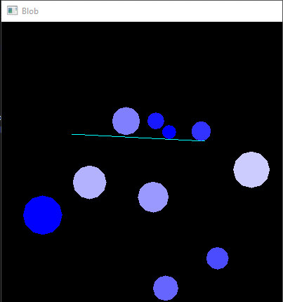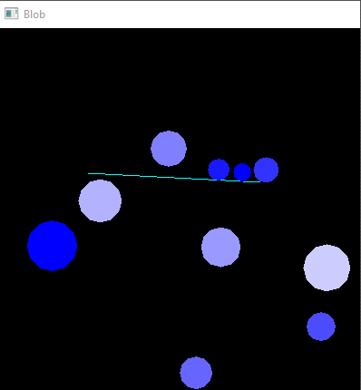

In these screenshots taken a moment apart, it can be seen that the sphere particles do not penetrate the platform. Instead, they bounce and roll off it, in the direction of the platform’s downwards slope.

### Test 2: Collision detection and resolution with spheres

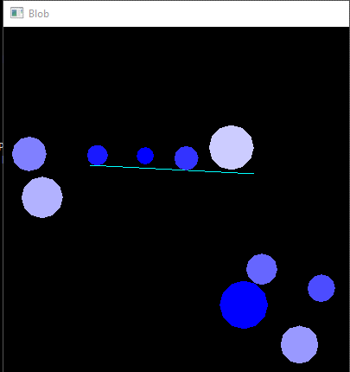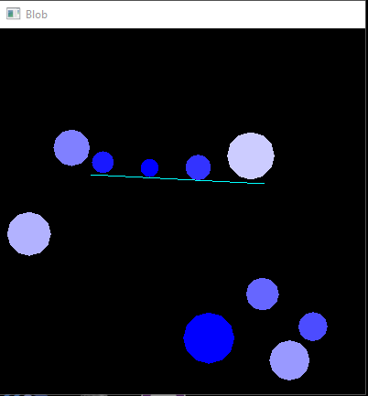

### Test 3: Test that drag force works. Test that particles stay within the boundaries of the window

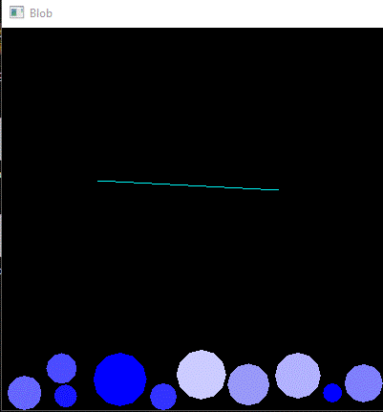

### Test 4: Increase number of spheres to observe effect

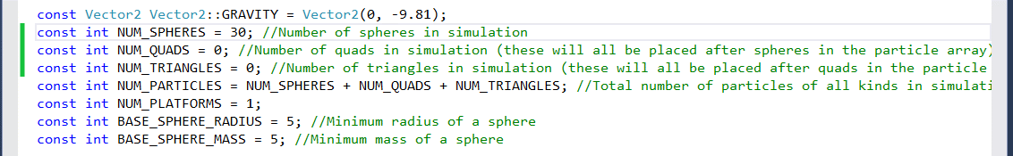

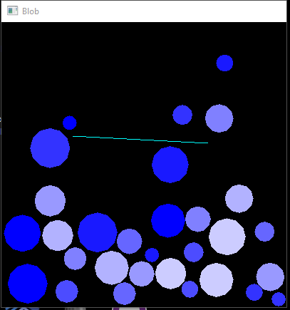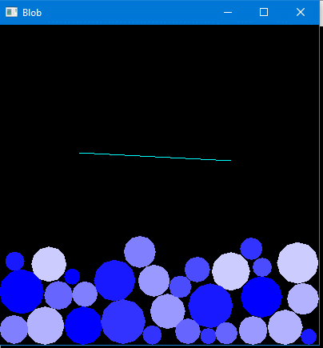

### Test 5: Test with different masses and radii (one small, light particle and one large, heavy one)

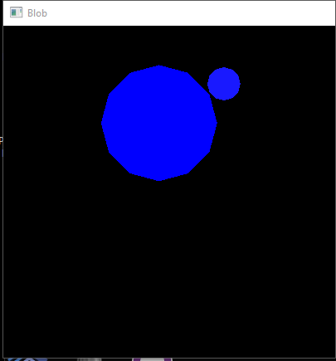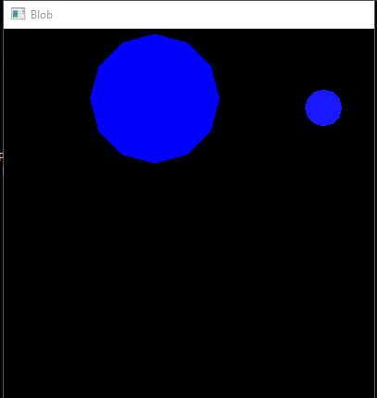

### Test 6: Test that collision detection and resolution works between spheres and boxes

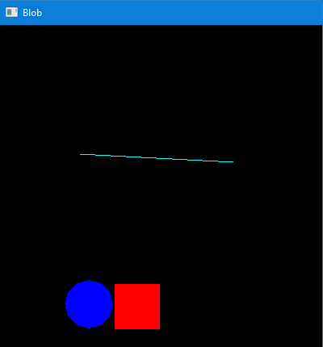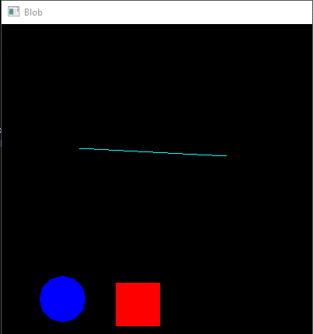

### Test 7: Test that collision detection and resolution works between spheres and triangles

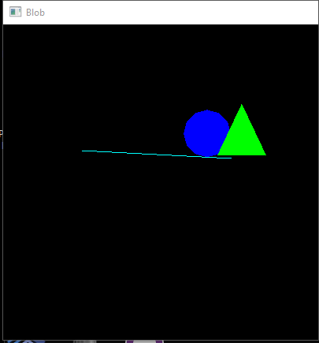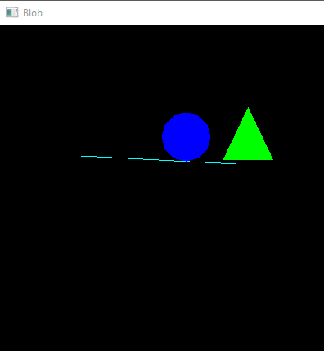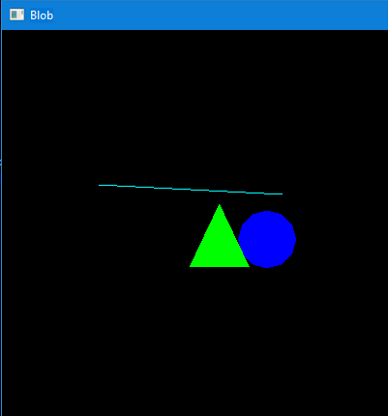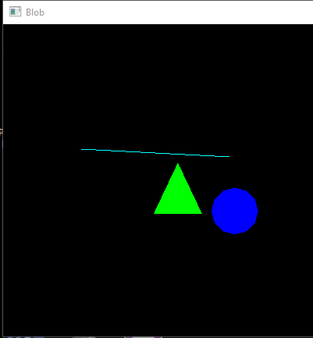

### Test 8: Test that collision detection and resolution works between boxes and triangles

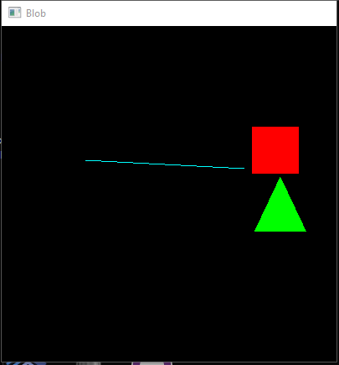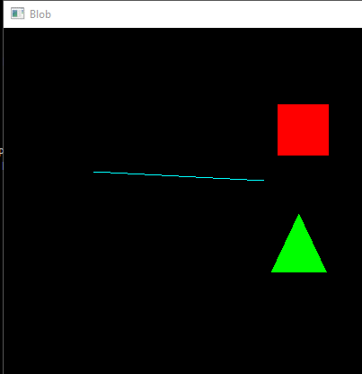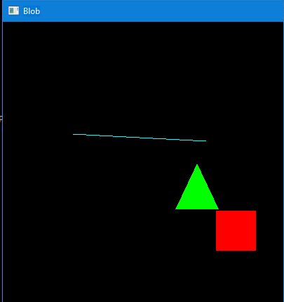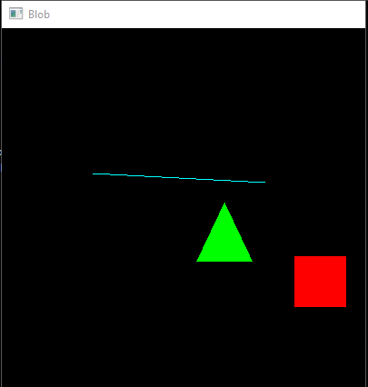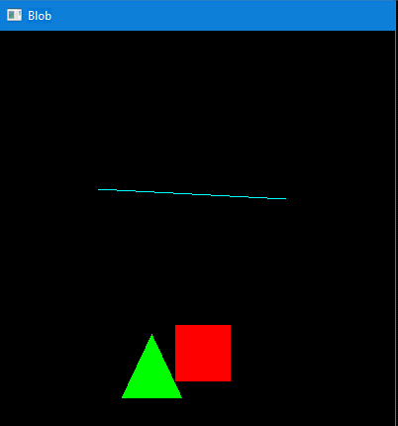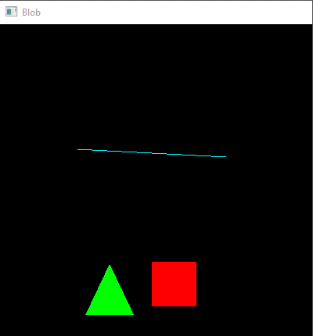

### Test 9: Increase number of boxes and triangles to observe effect

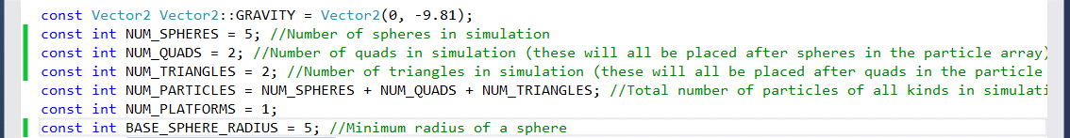

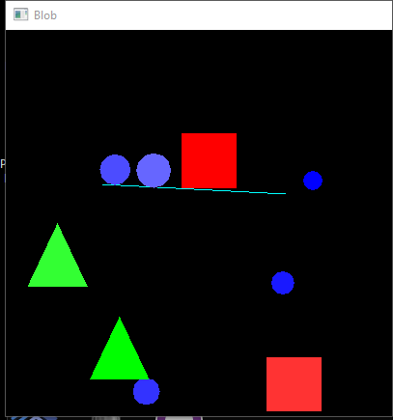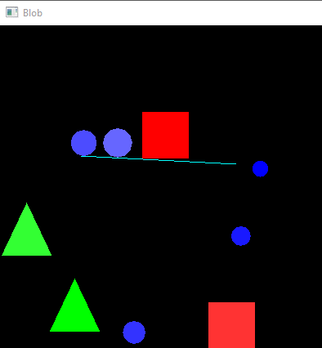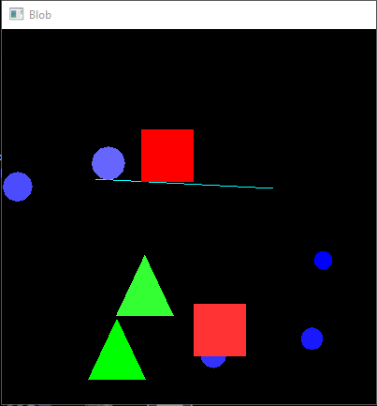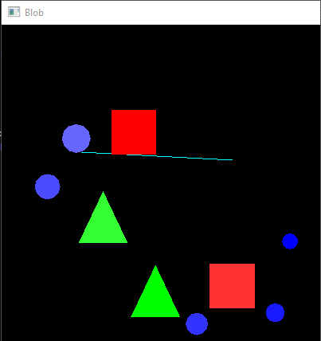

## References

Ericson, C. (2005) *Real-Time Collision Detection.* San Francisco : Morgan Kaufmann

<ftp://134.197.33.49/downloads/russell/jimenez_2001_3d_collision_detection_survey.pdf>

<https://hal.archives-ouvertes.fr/hal-00412870/document>

<http://www.stonybrook.edu/libmap/coordinates/seriesa/no2/a2.htm>

<https://wwwx.cs.unc.edu/~geom/papers/documents/dissertations/lin93.pdf>

<http://gamma.cs.unc.edu/research/collision/>

<http://www.tandfonline.com/doi/abs/10.1080/0951192X.2015.1033755>