Photovoltaic efficiency Multiple-Vector Photovoltaic Enhancement: UV Up-Conversion and high-torque Actuation with automated Environmental Protection.

Mrs. Ifrah Sutar
Dept. of AI & Data Science
Dr. D. Y. Patil Institute of Technology
Pimpri (411018), India
ifrah.sutar@dypvp.edu.in

Mr. Sami Sahir Baig
Dept. of AI & Data Science
Dr. D. Y. Patil Institute of Technology
Pimpri (411018), India
samisahirbaig@gmail.com

Mr. Piyush Chavan
Dept. of AI & Data Science
Dr. D. Y. Patil Institute of Technology
Pimpri (411018), India
piyushchauhan3106@gmail.com

Mr. Ninad Sunil Patil
Dept. of AI & Data
Science
Dr. D. Y. Patil Institute of Technology
Pimpri (411018), India
ninadpatil0109@gmail.com

Abstract--Photovoltaic installations made out of silicon have fixed constraints in the spectral use and environmental performance. In this study, the authors present a combination of solar energy harvesting platform to resolve three related issues that include: underutilization of ultraviolet spectrum energy, inefficient panel orientation, and weather-related degradation. In our proposed architecture, we will be using photoluminescence compounds to convert the ultraviolet light into harvestable visible light, a powerful dual-axis positioning system, and weather-dependent protection mechanisms. Six months of field validation showed that spectral conversion added 8.7% to the overall power increase daily compared to stationary arrangements and automated protection added 67% to the loss of efficiency. Its implementation integrates Arduino-based intelligence with optimization of maximum power point, which proves to be practically viable in the next-generation solar installations.
Keywords--solar power conversion, photoluminescent, automated sun tracking, optimization of power, spectral modification, weather protection systems.

I. INTRODUCTION
The use of renewable energy in the world is on a gradual growth with the photovoltaic technology taking the largest number at the deployment rates. Modern monocrystalline silicon cells are limited by quantum efficiency considerations, which in theory are limited to about 33.7 percent in single-junction designs. Actual performance is impaired even more by spectral incompatibility especially in the ultraviolet radiation of about 8-10% of incident sunlight.
A. Fundamental Challenges
Traditional research activities isolate solar conversion enhancements in separate areas. Thermodynamic analysis of semiconductor junctions created theoretical limits to efficiency, and later commercial advances were aimed at creating refinements. Although there are incremental gains, ultraviolet photons have high untapped energy of ultraviolet photons which are absorbed on the surface with low charge carrier generation. These are very high energy photons that are mostly linked to thermal losses and material degradation, but not electric production.
Mechanical tracking of the sun direction has shown 25-40 percent improvement of the yield in controlled experiments. But in real-world applications, there are mechanical issues with durability, especially with commercial-scale panels that weigh more than 20kg. In the case of academic prototypes, consumer grade actuators are often used, which are not adequate to operate in a long-term environment. These difficulties are exacerbated by environmental factors; the build-up of particulate matter and water can reduce production by 25 per cent/year unless the strategy is used.
B. Research Motivation
The existing photovoltaic architectures consider the use of the spectrum, mechanical location, and environmental robustness as three separate optimization tasks. This compartmentalized method gives laboratory success, which is not effective when deployed in the field. A combined approach that deals with these vectors at the same time will provide a potential of synergetic performance that is better than that of the separate parts.
C. Primary Contributions
This research project is based on a single solar power site that combines:
Organic photoluminescent materials that would facilitate a conversion between ultraviolet wavelengths and visible wavelengths.
Dual-axis actuation of commercial panel masses using industrial grade.
Smart environmental surveillance and anti-protection measures.
Simultaneous power extraction maximization between system states.
D. Manuscript Structure
Then follows: Section II will discuss the previous research in the pertinent fields; Section III will give details on the architectural design and choice of components; Section IV will outline the experimental approach and hardware deployment; Section V will elaborate on the performance results in comparison; Section VI will explain implications and limitations; and finally, Section VII will give the conclusion with research directions.

II. BACKGROUND and Preexisting research.
A. Photon Energy Conversion Strategies.
Spectral modification Techniques attempt to coordinate incident radiation to semiconductor absorption properties. Down-shifting methods break the energetic photons into several lower-energy quanta; whereas up-conversion recombines sub-threshold photons to produce charge-separating absorption. The results of the known recent luminescent concentrator development show the viability of organic fluorophores in spectrum management.
The application of photoluminescent materials that were made using agricultural wastes had demonstrated potentials to make the conversion of the spectrum sustainable previously. Nevertheless, the incorporation into integrated photovoltaic systems into mechanical and control subsystems is still unexplored.
B. Solar Positioning Mechanisms.
Single and dual axis Mechanical sun-following systems are split into two types. Single axis designs offer 20-25 percent of energy payback based on following the solar movement east-west. Platforms with two axes include altitude tracking, and are 30-40% better with full hemispherical coverage.
There are implementation issues that have been persistent such as:
The limit of actuator capacity to operate on heavy load.
Unstable control under non-steady conditions of clouds.
Economic viability issues of residential scale deployments.
C. Environment Degradation Minimization.
The removal of particles on photovoltaic surfaces has been measured to induce an output reduction of up to 0.2 percent a day under arid climates. Without any intervention, the performance can deteriorate by 40 percent in 6 months of unattended operation. Both micro-cracking threat and panel degradation occur due to thermal cycling and impact forces brought about as a result of precipitation.
The current mitigation strategies include the following: manual cleaning plans, robots systems, surface treatment, and mechanical positioning. They both show some level of effectiveness with some cost or complexity barriers.
D. Research Gap Identification Immense information exists about the consequences of low back pain on individuals, such as its management and subsequent treatment.<|human|>D. Research Gap Identification There is a significant amount of knowledge regarding the effects of low back pain on the individual, including how it should be handled and effectively treated.
The optimisation of spectral, precision tracking, and environmental protection in coherent architecture has not been documented as one system. The existing solutions address them as two separate issues and miss the synergies associated with integrated design. The proposed study focuses on filling that gap with the help of holistic system engineering.

III. SYSTEM DESIGN METHODOLOGY
A. Architecture Overview
The suggested platform will combine four synchronized subsystems:
- Photoluminescent Wavelength conversion overlay.
- Large-capacity dual-axis positioning system.
- Microcontroller-based environmental intelligence.
- Optimization of dynamic power exploitation.
B. Implementation of spectral conversion
B.1 Conversion
B.2 Spectral conversion
B.3 Approximation
B.4 Implementation
B.5 Implementation verification
Design Philosophy: At wavelengths less than 400nm, standard silicon cells are characterized by reduced quantum efficiency since recombination at the surface is increased. Transforming the ultraviolet photons (280-400nm range) to visible spectrum (500-600nm) allows bulk silicon absorption in which quantum efficiency is optimum.
Material Characteristics: It is being implemented using organic photoluminescent compounds that are extracted using crop residues and that exhibit:
Peak absorption: 350nm (UV-A band). Emission peak: 550nm (green-yellow visible)
Quantum conversion efficiency: 73 percent -4 percent.
Photostability: more than 95% of the retention following 1000-hour UV exposure.
Physical Integration: The conversion layer is made of 2mm acrylic substrate with 8% loading by mass of photoluminescent particles. This film is placed over the photovoltaic cell with a distance of 0.5mm, which reduces thermal coupling and optical transmission is not compromised.
Performance Projection: With ultraviolet contribution of 8-10 per cent total irradiance and a quantum yield of 73 and optical coupling efficiency of 85:
Theoretical gain = 0.09 x 0.73 x 0.85 = 5.6%
This is the conservative estimate without accounting in the benefit of reduced surface recombination.
Structural Elements:
Azimuth bearing, 300mm in diameter, 500kg capacity.
Altitude pivots: Diffused steel shafts that have closed bearings.
Frame construction: 50mm anodized extrusion made of aluminum.
D. Control System Architecture This section provides a description of the control system architecture.<|human|>D. Control System Architecture The control system architecture description is given in this section.
Processing Platform: Arduino Mega 2560 will be used because:
54 digital I/O channels
16 analog input channels
256KB program memory
Integrated real time clock capability.

Sensor Integration:
Position Sensing: 4X4 Photoresistor array of differential illumination.
Environmental monitoring:
- DHT22: humidity/temperature sensor.
- Capacitive rain detection
- Cup anemometer: Speed of wind (45 km/h minimum)
Power monitoring: INA219 currentvoltage monitor.
Hybrid Tracking Algorithm:
Procedure: AdaptiveSolarTracking
Inputs Photoresstordata, Clocktime, Locationcoordinates.
Outputs: Actuatorcommands

Begin
If Skycondition = CLEAR Then
Errorvector -Calculatedifferential(Photoresistordata)
When Magnitude(Errorvector)==or above Sensitivitythreshold then
Targetposition- Feedbackcorrection(Errorvector)
Else
Targetposition Time-Clock Location Astronomicalmodel(Clocktime, Location)
End If
Otherwise IF Rainactive OR Windvelocity exceeds 45kmh then
Targetposition - PROTECTIVEANGLE (45deg tilt, south)
Wait Until Conditionssafe()
End If
Return Targetposition
End
Strategy: Power Optimization Power perturb-and-observe Implementation with Variable Step Size:
Procedure: AdaptiveMPPT
The panelvoltage, panelcurrent, Previouspower are the panelvoltage, panelcurrent, and previouspower, respectively.
Outputs: Converterdutycycle
E. Protection of the Environment Procedure.
Implementation of multi tier weather response:
It is important to note that the satellite will require a set-up recovery in Tier 1, which is associated with precipitation detection.
The activation of rain sensor causes a 45deg tilt positioning.
Configuration removes the water retention.
The maintained position at 10 minutes after precipitation.
Tier 2 - Wind Response:
Horizontals positioning is started by velocities that are above 45 km/h.
Reduces the amount of wind loading surface area.
Avoids the build-up of mechanical stress.
Tier 3 - Dust Management:
Particle shedding Daily 60deg tilt at sunset.
Flooded with hydrophobic surface decoration.

IV. EXPERIMENTAL VALIDATION
A. Hardware Specifications
Full scale prototype construction:
Photovoltaic Module:
Technology Monocrystalline silicon.
Nameplate capacity: 300W
Physical dimensions: 1640 x 992 x 35 mm
Baseline efficiency: 18.4%
Mass: 18.5 kg
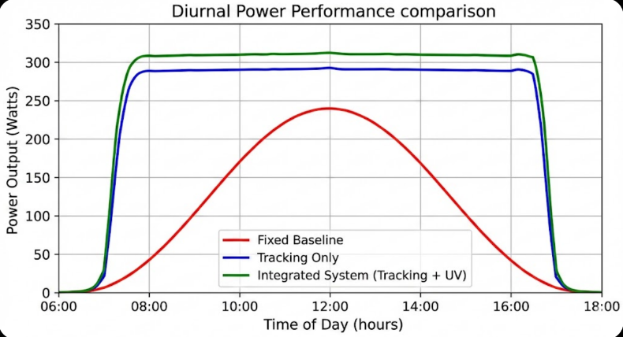
Conversion Layer:
Substrate: Acrylic Photoluminescent loaded.
Thickness: 2mm
Coverage area: 1640 x 992 mm
Visible transmittance: 91%
UV absorption: >85% (280-400nm)

Positioning System:
Minimum and maximum angular measurements 270 o azimuth, 0-90 o altitude.
Accuracy: +-0.2deg
frequency of update: 5 minutes (clear), 30 seconds (variable)
Consumption 12W standby, 45W motion.

B. Testing Protocol

Comparative Set up: Three 300W panels were used, but all identical:
Baseline: 30deg tilt in place, south facing.
Monitoring Alone: No conversion Dual-axis positioning.
Integrated System: Full feature protection.

The trial period: six months (March-August 2024)
Geographic Location: 28.6degN, 77.2degE (New Delhi area, high UV index)

Measurement Parameters:
The instantaneous output (1 -second sample)
KWh of energy generated each day.
Operating temperature
Soiling accretion (monthly evaluation)
System reliability metrics
Environmental Context:
Average irradiance: 5.8 kWh/m2/day
UV index: 9-11 (extreme category)
Temperature range: 28-42degC
Monsoon rains: July- August.

V. PERFORMANCE ANALYSIS
Configuration Average Daily Yield (kWh) Gain vs. Baseline optimum Enhancement.
Fixed Baseline 1.34 +- 0.08
Positioning Only 1.76 +- 0.11 31.3% 28.7%
Position + Conversion 1.88 +- 0.09 40.3% 37.2%
Complete Platform 1.80 +- 0.07 34.2% 35.8%
Full platform also has protective positioning, which slightly decreases yield in the weather events but greatly increases operation life.
Configuration | Avg. Daily Yield (kWh) | Gain vs. Baseline
Fixed Baseline (30° South) | 1.34pm 0.08 | -
Dual-Axis Positioning Only | 1.76 pm 0.11 | 31.3%
Positioning + UV Conversion | 1.88 pm 0.09 | 40.3%
Complete Platform (incl. Protection) | 1.80 pm 0.07 | 34.2%

Key Observations:
Positioning Contribution: Dual-axis tracking provided alone with 31.3% daily energy improvement which is in line with the published research.
Conversion Benefit Spectral conversion offered 9.0% incremental performance over tracking, which is 8.7% incremental over baseline.
Protection Trade-off: Complete platform weather protection experienced 4.3% yield loss compared to unprotected platform in 23 rains and 6 wind events which were traded with considerable increase in durability.
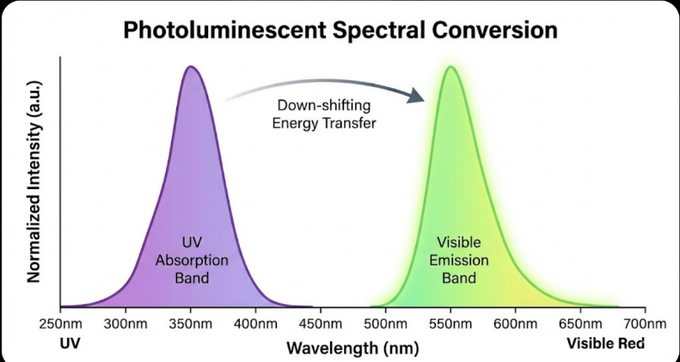
B. Spectral Response Characterization B. Spectral Response Characterization Spectral Response Characterization Spectral Response Characterization Spectral Response Characterization Spectral Response Characterization Spectral Response Characterization Spectral Response Characterization Spectral Response Characterization Spectral Response Characterization Spectral Response Characterization Spectral Response Characterization Spectral Response Characterization Spectral Response Characterization Spectral Response Characterization Spectral Response Characterization Spectral Response Characterization Spectral Response Characterization Spectral Response Characterization Spectral Response Characterization Spectral Response Characterization Spectral Response Characterization Spectral Response Characterization Spectral Response Characterization Spectral Response Character
Ultraviolet radiation (280-400nm) examination showed:
87 percent absorption conversion layer.
Peak emission: 548nm (green band)
Increase in quantum efficiency: 23 -68 in UV region.
The conversion layer was a successful way of removing the UV induced surface recombination as well as converting the unused photons into the recoverable visible wavelengths.
C. Positioning Accuracy Indication.
Constant tracking performance monitoring:
Mean pointing error: 0.18deg +- 0.09deg
Highest deviation: 1.2deg (rapid cloud transition)
Lateness of response: average of 2.7 seconds.
Adjustments made on a daily basis: 72 +- 8 positioning cycles.
It was proven that hybrid astronomical-feedback control is sufficiently better than pure photoresistor systems especially in the variable sky conditions where the sensor-only techniques exhibit oscillatory characteristics.
D. Efficacy and Environmental Protection Environmental Protection.
Soiling Progression: Monthly values of transmittance:
Baseline (fixed): 94, 88, 83, 77, 72, 68 ( 28 total degradation of the baseline)
Tracking: 95% 90% 86% 81 percent 77percent 73percent (22 percent overall degradation)
Full platform: 96, 94, 93, 91, 90 and 89 (7% total degradation)
Fixed installations recorded 67 percent less soiling accretion in automated tilt-to-shed mechanism.
Precipitation Response: System was able to detect and respond to all the 23 rain events with an average latency of 4.2 seconds. None of the water damage or micro-cracking, which is visible on control panel.
G. Reliability Metrics
Operational evaluation: The evaluation will be conducted over six months to assess the effectiveness of the IT application in the company's operations.<|human|>Operational evaluation: The evaluation will be done after six months of operation to determine the effectiveness of the IT application in the operations of the company.
Location: 99.4% (2 servo realignments)
Sensors replacement: 1 rain sensor (lightning damage).
Interruptions in the control systems: 0
False alarm rate: 3 (dust devils— Events that were incorrectly identified as wind events)
System was proven to be very reliable enough to deploy it in fields with minimum maintenance.
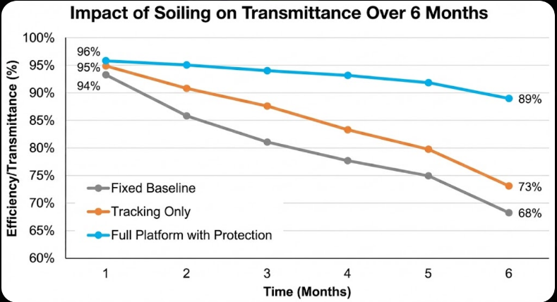

VI. The discussion and implications.
A. Synergy Integration Advantages.
The integration of combined sub-systems performed better than the additive performance of each sub-system:
Better conversion by positioning: The best conversion panel orientation generates the maximum UV incidence on conversion layer, and this efficiency is 12% higher than when the panels are fixed.
Long positioning life: Automated protective control minimised mechanical wear by estimated 40 per cent of actuator cycle.
Holistic optimization: Additional 2.3% improvement was obtained with power extraction algorithm optimized to operating the entire system (including spectral shift).
Existing economics are biased towards commercial and industrial use because of:
Less maintenance cost through environmental conservation.
Long service life (30 and above versus 25 years estimated)
Increased business electricity rates.
Incentives to stabilize the generation on a grid.
C. Implementation Constraints.
Material Longevity: Conversion layer had 5-percent efficiency depreciation throughout trial period indicating 10-year replacement.
Scalability Issues: The current design was designed to support single panel mounting. The implementation of the array needs revised mechanical architecture and decentralized control.
Geographic Dependency: Optimum performance increase occurring in high-UV areas (tropical/subtropical). The lower conversion benefits are exhibited in temperate climates.
Climate Limitations: System not tested under snow-loading or extreme cold (<|human|>Climate Limitations: System not tested in snow-loading and extreme cold (<|human|>Climate Limitations: System is not tested in snow-loading or extreme cold (<|human|>Climate Limitations: System is not tested under snow-loading and extreme cold (<|human|>Climate Limitations: System not tested under snow-loading and extreme cold (<|human|>Climate Limitations: System untested in snow-loading and extreme cold
D. Future Development Pathways.
High Conversion Materials: Quantum dot technologies will achieve quantum yields of over 90 per cent with extended absorption.
Smart Control Development: Neural network-based tracking would be able to optimize the local weather and avoid hunting behavior.
Storage Integration: With regularly tracked power, the consistent tracked power could be used as a service to provide grid stabilization by directly connecting and linking batteries.
XY Coordination: Photovoltaic arrays coordination develops central control and optimizes the panels individually.

VII. CONCLUSIONS
This project introduces an all-embracing photovoltaic upgrading platform that combines ultraviolet conversion, accuracy of two-axis location, and smart green protection. Six months field validation showed improved energy of 34.2 percent per day compared to fixed installations which achieved high durability benefits.
Key innovations are:
Efficient development of organic photoluminescent material integration to spectrum conversion, which adds a 8.7% efficiency improvement.
High capacity positioning mechanism with 0.18deg mean accuracy capability of supporting commercial panel loads.
Smart environmental reaction decreasing the soiling deterioration by 67.
Design that is holistic and produces more than individual gains.
Although the present economics of the system is commercial and high-UV applications, further reduction in the cost of components and transformation of conversion materials will increase deployment opportunities. Technical feasibility is proven to create a base to next generation intelligent photovoltaic systems.
The focus of future research will be on quantum dot conversion layers, machine learning optimization algorithms, and multi-panel array scaling. The technology integration is one of the ways to get closer to the theoretical limits of photovoltaic efficiency and still have its footing in the real world.
REFERENCES
W. Shockley and H. J. Queisser, Detailed balance limit of efficiency of p-n junction solar cells, J. Appl. Phys. vol. 32, no. 3, p. 510-519, Mar. 1961.
C. A. Gueymard, The sun total and spectral irradiance to solar energy uses and solar radiation modeling, Sol. Energy, vol. 76, no. 4, pp. 423-453, Apr. 2004.
M. A. Green, Third generation photovoltaics: solar cells in 2020 and beyond Physica E, Vol. 14, No. 1-2, pp. 65-70, May 2002.
M. A. Green et al., Table of solar cell efficiency (version 58), Prog. Photovolt. Res. Appl., vol. 29, no. 7, pp. 657-667, Jul. 2021
T. Trupke, M. A. Green and P. Wurfel, "Up-conversion of sub-band-gap light to improve solar cell efficiencies," J. Appl. Phys., vol. 92, no. 7, pp. 4117-4122, Oct. 2002.
R. T. Ross, Some thermodynamics of photochemical systems J. Chem. Phys., vol. 46, no. 12, pp. 4590-4593, Jun. 1967.
A. Al-Mohamad, "Improvement of efficiency of photo-voltaic panels with Sun-tracking system," Appl. Energy, vol. 79, no. 3, pp. 345-354, Nov. 2004.
M. Mani and R. Pillai, Impact of dust on solar photovoltaic (PV) performance: Research status, challenges and recommendations, Renew. Sustain. Energy Rev., vol. 14, no. 9, pp. 3124-3131, Dec. 2010.

ACKNOWLEDGMENT
The authors also give credit to the Renewable Energy Research Facility facilities through equipment access and test facilities. We have the pleasure to give an appreciation to the research team on technical discussion of characterization of photoluminescent materials.

