**Computer Engineering Department**

**National University of Technology Islamabad, Pakistan**

**Introduction to Data Mining**

**Practice Exercise 11**



Name: Muhammad Sami Uddin Rafay

Roll Number: F18604013

Submitted To: Dr. Kamran Javed

Date: 02 February 2020

**Practice Exercise 10**

**Supervised Machine Learning | KNN**

**Objective:**

* Implement KNN using Fisher iris Data.

**Equipment/Software Required:**

* Python (Spyder 4.0 Anaconda Distribution)

**Background:**

**How Does KNN Work?**

1. Select no. of k of neighbors
2. Calculate the Euclidean distance of k no. of neighbors
3. Take the nearest neighbors as per the calculated Euclidean Distance
4. Among these k neighbors, count no. of data points in each category
5. Assign the new data points to that category for which the no. of neighbor is maximum
6. Our Model is ready

**Code:**

**# importing Libraries**

import pandas as pd

import matplotlib.pyplot as plt

from sklearn.neighbors import KNeighborsClassifier

import seaborn as sns

**# Loading iris dataset**

fisher_iris=pd.read_csv(r"C:\Users\User\Documents\IrIs.csv")

**# Before implementing KNN on fisher_iris Data frame let’s do some data quality assessment**

**# Converting fisher_iris as a Data Frame**

fisher_iris=pd.DataFrame(fisher_iris)

**# Printing the head of fisher_iris Data Frame**

print("Head of Data : \n",fisher_iris.head())

**# Printing shape/ Dimentions fisher_iris of Data Frame**

print("\n")

print("Shape of Data : \n",fisher_iris.shape)

**# Printing statistics of fisher_iris Data Frame**

print("\n")

print("Statistics of Data : \n", fisher_iris.describe())

**# Splitting the test and train Data**

X = fisher_iris[["petal_length","petal_width"]]

y = fisher_iris[["species"]]

KNN=KNeighborsClassifier(n_neighbors=5)

KNN.fit(X,y)

**# New Point**

newpoint= [[5, 1.45]]

**# New Point 2**

newpoint2 = [[5, 1.45],[6,2],[2.75, 0.75]]

**# Predicting New Point**

Predict_NewPoint=KNN.predict(newpoint)

**# Predicting New Point 2**

Predict_NewPoint2=KNN.predict(newpoint2)

**# Printing Predicted Results**

Distances,Indexes=KNN.kneighbors(X=newpoint2, n_neighbors=5, return_distance=True)

print(Predict_NewPoint)

print(Predict_NewPoint2)

print(Distances)

print(Indexes)

**# plot for first point**

plt.figure(1)

iris=sns.load_dataset('iris')

sns.scatterplot(x='petal_length',y='petal_width',data=iris,hue='species')

plt.plot(5,1.5,'x', color='k')

plt.grid(True)

**# plot for Second point**

plt.figure(2)

iris=sns.load_dataset('iris')

sns.scatterplot(x='petal_length',y='petal_width',data=iris,hue='species')

plt.plot(5,1.45,'x', color='k')

plt.plot(6,2,'x', color='k')

plt.plot(2.75,0.75,'x', color='k')

plt.grid(True)

plt.show()

**Output:**

**Head of Data:**

5.1 3.5 1.4 0.2 Iris-setosa

0 4.9 3.0 1.4 0.2 Iris-setosa

1 4.7 3.2 1.3 0.2 Iris-setosa

2 4.6 3.1 1.5 0.2 Iris-setosa

3 5.0 3.6 1.4 0.2 Iris-setosa

4 5.4 3.9 1.7 0.4 Iris-setosa

**Shape of Data:**

(149, 5)

**Statistics of Data:**

**sepal-length** **sepal-width** **petal-length petal-width**

**count** 149.000000 149.000000 149.000000 149.000000

**mean** 5.848322 3.051007 3.774497 1.205369

**std** 0.828594 0.433499 1.759651 0.761292

**min** 4.300000 2.000000 1.000000 0.100000

**25**% 5.100000 2.800000 1.600000 0.300000

**50**% 5.800000 3.000000 4.400000 1.300000

**75%** 6.400000 3.300000 5.100000 1.800000

**max** 7.900000 4.400000 6.900000 2.500000

**New Point 1 Prediction**

['Iris-versicolor']

**New Point 2 Prediction**

['Iris-versicolor' 'Iris-virginica' 'Iris-versicolor']

**Distances**

[[0.05 0.1118034 0.1118034 0.1118034 0.18027756]

[0.14142136 0.14142136 0.2 0.28284271 0.28284271]

[0.43011626 0.6041523 0.6041523 0.79056942 0.79056942]]

**Indexes**

[[119 52 72 133 83]

[102 130 125 108 104]

[ 98 57 93 79 60]]

**Graphs:**

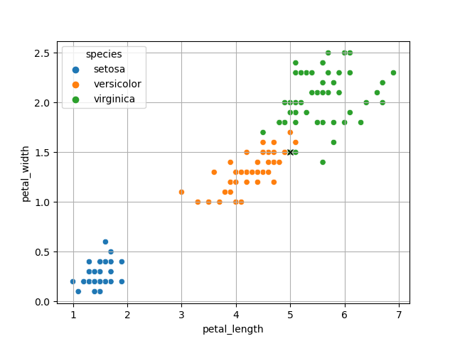

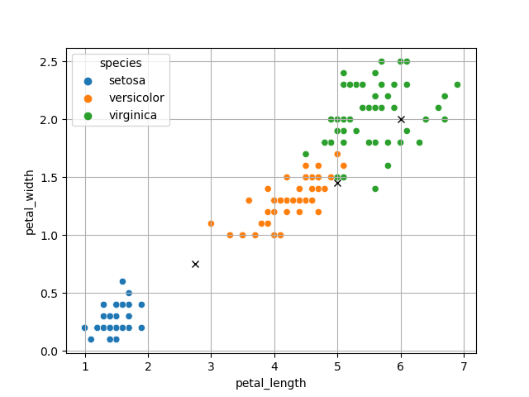

**Results and Discussions:**

As the target attribute is “species” column of iris dataset so according to trained KNN model both of new point and new point 2 are predicted as ['Iris-versicolor' 'Iris-virginica' 'Iris-versicolor'].

**Note:** The starting Index of dataset in **Python** is **zero** and in **MATLAB** is **one**, so don’t confuse with indexes of predicted neighbors. Distances are predicted same in both Programming Languages.

**Conclusion:**

K-Nearest Neighbours is the supervised machine learning algorithm used for classification and regression. It manipulates the training data and classifies the new test data based on distance metrics. It finds the k-nearest neighbours to the test data, and then classification is performed by the majority of class labels. KNN also be used to detect anomaly by setting a threshold based on distances. We can use features of data as threshold like mean, mode, median, minimum and maximum subjected to application.