**Computer Engineering Department National University of Technology Islamabad, Pakistan**

**Introduction to Data Mining**

**Practice Exercise 04**



Name: Muhammad Sami Uddin Rafay

Roll Number: F18604013

Submitted To: Dr. Kamran Javed

Date: 30 November 2020

**Practice Exercise 04**

**Feature Extraction**

**Objective:**

* Determining appropriate class for new data points.

**Equipment/Software Required:**

* Python (Spyder 4.0 Anaconda Distribution)

**Background:**

Assume that we have a learning/ training data set of a machine which indicates healthy and

faulty states of measurements (data points) from hour 1 to H (H=20). Given threshold is 0.5. We

want to determine state of a new machine by comparing its measurements with learned data:

**Tasks:**

1. Create training data set (20rxc3 ):
   1. Hour Health State (0= healthy, 1= faulty), note: health feature has random values

from 0-1.

* 1. Show a scatter plot of hour vs health features.

1. Initially the labels are fixed your task is to set state (class labels) according to the given

threshold value. i.e., if health measurement value is >=0.5 state 1 otherwise 0.

1. Get the input from user that should be <=1 (i.e., new observation newpt)
2. Compute the distance of newpt with each observation of health feature, i.e., vector D.

Plot distance feature D.

1. Use find command to determine indexes of distance D vector value <= threshold and the

corresponding states on the same indexes from state feature.

1. Use mode command to determine most similar class and display state of new data point

i.e. health or faulty.

1. Show a scatter plot of hour vs sorted health features and based on the threshold fill the

healthy states blue and faulty states red. Also plot the new observation on the scatter plot

(note the time index can be of your choice, i.e. hour 5 may be hour).

1. Plot states of the healthy and faulty class data.

**Code:**

**# Feature extraction from Time Series Data**

**# importing neccessary python pakages**

import matplotlib.pyplot as plt

import numpy as np

import random

import statistics

import pandas as pd

**# defining function for generating random temperature values**

def random_floats(low, high, size):

return [random.uniform(low, high) for _ in range(size)]

print('\n')

**# defining array for storing respective values**

Temperature_yearly=np.array([])

Temperature=np.array([])

Temperature_mean=np.array([])

Temperature_var=np.array([])

**# generating Time Series Temperature, Mean per day, Variance per day**

for i in range(365):

Temperature=random_floats(0, 50, 24)

Temperature_yearly=np.append(Temperature_yearly,Temperature)

Temperature_mean=np.append(Temperature_mean ,np.mean(Temperature))

Temperature_var=np.append(Temperature_var, statistics.variance(Temperature))

**# printing shape of respective arrays to confirm the total values**

print(Temperature_yearly.shape)

print(Temperature_mean.shape)

print(Temperature_var.shape)

**# intializing figure 1 for plotting Temperature values**

plt.figure(1, figsize=(10,8))

**# plotting temperature per year**

plt.subplot(111)

plt.plot(Temperature_yearly, color='purple')

plt.xlabel("Time (One Year)")

plt.ylabel("Temperature")

plt.grid()

**# intializing figure 2 for plotting Mean Temperature values**

plt.figure(2, figsize=(8,6))

**# plotting Mean temperature per day**

plt.subplot(111)

plt.plot(Temperature_mean, color='brown')

plt.xlabel("Time (365 Days)")

plt.ylabel("Mean(average) Temperature per Day")

plt.grid()

**# intializing figure 2 for plotting Mean Temperature values**

plt.figure(3, figsize=(6,4))

**# intializing figure 3 for plotting Variance Temperature values**

plt.subplot(111)

plt.plot(Temperature_var, color='gray')

plt.xlabel("Time (365 Days)")

plt.ylabel("Variance Temperature per Day")

plt.grid()

**# showing all graphs**

plt.show()

**# Selecting any random value of variances as threshold**

threshold=random.choice(Temperature_var)

print("\n")

print("Threshold : ")

print("\n")

print(threshold)

**# defining an array for saving variance values greater than threshold**

days_above_threshold=np.array([])

**# designing algorithm to sort out the day having variance values greater than Threshold**

for i in Temperature_var:

days_above_threshold=np.append(days_above_threshold,np.where(Temperature_var>threshold))

**# printing variances above threshold**

print("\n","Days above Threshold : ","\n")

print(days_above_threshold)

**# converting days_above_threshold in DataFrame**

day_above_DataFrame=pd.DataFrame(days_above_threshold)

**# exporting days_above_threshold in .csv**

day_above_csv=day_above_DataFrame.to_csv("D:\day_above_DataFrame.csv")

**Output:**

**Please Enter a number less than 1 :**0.6

**Please Enter the index for new Entry :**13

**Health Condition :**

[0.8957469950770193, 0.08077845796976235, 0.1783230740000642, 0.8196972267071088, 0.034014818235133415, 0.8065926392152845, 0.3065121095402894, 0.6145450614235138, 0.6604469817227682, 0.937840482168668, 0.8075594592804584, 0.15166735485838756, 0.0020670767195170026, 0.7506835619814233, 0.06885024904216963, 0.6921701015609686, 0.15236045131613207, 0.2281242334740049, 0.38522690404007975, 0.6301966132141353]

**After Discretization :**

**Good :** 0

**Faulty :** 1

**health_condition :**

[1. 0. 0. 1. 0. 1. 0. 1. 1. 1. 1. 0. 0. 1. 0. 1. 0. 0. 0. 1.]

**Distance Vector :**

[0.295747 0.51922154 0.42167693 0.21969723 0.56598518 0.20659264

0.29348789 0.01454506 0.06044698 0.33784048 0.20755946 0.44833265

0.59793292 0.15068356 0.53114975 0.0921701 0.44763955 0.37187577

0.2147731 0.03019661]

**Indexes at which D vector <= threshold**

[ 1. 2. 4. 6. 11. 12. 14. 16. 17. 18.]

**Corresponding states on the same indexes from state feature :**

[0.08077846 0.17832307 0.03401482 0.30651211 0.15166735 0.00206708

0.06885025 0.15236045 0.22812423 0.3852269 ]

**The Most Similar class :**

[(1.0, 10)]

**New Entry is Faulty**

**Sorted Health Features :**

[0.0020670767195170026, 0.034014818235133415, 0.06885024904216963, 0.08077845796976235, 0.15166735485838756, 0.15236045131613207, 0.1783230740000642, 0.2281242334740049, 0.3065121095402894, 0.38522690404007975, 0.6145450614235138, 0.6301966132141353, 0.6604469817227682, 0.6921701015609686, 0.7506835619814233, 0.8065926392152845, 0.8075594592804584, 0.8196972267071088, 0.8957469950770193, 0.937840482168668]

**Graphs:**

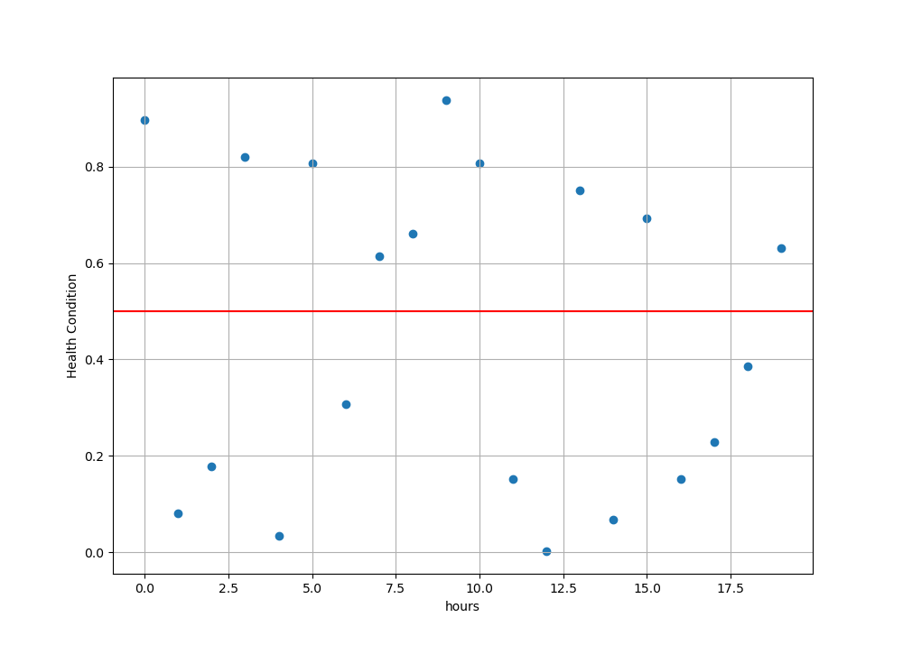

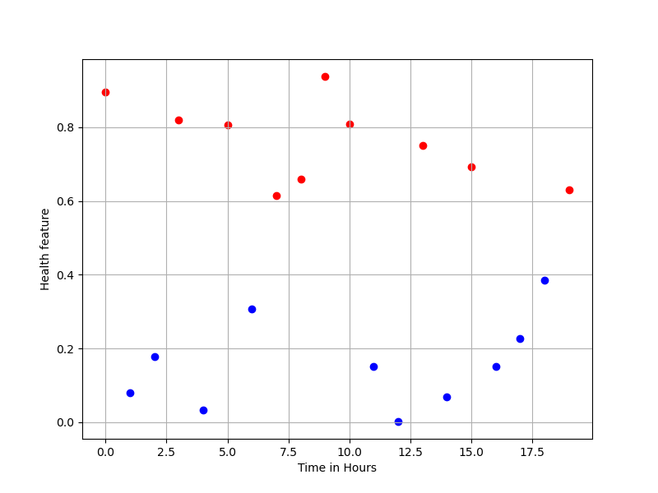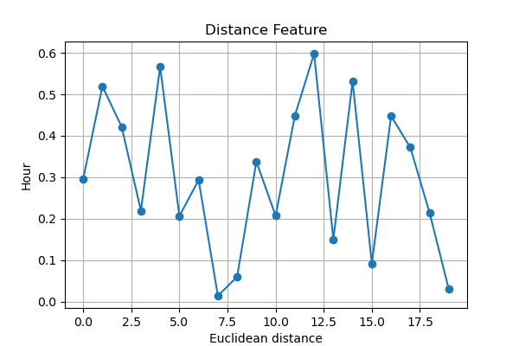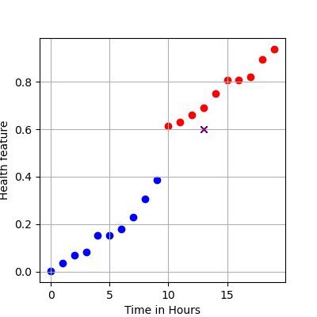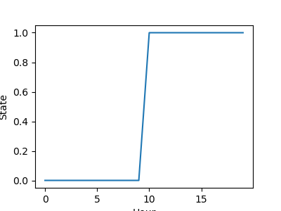

**Results and Discussions:**

In this practical I learned to discretize the health condition numerical data facts into binary form (0 and 1/ Good and Faulty) and try to extract the features from it. Also trained a model to estimate the new candidate health condition and its Euclidean distance from all data entries in the dataset. The results are changing at each run because of random data selection. And most especially the scatter plot helped a lot to do this in efficient way.

The python packages I used in this practical: -

* NumPy
* matplotlib
* pandas
* random

**Conclusion:**

What I found about Feature Extraction is used when we need to reduce dimensions of a dataset without losing important and respective information.

.py file is attached.