**Computer Engineering Department National University of Technology Islamabad, Pakistan**

**Introduction to Data Mining**

**Practice Exercise 06**



Name: Muhammad Sami Uddin Rafay

Roll Number: F18604013

Submitted To: Dr. Kamran Javed

Date: 17 December 2020

**Practice Exercise 06**

**Principle Component Analysis**

**Objective:**

* To implement Principal Component Analysis
* The principal components of a collection of points in a real p-space are a sequence of direction vectors, where the vector is the direction of a line that best fits the data while being orthogonal to the first vectors.

**Equipment/Software Required:**

* Python (Spyder 4.0 Anaconda Distribution)

**Background:**

**Tasks:**

**Code:**

import numpy as np

import pandas as pd

import matplotlib.pyplot as plt

from mpl_toolkits.mplot3d import Axes3D

from sklearn import datasets

from sklearn.decomposition import PCA

from pyod.models.copod import COPOD

**#from pca import pca**

**# Load the iris data from sklearn**

iris = datasets.load_iris()

iris=pd.DataFrame(iris.data)

#print(iris)

**# Get input variables (from column 1 to 4)**

X=iris[iris.columns[0:4]]

#Y = iris[iris[:,:5]]

print(X)

#print(Y)

**# De-mean data by subtrating mean form each point**

X1=X-np.mean(X)

#print(X1)

#[COEFF, SCORE, LATENT,TSQUARED, EXPLAINED]=PCA.fit_transform(X1)

pca = PCA()

pca.fit(X1)

coeff = np.transpose(pca.components_)

print(coeff)

latent=(pca.explained_variance_)

print(latent)

#print(pca.score(X))

explained=pca.explained_variance_ratio_

print(explained*100)

#d=pca.singular_values_

#print(d)

f=pca.n_samples_

print(f)

numberOfDimentions=4;

reducedDimention=coeff[0,0:4]

print(reducedDimention)

reducedFeatureMatrix=X-reducedDimention

print(reducedFeatureMatrix)

plt.figure(3,figsize=(5,10))

X = np.arange(4)

col=['b','g','r','y']

for i in range(1,5,1):

#plt.hist(coeff[3])

plt.subplot(2,2,i)

plt.bar(X,coeff[i-1], color = col[i-1] )

plt.title("Eigen Vector "+str(i))

plt.grid()

plt.show()

iris = datasets.load_iris()

X = iris.data[:, :4] # we only take the first two features.

y = iris.target

x_min, x_max = X[:, 0].min() - .5, X[:, 0].max() + .5

y_min, y_max = X[:, 1].min() - .5, X[:, 1].max() + .5

plt.figure(2, figsize=(8, 6))

plt.clf()

**# Plot the training points**

plt.scatter(X[:, 0], X[:, 1], c=y, cmap=plt.cm.Set1,

edgecolor='k')

plt.xlabel('Sepal length')

plt.ylabel('Sepal width')

plt.xlim(x_min, x_max)

plt.ylim(y_min, y_max)

plt.xticks(())

plt.yticks(())

**# To getter a better understanding of interaction of the dimensions**

**# plot the first three PCA dimensions**

fig = plt.figure(1, figsize=(8, 6))

ax = Axes3D(fig, elev=-150, azim=110)

X_reduced = PCA(n_components=3).fit_transform(iris.data)

ax.scatter(X_reduced[:, 0], X_reduced[:, 1], X_reduced[:, 2], c=y,

cmap=plt.cm.Set1, edgecolor='k', s=40)

ax.set_title("First three PCA directions")

ax.set_xlabel("1st eigenvector")

ax.w_xaxis.set_ticklabels([])

ax.set_ylabel("2nd eigenvector")

ax.w_yaxis.set_ticklabels([])

ax.set_zlabel("3rd eigenvector")

ax.w_zaxis.set_ticklabels([])

plt.show()

**Output:**

**0 1 2 3**

**0 5.1 3.5 1.4 0.2**

**1 4.9 3.0 1.4 0.2**

**2 4.7 3.2 1.3 0.2**

**3 4.6 3.1 1.5 0.2**

**4 5.0 3.6 1.4 0.2**

**.. ... ... ... ...**

**145 6.7 3.0 5.2 2.3**

**146 6.3 2.5 5.0 1.9**

**147 6.5 3.0 5.2 2.0**

**148 6.2 3.4 5.4 2.3**

**149 5.9 3.0 5.1 1.8**

**[150 rows x 4 columns]**

**[[ 0.36138659 0.65658877 -0.58202985 -0.31548719]**

**[-0.08452251 0.73016143 0.59791083 0.3197231 ]**

**[ 0.85667061 -0.17337266 0.07623608 0.47983899]**

**[ 0.3582892 -0.07548102 0.54583143 -0.75365743]]**

**[4.22824171 0.24267075 0.0782095 0.02383509]**

**[92.46187232 5.30664831 1.71026098 0.52121839]**

**150**

**[ 0.36138659 0.65658877 -0.58202985 -0.31548719]**

**0 1 2 3**

**0 4.738613 2.843411 1.98203 0.515487**

**1 4.538613 2.343411 1.98203 0.515487**

**2 4.338613 2.543411 1.88203 0.515487**

**3 4.238613 2.443411 2.08203 0.515487**

**4 4.638613 2.943411 1.98203 0.515487**

**.. ... ... ... ...**

**145 6.338613 2.343411 5.78203 2.615487**

**146 5.938613 1.843411 5.58203 2.215487**

**147 6.138613 2.343411 5.78203 2.315487**

**148 5.838613 2.743411 5.98203 2.615487**

**149 5.538613 2.343411 5.68203 2.115487**

**[150 rows x 4 columns]**

**runfile('D:/PCA in Python.py', wdir='D:')**

**0 1 2 3**

**0 5.1 3.5 1.4 0.2**

**1 4.9 3.0 1.4 0.2**

**2 4.7 3.2 1.3 0.2**

**3 4.6 3.1 1.5 0.2**

**4 5.0 3.6 1.4 0.2**

**.. ... ... ... ...**

**145 6.7 3.0 5.2 2.3**

**146 6.3 2.5 5.0 1.9**

**147 6.5 3.0 5.2 2.0**

**148 6.2 3.4 5.4 2.3**

**149 5.9 3.0 5.1 1.8**

**[150 rows x 4 columns]**

**[[ 0.36138659 0.65658877 -0.58202985 -0.31548719]**

**[-0.08452251 0.73016143 0.59791083 0.3197231 ]**

**[ 0.85667061 -0.17337266 0.07623608 0.47983899]**

**[ 0.3582892 -0.07548102 0.54583143 -0.75365743]]**

**[4.22824171 0.24267075 0.0782095 0.02383509]**

**[92.46187232 5.30664831 1.71026098 0.52121839]**

**150**

**[ 0.36138659 0.65658877 -0.58202985 -0.31548719]**

**0 1 2 3**

**0 4.738613 2.843411 1.98203 0.515487**

**1 4.538613 2.343411 1.98203 0.515487**

**2 4.338613 2.543411 1.88203 0.515487**

**3 4.238613 2.443411 2.08203 0.515487**

**4 4.638613 2.943411 1.98203 0.515487**

**.. ... ... ... ...**

**145 6.338613 2.343411 5.78203 2.615487**

**146 5.938613 1.843411 5.58203 2.215487**

**147 6.138613 2.343411 5.78203 2.315487**

**148 5.838613 2.743411 5.98203 2.615487**

**149 5.538613 2.343411 5.68203 2.115487**

**[150 rows x 4 columns]**

**Graphs:**

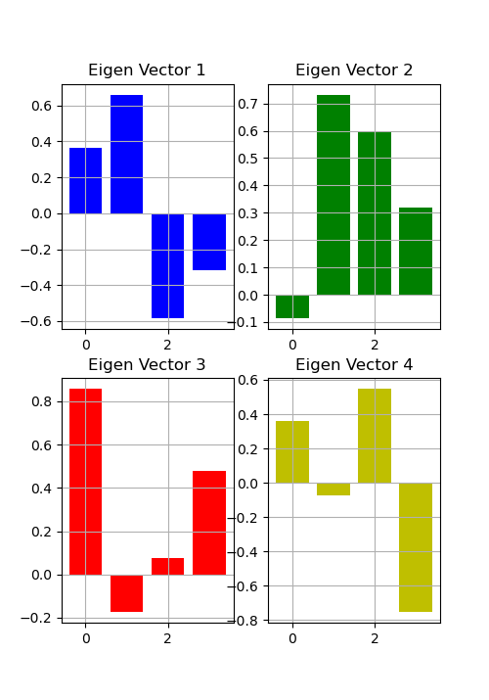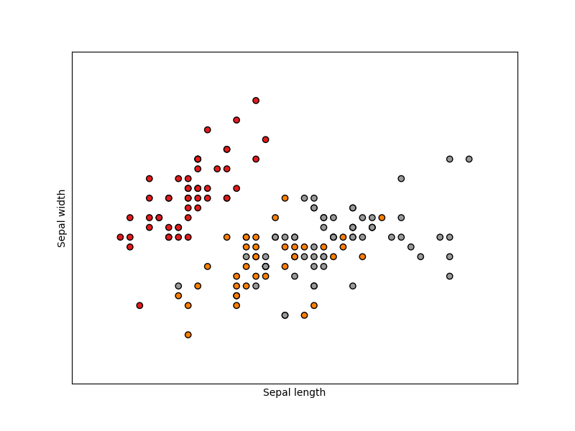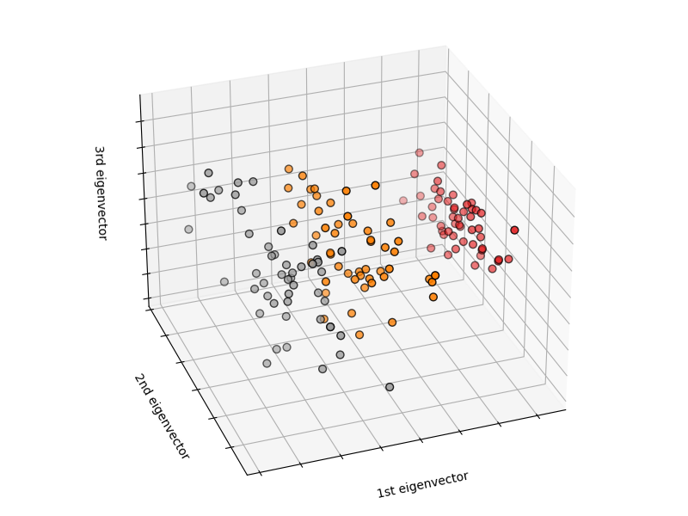

**Results and Discussions:**

The main purposes of a principal component analysis are the analysis of data to identify patterns and finding patterns to reduce the dimensions of the dataset with minimal loss of information.

The python packages I used in this practical: -

* NumPy
* matplotlib
* pandas
* Scikit-learn

**Conclusion:**

We can easily avoid curse of dimensionality with help of PCA algorithm.