BST
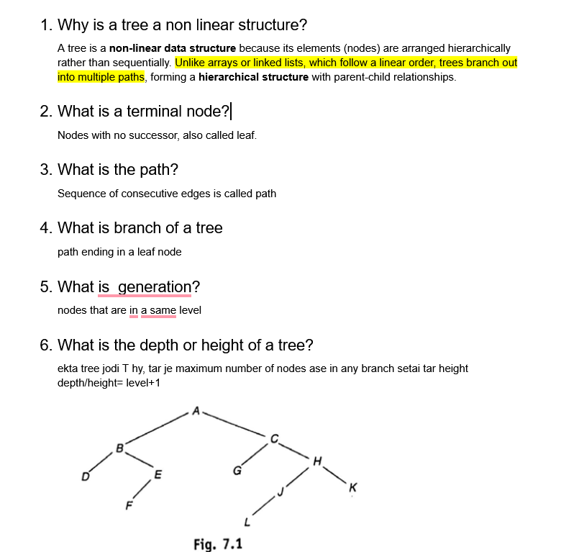
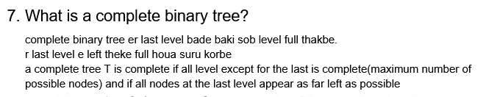
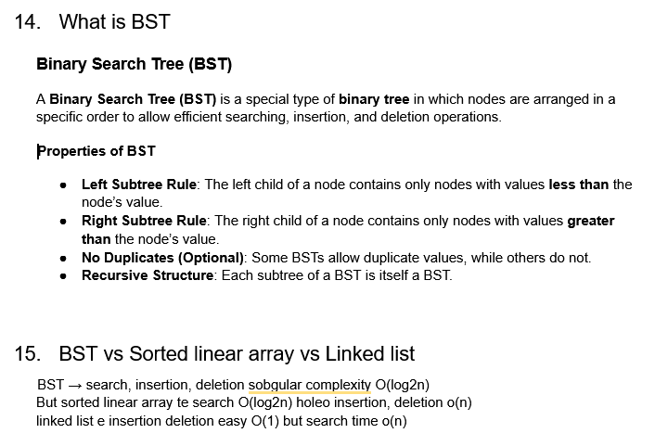
Self: Why is the Worst-Case Time Complexity of BST Operations O(n)?
function INSERT(root, key):
if root == NULL:
root = new Node(key)
return root

if key < root.data:
root.left = INSERT(root.left, key)
else if key > root.data:
root.right = INSERT(root.right, key)
// else: key already exists, do nothing (optional)
return root

function DELETE(root, key):
if root == NULL:
return root

// 1. Normal BST search
if key < root.data:
root.left = DELETE(root.left, key)
else if key > root.data:
root.right = DELETE(root.right, key)

else:
// Found the node to be deleted = root

// Case 1: no child
if root.left == NULL and root.right == NULL:
root = NULL
return root

// Case 2: only one child
else if root.left == NULL:
temp = root.right
root = temp
return root

else if root.right == NULL:
temp = root.left
root = temp
return root

// Case 3: two children
else:
temp = MIN_VALUE_NODE(root.right) // inorder successor
root.data = temp.data // copy value
root.right = DELETE(root.right, temp.data) // delete successor

return root

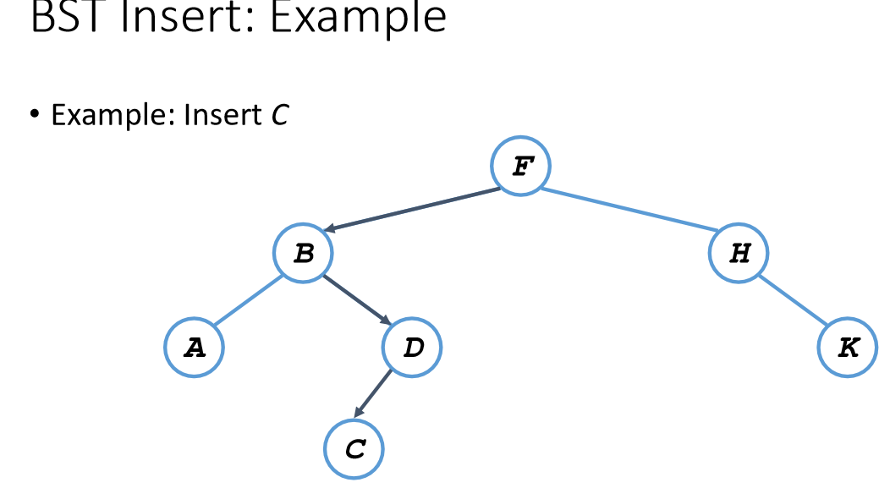
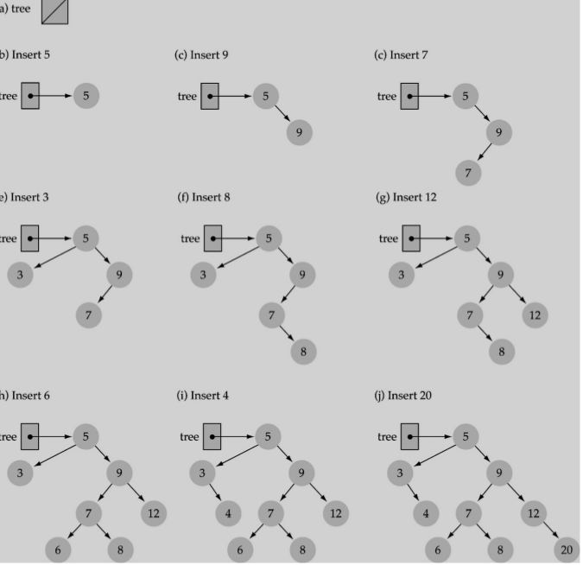
Full binary tree vs complete binary tree
Full-> hoy 0 child or 2 child
Complete-> complete from left, 1 ta child holeo problem nai, but left theke complete hote hobe
Tree traversal
