Create a super user/admin in Django admin so that you can see the tables without the database bash. Run this command:

docker exec -it django-new python manage.py createsuperuser

Now run these commands for

1. docker exec -it django-new python manage.py rewrite_property_titles

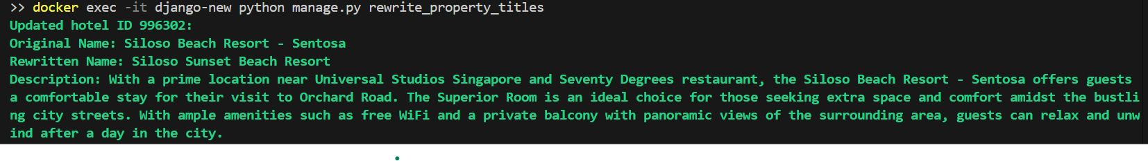

1. docker-compose exec django-new python manage.py rewrite_property_summary

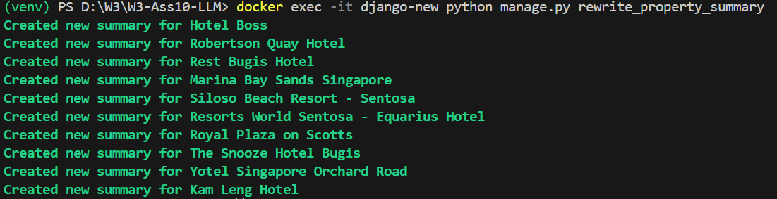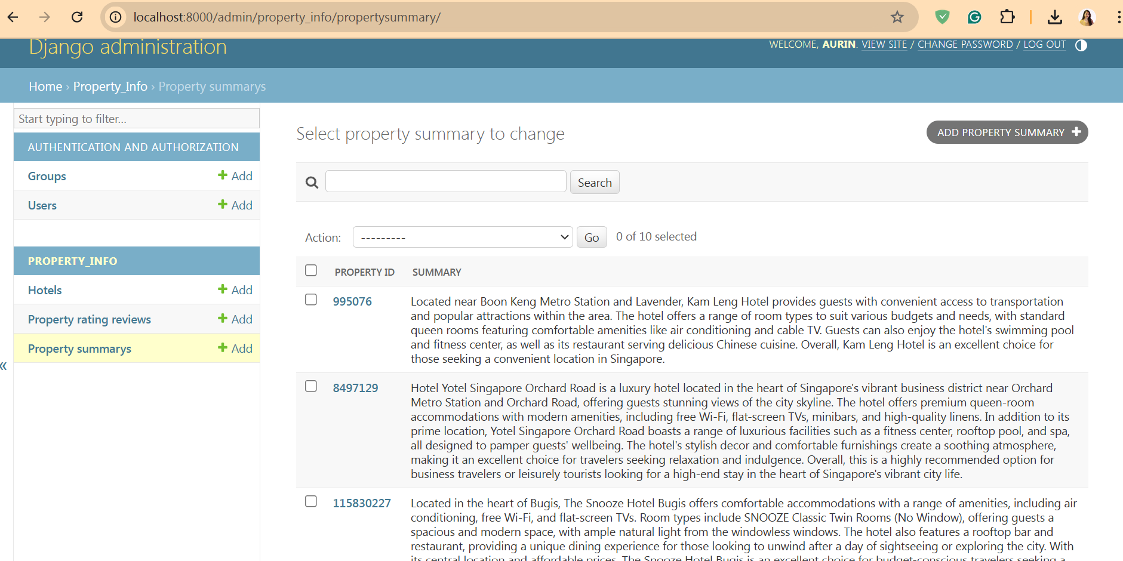

3. docker exec -it django-new python manage.py rewrite_property_rating_review

