Rethinking the Design Space of EHRs towards modeling tools: A pathway for health care to join the “Design Disciplines”

Arnold KIM  
line 2: *dept. name of organization   
(of Affiliation)*  
line 3: *name of organization   
(of Affiliation)*line 4: City, Country  
line 5: email address or ORCID

Laila Ikki  
line 2: *dept. name of organization*  
*(of Affiliation)*  
line 3: *name of organization   
(of Affiliation)*line 4: City, Country  
line 5: email address or ORCIDSabah Mohammed  
line 2: *dept. name of organization   
(of Affiliation)*  
line 3: *name of organization   
(of Affiliation)*line 4: City, Country  
line 5: email address or ORCID

Samia Ishaque  
line 2: *dept. name of organization   
(of Affiliation)*  
line 3: *name of organization   
(of Affiliation)*line 4: City, Country  
line 5: email address or ORCIDJinan Fiaidhi  
line 2: *dept. name of organization   
(of Affiliation)*  
line 3: *name of organization   
(of Affiliation)*line 4: City, Country  
line 5: email address or ORCID

Other Member  
line 2: *dept. name of organization   
(of Affiliation)*  
line 3: *name of organization   
(of Affiliation)*line 4: City, Country  
line 5: email address or ORCID

***Abstract*—**

***Keywords—component, formatting, style, styling, insert (****key words****)***

1. **Patient Case representation space in healthcare**

Complex clinical decision-making is at the forefront of modern medicine. Patient heterogeneity can now be captured with greater nuance, propelling a shift towards more individualized evidence-based care, or *precision medicine* [1]. Advancements in molecular genetics have enabled indicators such as genetic predisposition and biomarker identification to deeply stratify the patient profile [1]. As such, the construction of an optimal treatment plan is predicated on a thorough understanding of all these elements as they relate to each other and as they interact with one another. Moreover, the aging population in North America tends to contribute another layer of complexity to the clinical reasoning process, where there is an influx of patients with chronic conditions that necessitate ongoing management. Multimorbidity is to be expected in members of this age group, and they are more likely to be admitted (and readmitted) to the hospital with longer lengths of stay and greater instances of polypharmacy [2]. All of these dynamic components constitute the ever-evolving patient chart, and all need to be considered when developing, or *designing*, a treatment plan

That being said, there is more to the patient portfolio than empirical observations. In fact, healthcare providers use many non-discrete elements, ranging from body language to tone of voice when shaping a holistic understanding of their patients. These kinds of observations resist traditional modes of measurement because they are difficult to quantify. In fact, there has always been doubt as to whether notions like quality of life or happiness can be truly captured using a numerical scale. In this way, medicine is a human science in both the literal and figurative senses of the phrase一both a science and an art. Reconciling between these two very different spheres is both the labor and fruit of medicine. Healthcare providers continuously juggle the increasingly elaborate genetic screenings, laboratory test results, and clinical observations with the uncertainty and ambiguity concomitant with the discipline. This makes the compounding complexity of medical data an inevitable part of the clinical workflow.

During the diagnosis, treatment and management of medical conditions, the sheer volume of information that a healthcare provider must consider is colossal. It seems as though there is no feasible way to condense it all onto one small computer screen, and any attempt to do so would be similar to trying to view a large room from a keyhole. Accessing all the information needed in order to 1) construct a sound image of the patient and 2) design an optimal treatment plan, is therefore an example of the keyhole effect [3]. The healthcare provider is unable to see the big picture because the screen reduces the amount of information that can be viewed at a particular moment in time [3].

Since one screen does not provide sufficient space for even all the laboratory test results (let alone for documentation or any notes the provider wishes to highlight), modern electronic health records (EHRs) distribute medical data across multiple pages. This is a problematic workaround. Information fragmentation causes relevant content to be spread out, both within an EHR and beyond [4]. The dispersion of information in this manner necessarily conceals any relationships that may exist therein. Such highly fragmented medical data is difficult to access at point-of-care, which impairs the clinical decision-making process and leads to a disrupted clinical workflow [4]. Since healthcare providers need to constantly consult multiple screens, or frequently navigate to different parts of screens, in order to view all the relevant clinical information, they suffer from severe display fragmentation [4].

**FIGURE A:** Screen fragmentation and lack of synthesis of relationships (Problem)

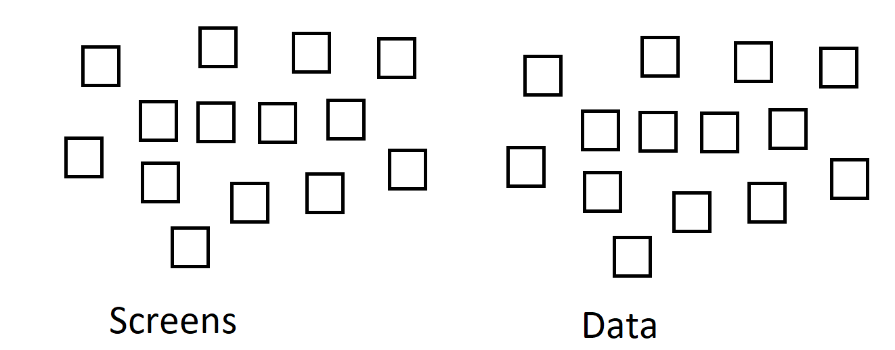

This is taxing on the healthcare provider in two ways: Firstly, there is a manual component, which involves repeated clicking, scrolling, as well as data entry and retrieval. While this may seem insignificant, many healthcare providers report spending more time with pull-down menus than with patients [5]. These manual searches are also pain points during the clinical workflow because they prevent the healthcare provider from completing the task more efficiently.

Next, and perhaps even more importantly, there is the cognitive component. Here, the disjointed nature of medical data forces healthcare providers to retain information pertaining to the case in working memory, even as they continue to search for other points of relevance. This is known as cognitive load [3]. Since display fragmentation purges medical data of the relationships that may exist therein, healthcare providers are expected to perform information retrieval and synthesis in parallel, often in highly stressful and time-sensitive situations. Over time, such cognitively-straining activities can lead to dissatisfaction, frustration, and ultimately burnout [4].

The main issue is that the current EHR setup is incompatible with the clinical workflow. In other words, there is a task-system mismatch, so the attention that should be dedicated to performing the task at hand (i.e., designing the medical plan) is regularly interrupted due to system navigation [4]. Instead of facilitating task completion, the system actually impedes it. There is an opportunity here to draw some similarities between the goals of healthcare providers and those of engineers and artists: Healthcare providers are architects of the patient’s treatment plan. Their job is to draft, propose, adapt, and revise medical plans, following the same iterative cycle used by other domains (e.g., an engineer preparing drafts for a bridge, a graphic designer sketching a three-dimensional model). One cannot help but notice, however, a glaring toolkit disparity. Considering that engineers can use AutoCad and graphic artists can make use of Photoshop, there is a marked robustness gap in the tools currently used by healthcare providers.

Like other disciplines, medicine is profoundly collaborative. However, where other industries have streamlined the joint drafting capabilities of a multidisciplinary team, healthcare is lagging sorely behind. In a field where non-discrete elements like patient wishes are evaluated just as importantly as laboratory test results, there is a marked complexity in striving to achieve a coherent synthesis between members of the primary care unit. As a matter of fact, continuity of care is near impossible to achieve without the ability for team members to recognize and develop an overarching synthesis in their treatment planning. There is therefore a desperate need for a design space conducive to the complex clinical taskscape, but this would necessitate a complete shift in paradigm.

To give you an example, let us take a care scenario that illustrates the difficulty of using EHRs. Assume that all discrete concepts represented here are already pre-mapped to established ontologies elsewhere for the sake of simplicity:

Scenario: A physician must represent their impressions and orders on a patient presenting with CHF. It is suspected to be 2ndary to a type2 NSTEMI. The patient also presented with atrial fibrillation. The physician decides to order a cardiology consult, medicines - *asa 160 mg*, *furosemide 20 mg IV*, *metoprolol 25mg* and oxygen to keep saturation above 94%.

Modern day EHRs are limited in their ability to represent this scenario with discrete data using the variety of data attributes available within the EHRs system. In this scenario, the physician wishes to note the observations made on admitting the patient and the orders they gave while also building relationships between these observations and orders. We face the challenge of adding subjective to the objective such as providing nuance for why a certain medicine is prescribed or how long doctors should wait before administering another medication.

Figure B illustrates this scenario in greater detail. The symbol ‘?’ represents lack of certainty and “!” represents negation. The patient presents with chest pain and on examining the issues are classified as *chf* and *afib*. The issue *nstemi* is unsure and needs to be verified with the opinion of the cardiology department. This diagram draws a relationship between all issues as *chf* and *afib* are linked to *nstemi,* showing that these issues occur due to *nstemi*. Moreover, it also adds narrative to issues and orders to help understand them better. For example, the narrative attached to *metoprolol* warns against administering the medicine before blood pressure stabilizes. EHRs have limited capability to draw these relationships, limiting their expressiveness. Instead, data is fragmented and these relationships are built by healthcare workers in real time.

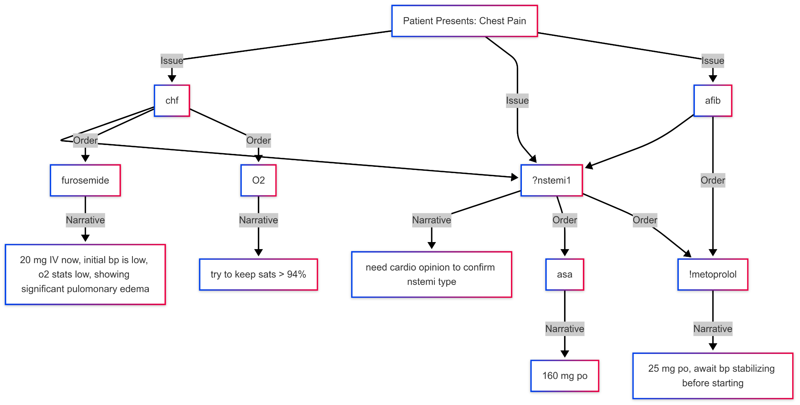

**FIGURE B:** Diagram for patient care scenario

Healthcare is challenged by an increasingly complex discrete concept space, knowledge space, while also having to incorporate concepts and ideas that resist discretization thus the utility of narrative. Relationships between these spaces are paramount for validation, minimizing cognitive load, team collaboration, automation and data analytics. Historically, healthcare's representation space is heavily dependent on statically arranged widgets to delineate data types, and documentation (which captures the indiscrete but is also used as weak substrate for expressing relationships).

To address these challenges, it is important to recognize the need for representing not only discrete ( i.e. labs, medicines and orders) but also the non-discrete (i.e. the reasoning, narrative and care orders flow) elements especially from the perspective of the caregiver according to the patient case progression. However, given the excessive workload healthcare providers face, complex softwares that require coding or technical expertise are often resisted. Therefore it is essential to move to solutions that capture relationships between components of the patient care model without having to write any code. Therefore, Aurora achieves this feat largely using the power of domain specific languages. Domain-specific languages (DSLs) are versatile tools that offer a blend of structured representation and expressive capabilities. Using DSL, we can generate a language specific to healthcare that not only captures what doctors do but is also machine understandable.

To explain this solution in detail and provide a clear understanding of this approach, this paper is organized in the following manner. Section II highlights the list of ideal properties for modeling and design, Section III explains the patient care model as a DSL using Aurora language, Section IV outlines the impact to teaching and learning . Finally Section V presents the conclusion with limitations and future directions.

# II. Ideal Properties for Modeling and Design

Before we discuss the solutions to the aforementioned problems, it is important to outline the principles on which any designing solution should be based. The solution proposed by Aurora focuses on the following principles:

1. Expressiveness

The model should be able to represent patient data, incorporating both discrete and non-discrete elements. This would enable clinicians to derive meaningful information regarding the patient.

1. Synthesis of Information

Clinicians should be able to build relationships between different components of the patient’s chart without navigating numerous widgets. Design tools would help draw connections and reduce cognitive load.

1. Collaborative Drafting

Members of the primary care unit should have access to the evolving status of the patient, as well as to the opinions of their colleagues, without needing to manually screen pages of documentation and charts.

1. Zoom Capability

Toggling between high-level and low-level views enables clinicians to continuously check in on the big picture all the while making adjustments in highly localized areas of the patient plan. High-level views make the relationships between coordinates of care more explicit (presenting them as *constellations* if you will), lowering the cognitive burden and centering the workflow on design.

# III. Envisioning Patient Care Model as Domain Specific Language (DSL)

Let us examine the patient care model as a DSL in the following pseudo code. For the sake of simplicity, let us assume that all shorthand and terms such as nstemi, chf, furosemide and asa are mapped to appropriate ontology terms by the author or local policy elsewhere.

| ProblemList: |
| --- |
| ?**nstemi1** //could be type 2 nstemi being 2ndary to a.fib and chf. need cardiology opinion  **afib [?nstemi1]**  **chf**[**nstemi1** ]  **homeless**  **trajectory:** unstable |
| Orders: |
| **Diagnosis** [**nstemi1** ,**afib**,**chf**]  **consult cardiology** stat [**nstemi1** ,**afib**,**chf**]  **asa** [**nstemi1** ] 160 mg po now  **furosemide** [**chf**] 20 mg iv now //there was an initial dip in blood pressure, however o2 sats are low and cxr showing significant pulmonary edema, we need to monitor closely  !**metoprolol** [**afib**,**nstemi1** ] 25 mg po now //will await bp showing more stability before starting this  **o2**[**chf**] //try to keep sats > 94%  **socialworker** [**homeless**] //recently evicted after recent job loss |

This illustrates how multiple discrete concepts can be laid out in a manner where their data types are delineated by syntax and not just by the static arrangement of widgets. Moreover, relationships between various data types are explicitly encoded as each order is connected to a certain care problem in the problem list.

Other than building relationships between problems and orders, this combines the discrete and non-discrete using double slashes. The double slashes are inspired by the classical comments used in programming and provide narrative to add to the discrete concept map that emerges. Is this documentation, orders or data entry? Arguably this is all of the above. It is both machine and human readable. In this way clinical documentation could exist in-line with medical orders and prescriptions. The immediate effect is access to the clinical reasoning process of other members of the primary care team, and the elimination of possible confusion resulting from unexplained orders.

Arranging information in this way also reduces data fragmentation and the cognitive load of frontline healthcare workers. Rather than navigating between widgets to gather information, this reshapes the design space to make information more accessible and easily readable.

Aurora is currently using Scala and Langium to develop a domain specific language to implement this pseudocode. The tech stack makes use of Langium to generate an abstract syntax tree (AST) for the domain specific language and builds on that using Sprotty and Scala to visualize the AST.

**# add an example of the AST and explain how it aligns with design principles**

This aligns with the design principles outlined in section II as it:

* Helps express discrete and non- discrete elements using narratives or comments
* Builds relationships between elements using the tree structure and drawing cross-reference between nodes of the tree
* Ensures zoom capability

# IV. Impact on Teaching and Learning

# V. Conclusion

After the text edit has been completed, the paper is ready for the template. Duplicate the template file by using the Save As command, and use the naming convention prescribed by your conference for the name of your paper. In this newly created file, highlight all of the contents and import your prepared text file. You are now ready to style your paper; use the scroll down window on the left of the MS Word Formatting toolbar.

## *Authors and Affiliations*

**The template is designed for, but not limited to, six authors.** A minimum of one author is required for all conference articles. Author names should be listed starting from left to right and then moving down to the next line. This is the author sequence that will be used in future citations and by indexing services. Names should not be listed in columns nor group by affiliation. Please keep your affiliations as succinct as possible (for example, do not differentiate among departments of the same organization).

### *For papers with more than six authors:* Add author names horizontally, moving to a third row if needed for more than 8 authors.

### *For papers with less than six authors:* To change the default, adjust the template as follows.

#### *Selection:* Highlight all author and affiliation lines.

#### *Change number of columns:* Select the Columns icon from the MS Word Standard toolbar and then select the correct number of columns from the selection palette.

#### *Deletion:* Delete the author and affiliation lines for the extra authors.

## *Identify the Headings*

Headings, or heads, are organizational devices that guide the reader through your paper. There are two types: component heads and text heads.

Component heads identify the different components of your paper and are not topically subordinate to each other. Examples include Acknowledgments and References and, for these, the correct style to use is “Heading 5”. Use “figure caption” for your Figure captions, and “table head” for your table title. Run-in heads, such as “Abstract”, will require you to apply a style (in this case, italic) in addition to the style provided by the drop down menu to differentiate the head from the text.

Text heads organize the topics on a relational, hierarchical basis. For example, the paper title is the primary text head because all subsequent material relates and elaborates on this one topic. If there are two or more sub-topics, the next level head (uppercase Roman numerals) should be used and, conversely, if there are not at least two sub-topics, then no subheads should be introduced. Styles named “Heading 1”, “Heading 2”, “Heading 3”, and “Heading 4” are prescribed.

## *Figures and Tables*

#### *Positioning Figures and Tables:* Place figures and tables at the top and bottom of columns. Avoid placing them in the middle of columns. Large figures and tables may span across both columns. Figure captions should be below the figures; table heads should appear above the tables. Insert figures and tables after they are cited in the text. Use the abbreviation “Fig. 1”, even at the beginning of a sentence.

1. Table Type Styles

| **Table Head** | **Table Column Head** | | |
| --- | --- | --- | --- |
| ***Table column subhead*** | ***Subhead*** | ***Subhead*** |
| copy | More table copya |  |  |

1. Sample of a Table footnote. (*Table footnote*)
2. Example of a figure caption. (*figure caption*)

Figure Labels: Use 8 point Times New Roman for Figure labels. Use words rather than symbols or abbreviations when writing Figure axis labels to avoid confusing the reader. As an example, write the quantity “Magnetization”, or “Magnetization, M”, not just “M”. If including units in the label, present them within parentheses. Do not label axes only with units. In the example, write “Magnetization (A/m)” or “Magnetization {A[m(1)]}”, not just “A/m”. Do not label axes with a ratio of quantities and units. For example, write “Temperature (K)”, not “Temperature/K”.

##### mm,m,mm,,mn,mn,mnn

##### Acknowledgment *(Heading 5)*

The preferred spelling of the word “acknowledgment” in America is without an “e” after the “g”. Avoid the stilted expression “one of us (R. B. G.) thanks ...”. Instead, try “R. B. G. thanks...”. Put sponsor acknowledgments in the unnumbered footnote on the first page.

##### References

The template will number citations consecutively within brackets [1]. The sentence punctuation follows the bracket [2]. Refer simply to the reference number, as in [3]—do not use “Ref. [3]” or “reference [3]” except at the beginning of a sentence: “Reference [3] was the first ...”

Number footnotes separately in superscripts. Place the actual footnote at the bottom of the column in which it was cited. Do not put footnotes in the abstract or reference list. Use letters for table footnotes.

Unless there are six authors or more give all authors’ names; do not use “et al.”. Papers that have not been published, even if they have been submitted for publication, should be cited as “unpublished” [4]. Papers that have been accepted for publication should be cited as “in press” [5]. Capitalize only the first word in a paper title, except for proper nouns and element symbols.

For papers published in translation journals, please give the English citation first, followed by the original foreign-language citation [6].

1. Igwama, Geneva Tamunobarafiri, Janet Aderonke Olaboye, Chukwudi Cosmos Maha, Mojeed Dayo Ajegbile, and Samira Abdul. "Integrating electronic health records systems across borders: Technical challenges and policy solutions." *International Medical Science Research Journal* 4, no. 7 (2024): 788-796.
2. Alanazi, Abdullah, Amal Almutib, and Bakheet Aldosari. "Physicians’ Perspectives on a Multi-Dimensional Model for the Roles of Electronic Health Records in Approaching a Proper Differential Diagnosis." Journal of Personalized Medicine 13, no. 4 (2023): 680.
3. Chen, Chun‑You, Ya-Lin Chen, Jeremiah Scholl, Hsuan-Chia Yang, and Yu-Chuan Jack Li. "Ability of machine-learning based clinical decision support system to reduce alert fatigue, wrong-drug errors, and alert users about look alike, sound alike medication." *Computer Methods and Programs in Biomedicine* 243 (2024): 107869.
4. Duval Jensen, Julie, Loni Ledderer, Raymond Kolbæk, and Kirsten Beedholm. "Fragmented care trajectories in municipal healthcare: Local sensemaking of digital documentation." *Digital Health* 9 (2023): 20552076231180521.

**IEEE conference templates contain guidance text for composing and formatting conference papers. Please ensure that all template text is removed from your conference paper prior to submission to the conference. Failure to remove template text from your paper may result in your paper not being published.**