FOOD FORWARD
A Web-Based Food Donation Platform
Connecting Donors, Restaurants, and Charities
PROPOSED SOLUTION REPORT
Junior Project • Web Application
Django • Python • MySQL • HTML • CSS • JavaScript • Bootstrap • GitHub
Prepared by: ____________________________________________
Student ID: ____________________________________________
Institution / Department: ____________________________________________
Submission Date: ____________________________________________
A transparent digital bridge from donation intent to confirmed meal receipt.

00 REPORT OVERVIEW
Purpose, scope, and structure of the proposed solution

Purpose of this report
This report defines how Food Forward will solve the coordination, transparency, verification, and allocation problems identified in the project proposal and literature review. It converts the project idea into a practical system design suitable for implementation as a junior web-application project.

Table of Contents
Section | Topic
01 | Introduction and Design Rationale
02 | Proposed Solution Overview
03 | Objectives and Scope
04 | Stakeholders and User Roles
05 | Core Functional Modules
06 | End-to-End Workflow
07 | Needed Most Allocation
08 | System Architecture
09 | Database Design
10 | Requirements
11 | Security, Safety and Governance
12 | Interface Design
13 | Implementation Plan
14 | Testing and Evaluation
15 | Feasibility and Risks
16 | Expected Outcomes and KPIs
17 | Future Enhancements
18 | Conclusion

Project at a Glance
Food Forward enables a donor to purchase a predefined meal package from an approved restaurant and direct it to a verified charity. The platform records every stage—payment, acceptance, preparation, delivery, and confirmation—while providing a demand-based option that assigns the donation to the charity with the greatest current need.

01 INTRODUCTION AND DESIGN RATIONALE
Why the proposed system is needed

Food Forward is proposed as a centralized, responsive web application that connects four key participants: donors, restaurants, charities, and administrators. The solution responds to fragmented donation practices in which communication, verification, payment records, preparation status, delivery confirmation, and impact reporting are often handled separately or manually.
The project does not treat technology as a complete solution to hunger or food waste. Instead, it uses digital coordination to make charitable meal donations easier to initiate, safer to manage, fairer to allocate, and more transparent to all participants. The core design principle is accountability: every donation must have a clear owner, recipient, status, and confirmation record.
Identified Challenge | Food Forward Response
Manual and disconnected coordination | One platform with role-based workflows and shared donation records
Limited donor visibility after payment | Status tracking, notifications, and searchable donation history
Unverified restaurants or charities | Administrator approval and account-status controls
Unequal distribution among charities | Demand-aware “Donate Where It Is Needed Most” assignment
Unclear responsibility at hand-off | Recorded status transitions and charity receipt confirmation
Weak reporting and impact evidence | Dashboards, totals, completion metrics, and downloadable reports
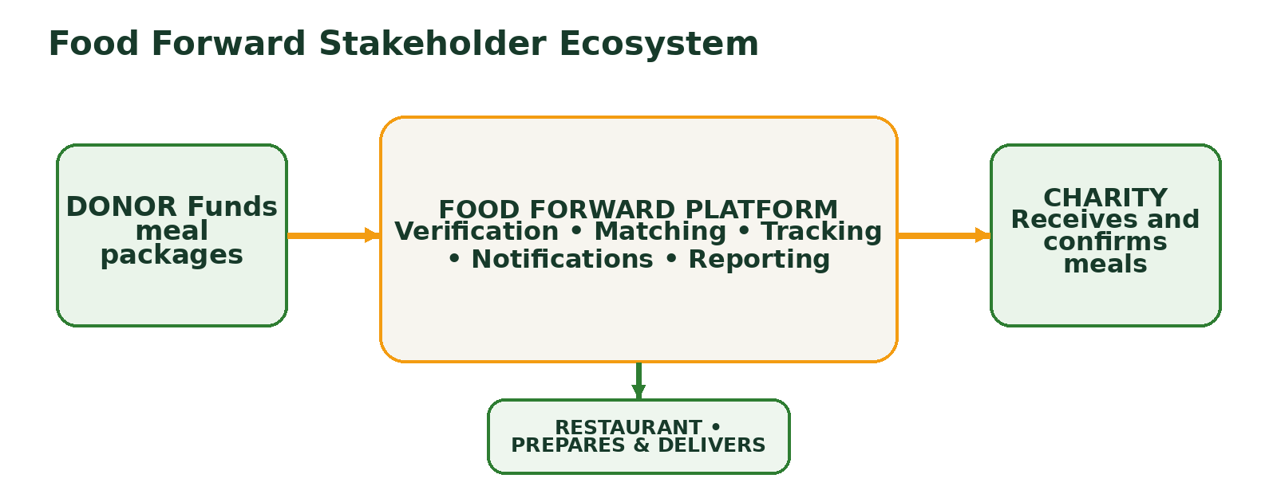
Figure 1. Food Forward stakeholder ecosystem and accountability chain.
Solution Principle
A donation is considered complete only when the charity confirms successful receipt. This avoids treating payment alone as proof of impact.

02 PROPOSED SOLUTION OVERVIEW
A responsive multi-role donation platform

Food Forward will provide a controlled marketplace-style donation experience. Unlike a normal food-delivery application, the donor does not purchase a meal for personal consumption. The donor selects a meal package offered by a registered restaurant and assigns that meal to a verified charity. The restaurant then accepts, prepares, and delivers or hands over the order, while the charity confirms completion.
Solution Component | Description
Centralized Web Platform | A browser-based application accessible from desktop, tablet, and mobile devices.
Verified Partner Network | Restaurants and charities become active only after administrator review.
Meal Package Catalogue | Restaurants publish standardized donation packages with name, quantity, price, and availability.
Trackable Donation Journey | Each order moves through defined statuses from creation to confirmed receipt.
Demand-Based Assignment | Donors can select a charity or let the platform prioritize the highest verified demand.
Notifications and History | Participants receive updates, and donors retain a complete record of their contributions.
Administrative Oversight | Administrators manage approvals, users, donations, complaints, and reporting.
Academic Payment Simulation | The prototype records payment completion without processing real funds.
Primary Value Proposition
Food Forward creates a single accountable digital workflow connecting the person funding the meal, the restaurant preparing it, and the charity confirming its receipt. The platform therefore improves coordination without removing human responsibility at the most important stages.
Scope Boundary
The junior-project version will focus on the complete software workflow. Real payment settlement, live GPS delivery tracking, regulatory certification, and large-scale logistics optimization are reserved for future development.

03 OBJECTIVES AND SCOPE
What the system must accomplish

- Develop a centralized platform dedicated to meal donations rather than commercial food ordering.
- Connect donors, approved restaurants, and verified charities through one consistent workflow.
- Provide transparent tracking from donation creation to charity confirmation.
- Enable restaurants to create and manage predefined charitable meal packages.
- Allow charities to maintain demand information and confirm received donations.
- Promote fairer distribution through demand-based automatic assignment.
- Provide administrators with verification, monitoring, reporting, and complaint-management controls.
- Demonstrate full-stack web development using Django, MySQL, Bootstrap, and GitHub.
Included in Prototype | Excluded / Future Scope
Role-based registration and authentication | Production payment processing
Restaurant and charity approval | Real-time GPS delivery tracking
Meal package management | Native Android or iOS application
Donation creation and simulated payment | Automated legal or food-safety certification
Status updates and notifications | AI-driven route optimization
Donation history and reports | Multi-country tax and regulatory support

04 STAKEHOLDERS AND USER ROLES
Responsibilities and permissions

Role | Primary Capabilities | Key Responsibility
Donor | Register and log in; browse restaurants; select meal packages; choose a charity or Needed Most; complete simulated payment; track donations; view notifications. | Provide accurate information and fund a selected donation package.
Restaurant | Manage profile; publish meal packages; accept donation orders; update preparation and delivery status; view order history. | Prepare the correct quantity within the stated time and update status accurately.
Charity | Register for approval; maintain profile and demand level; receive donations; confirm delivery; view donation records. | Confirm only successfully received meals and keep need information current.
Administrator | Verify restaurants and charities; manage accounts; monitor donations; review complaints; configure allocation rules; produce reports. | Maintain trust, data quality, fairness, and operational oversight.
Role-Based Access Control
Users will see only the functions relevant to their role. Donors cannot change restaurant statuses, restaurants cannot approve charities, charities cannot alter payment records, and administrators can review platform activity without impersonating normal workflow actions. Django permissions and view-level checks will enforce these boundaries.
Approval Rule
Restaurant and charity profiles remain inactive until an administrator reviews required details and marks the account as approved. Unapproved profiles cannot publish packages or receive donations.

05 CORE FUNCTIONAL MODULES
The building blocks of the platform

Module | Purpose
Authentication and Profiles | Registration, login, logout, password handling, profile editing, role assignment, and account status.
Restaurant Management | Restaurant profile, verification status, service area, contact details, and operational availability.
Charity Management | Charity profile, approval status, demand level, capacity, location, and receipt records.
Meal Package Management | Package name, description, price, meal quantity, availability, preparation time, and image.
Donation Management | Order creation, recipient selection, allocation mode, quantity, amount, timestamps, and status history.
Payment Simulation | Demonstration payment method, transaction reference, amount, and completion status.
Tracking and Notifications | Status updates, in-app messages, read/unread state, and activity timestamps.
Donation History | Searchable donor, restaurant, and charity records with completion evidence.
Administrative Dashboard | Approvals, user management, donation monitoring, reports, statistics, complaints, and settings.
Impact Reporting | Meals funded, donations completed, average completion time, allocation distribution, and partner activity.

06 END-TO-END DONATION WORKFLOW
How a donation moves from intent to confirmed receipt

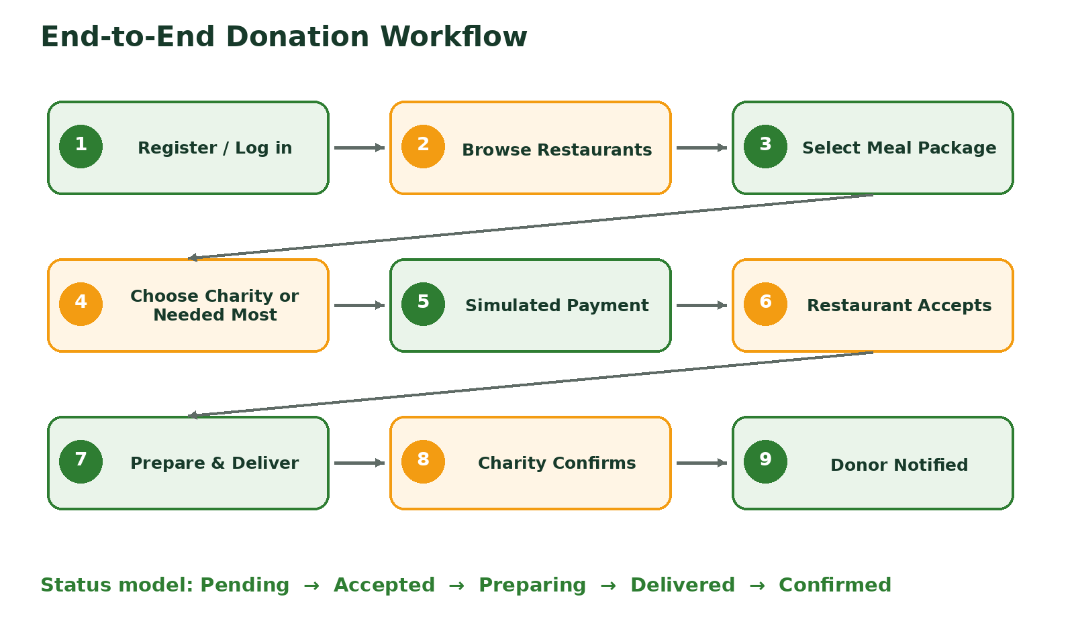
Figure 2. Proposed end-to-end donation workflow.
Status | Triggered By | Meaning
Pending | System after payment simulation | Donation has been created and awaits restaurant review.
Accepted | Restaurant | Restaurant has committed to preparing the selected package.
Preparing | Restaurant | Meal preparation is underway.
Delivered | Restaurant | Meal has been delivered or handed over to the charity.
Confirmed | Charity | Charity confirms correct and successful receipt.
Cancelled | Authorized participant / admin | Donation cannot continue; reason must be recorded.
Workflow Controls
- Each status transition records the responsible user and timestamp.
- Only valid transitions are accepted; for example, a donation cannot move directly from Pending to Confirmed.
- Donors are notified after key events, including acceptance, delivery, confirmation, or cancellation.
- Administrators can review the full status history and investigate delays or disputes.
- Charity confirmation closes the operational workflow and contributes to impact totals.
07 DONATE WHERE IT IS NEEDED MOST
Demand-aware charity allocation

A distinctive feature of Food Forward is the option to donate without choosing a specific charity. When the donor selects “Donate Where It Is Needed Most,” the platform considers only approved charities that are active, eligible, and currently accepting donations. It then assigns the donation to the highest-priority organization using clearly defined criteria.
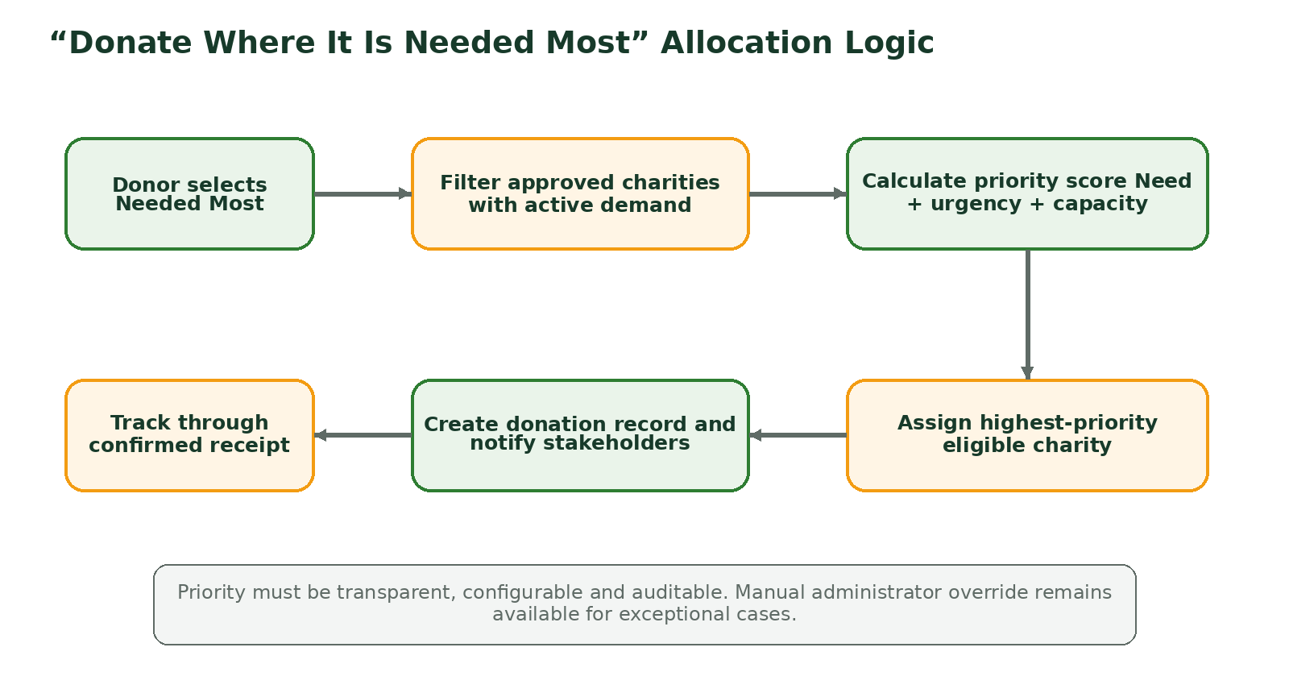
Figure 3. Proposed demand-based allocation logic.
Priority Factor | Example Input | Purpose
Current Demand | Meals currently requested or demand level | Direct support toward documented need.
Urgency | Time-sensitive request or low remaining supply | Prioritize immediate service pressure.
Capacity | Ability to receive the package quantity | Avoid assignments that cannot be handled.
Recent Allocation | Donations received in a configurable period | Reduce repeated concentration on one charity.
Location / Service Area | Restaurant and charity delivery compatibility | Support practical and timely hand-off.
Eligibility | Approval, active status, and policy compliance | Exclude unavailable or unverified recipients.
Fairness and Auditability
The prototype should store the selected charity, allocation mode, priority inputs, score, and assignment time. Administrators must be able to review the result and apply a reasoned override when necessary.

08 SYSTEM ARCHITECTURE
Technical structure and technology stack

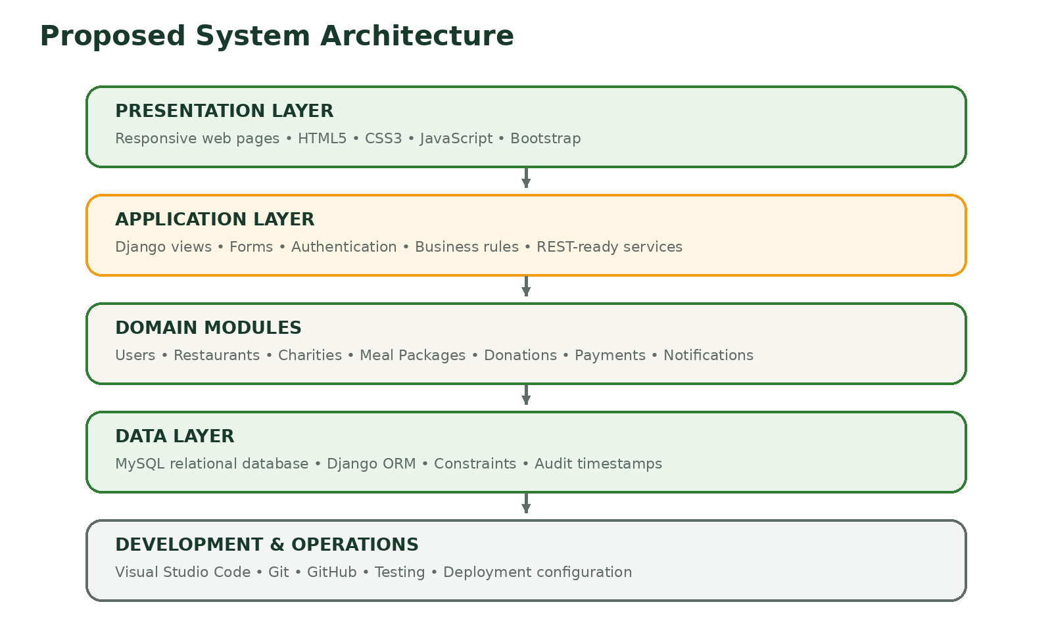
Figure 4. Layered architecture for the Food Forward prototype.
Component | Technology | Reason for Selection
Frontend | HTML5, CSS3, JavaScript, Bootstrap | Responsive interfaces, rapid prototyping, and broad browser support.
Backend | Django with Python | Built-in authentication, ORM, forms, admin interface, security features, and modular development.
Database | MySQL | Structured relational storage for users, transactions, statuses, and reports.
Database Tool | phpMyAdmin | Convenient academic database inspection and administration.
Development Environment | Visual Studio Code | Accessible editor with Python, Git, and web-development support.
Version Control | Git and GitHub | Collaboration, change history, issue tracking, documentation, and release management.
Suggested Django Application Structure
Django App | Responsibility
accounts | Authentication, profiles, roles, permissions, and approval status.
restaurants | Restaurant profiles, meal packages, availability, and order actions.
charities | Charity profiles, demand data, capacity, and receipt confirmation.
donations | Donation creation, allocation, statuses, history, and impact records.
payments | Simulated transactions and future payment-gateway integration points.
notifications | In-app updates and future email/SMS service hooks.
dashboard | Administrative monitoring, reports, analytics, and configuration.
09 DATABASE DESIGN
Entities, relationships, and data integrity

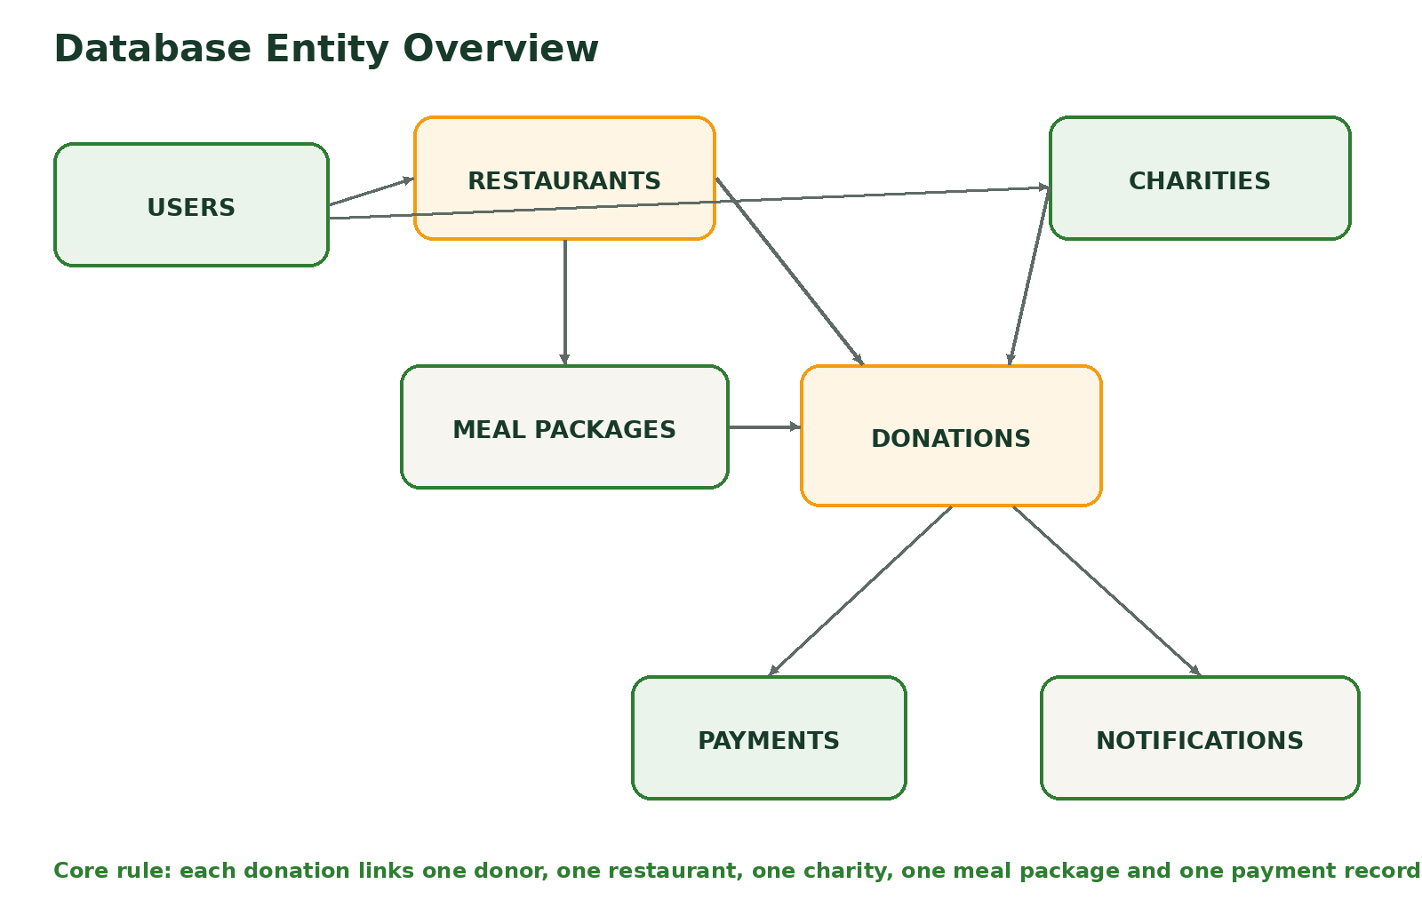
Figure 5. High-level database entity overview.
Primary Table | Purpose
Users | Authentication details, role, account status, and profile metadata.
Restaurants | Restaurant profile, verification, address, owner, and operational status.
Charities | Charity details, approval status, current demand, capacity, and receipt settings.
Meal Packages | Restaurant-created package, description, price, quantity, preparation time, and availability.
Donations | Donor, restaurant, charity, package, quantity, allocation mode, amount, and current status.
Donation Status History | Every status transition with timestamp, responsible user, and optional note.
Payments | Simulated transaction reference, method, amount, status, and completion time.
Notifications | Recipient, message, read state, related donation, and created time.
Complaints / Support | Issue type, participant, related donation, evidence, resolution, and status.
Data Integrity Rules
- A donation must reference an active donor, approved restaurant, available meal package, and approved charity.
- The selected meal package must belong to the selected restaurant.
- The total donation amount should be calculated by the system rather than entered manually.
- Only the restaurant associated with the donation can update preparation and delivery statuses.
- Only the assigned charity can confirm receipt.
- Important transaction and status records should not be physically deleted; they should be archived or marked inactive.

10 SYSTEM REQUIREMENTS
Functional and non-functional expectations

10.1 Functional Requirements
ID | Requirement
FR-01 | The system shall allow users to register and authenticate according to role.
FR-02 | The administrator shall approve or reject restaurant and charity applications.
FR-03 | Approved restaurants shall create, edit, activate, and deactivate meal packages.
FR-04 | Donors shall browse approved restaurants and available meal packages.
FR-05 | Donors shall select a charity or choose Needed Most allocation.
FR-06 | The system shall create a payment record and donation after successful payment simulation.
FR-07 | Restaurants shall accept donations and update preparation and delivery statuses.
FR-08 | Charities shall confirm successful receipt or report an issue.
FR-09 | The system shall notify relevant users when important status changes occur.
FR-10 | The system shall maintain donation history and status history.
FR-11 | Administrators shall monitor donations, users, approvals, complaints, and reports.
FR-12 | The system shall calculate impact indicators from confirmed donations.
10.2 Non-Functional Requirements
Category | Requirement
Usability | Core tasks should be understandable without technical training and usable on mobile-sized screens.
Performance | Normal pages and dashboard views should respond quickly under expected prototype usage.
Security | Authentication, authorization, validation, CSRF protection, password hashing, and secure session handling are required.
Reliability | Status records, payment records, and confirmation evidence must remain consistent after errors or refreshes.
Maintainability | Modules, templates, models, and services should be separated and documented.
Scalability | The data model should support additional cities, restaurants, charities, and donations.
Accessibility | Forms should have labels, readable contrast, keyboard support, and clear validation messages.
Auditability | Critical approvals, assignments, payments, and status transitions should record actor and time.
11 SECURITY, SAFETY AND GOVERNANCE
Trust controls beyond basic functionality

Area | Proposed Control
Authentication | Django authentication, password hashing, session management, logout, and password-reset readiness.
Authorization | Role checks, ownership checks, approval checks, and server-side permission enforcement.
Input Security | Form validation, CSRF protection, safe file-upload rules, output escaping, and database ORM usage.
Privacy | Collect only required personal information; limit profile visibility; protect contact details.
Transaction Integrity | System-calculated totals, immutable references, status-history logging, and duplicate-submission protection.
Partner Verification | Administrator review of restaurant and charity identity and operational information.
Food Safety Support | Package descriptions, preparation windows, handling notes, and clear responsibility for safe preparation and hand-off.
Complaint Resolution | Participants can report missing, late, incorrect, or unsafe deliveries for administrator review.
Data Backup | Scheduled database backup procedures for deployment and recovery.
Governance | Published terms, role responsibilities, cancellation rules, allocation logic, and administrator audit trail.
Important Limitation
The software can support food-safety information and traceability, but it cannot replace legal compliance, trained food handling, inspection, or partner responsibility. A real deployment would require local legal and operational review.

12 INTERFACE AND USER EXPERIENCE DESIGN
Simple, role-specific, and transparent

User | Recommended Main Screens
Public Visitor | Home, how it works, restaurants, charities, impact summary, registration, login.
Donor | Dashboard, restaurant catalogue, package details, charity selection, checkout simulation, donation tracking, history, notifications.
Restaurant | Dashboard, profile, meal packages, incoming donations, status update, history, performance summary.
Charity | Dashboard, profile, demand update, incoming donations, receipt confirmation, history, notifications.
Administrator | Approval queue, users, restaurants, charities, donations, complaints, reports, allocation settings, audit records.
Design Principles
- Use a calm green and warm orange visual identity associated with sustainability, food, and action.
- Keep the main donation flow short: package, charity, review, payment simulation, confirmation.
- Show the current donation status prominently with a readable timeline.
- Use plain-language messages rather than technical terms.
- Display approval and availability states clearly to prevent invalid actions.
- Provide immediate form feedback and confirmation after critical actions.
- Make all major screens responsive and keyboard accessible.
13 IMPLEMENTATION PLAN
Iterative development through the SDLC

Phase | Main Activities | Deliverable
1. Requirements | Confirm roles, workflows, rules, fields, and acceptance criteria. | Requirements specification and backlog.
2. Design | Database model, wireframes, architecture, permissions, and status rules. | ER overview, UI plan, and technical design.
3. Foundation | Create Django project, apps, authentication, MySQL connection, and base templates. | Running project skeleton.
4. Partner Modules | Develop restaurant, charity, approval, and meal-package features. | Verified partner workflow.
5. Donation Workflow | Develop package selection, allocation, simulated payment, status tracking, and notifications. | Complete donation journey.
6. Administration | Build monitoring, reports, complaints, and configuration screens. | Administrator dashboard.
7. Testing | Unit, integration, permission, usability, validation, and workflow testing. | Test report and corrected prototype.
8. Delivery | Deployment preparation, documentation, user guide, presentation, and final report. | Submitted project package.
Suggested Development Order
- Authentication and role models
- Restaurant and charity approval
- Meal package catalogue
- Donation and payment simulation
- Status history and notifications
- Needed Most allocation
- Administrative reports and complaint handling
- Responsive design, testing, and deployment documentation
14 TESTING AND EVALUATION
How the solution will be validated

Test Type | Focus | Example
Unit Testing | Individual functions, models, forms, and allocation rules. | Donation total and priority score are calculated correctly.
Integration Testing | Interaction among modules and database relationships. | Payment simulation creates one valid donation and notification set.
Permission Testing | Role and ownership restrictions. | A restaurant cannot update another restaurant’s donation.
Workflow Testing | Valid and invalid status transitions. | Confirmed status is blocked before Delivered.
Validation Testing | Required fields, limits, and invalid data. | Unavailable packages cannot be ordered.
Usability Testing | Clarity, task completion, mobile layout, and messages. | A donor completes the donation flow without assistance.
Security Testing | Authentication, CSRF, access control, and input handling. | Protected pages reject unauthorized requests.
User Acceptance Testing | Stakeholder expectations and practical usefulness. | Representatives review donor, restaurant, charity, and admin tasks.
Evaluation Metrics
Metric | Definition
Completion Rate | Percentage of created donations that reach Confirmed status.
Median Completion Time | Typical duration from payment simulation to charity confirmation.
Allocation Equity | Distribution of donations across charities relative to demand levels.
User Task Success | Percentage of participants completing key tasks correctly.
Error Rate | Validation, permission, or workflow failures observed during testing.
User Satisfaction | Stakeholder rating of usability, trust, and transparency.
Meals Delivered | Total meal quantity represented by confirmed donations.
Partner Activity | Number of active restaurants, charities, packages, and completed donations.

15 FEASIBILITY AND RISK MANAGEMENT
Why the solution is achievable and how challenges will be controlled

Feasibility Area | Assessment
Technical | The selected stack supports authentication, relational data, forms, dashboards, and rapid modular development.
Operational | Each user role has a clear responsibility, reducing ambiguity in the donation workflow.
Economic | Open-source technologies and simulated payment keep prototype development costs low.
Schedule | Core features can be developed incrementally and demonstrated without external logistics integration.
Academic | The project demonstrates database design, security, full-stack development, testing, teamwork, and documentation.
Social | The system addresses a meaningful coordination problem and provides measurable indicators of contribution delivery.
Risk | Impact | Mitigation
Partner information is inaccurate | Low trust and failed donations | Administrator verification, profile review, and periodic revalidation.
Restaurant delays or cancellation | Poor donor and charity experience | Preparation estimates, status deadlines, alerts, and cancellation reasons.
Charity demand data is outdated | Unfair Needed Most allocation | Demand expiry, reminders, activity checks, and administrator override.
Duplicate or invalid payment simulation | Incorrect donation records | Unique references, server-side validation, and idempotent submission handling.
Unauthorized status changes | Data and trust failure | Role, ownership, and transition checks on the server.
Scope becomes too large | Incomplete prototype | Prioritize the core journey and defer real payment, GPS, mobile app, and advanced AI.
Limited stakeholder testing | Weak practical validation | Use structured usability sessions and document limitations clearly.
16 EXPECTED OUTCOMES AND KEY PERFORMANCE INDICATORS
Technical, academic, and social value

Outcome | Expected Evidence
Transparent Donations | Complete payment, status, notification, and confirmation history for each donation.
Improved Coordination | Clear next actions for donor, restaurant, charity, and administrator.
Fairer Allocation | Demand-aware assignments with recorded factors and administrator oversight.
Verified Participation | Only approved restaurant and charity profiles are active in the workflow.
Measurable Impact | Confirmed meals, completion rate, completion time, and partner activity totals.
Reduced Process Friction | Shorter and more consistent coordination than manual messaging.
Full-Stack Learning | Practical use of Django, MySQL, Bootstrap, GitHub, testing, and deployment preparation.
Professional Documentation | Requirements, design, source history, test results, user guide, and final report.
Prototype Success Criterion
The project is successful when a donor can create a donation, the correct restaurant can accept and prepare it, the assigned charity can confirm receipt, and the entire journey remains visible in a consistent activity record.

17 FUTURE ENHANCEMENTS
Path from academic prototype to real deployment

Enhancement | Description
Real Payment Gateways | Integrate SSLCommerz, bKash, Nagad, cards, refunds, receipts, and reconciliation.
Mobile Applications | Native or cross-platform applications for donors and partners.
GPS and Delivery Tracking | Location updates, estimated arrival, proof of hand-off, and delivery zones.
Real-Time Communication | WebSockets, email, SMS, and push notifications.
Advanced Allocation | Use demand, urgency, distance, capacity, dietary fit, and historical equity.
Analytics Dashboard | Trend charts, impact reports, restaurant activity, charity need, and completion bottlenecks.
Food-Safety Records | Handling guidance, timestamps, temperature or packaging evidence, and issue reporting.
Multi-City Operations | Regional administration, location discovery, service zones, and localized policies.
Surplus Food Module | Allow approved restaurants to offer safe surplus items in addition to donor-funded packages.
Public Impact Portal | Anonymized totals, success stories, partner recognition, and downloadable reports.
18 CONCLUSION
Overall value of the proposed solution

Food Forward is designed as a transparent digital bridge among people willing to fund meals, restaurants able to prepare them, and charities serving communities in need. The proposed solution combines role-based access, verified participation, structured meal packages, simulated payment, status tracking, notifications, charity confirmation, administrative oversight, and demand-aware allocation in one coherent workflow.
The design is technically feasible within a junior-project scope because it uses a mature web framework, a relational database, responsive frontend tools, and modular development practices. At the same time, it creates meaningful opportunities to demonstrate authentication, permissions, workflow modeling, database integrity, usability, testing, version control, and reporting.
Most importantly, the platform treats transparency as an operational feature rather than a slogan. A donation is not merely recorded when money is committed; it is tracked until the meal is prepared, delivered, and confirmed. This gives Food Forward a clear academic contribution and a practical foundation for future community deployment.
Final Statement
Food Forward transforms a simple intention to help into a verifiable, coordinated, and fairly allocated meal donation journey.

Project Basis and Technical References
- Django Software Foundation. Django Documentation.
- Oracle Corporation. MySQL Documentation.
- Bootstrap Team. Bootstrap Documentation.
- GitHub. GitHub Documentation.
- Food Forward project proposal and literature-review materials prepared for the Junior Project.
- United Nations Sustainable Development Goal 2: Zero Hunger and Goal 12: Responsible Consumption and Production.
END OF PROPOSED SOLUTION REPORT

