User Adoption Analysis Report

This report analyzes user adoption based on engagement and account metadata. An 'adopted user' is defined as a user who logged in on 3 separate days within any 7-day period. Out of 12,000 users, approximately 13.80% became adopted users.

# Key Findings

- Only 13.8% of users became adopted.

- Users invited via organizations (ORG_INVITE) had the highest adoption rates.

- Features such as recent sessions, email opt-in, and creation source show influence on adoption.

## Adoption Rate by Source

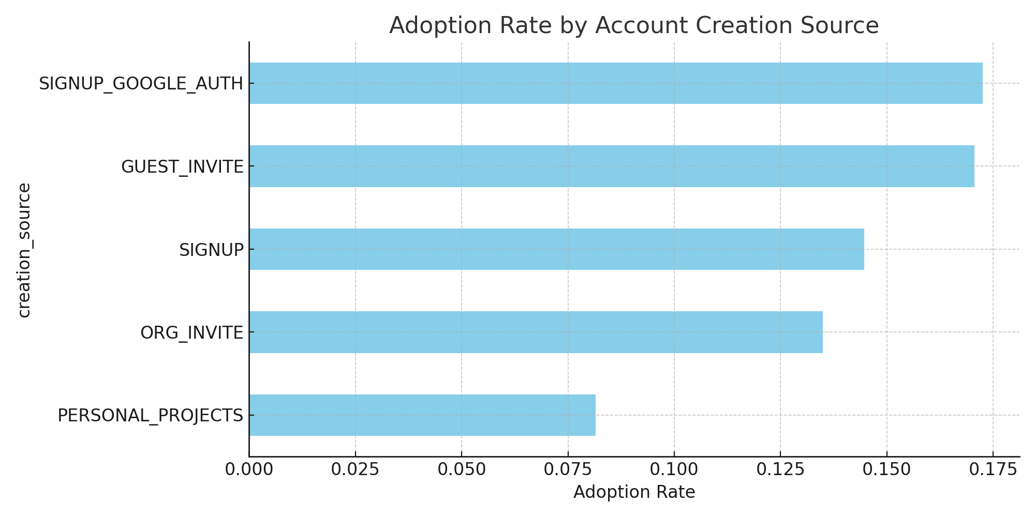

## Summary Table

object_id opted_in_to_mailing_list enabled_for_marketing_drip \  
adopted_user   
0 10344 0.25 0.15   
1 1656 0.26 0.16   
  
 last_session_creation_time   
adopted_user   
0 1.375596e+09   
1 1.395221e+09

## Code Snippet Used for Adoption Flag

def check_adopted(dates):  
 dates = sorted(dates)  
 for i in range(len(dates)):  
 count = 1  
 for j in range(i + 1, len(dates)):  
 if (dates[j] - dates[i]).days <= 7:  
 count += 1  
 if count >= 3:  
 return 1  
 else:  
 break  
 return 0