**Nama : Samiaji Santoso**

**NIM : 1710131310039**

**Mata Kuliah : ABKC6505 - Pengajaran Berbantuan Komputer**

**Hari / Tanggal : Kamis, 20 Oktober 2022**

* **Mind Map**

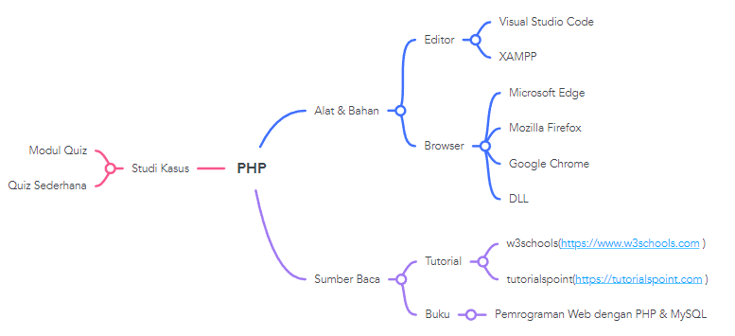

* **Alokasi Waktu Coding**

|  |  |  |  |
| --- | --- | --- | --- |
| **Hari** | **Kegiatan** | **Jam** | **Alokasi Waktu** |
| Senin | Coding | 21.00 – 22.00 | 1 Jam |
| Selasa | Coding | 21.00 – 22.00 | 1 Jam |
| Rabu | Coding | 21.00 – 22.00 | 1 Jam |
| Kamis | Coding | 21.00 – 22.00 | 1 Jam |
| Jumat | Coding | 20.00 – 22.00 | 2 Jam |
| Total | | | 6 Jam |